EXHIBITION
‘TAPIO WIRKKALA: A POET IN GLASS AND SILVER’
Finnish Glass Museum, Riihimaki
May-December 2013
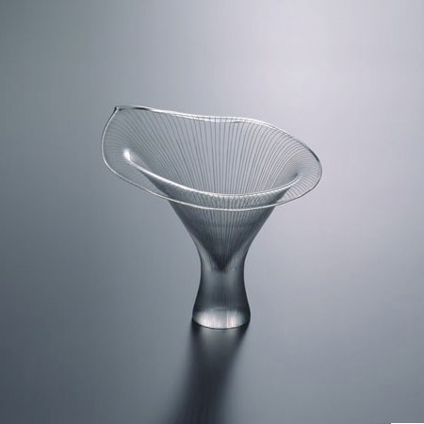
‘Chanterelle 1947’ ‘Paadar’s Ice 1960’
The curatorial agenda for the exhibition ‘Tapio Wirkkala: A Poet in Glass and Design’ is based on the themes and issues that were identified and evaluated in the key text ‘Tapio Wirkkala: Iconic Designer and Myth Maker’. The vast majority of the objects included in the exhibition were selected from the most important collection of Wirkkala’s work that is privately owned by the Finnish collector Kyosti Kakkonen, and which is not normally on public display. Over the years Kakkonen has built up a collection that includes numerous variations of Wirkkala’s key exemplars, and which provide important insights into the designer’s approach to glass, silver and the plywood abstract sculptures. The exhibition is internationally significant therefore in that it extends the boundaries of existing knowledge about this seminal figure in 20thC art and design.
In more recent years, international exhibitions have become increasingly important, with the actual curating and the resultant cultural manifestations forming a vital and critical point of intervention between the viewer and the objects, the relationship of object to object, the context in which the exhibition is placed, and the accompanying interpretation with its specific methodologies and intellectual focus. In this sense, major exhibitions such as the Wirkkala project are not merely the result of ‘putting on a show’, but provide a space for debate around the discourses that both inform the current theoretical ambition and the discourses that are being potentially challenged or that have informed the past.
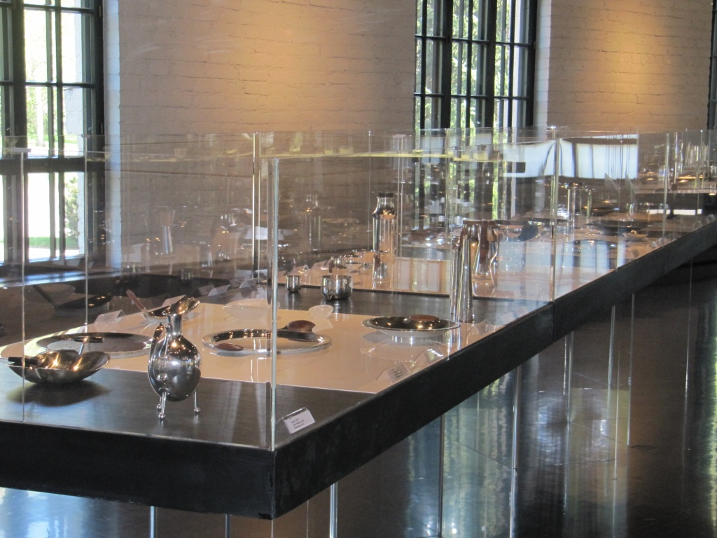
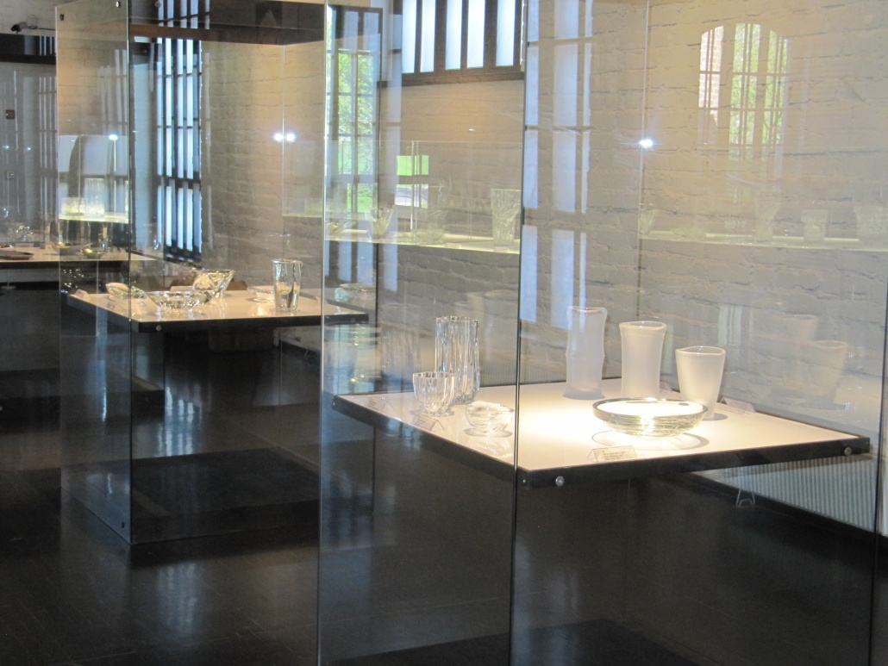
In placing objects in specific contexts and configurations the curator is constantly therefore making crucial value judgements about knowledge past and future possibilities. The exhibition environment provides a site and context where intellectual, moral, socio-economic, political debates and compromises can be presented, analysed, and reflected on, thus providing the exhibition visitor with an opportunity to question the role of objects within cultural discourses and gain a better understanding of their power within the historical context.
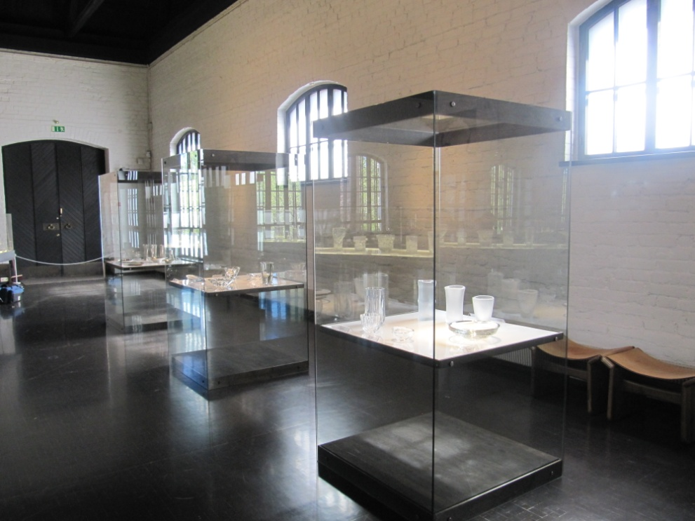
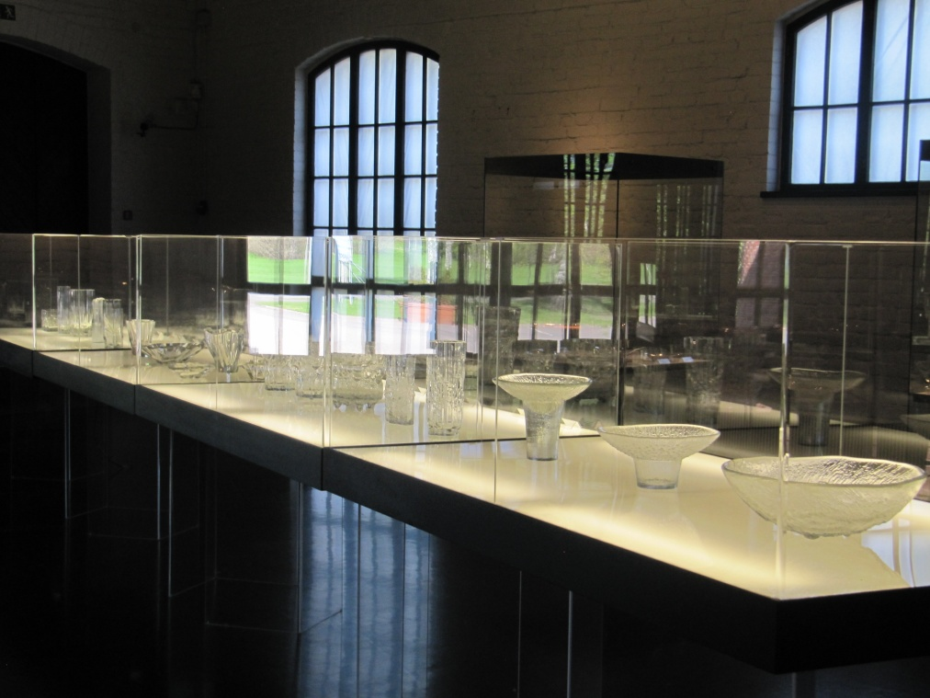
Crucially, exhibitions are invariably transient experiences and therefore have to make the maximum critical and intellectual impact through a range of supporting interpretive elements that assist and inform the primary themes.
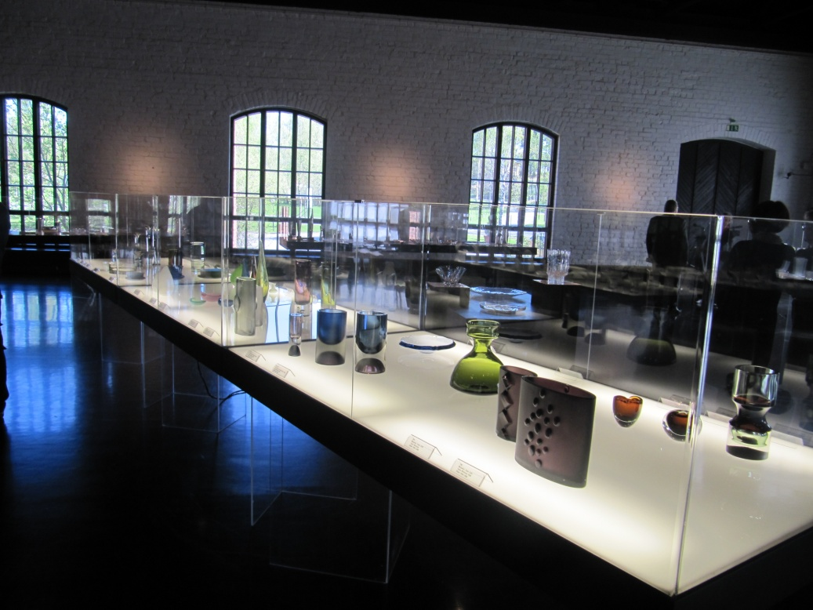

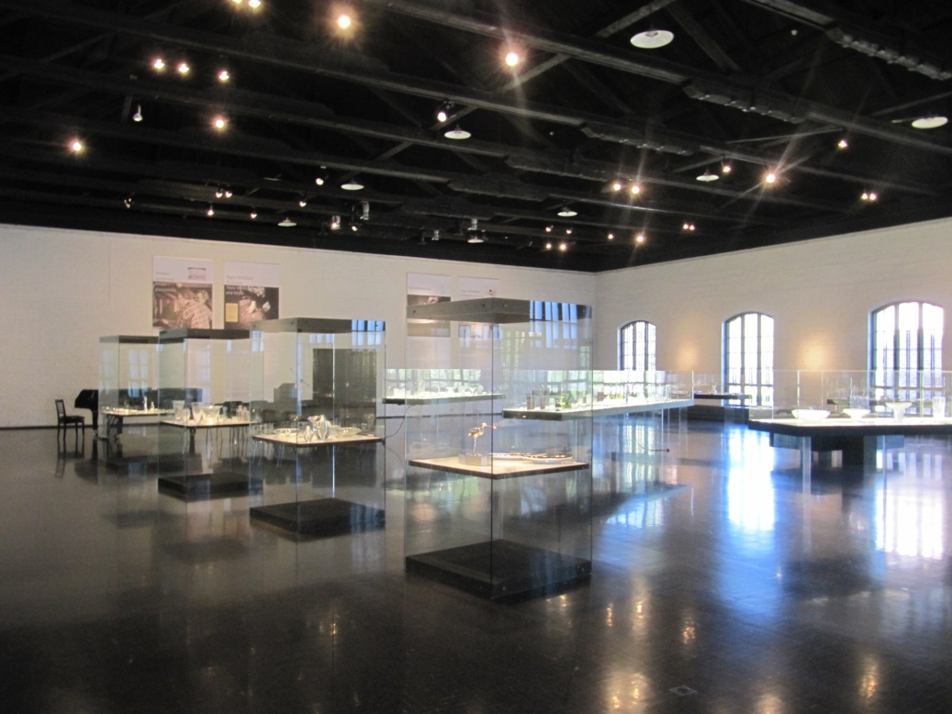

The link between traditional craft methods and techniques and advanced technologies in relation to both experimental glass and serial production, also forms an important strand in the methodological approach underpinning the curatorial process, These exemplars provided an opportunity to question what cultural objects do; how they might act as a conduit for specific aesthetic experiences; present a focus for alternative values and assumptions; and find and communicate information and new knowledge. More specifically, they created an opportunity to identify, describe and appraise the assumptions, values and beliefs that have come to be synonymous with Scandinavian design in general and glass in particular.
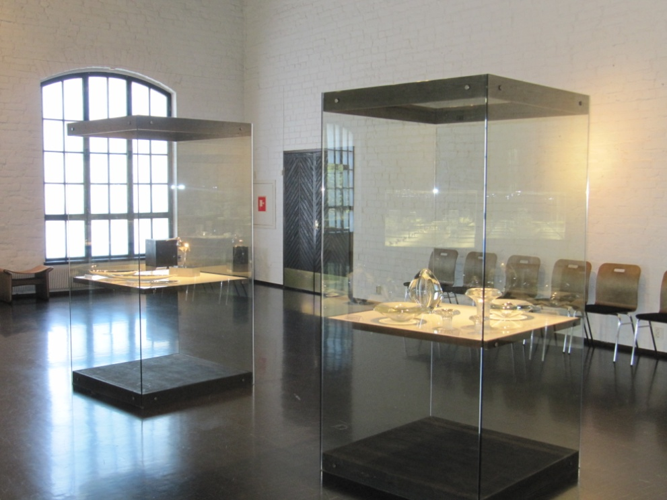
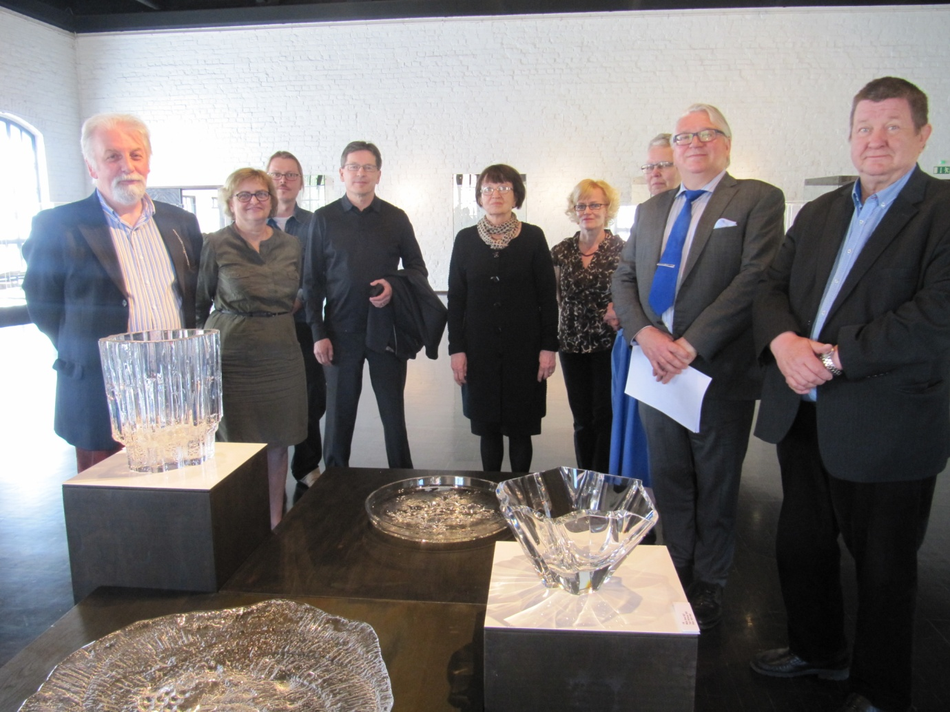
Dr Jack Dawson (Author/Curator) Dr Koivisto (Curator) K. Kakkonen (Collector) and Prof Matiskainen PhD (Museum Director)

Author/curator outlined the important role of Wirkkala in international design from a non-Scandinavian perspective.
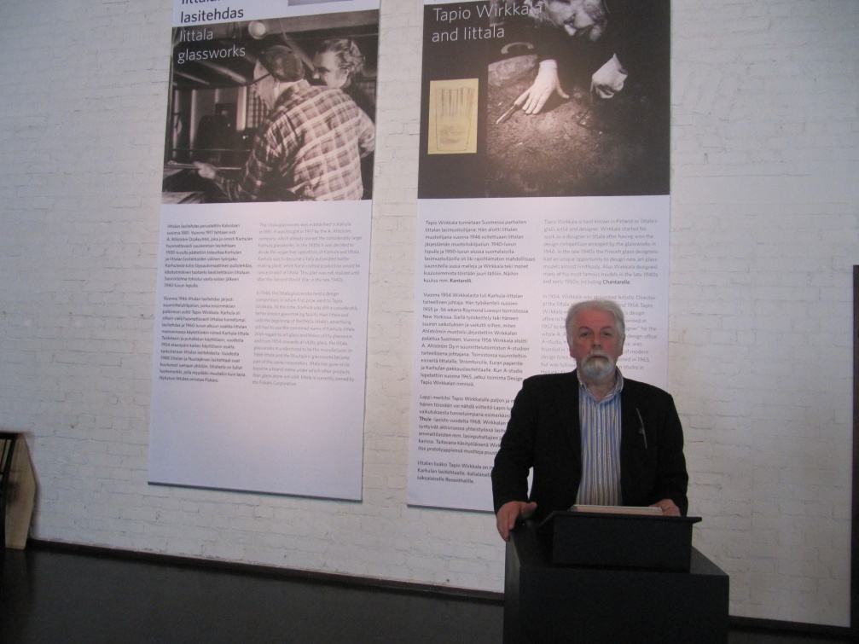
At the opening events
It was argued that there undoubtedly remains an air of mysticism and romanticism that seems to support and inform the populist design phenomenon of ‘cool’ Scandinavia. The stereotypical clichés that in the past have been employed to promote a kind of idealised Nordic psyche continue to play an important role in contemporary life. Phrases such as remoteness and isolation, simplicity and purity, homeliness, and a close affinity to nature and the power and benefits of the natural world, bring a specific type of added value to the Scandinavian contribution to twentieth century design.
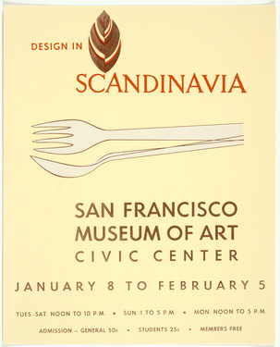 me

Underpinning this success was the discourse that argued that there was a kind of stylistic homogeneity that was profoundly influenced by an engagement with nature and craft and a more organic and humanistic approach to form. The Scandinavian nations were quick to utilize this image and united throughout the late 1950s and 1960s to create the major international promotional exhibitions that toured north America and Europe, and which gave rise to the defining terms ‘Scandinavian Design’ and ‘Scandinavian Modern’.

