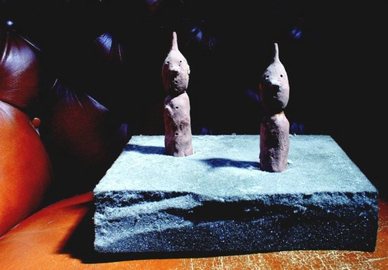
Image: Eric Bainbridge Two Bobs, 2008, Archival Inkjet Print, 90 x 128 cms, Courtesy of the artist and Workplace Gallery

Tip of the Iceberg Private View - Thursday 3 October (18.30-20.30) 59 Central Street, London EC1V 3AF
4th October 2013 - 3rd January 2014

http://www.contemporaryartsociety.org
Over the last four years, Contemporary Art Society North has organised studio visits and exhibition tours with over 60 artists based across the region. Tip of the Iceberg is an exhibition, curated by Mark Doyle and Rebecca Morrill, that offers audiences in London the chance to see work by 28 of these artists. It is the fourth in the guest-curated PROJECTS series, which takes place at Contemporary Art Society's headquarters: 59 Central Street. The exhibition features work by Iain Andrews, Eric Bainbridge, Catherine Bertola, Andrew Bracey, Pavel Büchler, Tony Charles, James Clarkson, Rachael Clewlow, Samantha Donnelly, Graham Dolphin, Leo Fitzmaurice, Susie Green, Dave Griffiths, Mary Griffiths, Matthew Houlding, Nick Kennedy, Laura Lancaster, Harry Meadley, Paul Merrick, Tim Machin, Anne Vibeke Mou, Michael Mulvihill, Emily Speed, David Steans, Cecilia Stenbom, Matt Stokes, Imogen Stidworthyand Rafal Topolewski.

