The Respiratory System

Marina Sawdon

# Overview; why we breathe

The purpose of breathing is to get oxygen (O2) from the atmosphere and into the body so it can be used in cellular respiration (internal respiration) to produce adenosine triphosphate (ATP) to fuel the cells activities. A by-product of cellular respiration is carbon dioxide (CO2). Carbon dioxide must be expelled from the body as it constantly forms carbonic acid in the body fluids.

The task of the lungs is exchange these gases with the atmosphere. This is achieved easily, in health, at the blood-gas interface. The first step in this process is to move air by bulk flow from the atmosphere into the lungs by rhythmical contractions of the respiratory muscles (external respiration). Deep in the lungs the molecular gases move by diffusion down their gradients, between the blood in the pulmonary circulation and the gas exchange areas of the lungs. CO2 is expelled from the blood and into the atmosphere, and O2 is transported in the blood to the cells for internal respiration.

# Anatomy of the respiratory system

Gross anatomy of the thorax



Figure 1 Gross anatomy of the thorax

Structure of the airways

In order to meet the demands of cellular respiration, a massive blood-gas interface must be created within the thorax. Thus, the airways form a series of branching tubes which double at each generation as they penetrate deep into the lungs. There are 23 generations of branching tubes, beginning with the trachea and ending with the blind-ended alveolar sacs. Functionally, there are 2 structurally distinct zones; the conducting zone and the respiratory zone.

The function of the conducting zone is to move air by bulk flow to the respiratory zone for gas exchange. The conducting zone itself does not take part in gas exchange due to the structure of the airways within it; the larger airways (generations 0, the trachea, through to about 10) contain cartridge for support to maintain patency of the airways. Generations 10 through to 16 make up the bronchioles, the smallest airways which do not take part in gas exchange are the terminal bronchioles which demarcate the end of the conducting zone. These airways are lined with mucus-secreting ciliated epithelium. The cilia move and sway to sweep mucus and inhaled particles up and out of the lungs (the mucociliary escalator).

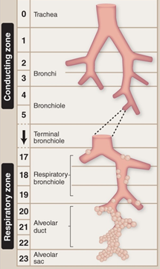

Figure 2 Branching structure of the airways.

Generations 17 to 23 form the respiratory zone. The respiratory zone begins with respiratory bronchioles, which have occasional alveolar budding from their walls, and end with the alveolar ducts. This alveolated area is where gas exchange takes place as the walls are thin enough for O2 and CO2 to diffuse across. The surface area of the respiratory zone in contact with the pulmonary capillaries for gas exchange is estimated at about 80m2, approximately the size of a tennis court! The volume of air contained within it is approximately 2.5 to 3 litres at rest.

Surface tension

All 300 million alveoli contain a thin film of fluid lining the internal surface, keeping them moist. The molecular forces of attraction between each water molecule are stronger than those with the surrounding air. This attraction generates surface tension as the water molecules are drawn to each other and away from the surface near the air. Surface tension forces try to reduce the area of the surface (that’s why falling rain drops form a sphere; the smallest surface area for given volume). Thus, unless we reduce the magnitude of this powerful force the lungs would collapse with the immense elastic recoil force of surface tension.

Alveoli contain Type II pneumocytes which produce a substance called surfactant. Surfactant is a special phospholipid molecule that reduces surface tension within the alveolar lining. Surfactant molecules intersperse between adjacent water molecules, reducing the molecular forces of attraction between them, thus the elastic recoil force of surface tension is reduced. The strength of surfactant’s effect is related to the density of the surfactant molecules, thus surfactant has a greater effect in smaller alveoli where the molecules are more densely packed together. Thus, this stabilises the whole lung, consisting of different sized alveoli.

Deadspace

Deadspace is a term used for the part of the lung which does not take part in gas exchange, for whatever reason. There are different types of deadspace; anatomical deadspace and physiological deadspace.

Anatomical deadspace does not take part in gas exchange because of the anatomy of the airways within that zone, this is the conducting zone. Its volume is approximately 150mL.

Physiological deadspace is anatomical deadspace plus what areas of the lung which should take part in gas exchange but for some reason does not. Thus in health the physiological deadspace should be only slightly larger than anatomical deadspace. However, in disease physiological deadspace can be significantly larger due to non-functioning alveoli.

Pleurae

Each lung is enveloped by its own closed pleural sac, which contains a few millilitres of secreted pleural fluid. The surface attached to the lung is called the visceral pleura and outside the lung the parietal pleura is connected to the chest wall, diaphragm and mediastinum. The pleurae are sealed units and the pressure within the pleural cavity is called the intrapleural pressure. Changes in the intrapleural pressure (as discussed below) are transmitted into the airways to cause air to move in and out down a pressure gradient.

# Lung Mechanics; how we breathe

Ventilation

The lungs are low resistance, distensible airspaces which only take a tenth of the pressure required to inflate a child's balloon by the same volume. The gas exchange zone is separated from atmospheric air by about 30cm of airways. Oxygen cannot diffuse this distance quickly enough and so air must be drawn in via a pump mechanism. The air pump works by muscles and bones causing a change in volume in the chest; changes in volume lead to changes in pressure and air moves down a pressure gradient. This is Boyle's law.

Changing volumes in the chest

* Inspiration

The most important muscle of inspiration is the diaphragm. The diaphragm is a thin dome-shaped sheet of muscle that sits under the ribs and is supplied by the phrenic nerve. After receiving a signal from this nerve, the diaphragm contracts and moves down into the abdomen, forcing its contents downward and forward and increasing the capacity of the chest cavity vertically. In addition, the ribs are lifted up and out, aided by contraction of the external intercostal muscles which connect adjacent ribs, causing an increase in the diameter of the chest cavity. During exercise or in some diseases an extra set of inspiratory muscles help increase the capacity of the chest to move air in more easily; the accessory muscles. The accessory muscles of inspiration are the scalene muscles, which lift the first two ribs, and the sternomastoids which lift the sternum. Volume (capacity) of the chest increases, pressure within the chest cavity falls below atmospheric pressure and air moves in down its pressure gradient.

* Expiration

During quiet breathing expiration is always passive (inspiration is always active). The diaphragm relaxes and moves back up under the ribs, decreasing the capacity of the chest. This is also aided by the elastic recoil of the lung's elastic elements (see later). During exercise, voluntary hyperventilation or disease expiration becomes active. The abdominal muscles are the most important muscles of expiration. They contract and push the abdominal contents up onto the diaphragm. In addition, internal intercostal muscles connecting adjacent ribs contract and pull the rib cage down and in. Thus the capacity of the chest is deceased, pressure within it increases above atmospheric pressure and air moves out of the lungs down its pressure gradient.

To understand where these pressure changes occur that allow air to move in and out of the lungs you need to understand the relationship between the lungs and its surrounding pleurae.

Static lung mechanics

Balance of forces acting on the lungs at rest:

At the end of a normal expiration the lungs remain partially inflated; they do not completely collapse. This is due to the balance of forces acting on the lungs at this time.

* Inward force on the lung

The lung's elasticity and surface tension within the alveoli make the lungs want to recoil inwardly (collapse) at the end of a normal expiration.

* Outward force on the lung

The muscles and bones making up the chest wall are also elastic structures. At the end of a normal expiration they favour outward movement (expansion) of the chest wall.

As the lung tissues and chest wall are connected by the sealed pleurae then neither can assume their natural resting position (collapsed for the lung tissue and expanded outward for the chest wall) at the end of a normal expiration. This creates a negative pressure within the pleural space; intrapleural pressure (Pip) is about -4 mmHg (4 mmHg below atmospheric). This negative pressure is demonstrated when the pleural membrane is breached, for instance during a stabbing. A hiss can be heard as atmospheric air is sucked into the pleura down the pressure gradient between the pleura and atmosphere. Intrapleural pressure becomes zero (i.e., equal to atmospheric) and the chest wall expands as the lung collapses beneath it (pneumothorax).

The pressure within the alveoli (intraalveolar pressure; Palv) is the same as atmospheric pressure at the end of a normal expiration, when no air is flowing (and so is said to be zero). The difference between intraalveolar pressure and intrapleural pressure is the transpulmonary pressure; the pressure across the lungs (4 mmHg at the end of a normal expiration as shown in Figure 3). It is this pressure that keeps the lungs open at the end of a normal expiration. Changes in these pressures facilitate ventilation.

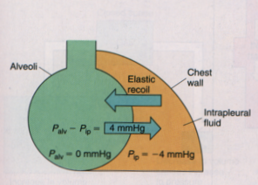

Figure 3 Pressures keeping the lungs partially expanded at the end of a normal expiration. Taken from *Vander et al 1994*

Dynamic lung mechanics

This section will explain the pressure, volume and airflow changes during breathing.

For air to move into the lungs a pressure gradient must be created between inside the lungs (intraalveolar pressure) and atmosphere. This is achieved by the expansion of the chest by contraction of the diaphragm and external intercostal muscles as described earlier. This expansion pulls on the sealed pleura decreasing the already negative pressure within there (due to Boyle's law; pressure and volume of a fixed number of air molecules remains constant).

P1V1 = P2V2 (Boyle’s law)

P1 and P2 denote alveolar pressure before and after alveolar expansion (V1 and V2).

This negative intrapleural pressure is transmitted through into the alveoli, creating a negative intraalveolar pressure. Air now moves in down the pressure gradient between the atmosphere and the alveoli. As air moves in through the airways against a resistance (offered mainly by airway diameter) it takes time to increase air volume in the chest and the pressure gradient to dissipate.

# Airway resistance

In healthy individuals breathing requires no effort and indeed is often not given a second thought. So it is difficult to imagine then that the airways offer a resistance to airflow. This resistance is mainly due to airway radius (if airway radius halves, resistance increases 16-fold), but airway length and the viscosity of the gas also have some influence. As the airway generations increase, the branches become more numerous and narrower. It would be reasonable to assume then that the biggest resistance to airflow was in the smallest airways, deep in the lungs. However, this is not the case, although the airways here are very narrow, they are numerous and so collectively afford little in the way of resistance. Indeed the largest contribution to airway resistance is in the medium sized bronchi in the conducting zone.

The fact that the smallest airways contribute little to resistance can be a problem for the early detection of chronic obstructive pulmonary disease (COPD). By the time diagnostic resistance changes (see table 1) can be measured, larger changes have already occurred, and the lungs can be already considerably damaged.

Factors affecting airway radius

Airway radius is the largest factor influencing airway resistance. Thus, anything that changes radius will impact on lung function. The two biggest factors affecting airway radius are airway smooth muscle tone and lung volume.

* Smooth muscle

Smooth muscle cells are abundant in the walls of bronchioles. When they contract they reduce the lumen of the airway and thus increase resistance to airflow. Likewise, relaxation of the smooth muscle increases the lumen radius and decreases resistance, making it easier for airflow to occur (i.e., requires less a pressure gradient from chest cavity changes; see above), reducing the work of breathing. Changes to airway smooth muscle tone are regulated by several factors; the autonomic nervous system, and local irritants and allergens in susceptible individuals.

Autonomic nervous system

When triggered, the vagus nerve releases acetylcholine (ACh) from its nerve terminal to act on muscarinic ACh receptors on the smooth muscle. This leads to smooth muscle contraction and bronchoconstriction, increases resistance and reduces airflow. In susceptible patients often innocuous substances can trigger this response leading to an asthma attack.

Whereas parasympathetic (vagus) nerve activation leads to bronchoconstriction, sympathetic nerve activation leads to bronchodilation. Noradrenaline is released from sympathetic nerve terminals to act on beta-2 adrenergic receptors on the bronchial smooth muscle, causing relaxation of the muscle and increased air flow (the same response is elicited by adrenaline release from the adrenal medulla, for instance during exercise).

Thus, the autonomic nervous system can be a target for therapeutic interventions of some diseases of airway resistance such as asthma. Drugs such as anticholinergic agents (e.g Ipratropium bromide) and beta-2 adrenergic receptor agonists (such as salbutamol) can reverse bronchoconstriction to open up the airways and improve airflow during asthma attacks (see below).

Irritants and allergens

Irritants, such as cigarette smoke, and allergens, such as the faeces of the house dust mite, can trigger bronchoconstriction and increased airway resistance in susceptible individuals. The mechanism for this can be via the vagus nerve, or the production of histamine; an inflammatory mediator. This can trigger increased mucus secretion, decreasing the lumen of the airway. These lead to airway obstruction, decreased airflow and increased work of breathing.

* Lung volume

Lung volume has an important effect on airway resistance. At low lung volumes resistance is high, and at high lung volumes resistance is low. This is due to radial traction. When alveoli expand the nearby tethered airways are pulled open, increasing their radius and reducing resistance on lung expansion. At low lung volumes the tethered airways are not pulled open as much and thus their radius is smaller and resistance higher.

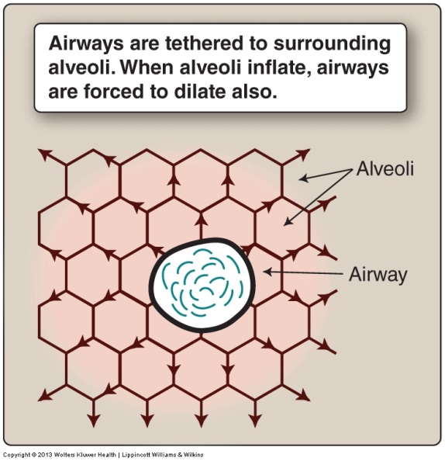

Figure 4 The effect of lung volume on airway radius

Dynamic airway collapse

The amount of expiratory airflow one can achieve is not always related to the amount of effort put in to an expiration. Airways tend to collapse and trap air within them. This will limit airflow towards the end of the expiration as airways close off due to compression from the pressure difference inside and surrounding the airways. This best explained with the example of a forced expiration. To conduct a forced expiration one must contract the muscles in the abdominal wall and the internal intercostals. This will compress the thorax and increase intrapleural pressure, such that it becomes positive. This positive pressure is transmitted into the alveoli and airways, causing alveolar pressure to rise above atmospheric. The positive pleural pressure would favour airway collapse but the high alveolar pressure counteracts this and maintains the airway open. The pressure gradient between alveoli and atmosphere favours the movement of air towards the mouth and out into the atmosphere. As the air moves through the branching airways alveolar pressure falls, whilst pleural pressure remains the same. Thus, there will come a point when the pressure outside the airway trying to collapse it (intrapleural pressure) equals the pressure inside the airway trying to keep it open (intraalveolar pressure); this is termed the equal pressure point. Beyond this point, further falls in intraalveolar pressure, as the air continues to flow out, will cause the airway to collapse as the pressure outside the airway (intrapleural pressure) exceeds the pressure inside the airway (intra alveolar pressure) and the airway collapses, trapping air within it and limiting expiratory flow rate. Increases the effort of the manoeuvre will serve no purpose as this will only increase intrapleural pressure (the pressure trying to collapse the airway) further. With lung diseases characterised by high airway resistance, dynamic airway collapse will happen sooner, trapping more air and making it difficult for the patient to breath. This is because areas of the lung with high airway resistance will cause intra alveolar pressure to fall sooner.

# Lung compliance

Compliance is how easily the lung stretches; it is a measure of the amount of pressure needed to inflate the lungs to a given volume. The compliance of the lung is due to two factors; the elastic properties of the lung tissue and chest wall, and surface tension. Surfactant reduces surface tension (see earlier) and thus reduces lung compliance, making it easier to inflate the lungs and reduce the work of breathing. Several lung diseases can affect compliance, e.g., a loss of elastin in emphysema will decrease the elastic recoil of the lung parenchyma and increase lung compliance, making the lungs easier to inflate but deflation can now become an active process. In addition, radial traction is reduced which increases resistance to airflow. An increase in the deposition of collagen in pulmonary fibrosis will decrease compliance. The lungs inflation becomes restricted.

# Lung diseases

Most pulmonary diseases fall into two categories; restrictive and obstructive. Restrictive lung diseases are conditions which restrict lung inflation. Obstructive lung diseases are conditions which obstruct airflow due to high airway resistance. See Table 1 for the restrictive and obstructive pattern of lung function test results.

Restrictive lung diseases

Restrictive lung diseases are characterised by low compliance, and thus reduced lung volumes (see lung function tests below) as the lungs are stiff and difficult to inflate. Limited lung expansion results from any one of a number of interstitial lung diseases. The process starts with thickening of the alveolar walls and exudate filling alveolar spaces, in response to any of several inhaled compounds. Fibroblasts then lay down collagen and other substances between alveolar sacs forming stiff, non-compliant scar tissue. Examples of restrictive lung diseases include fibrosis, silicosis and asbestosis. Scoliosis and volume-occupying tumours can also be classed as restrictive lung diseases.

Obstructive lung diseases

Obstructive lung diseases are characterised by increases airway resistance which obstructs airflow. Asthma, emphysema and chronic bronchitis all represent obstructive lung diseases. However, the increase resistance in each of these conditions is due to different reasons. In addition, asthma has a reversible component which the other two do not have. Chronic bronchitis and emphysema often occur together and are collectively referred to as chronic obstructive pulmonary disease (COPD).

* Asthma

*Presentation*

During an asthma attack patients typically present with shortness of breath that can differ in severity between attacks, coughing, high pulse rate and anxiety. It often presents during the night or early on the morning, when the air is cold, or when the pollen count is high.

*Pathophysiology*

Asthma is a common, chronic, inflammatory disease of the lower respiratory tract. It characterised by intermittent, but reversible, episodes of bronchospasm (contraction of the smooth muscle around the bronchioles), increased mucus production and inflammation of the airways. This is sufficient enough to reduce the radius, increase airway resistance and impair lung function. The cause of asthma is not completely understood but it may have a genetic and/or allergic component. The underlying inflammation causes the hypertrophied airways to be hyper-responsive to certain stimuli such as cold air, the faeces of the house dust mite, cigarette smoke, dust, certain fumes and vapours and even exercise. Thus, these often innocuous stimuli cause the bronchial smooth muscle to contract and reduce airway radius.

Patients find it difficult to breathe in but even more difficult to breathe out as the high resistance of the airways causes intraalveolar pressure to fall sooner (the pressure inside the airway acting to keep it open), resulting in dynamic airway collapse and air trapping (as seen by increased residual volume; see lung volumes and capacities). Trying to increase the effort of expiration is futile, as this will only serve to increase the pressure outside the airways (intrapleural pressure) and the airway would collapse sooner. Patients in this state often recruit accessory muscles of respiration to help increase the volume of the chest. A bigger lung volume will increase radial traction and ‘pull open’ the airways. This will reduce resistance and make it a little easier to breathe (see Figure 4).

*Treatment and management*

Treatment and management of asthma is dependent on the severity of the disease. The pharmacological treatment may be classed as relievers and controllers.

Relievers are drugs which cause bronchodilation, such as beta-2 adrenergic receptor agonists (e.g., salbutamol and salmeterol), methylxanthines (e.g., theophylline) and anticholinergics (e.g., ipratropium).

Controllers are drugs which reduce inflammation such as corticosteroids (e.g., beclomethasone) and leukotriene receptor antagonists (e.g., montelukast and zafirlukast).

* COPD

*Presentation*

Patients often present with breathlessness, particularly on exertion, a chronic cough, regular sputum production, wheeze and regular chest infections. Diagnosis is made with the patients history (looking for risk factors such smoking and age), physical examination, laboratory investigations and lung function tests using spirometry (see below).

*Pathophysiology*

Emphysema is characterised by enlargement of air spaces and destruction of alveolar walls. Destruction of large amounts of lung tissue results in loss of elastic recoil and thus reduced radial traction. This will decrease airway radius and increase resistance to airflow.

Chronic bronchitis is characterised by excessive mucus production by hypertrophied mucus glands within the bronchioles. This results in thickening of the bronchial walls and obstruction with mucus secretions. The reduced lumen of the bronchioles increases resistance and decreases airflow.

*Treatment and management*

The treatment and management of COPD is dependent on the severity of the condition. COPD is not curable but progression can be slowed with the appropriate treatment and advice. Patients with COPD will be offered advice on cessation of smoking to slow the progression of the disease, and treated pharmacologically with bronchodilators (such as salbutamol and theophylline), steroid inhalers to reduce inflammation of the airways, mucolytic tablets such as carbocisteine, to thin the mucus and phlegm making it easier to cough up, antibiotics for chest infections, and oxygen therapy if the condition is severe enough.

See Table 1 for patterns of changes in pulmonary function tests for restrictive and obstructive lung diseases.

# The work of breathing

Overview

There is an energy cost to breathing. In health, this is usually less than 5% of the metabolic rate at rest. However, the lungs are not very efficient as only 10% of the energy consumed by ventilation is used for useful work, i.e., shifting air in and out of the lungs, the rest is used to move the muscles and bones of respiration against the resistance of the elastic tissues and airways, and heat production. Energy expenditure from ventilation is minimised in health by breathing an optimum rate and depth, and rarely limits ones exercise capacity. However, with lung disease the optimum breathing pattern is often lost and the work of breathing increases. In severe cases, particularly during exercise, the energy cost (oxygen consumption) of ventilating the lungs may exceed the amount of oxygen that ventilation provides. If a patient is in this condition at rest, respiratory failure may prevail.

Why work needs to be done

Work needs to be done when contracting the respiratory muscles to inflate the lungs, to overcome the elastic resistance of the lung tissues (elastic work) and airway resistance (resistive, or non-elastic work). To inflate the lungs one must overcome the elastic recoil properties of the lung tissue, thus this requires work to be done, energy to be consumed. As the chest wall components also have elastic properties, displacing the chest also requires work. Non-elastic (resistive) work involves moving air against the resistance offered by the airways; the higher the resistance, the greater the energy cost. Thus, several pulmonary diseases increase the work of breathing as the elastic properties and airway resistance are often affected.

Optimum breathing pattern

As respiratory minute volume (RMV; the volume of air shifted into or out of the lungs per minute) is respiratory rate times tidal volume (*f* x VT) the same RMV can be achieved by breathing either fast and shallow or slow and deep. In health, the optimum pattern to minimise the energy cost of breathing (from elastic and resistive forces) is somewhere between these two extremes.

This optimisation pattern is lost in pulmonary disease. Patients with COPD (not during an acute episode, where they would be gasping for air) would tend to breathe slowly and deeply to minimise the restrictive work (as resistance is high); breathing slower minimises the chances that airflow will be turbulent and hence require more energy to move it through the airways. In addition, breathing deeper inflates the lungs more, increasing radial traction and thus decreasing resistance (see Factors affecting airway resistance).

Patients with restrictive lung disease (e.g., pulmonary fibrosis) tend to breath fast and shallow as smaller tidal volumes will decrease the elastic work (as they do not have to distend the stiff, elastic tissues as far). Both patterns will increase the work of breathing for these patients as they work harder to overcome the pathophysiology of their condition but increase the work elsewhere.

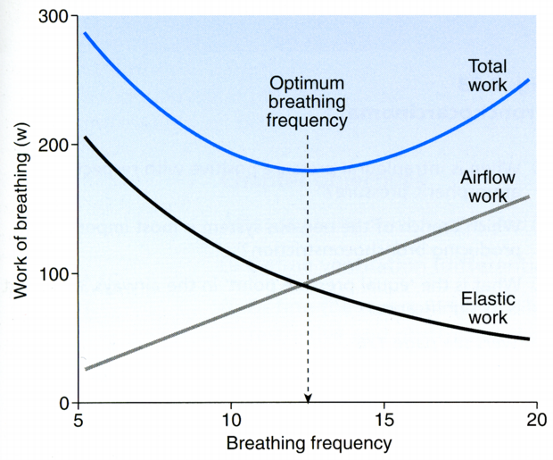

Figure 5 The work of breathing at different frequencies

# Lung volumes and capacities

Spirometry

Pulmonary function tests typically measure lung volumes, and from combinations of these, capacities can be derived. All lung volumes that can be ventilated (moved in and out of the lungs) have traditionally been measured using an apparatus called a spirometer, hence the technique is called spirometry. A spirometer consists of a closed circuit whereby the subject breathes from a cylinder floating on water. When the subject breathes in gas is inspired from the cylinder into the lungs, and the cylinder sinks into the water. When the subject expires gas moves from the subject’s lungs into the cylinder, which then rises in the water. By making appropriate allowances for changes in temperature (room vs body) the volume changes in the cylinder are equal and opposite to those in the lungs. A pen is connected to the cylinder which marks the volume changes onto chart paper. Spirometers are still used and are very reliable. However, they are bulky and contain a lot of water which makes them cumbersome to handle. More recent advances involve using a pneumotachograph. A pneumotachograph consists of a ‘flow head’ through which the subject breathes. This flow head (Figure 6b) consists of a tube with a fine mesh inserted into it. The mesh imposes a very small resistance to air flow, consequently as the subject breathes through the mesh a pressure difference is generated across it. The faster the air flow, the greater the pressure difference. The flow head is connected to a very sensitive pressure measuring device and with the aid of a computer the flow rate (L/min) is calculated. The software further integrates the flow over time to give volume (L).

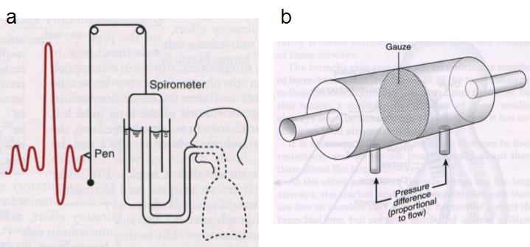

Figure 6 a) traditional water-filled spirometer used to measure lung volumes; b) pneumotachograph used to measure airflow. a has been taken from West, 2001; b from Davies & Moores, 2003.

Volumes

We never completely empty our lungs, even during exercise. The volume of air remaining in the lungs at the end of a normal expiration is the **residual volume** (**RV**; see Figure 7). The volume of air inhaled or exhaled at each breath is called the **tidal volume** (**VT**), and is around 500mL. The amount of air that can be inhaled or exhaled above tidal volume is the **inspiratory reserve volume** (**IRV**)and the **expiratory reserve volume** (**ERV**).

Capacities

**Total lung capacity** (**TLC**) is the sum of the four lung volumes mentioned above and is the maximum amount of air the lungs can hold when fully inflated. The **functional residual capacity** (**FRC**) is the volume of air left in the lungs at the end of a normal expiration. **Inspiratory capacity** (**IC**) is the sum of the tidal volume and inspiratory reserve volume. Likewise, **expiratory capacity** (**EC**) is the sum of the tidal volume and expiratory reserve volume. Finally, **vital capacity** (**VC**) is the sum of the tidal volume, inspiratory and expiratory reserve volumes (a single maximal breath).

As residual volume cannot be breathed out, any lung volume that includes RV cannot be measured using spirometry.

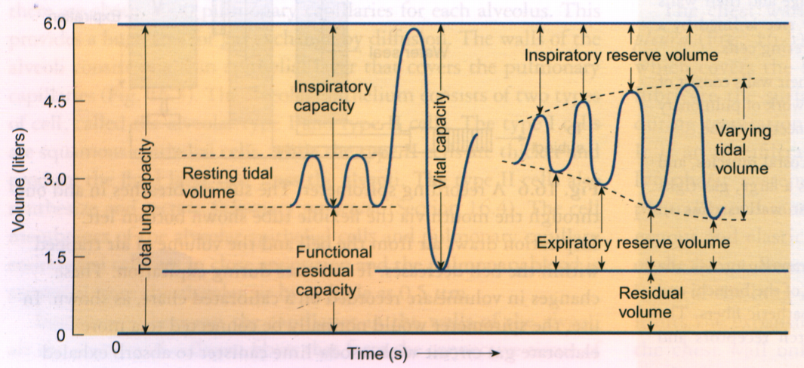

Figure 7 Lung volumes and capacities*. Pocock & Richards 1999*

Lung function tests

Lung function tests are useful in helping to assess pulmonary function. However, they are rarely used in isolation to diagnose a particular condition as there is often an overlap of functional impairment between different pulmonary diseases. However, the results can help distinguish between restrictive and obstructive pulmonary diseases. What these tests are most useful for is in monitoring the progression of a disease and the response to treatment. Some lung function tests use spirometry to measure lung volumes, others assess flow rate.

* Volumes

Forced vital capacity (**FVC**) is the volume of air exhaled during a fast, forced expiration, following a maximum inspiration. The volume of air which is expired in the first second of a FVC is called the forced expiratory volume 1 (**FEV1**). The ratio of FEV1 to FVC is assessed in order to normalise for different size lungs (**FEV1/FVC**).

Restrictive lung diseases are characterised by a normal FEV1/FVC ratio (over 70%) but both FVC and FEV1 can be reduced (restrictive lung diseases are called volume reducing diseases due to the low compliance of the stiff lungs making them difficult to inflate). Thus, TLC, RV and FVC (volumes) are all reduced in the restrictive pattern. Obstructive lung diseases result in a low (less than 70%) FEV1/FVC ratio as FEV1 is greatly reduced due to airway obstruction and exhalation impairment (see Table 1).

|  |  |  |
| --- | --- | --- |
| Pulmonary Function Test | Obstructive Pattern | Restrictive Pattern |
| FVC | Decreased or normal | Decreased |
| FEV1 | Decreased | Decreased or normal |
| FEV1/FVC | Decreased | Normal |

Table 1 Pattern of pulmonary function test results in restrictive and obstructive pulmonary diseases.

* Flow rates

Peak expiratory flow rate (**PEFR**) is one of the most commonly carried out tests. It measures the maximum flow rate achieved during a FVC. It is carried out using a peak flow meter that can be portable and hand held for monitoring the disease at home. It is the most common lung function test used in the diagnosis and treatment response of asthma. The average flow rate during any portion (x) of the FVC can be assessed; this is termed the forced expiratory flow rate (**FEFx**). Both of these tests show a reduction in values in obstructive lung diseases such as COPD and asthma, due to a reduction in elastic recoil or an increase in airway resistance.

The results of all these tests are independent of the amount of effort the patient puts in, but limited by physiology.

# Blood supply to the lungs

The lungs are supplied by two circulations; pulmonary and bronchial.

The bronchial circulation brings nutritive flow to the conducting airways. After delivering oxygen and nutrients to the airways of the conducting zone, this blood will re-entered the systemic circulation without being oxygenated. This process is called physiological shunt. This deoxygenated blood leaves the bronchial circulation via the veins of the pulmonary circulation and mixes with the oxygenated blood from the pulmonary circulation. This blood is called venous admixture and decreases the oxygen saturation of pulmonary venous blood by about 1 or 2%.

The pulmonary circulation delivers deoxygenated blood from the right side of the heart ultimately to the pulmonary capillaries, which 'wrap' themselves around the alveolar sacs, for gas exchange (see above for mechanism). The pulmonary circulation has a low vascular resistance to blood flow and hence the pulmonary blood pressure is very low. It receives the entire cardiac output (~5L/min at rest) which can increase 5-fold during exercise, without significant increases in pulmonary blood pressure.

# Gas exchange

The lungs facilitate the exchange of gases between blood and atmospheric air by bringing the two into close proximity at the blood-gas interface. The structure of the blood-gas interface is well suited to its function as the barrier is extremely thin (less than 1 µm) and the surface area is extremely large (~80m2). This permits rapid exchange of large amounts of oxygen and carbon dioxide. Efficient gas exchange is also critically dependant on an adequate blood supply to deliver CO2 for elimination and replenish O2. Changes in either ventilation or perfusion can severely affect lung function.

The barrier for gas exchange

Air is separated from blood by a thin barrier. The barrier must be kept as thin as possible to facilitate adequate gas exchange. The barrier for gas exchange consists of three layers; the alveolar epithelium, the capillary endothelium (and their basement membranes) and the interstitium. The gases move across this barrier by a process of diffusion. The driving force for gas diffusion is the partial pressure gradient.

The concept of partial pressure

Oxygen and carbon dioxide move between alveolar air and pulmonary capillary blood by passive diffusion. As the amount of gas movement is also confounded by its solubility in blood (CO2 is 20 times more soluble than O2) then driving forces for diffusion in this instance is discussed with respect to a gases partial pressure, rather than concentration.

In air or blood, molecular gas moves around in a random manner and exerts a pressure on the walls that contain it. Each gas will exert its own pressure, a partial pressure, which is a fraction of the total pressure of the gas mixture (this is Dalton's law of partial pressures). For example, the total pressure of atmospheric air at sea level is 760 mmHg, however, it contains several gases. Atmospheric oxygen makes up 21% of those gases. Thus, the partial pressure of oxygen in atmospheric air is 760 x 0.21 which is 160 mmHg. By the time it reaches the alveoli the air is moistened and saturated with water vapour, which also exerts a partial pressure. This reduces the partial pressure of the oxygen in alveolar air to 150 mmHg. Gases move between alveolar air and blood by diffusion down their partial pressure gradient; from an area of high partial pressure to an area of low partial pressure for that gas. The gases will continue to diffuse until equilibrium with the blood is reached. However, the partial pressure in pulmonary venous blood at equilibrium is slightly less than in the alveoli (100 vs 150 mmHg) because blood flow through the pulmonary circulation is slightly higher than ventilation rate (see Matching ventilation and perfusion, below) and the blood is continuously carrying the diffused oxygen away.

The concentration of oxygen that ends up dissolved in the blood is related to not only its partial pressure gradient between the air and blood, but also how soluble the gas is in blood. This is depicted by Henry's law which states that the amount of a given gas dissolved in a liquid is directly proportional to the partial pressure of the gas in equilibrium with the liquid. As CO2 is approximately 20 times more soluble than oxygen in blood and approximately the same molecular weight (see Fick’s law below), it diffuses more easily than oxygen for a given partial pressure gradient. Thus, any diseases that thicken the blood-gas barrier (e.g., pulmonary fibrosis) will affect the diffusion of oxygen before CO2, and therefore the partial pressure of O2 in systemic arterial blood (depicted as PaO2).

Gas diffusion across the barrier

Gas transfer across the blood-gas barrier occurs passively. Fick's law of diffusion (Figure 8) states that the rate of diffusion is proportional to:

The area available for diffusion

The partial pressure gradient

The solubility of the gas in blood

And inversely proportional to:

The square root of the molecular weight of the gas barrier thickness

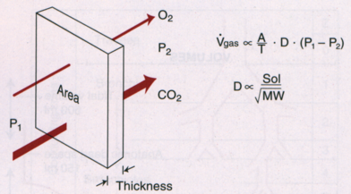

Figure 8 Fick’s law of diffusion. *West 9th edition*

The area available for diffusion is vast (~80m2). However, some pulmonary diseases result in a loss of large areas of the blood-gas barrier (e.g., emphysema). This affects gas exchange and the levels of these gases in the blood. CO2 diffuses more rapidly than O2 because of its higher solubility in blood, but similar molecular weight. As we have seen earlier the thickness of the barrier is extremely small in health (~1 µm) however, diseases such as pulmonary fibrosis can cause thickening of this barrier, impeding gas exchange and limiting the amount of oxygen that can diffuse into the blood.

In a healthy lung, area, barrier thickness, solubility, molecular weight of the gases and barrier thickness do not change significantly; therefore diffusion is dependent on the partial pressure gradient.

Oxygen has a poor solubility in blood, and therefore only small amounts are dissolved within it. The partial pressure gradient between alveolar air and pulmonary capillary blood would be quickly dissipated and diffusion would end prematurely without a means of increasing the blood's ability to carry oxygen. Indeed, the maximum amount of oxygen that the blood could transport in solution is only about 3 mL per litre of blood. The body's oxygen demands amount to about 250 mL/min. Thus, a resting cardiac output of 83 L/min would be required! However, the blood's ability to carry oxygen is increased by the presence of large amounts of haemoglobin (each red blood cells contains ~280 million haemoglobin molecules). Haemoglobin has a high affinity for oxygen and quickly binds it following diffusion across the barrier. This prevents the molecular oxygen from moving through the blood in random motion and exerting a partial pressure within it. This maintains the partial pressure gradient between alveolar air and pulmonary capillary blood to allow oxygen to continue to diffuse until equilibrium (the same partial pressure in pulmonary capillary blood as in the alveolar air) has been reached.

Matching ventilation and perfusion

Assuming a normal gas exchange barrier, gas concentration and partial pressure of an alveolus (and the blood leaving it as they are in equilibrium) is dependent on the amount of oxygen added per unit time and the volume of blood into which it is dissolved. The former is determined by ventilation rate and the latter by pulmonary blood flow. Therefore the concentration of oxygen in any lung unit (an alveolus and its capillary network) is determined by the ventilation (V) to perfusion (Q) ratio (V/Q). The V/Q ratio can give important information on lung function. Cardiac output to the pulmonary circulation is approximately 5L/min and ventilation provides about 4L of air to the alveoli in this time, at rest. Thus, in an ideal lung unit that is well ventilated and well perfused the V/Q ratio will be 0.8, meaning that blood oxygenation is optimal. However, this is not always the case as there are local differences in both blood flow and ventilation even in the normal lung, giving rise to a whole spectrum of possible V/Q ratios.

Atmospheric air contains oxygen with a partial pressure of 150 mmHg and negligible amounts of carbon dioxide. Systemic venous blood entering the pulmonary capillaries contains oxygen with a partial pressure of only 40 mmHg but higher partial pressure of carbon dioxide at 45 mmHg. Blood traverses the pulmonary capillary in only 0.75 seconds. Equilibration of the gases between blood and alveolar air is achieved when the blood is only a third of the way through this vessel, resulting in a PO2 of 100 mmHg and a PCO2 of 40 mmHg in both alveolar air and pulmonary capillary blood (see example of normal in Figure 9). Changes in either ventilation of perfusion can change these values.

Pulmonary diseases can lead to abnormalities that result in a ventilation/ perfusion mismatch. Ventilating under-perfused alveoli will result in wasted ventilation and a high V/Q ratio (e.g., vascular obstruction as shown in Figure 9). Likewise, perfusing an unventilated alveolus (e.g., airway obstruction as shown in Figure 9) will lead to shunted blood (blood passing through the pulmonary circulation without being oxygenated) and a low V/Q ratio of the blood leaving that unit resulting in venous admixture. Serious V/Q mismatch can occur in both asthma and emphysema due to un-ventilated lung units. Increasing ventilation to normal lung units cannot compensate for the hypoxic blood leaving the un-ventilated lung units due to the shape of the oxygen-dissociation curve (see cardiovascular chapter); blood leaving the normal lung units is already fully saturated with oxygen and thus cannot increase its oxygen content significantly. However, increasing ventilation in normal lung units can result in a lower PaCO2 in the blood leaving that lung unit, thus compensating overall for the high PaCO2 from the un-ventilated lung units once the blood from these different areas has mixed in the pulmonary veins.

Both of the extremes shown in Figure 9 will affect the levels of oxygen and carbon dioxide present in systemic arterial blood. However, there are mechanisms that can act to minimise this but these will not compensate fully for diseased lungs.

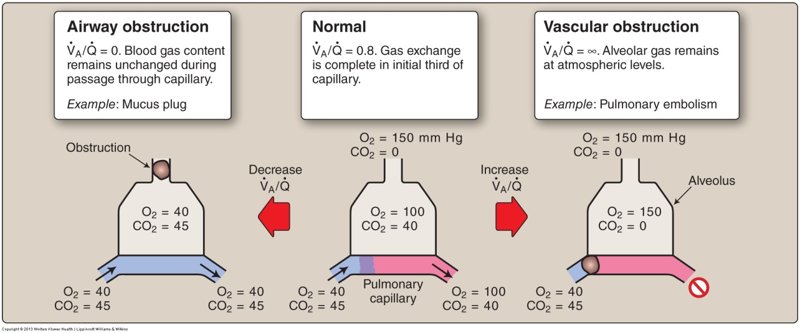

Figure 9 Effects of obstructing either ventilation or perfusion on V/Q ratios and systemic oxygen and carbon dioxide levels.

Mechanism to divert blood away from poorly ventilated lung units

The mechanism to divert blood away from poorly ventilated lung units and towards better ventilated areas is called **hypoxic pulmonary vasoconstriction**. This mechanism serves to reduce any ventilation/perfusion mismatch and thus minimise an otherwise overall reduction in PaO2. Low partial pressures of oxygen within alveoli gas (denoted PAO2) lead to the constriction of local pulmonary arterioles. This vasoconstriction increases resistance through these vessels and thus reduces blood flow. The mechanism behind this is possibly the local release of vasoconstrictor agents from the blood vessels themselves, triggered by the hypoxic environment. The effect of alveolar oxygen tension on pulmonary blood flow is non-linear (see Figure 10); at PAO2 above 100 mmHg there is no response, however, when PAO2 falls below 70 mmHg vasoconstriction occurs. At very low PAO2 blood flow is almost abolished.

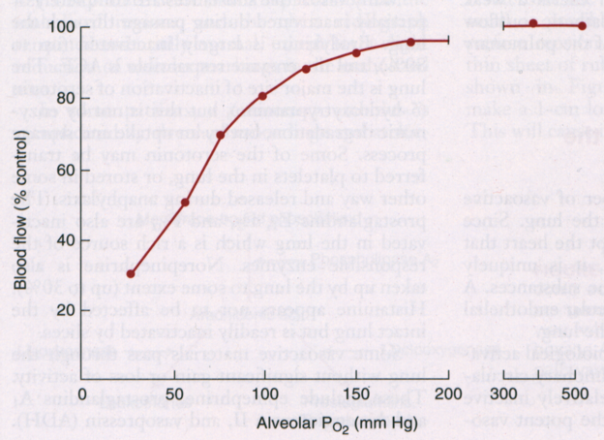

Figure 10 Hypoxic pulmonary vasoconstriction; the mechanism to reduce blood flow to under-ventilated alveoli. *West 9th edition*

Mechanism to decrease ventilation to poorly perfused lung units

Low carbon dioxide tension within alveoli (PACO2) due to poor perfusion (see vascular obstruction example in Figure 9) will lead to the release of local metabolites (e.g., hydrogen ions) that lead to airway constriction, and increased airway resistance; thus diverting ventilation to better perfused lung units. This response occurs within minutes of a reduction in perfusion locally. A slower mechanism (hours to days) involves decreased alveolar cell metabolism in poorly perfused lung units, decreased surfactant production, increased surface tension, and thus decreased functional residual capacity in that area.

# Chapter summary or list of key learning points (?)