Raising awareness of autistic spectrum disorders for healthcare assistants
Catherine Hayes, Reader in Health Professions Pedagogic Practice, Faculty of Health Sciences and Wellbeing, University of Sunderland, Visiting Professor of Higher Education Pedagogic Practice, University of Cumbria, Visiting Professor of Higher Education, Liverpool Hope University; Lisa Alcorn, Director of Strategic Operations, Potens UK, Professional
Doctorate Graduate, Faculty of Health Sciences and Wellbeing, University of Sunderland; and Yitka Graham, Senior
Lecturer in NHS and Health Services Engagement, Faculty of Health Sciences and Wellbeing, University of Sunderland

H
ealthcare assistants (HCAs) play a significant role in the reassurance and holistic management of
patient caseloads in practice. Autistic spectrum disorder (ASD) is a series of conditions necessitating understanding and compassion that HCAs are ideally placed to support in clinical practice.
Providing a straightforward definition of what ASD is and the challenges it can pose to healthcare workers is one of the first means of devising supportive adaptations to healthcare in practice. ASD can be defined as a series of developmental conditions with a corresponding set of characteristic presentations (Lo et al, 2018). Compared to people who do not have ASD, people with the condition often appear to lack social capacity to engage with others. They also react profoundly differently to changes in their sensory environments (i.e. to sound, touch, lighting, visual stimulation or taste, where exaggerated responses such as shouting may occur). These reactions are collectively termed ‘cognitive overload’ (McDonnell et al, 2015).
The basis of feeling calm and settled for most people with ASD comes from having a very definite degree of structure and routine in their lives (Karpin and O’Connell, 2015). This provides a valuable means of aiding people with ASD to make meaning of their experiences and to make it less stressful to them overall.
Backing this, structure and routine can be pivotal to support and enable people with ASD to integrate and function well in relation to societal norms. This is where
HCAs can perform an invaluable role in
Abstract
This article provides an insight for healthcare assistants (HCAs) who may have limited knowledge of the implications of autistic spectrum disorder (ASD) for their everyday practice working with patients and their families and carers. The role of HCAs in this context is invaluable in providing compassion, support and much–needed reassurance in the different contexts within which healthcare is delivered.
This article provides a basic overview of what the common presentations of ASD are and this is framed in an understanding of why a key consideration for patients living with the condition and their families and carers is where care is provided. Via raising awareness of how adaptations to HCA practice might best be made to facilitate high–quality care, the paper simultaneously raises the need for holistic management of a very vulnerable patient caseload.
The article ends by facilitating HCAs in reflecting on their level of existing knowledge of autism and how they might better apply this in practice with patients living with the everyday challenges of ASD.
Keywords
Autistic spectrum disorder Autism
Intellectual disability Communication
Holistic care Healthcare assistants
supporting patients and their families and carers living with autism through visits to healthcare environments, which are not a usual part of their daily routines. Learning specific mechanisms of support is an ideal way to begin actively supporting patients in practice (see Table 1).
This article provides an insight into how this might be achieved for HCAs.
A key problem for people living with ASD has been the manner in which they have been homogenously grouped, instead of being treated as individuals with individual needs. Despite this having been done often with the best of intentions to provide designated support, it is important that they maintain a sense of self and individuality that comes from holistic care.
ASD can appear very different from person to person, and throughout their lives, some patients may have what can appear as a diminished intellectual ability, whereas others are very capable intellectually (Bishop-Fitzpatrick et al, 2018). Individuals with ASD often have other conditions that exist alongside their condition, for example, epilepsy, metabolic disorders such as phenylketonuria, sensory impairments and genetic conditions such as fragile X syndrome and Down’s syndrome (Boucher, 2011).
It is recognized that this caseload of patients often represents a complex and vulnerable group in society and that people are often at increased risk of stigma and discrimination, which has a negative impact on their quality of life (Zuckerman et al, 2018).
Just how common is ASD?
Global statistics on ASD reveal that there are 7.6 million people living with autism in the world, of whom half also have an intellectual disability
(World Health Organisation (WHO), 2013). Despite this exceptionally high statistic, the reasons for the development of ASD remain uncertain from a scientific perspective. It is suspected, though, that there are a number of contributing factors that predispose people to develop the condition, such as genetics and environmental issues (Vinogradova, 2014).
ASD is one of the commonest diagnosed developmental conditions (Taylor et al, 2013). There is a distinct difference in how symptoms present in those males who live with the condition. They are statistically more likely to develop ASD than females, who are statistically more likely to be misdiagnosed or discharged during the process of diagnosis.
In relation to ASD in adults living in households throughout the UK, the published evidence base reveals that 4.5% of males have an autistic spectrum condition as opposed to 0.3% of females (Brugha et al, 2009). Approximately 60–70% of these people also have an intellectual disability (IQ below 70).
Emerson et al (2007) estimated that, of adults known to councils, between 20% and 33% who have learning disabilities also have autism. Across England, this suggested that between 35 000 and 58 000 adults who are likely users of social care services have both learning disabilities and autism. The number of adults in the population who have both learning disabilities and autism (including those who do not use specialised social care services) is therefore likely to be much higher.
Consequences of autism in everyday life and healthcare Although many people with high–functioning autism can live independently in our communities, those with accompanying intellectual disabilities often require a lifetime of specialist support (Matson and Shoemaker, 2009). Complexities of autism are further pressurised due to people reporting more mental health issues, aggressive behaviour and stress

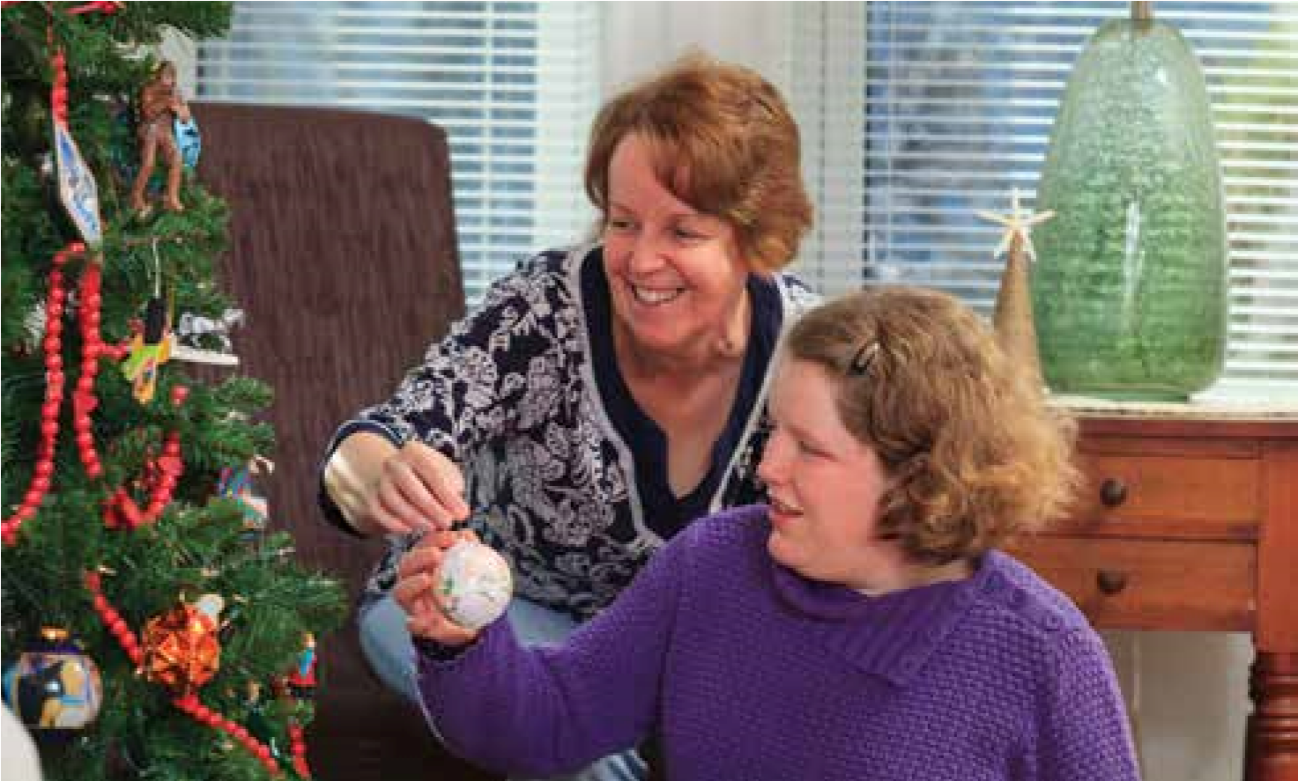
DisabilityImages/Science Photo Library
Young woman with autism and her mother putting an ornament on Christmas tree.
within families (Totsika et al, 2011). These issues often contribute to why autistic people are in hospital.  Individuals with autism also exhibit higher levels of challenging behaviour than those with just a formally diagnosed intellectual disability (Birch et al, 2017). As a result of these behaviours, people with autism are wrongly more likely to endure more restrictive practices, such as physical control and restraint (Lunsky et al, 2018).  Managing and caring for people living with ASD in healthcare practice  The care of people living with ASD is a professional and very specialist role in itself. The complexities of ASD mean there is no definitive presentation of autism and the fact that it impacts on the capacity of these people to communicate, behave and cope in social and professional settings is a challenge. Within the context of healthcare provision, where informed consent and the ability to rationalise decision–making is paramount to successful interaction with patients and their families and carers, then awareness and effective planning for the care of this unique caseload is pivotal to the provision of high–quality care.  A lack of preparedness on behalf of healthcare professionals can also be attributed to the increased need for restrictive practice, which consequently impacts on the quality of life for people living with ASD and can send patients into a spiral where their condition, in | turn, makes their behavioural response even worse (Murphy et al, 2016).  As a consequence of these interactions in clinical practice, emphasis is often placed on these behavioural responses, rather than on the emotional and physical needs of vulnerable members of our society. While having a specifically tailored infrastructure and environmental adaptation to support people with autism may not always be possible due to resource limitations and the contextual constraints of clinical provision in primary (community–based settings) and secondary care (hospital inpatient care), it is possible to better accommodate patient need in relation to forward planning and the notion of patient–centred care. The possibility of this happening lies in the imperative to raise awareness of the needs of people living with ASD in practice for all healthcare practitioners, not just HCAs.  Best practice for autistic spectrum disorder for HCAs in practice  What is clear from the body of literature available to date, is that any care pathway initiated in the context of primary or secondary care ought to take a holistic overview of the individual needs of the person and the support that implementing a care pathway may necessitate (Punshon et al, 2009). It is here that HCAs can play an invaluable role in the support of patients and their carers and families.  Understanding the stress that visiting the different context or environment of healthcare management in practice
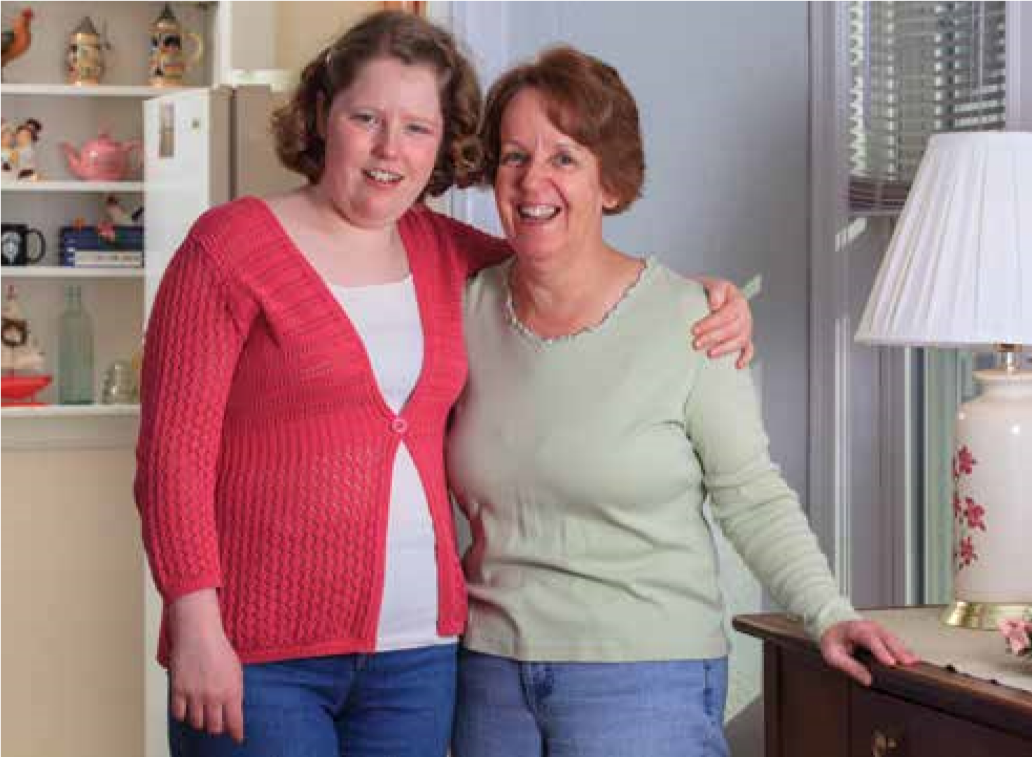
DisabilityImages/Science Photo Library
Portrait of a young woman with autism and her mother smiling.

Depending on the patient’s relative degree of independence, it might be feasible to identify a suitable collection or waiting area while the consultation takes place and it might be feasible for the HCA to wait with them and support them.
What matters most is that the patient is afforded the same dignity and access to physical and healthcare resources as any other patient without the condition and that these people are a recognised and valued contingent of our societies as integral parts of it. The communication of specific need in the context of primary care settings may be an issue for these patients, some of whom may struggle to recall their specific detail of their medical history and even their present need. This is where effective communication between interdisciplinary and multidisciplinary professionals is paramount and where the HCA is an integral part of the effectiveness of these teams. Formalisation of this may take the form of a ‘health passport’, where information can be made accessible to healthcare providers, thus enhancing their ability to provide holistic management to patients in their care.
Communication needs of people living with autistic spectrum disorder
Being able to communicate effectively with patients living with ASD is pivotal to the success of treatment intervention and compliance and HCAs play an important role in this. Providing an explanation of all proposed healthcare interventions is at the heart of this, as this minimises the potential for unnecessary worry on behalf of the patient and ensures that expectations can be appropriately managed at all times. This is also essential to the process of gaining informed consent from patients with special needs who have the same rights and dignities as other patients in practice.
HCAs might see practitioners using dolls to provide an insight into the process of procedures or examinations that might otherwise distress people with ASD, for example, in relation to specific parts of the body that need to be examined, or if instrumentation use is an integral part of patient monitoring. Similarly, picture books can provide a similar physical overview of planned treatments for people with ASD.

can cause a person living with ASD is fundamental to accommodating the challenges this poses in relation to their predisposition to sensory overload and their potential to exhibit challenging behaviours.
Pragmatic approaches to health
service provision for people living with autism
Coping with everyday appointments and check–ups is something that the majority of people take for granted, in terms of being able to attend for regular healthcare. Meeting the HCA is often an integral part of this experience in practice. However, this capacity to cope with difference in routine and the potential for sensory overload can become somewhat overwhelming for people living with ASD. In best accommodating these issues and hence making healthcare provision in the context of HCA workplaces more accessible to patients and their families and carers, pragmatic issues can be implemented, with minimal implications for the everyday running of clinical practices.
Accommodating care needs in practice
Where a patient with autism is either unfamiliar with medical, nursing or allied healthcare staff, or a new process of consultation is needed, it is advisable for them to be able to make a very informal visit to the setting or context beforehand.
Having an HCA to support them in this experience is an excellent idea, as this means that the person with ASD can familiarise themselves with treatment/ consultation areas and new environments with a person who may also become a familiar face to them. It is issues in these contexts that can potentially cause them distress or sensory overload. Where the person living with ASD has a carer or family member with them can make a difference to their capacity to cope, due to the opportunity for additional reassurance and the consistency in the people surrounding them. It can be helpful for them to attend appointments with friends or family undergoing a similar experience, so that in the future they can anticipate and have realistic expectations of their own appointment in the future.
Additional appointment time may be needed to accommodate the additional needs of the person and also to ensure that the people providing care have adequate time to accommodate optimal care provision alongside this. It can often be helpful in relation to patient need to give them the very first or last appointment of the day, as waiting for appointments can be an unintentional means of stressing a patient with ASD.

Table 1. Some considerations in caring for people with autistic spectrum disorder (ASD)
3 practical issues If possible, do … If possible, don’t … to be addressed
People living with autistic spectrum Accommodate and adapt clinical Unintentionally forget to consider the impact of sensory disorder (ASD) have an enhanced environments and circumstances as far as changes
response to sensory experiences—you can to minimise stress Do anything without explaining it first
in particular light, sound, visual Be reassuring and supportive Be ambiguous or use analogies to describe treatment changes, smells and touch that may Be clear and truthful about any interventions be taken for granted and regarded as treatment that is provided normal in healthcare practice
All patients with ASD have holistic Consider every patient you see in practice Make collective judgements based on experience with a and individual needs, linked to their as an individual person, not a condition limited number of people living with ASD. Everyone is intellectual and social ability. These Respect the individual decision–making different
need to be accommodated, wherever rights that all patients have about their Disregard someone with ASD as not being able to make
possiblecare decisions intelligently or with social capability
Offer key support in helping them to Expect people living with ASD to understand complexity understand what healthcare intervention immediately. Different people have different cognitive might entail, relative and tailored to their abilities that necessitate time and patience individual capacity to understand
Where care takes place is Read medical records carefully prior to Ignore the wishes and suggestions of family members always important to consider for bringing the patient into a care setting; and carers
patients and their families and this documentation might offer key Be afraid to ask a patient with ASD about their carers. Wherever it is possible to suggestions as to how small changes can preferences
accommodate their needs by the be made to accommodate the needs of Forget that regular communication that is minor adjustment of clinical settings, patients living with ASD straightforward and reassuring is better than not this can be practical and helpful. Avoid switching on noisy machinery, speaking at all These small changes can make wherever possible
a huge difference to how people Avoid sudden changes in lighting, with ASD can cope with potential wherever possible sensory overload
Providing a reasoned justification of why specific treatments are necessary is a way of being able to present information clearly and concisely. The sensation of unexpected touch can be distressing to people with ASD and pre-warning can be helpful as a treatment intervention proceeds and might be another instance where an HCA can offer direct support. Similarly, establishing whether a family member or carer can support the patient during their appointment is a useful approach, especially where alternative mechanisms of communication are preferred by the patient in practice.
Straightforward language ought to be adopted, as literal interpretation of information by people with ASD, particularly with regard to ambiguous terminology such as ‘it might hurt a little bit’, which they might find difficult to comprehend—as opposed to just
“Consider every patient you see in practice as an individual person, not a condition ”
saying ‘it will (or won’t) hurt’. This rather straightforward approach can minimise unnecessary stress for a patient, where binary decision–making (yes or no) might be much easier for them.
In order to support them in complying with proposed treatment, it can be useful to provide direction, rather than a rhetorical questioning approach—for example, ‘please put your finger over this small dressing now’, rather than ‘can you hold this little dressing in place?’
Checking that what has been said is understood, is also a great means of establishing that the patient understands and complies with the continuation of the treatment. Using overt facial expressions and elaborate gesturing or articulation of non-verbal instructions can also confuse patients with autism. In summary, a direct but at all times compassionate approach is best, so that the person living with ASD feels as reassured and relaxed as they possibly can (Wong et al, 2017).
Differences in active dialogue with patients with autistic spectrum disorder
A tendency to reach sensory overload
is a common characteristic of people living with ASD in practice and there are key approaches that can be adopted to support and facilitate people as they access physical and mental healthcare provision, where they are often supported by HCAs (Tager-Flusberg, 2017).
Key indicators of stress in a patient living with ASD:
Lack of eye contact Distressed ASD patients may often use avoidance of eye contact as a strategy to stabilise their condition. This does not mean they cannot listen to instructions, but it may mean that they need additional time and support to interpret and understand what is being communicated to them and to make meaning of the information HCAs are trying to articulate. Similarly, those patients who appear particularly non–communicative are just as capable of this degree of interpretation and meaning–making, but also may need additional time to do so. Lack of perspective People who do not live with ASD usually demonstrate the capacity for a sense of perspective of the needs of others, whereas people with the condition may not and there might be an expectation that people can determine what they are thinking and feeling, without them first having articulated it to them (Candini et al, 2017). This obviously necessitates HCA understanding, particularly with regard to the information you may be articulating in relation to your everyday clinical practice and support.
Lack of awareness of appropriate spatial parameters Autistic people may also not exhibit signs of awareness of the need to respect the personal space of others or themselves and as a consequence this may be projected in their overt actions in clinical practice, which is often carried out in a relatively confined space. This is something which ought to be considered in the planning and execution of clinical practice for HCAs (Weill et al, 2018). Social withdrawal Withdrawal and solemnness can also be a key sign of distress for people living with autism, particularly, although not exclusively, children (Adams et al, 2018; Baumer and Spence, 2018). When carers are present, they are usually able to judge early stages of sensory response and provide valuable information about the likely impact of sensory experience, which can then be accommodated in practice (Foley et al, 2017).
It may also be useful if they are able to stay with the patient during a healthcare consultation, if the patient is willing, so that any supplementary information they provide, can be used to support the patient and also support and effectively manage their behaviour, if this does become an issue (Hayes et al, 2018).
Sensory overload or sensory underload
In relation to specific sensory stimulus, consideration ought also to be made of those aspects of clinical care provision that might be completely overlooked in the treatment of those who do not live with ASD (Deboth et al, 2017). These include:
Clinical lighting While designed to enhance the clinical working environment for clinicians, clinical lighting can often prove overwhelming for people living with autism, who can be extremely sensitive and responsive to the fluorescent nature of many clinical contexts. Alongside this, at least 20–30% of people with autism are susceptible to seizures, a trigger of which can be light sensitivity to pen lights for eye examinations or other more focused clinical examination of problematic areas. Clinical sounds While the unfamiliarity of the sound of equipment operating in medical surroundings is an expected norm for the majority of patients, for some patients with autism, it can inflict severe levels of distress and suffering. These typically can be worsened by an elevation in the pitch of surrounding sounds, which in the context, for example of emergency care provision, or dental healthcare, might be much more difficult to minimise than in the context of everyday primary and secondary care settings.
Recognising the normal coping strategies of patients with ASD Some patients with autism will provide a distracting sensory stimulus, such as rocking or flicking, in order to counteract the stress around them. Under no circumstances should this be stopped, as it may be an effective and established mechanism of them calming themselves. It may also distract the patient from their innate sense of postural positioning and unnecessarily cause them to fall and hurt themselves if they are prevented from consoling themselves (Ke et al, 2018).
Pain sensory thresholds: stress and excitability
In certain instances, people living with autism can have an inordinately high pain threshold, where they may present with what can be perceived as an excruciating pain for a person who does not have the condition. Their responses to pain may also be simply characterised by a different reaction, such as uncontrollable laughter, singing, or the unexplained removal of their clothes. This is pivotal in understanding potentially painful interventions such as phlebotomy, injecting or anywhere that a normalised response to slight pain may be very different in practice.
For this reason, skin creams to numb the skin are advisable to minimise pain for the patient. Similarly, signs of agitation may present as a level of unintentionally aggressive behaviour, purely as a means of a response. As outlined earlier in the article, using toys such as dolls or teddy bears to demonstrate the anatomical positioning of specific medical or healthcare interventions can be a useful process (Spain et al, 2017).
Conclusion
While this article has covered the implications of living with ASD and how people can be supported in clinical practice, it also reveals gaps in practice– based knowledge for HCAs. Emphasis ought to be placed on the ability of HCAs to recognise and accommodate the needs of patients with ASD who are prone to sensory overload, so that as a valued member of healthcare teams, these people and their families might be better supported. Most importantly, those people living with ASD and their families and carers ought to be treated with the respect and dignity afforded to all patients in the context of healthcare practice. The ambiguous nature of the presenting conditions that ASD patients live with, can often prove challenging. However, with basic modifications, such as those outlined here, these are something which can become an integral part of empowering an often overlooked and under acknowledged sector of patient care in healthcare practice. BJHCA

References
Adams D, Young K, Simpson K, Keen D. Parent descriptions of the presentation and management of anxiousness in children on the autism spectrum. Autism.
2018 Aug 16; 1362361318794031. doi:
10.1177/1362361318794031
Birch RC, Foley KR, Pollack A, Britt H, Lennox N, Trollor JN. Problems managed and medications prescribed during encounters with people with autism spectrum disorder in Australian general practice. Autism. 2018 Nov; 22(8):995–1004. doi:
10.1177/1362361317714588. Epub 2017 Sep 15
Baumer N, Spence SJ. Evaluation and management of the child with autism spectrum disorder. Continuum (Minneap Minn). 2018 Feb; 24(1, Child
Neurology):248–275. doi: 10.1212/ CON.0000000000000578.
Bishop-Fitzpatrick L, Mazefsky CA, Eack SM. The combined impact of social support and perceived stress on quality of life in adults with autism spectrum disorder and without intellectual disability.
Autism. 2018 Aug; 22(6):703–711. doi:
10.1177/1362361317703090. Epub 2017 Jun 30
Boucher J. Redefining the concept of autism as a unitary disorder: multiple causal

deficits of a single kind? In Fein D, ed. The neuropsychology of autism. New York: Oxford
University Press; 2011:469–482
Brugha T, McManus S, Meltzer H, Smith J, Scott FJ, Purdon S, Bankart J. Autism spectrum disorders in adults living in households throughout England: Report from the adult psychiatric morbidity survey 2007. Leeds:
NHS Information Centre for Health and
Social Care; 2009
Candini M, Giuberti V, Manattini A, Grittani S, di Pellegrino G, Frassinetti F. Personal space regulation in childhood autism: effects of social interaction and person’s perspective.
Autism Research. 2017; 10(1):144–154
Deboth K, Reynolds S, Lane SJ, Carretta H, Lane AE, Schaaf RC. Neurophysiological correlates of sensory-based subtypes in autism. Am J Occup Ther. 2017; 71(4_
Supplement_1):7111505090
Emerson E, Baines S, Hatton C. Disability equality: how will we know we are making a difference? Summary of the results of consultation. London: Office for Disability
Issues; 2007
Foley KR, Pollack AJ, Britt HC, Lennox NG, Trollor JN. General practice encounters for young patients with autism spectrum disorder in Australia. Autism. 2018 Oct; 22(7):784–793. doi:
10.1177/1362361317702560. Epub 2017 Jul 7
Hayes J, Ford T, Rafeeque H, Russell G. Clinical practice guidelines for diagnosis of autism spectrum disorder in adults and children in the UK: a narrative review. BMC Psychiatry.
2018; 18(1):222. doi: 10.1186/s12888-018-
1800-1
Karpin I, O’Connell, K. Stigmatising the normal: the legal regulation of behaviour as a disability.
UNSWLJ. 2015; 38(4):1461
Ke F, Whalon K, Yun J. Social skill interventions for youth and adults with autism spectrum disorder: a systematic review. Rev Educ Res.
2018; 88(1):3–42
Lo BH, Klopper F, Barnes E, Williams K. Autism spectrum disorder. J Paediatr Child Health.
2018; 54(2):212–213
Lunsky Y, Tint A, Weiss JA, Palucka A, Bradley E. A review of emergency department visits made by youth and adults with autism spectrum disorder from the parent perspective. Advances in Autism; 2018.
4(1):10–18
Matson JL, Shoemaker M. Intellectual disability and its relationship to autism spectrum disorders. Res Dev Disabil. 2009
Nov-Dec; 30(6):1107–14. doi: 10.1016/j.
ridd.2009.06.003. Epub 2009 Jul 14
McDonnell A, McCreadie M, Mills R, Deveau R, Anker R, Hayden J. The role of physiological arousal in the management of challenging behaviours in individuals with autistic spectrum disorders. Res Dev Disabil. 2015 Jan; 36C:311–322. doi: 10.1016/j.ridd.2014.09.012.
Epub 2014 Nov 1
Murphy CM, Wilson CE, Robertson DM,
Ecker C, Daly EM, Hammond N, McAlonan GM. Autism spectrum disorder in adults: diagnosis, management, and health services development. Neuropsychiatr Dis Treat. 2016 Jul 7; 12:1669–86. doi: 10.2147/NDT.S65455.
eCollection 2016  Punshon C, Skirrow P, Murphy G. The not guilty verdict: psychological reactions to a diagnosis of Asperger syndrome in adulthood.  Autism. 2009 May; 13(3):265–83. doi:  10.1177/1362361309103795  Spain D, Sin J, Harwood L, Mendez MA, Happé F. Cognitive behaviour therapy for social anxiety in autism spectrum disorder: a systematic review. Advances in Autism. 2017; 3(1):34–46  Tager-Flusberg H, Plesa Skwerer D, Joseph RM,  Brukilacchio B, Decker J, Eggleston B, Yoder A. Conducting research with minimally verbal participants with autism spectrum disorder.  Autism. 2017 Oct; 21(7):852–861. doi:  10.1177/1362361316654605. Epub 2016 Jun 26 Taylor B, Jick H, MacLaughlin D. (2013). | Evidence-based practices for children, youth, and young adults with autism spectrum disorder: a comprehensive review. J Autism Dev Disord. 2015 Jul; 45(7):1951–1966. doi:  10.1007/s10803-014-2351-z  World Health Organization. Autism spectrum disorders and other developmental disorders: from raising awareness to building capacity. 2013. http://www.who.int/mental_health/ maternal-child/autism_report/en/ (accessed  29 October 2018)  Zuckerman KE, Lindly OJ, Reyes NM, Chavez AE, Cobian M, Macias K, Smith KA. (2018). Parent perceptions of community autism spectrum disorder stigma: measure validation and associations in a multi-site sample. J Autism Dev Disord. 2018 Sep; 48(9):3199–  3209. doi: 10.1007/s10803-018-3586-x
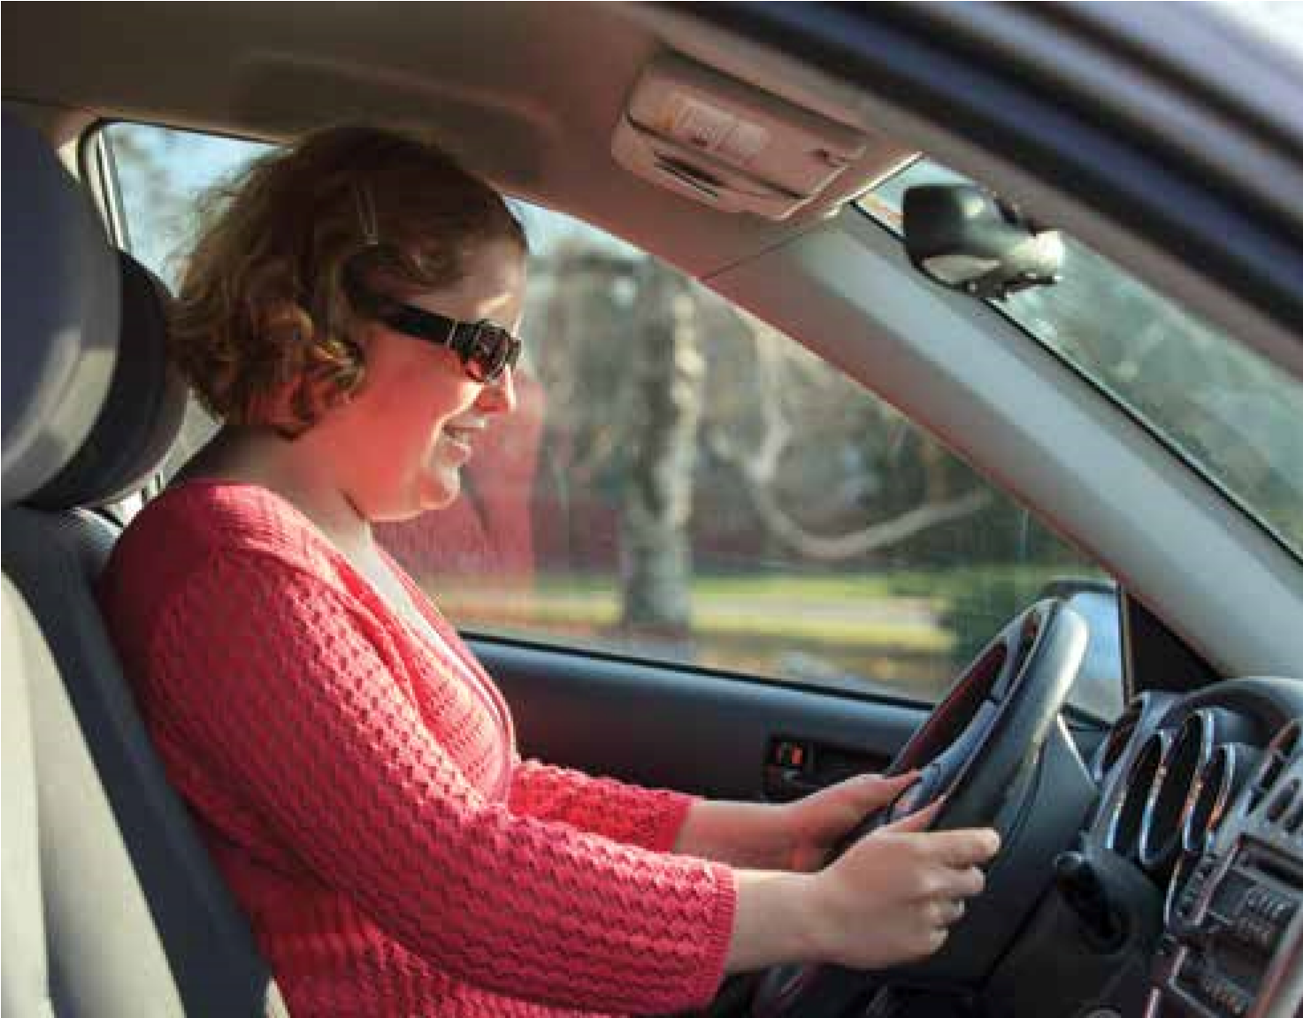
Young woman with autism sitting in the driver’s seat of her car.
DisabilityImages/Science Photo Library
Reflective questions to consider
What sort of assumptions did you have about people with ASD before you read this article? How has this article challenged your thinking? How might you adapt your new knowledge of ASD to support people and their families and carers living with the condition on a daily basis in your own practice as an HCA?
Which barriers might you have to overcome to support people with ASD more fully? How might you be able to raise these as issues in your work environment?
When you next meet a patient and their family and carers in HCA practice, what will your first priority in supporting them be, and why?
Prevalence and incidence rates of autism in the UK: time trend from 2004–2010 in children aged 8 years. BMJ Open. 2013 Oct 16; 3(10):e003219. doi: 10.1136/ bmjopen-2013-003219
Totsika V, Hastings RP, Emerson E, Lancaster GA, Berridge DM. A population‐based investigation of behavioural and emotional problems and maternal mental health: associations with autism spectrum disorder and intellectual disability. J Child Psychol Psychiatry. 2011 Jan; 52(1):91–99. doi:
10.1111/j.1469-7610.2010.02295.x
Vinogradova K. Aetiology of autism spectrum disorders. Journal of Modern Foreign
Psychology. 2014; 3(4):112–131
Weill VA, Zavodny S, Souders MC. Autism spectrum disorder in primary care. Nurse Pract. 2018 Feb 16; 43(2):21–28. doi:
10.1097/01.NPR.0000529670.62188.1a
Wong C, Odom SL, Hume KA, Cox AW,
Fettig A, Kucharczyk S, Schultz TR. (2015).

