Using energy consumption profiles as an indicator of equipment condition
Adrian Morris *, David Baglee^{b}, and Michael Knowles^{c}
ªUniversity of Sunderland, Faculty of Technology,Sunderland, SR6 0DD, UK

∗ Adrian Morris. Tel.: +00-191-515-2883; email: adrian.morris@sunderland.ac.uk
ABSTRACT
The authors present a short summary of various CBM tools and techniques followed by a discussion of energy monitoring and its uses. They investigate energy consumption in CNC milling machines and compare that with predicted results showing a strong degree of correlation. The data is then examined for stability and repeatability once again demonstrating that energy data is both predictable and repeatable. It is then proposed that by linking this via existing and increasingly popular I4.0 technologies it is possible to develop a system to collect compare and interpret energy data as a Condition Based monitoring tool.
Keywords: Condition Based Monitoring, energy consumption, machine tool condition diagnosis, SPC .
Article history: Received ; Published .

- Introduction

It has been established that poorly maintained equipment is likely to consume more energy than equipment in better condition [1]. Whilst energy consumption can provide valuable intelligence regarding equipment condition, it is largely restricted to machines with a relatively stable duty cycle. Energy monitoring at machine level, in particular by Small to Medium Enterprises (SME) in the UK does not appear to be widespread and the adoption of I4.0 technologies is likewise poor. A recent survey by a sector body suggests that it is largely due to a misunderstanding of the advantages of I4.0 [2]. In addition, Machining Centres have a number of factors that explain an increase in energy consumption that may not be linked to its primary function such as removing metal and much of the vibration analysis research has been aimed at the tooltip [3]. Ancillary equipment, such as coolant pumps and table motors could provide the necessary data to establish a link between higher or erratic energy consumption and machine condition. With the advent of Industry 4.0 sources of data that were previously disparate, such as vibration and temperature can be integrated with energy measurements using Internet of Things (IoT) technologies. This can, in turn, be compared with data from Enterprise Resource Planning systems to allow for maintenance scheduling that is flexible and adaptive to production demands, equipment condition and efficiency. In this paper the authors examine the reliability of energy data as an indicator of machine condition and make proposals regarding how that energy may be used.

2. Theoretical background

Since the turn of the century interest in Industry 4.0, a term coined by the German Government to describe the increasing use of Cyber Physical Systems, has been growing rapidly [4]. The increasing influence of information technologies within every aspect of manufacturing has not only created a hunger for data, but a desire to understand what these data may be used for and so which data are the most useful to collect [5]. The aim of Industry 4.0 to develop smart, interconnected processes and factories creating intelligent, self-regulating value streams is laudable but the levels of understanding and adoption vary widely due to misunderstandings of the nature of Industry 4.0 and the potential cost. A survey of 800 companies within the UK carried out by the Institute of Engineering Technology (IET) revealed that only 7% expressed an understanding of the term. There is also a suspicion regarding the nature of this fourth industrial revolution [4] and whether or not actions and technologies designed to maximise the leverage of Germany’s manufacturing sector will have similar effects on other nations’ manufacturing sectors. Never the less, the opportunity to make use of large scale implementations of embedded linked sensor technologies generating vast amounts of data is tantalising and well within the reach of most manufacturing organisations. Recent developments such as those from the Advanced Manufacturing Research Centre (AMRC) in Sheffield have demonstrated that capturing significant amounts of useful data is possible via a network of low cost sensors linked through the Industrial Internet of Things (IIoT). Whilst Industry 4.0 cannot be boiled down to the use of linked sensors to provide data in a timely and intelligent fashion to assist managers in their decision making, it does provide a suitable and in many ways appropriate starting point for hard pressed manufacturing managers with a constant eye on costs. Lu [7] and Goyal and Pabla [8] provide a useful review of available technologies. Vibration analysis is described as being used to diagnose both the seriousness and potential source of a problem. However, due to noise within the system one or more of several signal processing techniques may be employed in order to diagnose issues. However, due to the speed at which data may be acquired and analysed, it provides a very useful indicator of machine condition. Vibration monitoring is also a component of machine condition monitoring (MCM) which combines vibration, temperature and potentially noise in order to identify problems and highlight the need for actions. This is the foundation of condition based maintenance (CBM). One drawback of these methods is that they are largely used for early fault detection and diagnosis. Diagnosis being an after the event activity means a fault has occurred that requires a remedy [8] and a move towards prognosis: before the event, data collection and interpretation may increase equipment availability. A key problem with this being the amount of data that requires analysis in real time and the algorithms necessary for accurate prognosis of potential issues [9]. Rao and Gandhi [22] proposed the use of Digraph and matrix methods in order to diagnose potential issues and used the terms trend or gradual failure and catastrophic failure to differentiate two very different failure modes. The former may be tracked as gradual deterioration creates a worsening performance in a machine tool. The latter however, may be less predictable and so much more difficult to diagnose in a timely manner to prevent machine breakdown. Er at al [3] proposed a protocol for vibration sensor placement and analysis. The results presented in their paper are extremely encouraging for those with an interest in machine condition but the work also raises some significant questions. Firstly it may prove difficult to place sensors in the optimum positions for the analysis required. Secondly, the vibration signals will vary significantly between machines and between operations making it difficult to differentiate between legitimate vibrations and that caused by deterioration in the machine tool of cutting tips and/or bearings. Thirdly, any changes in the operating parameters, such as cutting speed, feed rate and depth of cut, i.e. the metal removal rate (MMR) will result in a change in the signal to be processed. This has the potential to flag up false alarms, although the authors do concede that it will also flag up potentially unauthorised changes to an agreed cutting strategy. Finally, not all maintenance issues, such as electrical issues, loss of lubrication, unbalanced motor drives, motion control problems, will produce a vibration signature [22].
Another common method used within CBM is energy monitoring. Knowles and Baglee [1] discussed the importance of machine condition and showed how poor maintenance can lead to increased energy usage in refrigeration equipment. Xu and Cao [10] went on to show that similar models could be developed for machining centres and used to show that regular maintenance would help to reduce energy costs dramatically. Svenson and Paramonova [10] propose a model for identifying energy efficiency improvements that includes maintenance of equipment.
In the midst of this, research is being carried out into the environmental impact of machining operations in terms of energy consumption [12, 13]. Energy prediction models tend to approach the subject from one of two perspectives: that is a focus upon the energy required at the tool tip or the overall energy required for the system. Energy models derived from cutting forces were generally aimed at optimising tool tip condition, chip generation and/or metal removal rates [14]. These models are generally very complex and may ignore other energy draws upon the overall system identified by [12, 13, 14].
Several authors have proposed energy consumption models and equations [15, 16, 17, 18, 19] and most require the use of empirically derived constants for individual machines. This limits the ability for those seeking to apply this new knowledge to other equipment. However, their work has demonstrated that it is possible to predict energy usage and profiles. Peng and Xu [19] and showed that it is possible to compare predicted patterns of energy consumption derived from calculations and Computer aided Manufacturing (CAM) software simulations in order to establish more energy efficient machining strategies. A typical comparative plot reproduced from [19] may be seen in figure 1.
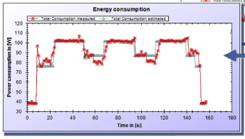
Figure 1: Comparison of predicted energy consumption with recorded energy consumption taken from Peng & Xu (2017)
In this figure the predicted result is shown as the blue coloured trace whereas the recorded result is shown in red. Pavanaskar [20] uses similar data to predict energy consumption and suggest optimised machining strategies as a result. Pavanaskar continues his work with colleagues in [21] and applies his theories to pocket milling and energy consumption optimisation. To date though, there has been little thought given to utilising this data for multiple purposes and CBM literature tends to exclude the use such data, potentially as a result of the additional cost of the necessary equipment. Xu and Cao [23] propose the use of Markov chains to optimise machine tool performance and improve the maintenance function. Whilst this work presents a useful methodology for analysing data associated with gradual failure, it does not address the potential for predicting and thus avoiding catastrophic failure. As a result the authors will propose a cost effective model for collecting, analysing and utilising such energy data based upon experimental work carried out on CNC machine tools in the workshop of the University of Sunderland. They will show that energy data is repeatable, can be analysed using well known simple tools that are understood by most industrial engineers, and form a pattern or system that may be used to predict or diagnose performance issues.

3. Methodology
The CNC machine tools based within the workshops at the Faculty of Technology are not used solely for research or teaching purposes. These machines are utilised for part of their time as a production facility providing capacity to regional small to medium manufacturing enterprises (SME). As a result the machines have the potential to provide a large amount of data regarding machine condition, energy usage and wear. One of these machines, a HAAS VF5, five axis, CNC machine tool was connected to an energy consumption monitoring device. This device measured the energy delivered to the machine tool over the three phases and transmitted this data via Bluetooth and wifi to a central hub. These data were logged in one minute intervals as this was felt to be a short enough timescale to produce meaningful insights without becoming prohibitively expensive. The data was then uploaded to the researchers as a CSV file, with the data averaged on a minute by minute basis In addition sub one minute recording was felt would be beyond the requirements of most industrial users, however, the authors took advantage of the system’s ability to record the maximum power draw during each time period to identify system spikes.
Operational data regarding energy consumption was gathered over a period of several months. These data were comprised of the energy consumption of the machine while it manufactured various components. These data were used to understand whether or not such energy data demonstrated a repeatable pattern.
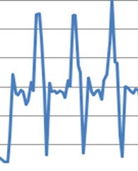
The authors utilised energy equations provided by Sandvik Coromant to calculate the predicted energy consumption for a particular component. This calculation was then compared with actual data collected whilst machining this component to confirm that the methodology was robust. The work involved collecting the energy data from two component manufacturing cycles. In this case it was not the entire cycle but only a face milling operation. The energy used to manufacture the component was calculated by collecting the data from the first peak until the last trough as shown in figure 2. This data was then converted into kWh by multiplying by the fraction of an hour it took to produce the part.
Cycle finish
Cycle start

Figure 2: Identification of a single manufacturing cycle from average power trace
A longitudinal analysis of the energy data was then carried out on the energy consumed during each component cycle by multiplying the power consumed by the cycle time. These data were then plotted using individual and moving range SPC analysis in order to establish if the data were in statistical control and so future patterns would be predictable or, if not, unusual patterns and trends might be identified indicating potential maintenance issues.
Peak power demand during a time period was measured and correlated to a particular operation within the CNC program. It was anticipated that this would enable the researchers to identify potential problems linked to catastrophic failures. Examples of these peaks may be seen in figure 3.
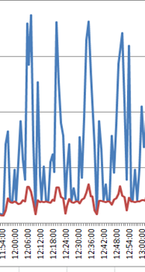
Average Power kW shown in Red
Peak Power kW shown in Blue
Figure 3
The same repeating pattern of average power consumption may be observed in figure 4 and later in figure 5 as these traces were taken from the manufacture of the same component over one day. Key peaks that correlated to particular events within the CNC program were identified and their values recorded for comparison. These data will be analysed using moving mean and range charts to identify potential problems and link these to particular events within the machining cycle.
4. Data collection and analysis
The energy consumption data was collected over a number of months and an example of these profiles is shown in figure 4. The patterns, similar to those represented in figures 2 and 3, can be seen to be repeating themselves within reason. There will always be some variation due to various spikes within the machining cycles caused by different auxiliary components switching on and off. However, the level of similarity between the cycle traces leads the authors to agree with Peng and Xu although no statistical population testing has been carried out as yet. The different profiles created by machining different components are clearly visible indicating that each component would have its own particular profile. Machine stoppages may also be clearly seen as well as periods when the machine has been left on standby. This is an opportunity for energy, and so cost, saving that will not be addressed in this paper. However, it provides an interesting insight into the machine operator’s habits. An analysis of the peak to peak data shows that it is in statistical control, although varies between different component types.

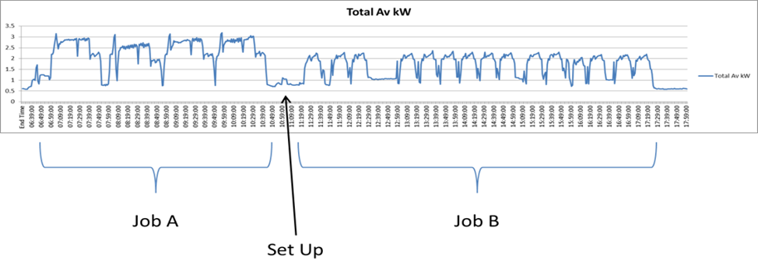

Figure 4: Typical repeating energy consumption pattern

Further experimental work carried out by the authors has showed that relatively simple calculations, using equations supplied by Sandvik Coromant (https://www.sandvik.coromant.com/en-gb/knowledge/milling/formulas_and_definitions/formulas/pages/default.aspx.), may accurately predict cutting energy for a given milling operation. The equation may be seen below:
$P_{c }= \frac{a_{p} × a_{e} × V_{f} × k_{c}}{60×{10}^{6}}$ 1
Where:
P_{c} = Cutting Power
a_{p} = Depth of cut
a_{e} = Width of cut
V_{f} = Feed rate in mm/min
k_{c} = the specific cutting force for the material (taken from a table of values supplied by Sandvik Coromant)

It was not practical to interrupt the operation and perform an “air cut” where the machine performs all of the operations necessary to produce a component without actually cutting metal as the presence of in process probing/measurement rendered this action ineffective. However, an approximation was made for the auxiliary power requirements not involved in cutting by taking the energy readings from a non-cutting operation, in this case measurement with a probe and subtracting this from the total power consumed. A sample of the data collected during this work is shown in table 1.
In total 25 face milling cycles were analysed producing an average energy consumption of 0.037kWh. It may be seen that despite the inability to carry out an “air cut” and so establish more accurately the non-cutting energy consumed, there is a good correlation between the theoretical value and the measured values. Although more data would have been beneficial, this proved impossible at the time due to a combination of operator shortages and this particular component run coming to an end. In addition, as the face milling operation took place during minute 1 and 2 but did not take the entirety of these minutes, it was difficult to establish with complete accuracy the energy consumption of this operation. Never the less, the data supports the findings of Peng and Xu [19] and Pavanaskar [20] and shows that energy consumption is predictable, if not completely repeatable.

Table 1: Comparison of theoretical and experimental data

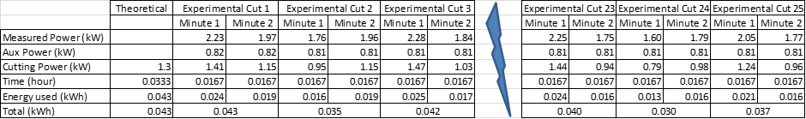

The team then analysed the energy data that had been collected whilst another component was being produced. The trace for this component is shown in figure 5. The trace was used to identify a single component’s manufacturing cycle. By measuring from the first peak to the last trough, as shown in figure 2, it is possible to identify the repeating pattern. The pattern was then used to identify the energy consumed as the time for each cycle can be identified.
In Figure 6 the energy data (based on average power consumption measured in one minute intervals) for one day’s production may be seen as an Individual SPC chart. Standard analysis of the individual chart shows that it is in statistical control apart from early in the morning. It is possible that these particular cycles took slightly longer than the others for a variety of reasons, but it may be an indicator of machine or tool condition. This view is reinforced by analysis of the moving range chart (n=3) shown in figure 7. This shows that the process is in statistical control apart from the first and last jobs of the day. Some of the possible reasons for this are discussed in the next section.
Further SPC analysis (figure 8) of other components from other days of production shows a process largely in control. The change from one component to the next in the production schedule at 16:29 can be clearly seen. In this case a period of instability is evident as the part is programmed at the machine rather than through the use of offline programming tools.
A peak within the cycle that corresponded to a 90 degree trunnion move was identified and the results for peak kW power plotted as a moving average and range change (n=3). The results are presented in figures 9 and 10.

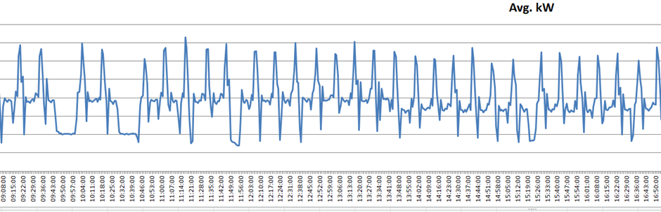
Figure 5: Sample energy data collected from a component production run
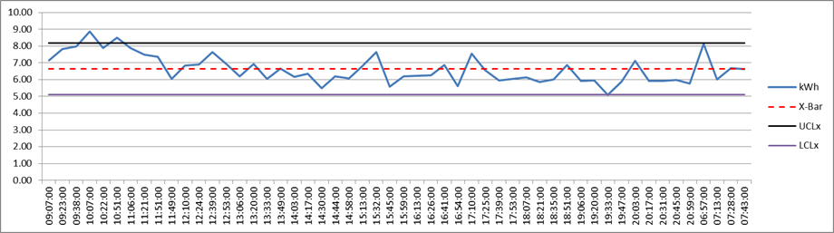
Figure 6: Approximately 24 hours’ energy data

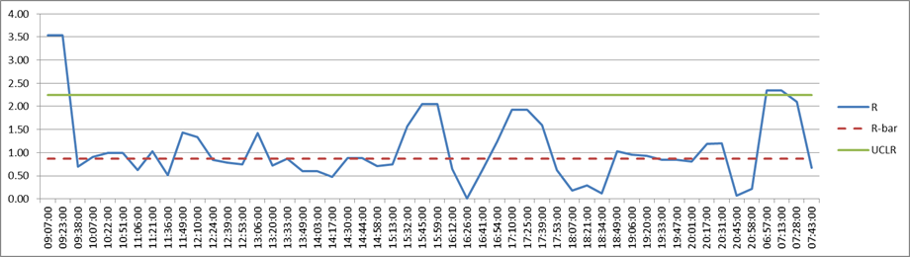
Figure 7: the Moving Range chart for the same day’s data

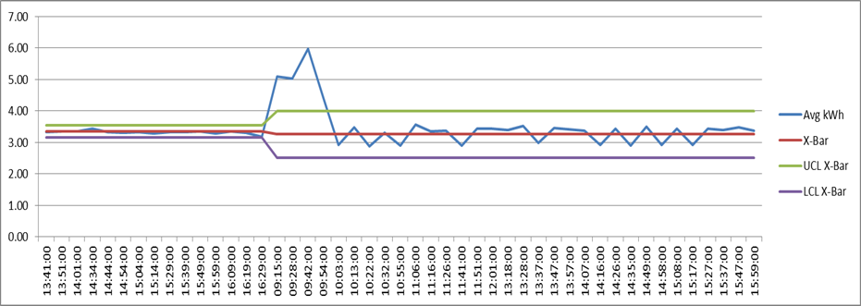
Figure 8: The transition from one component to another of a different type

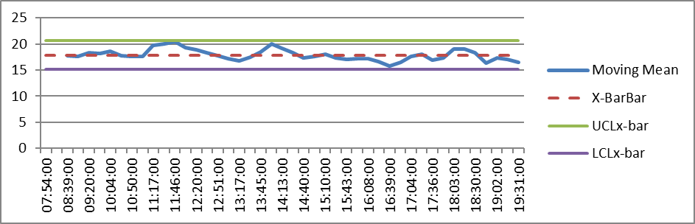
Figure 9: the moving average chart for data for peak power

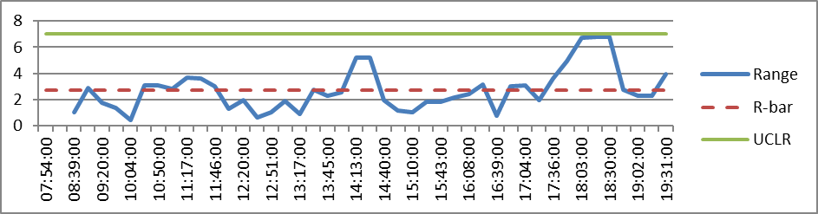
Figure 10: corresponding range chart for the moving average data

Both charts appear to be largely in control, however, two points on the range chart are worth investigation. These occur at 18:03 and 18:30. It is statistically unusual for two corresponding points to appear so close to one of the control limits.
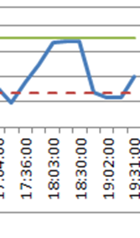
Figure 11: Interesting points on the range chart

Reviewing the original data shows the issue. It is related to two consecutive spikes in the peak power data. Figure 12 shows the peak values used to calculate the moving mean and range for 18:03 and figure 13 the three points used to calculate the points for 18:30.
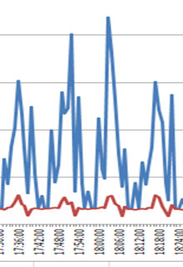
Figure 12: Points used to calculate the range for 18:03

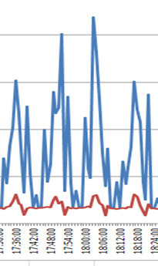
Figure 13: Points used to calculate the range for 18:30

The trunnion moves at 17:52 and 18:03 appear to be the cause of this out of control condition. Reviewing the rest of the data shows other similar events linked to a trunnion movement. The existence of points such as these is consistent with a problem within the trunnion mechanism, although it does not yet require immediate action.

5. Discussion
Whilst the results are encouraging, the authors concede that there are problems with the collection of this data. Firstly, the data are logged in one minute intervals. Whilst this means that the data are averaged over this one minute it is very difficult, given the equipment used, to accurately establish when a particular operation began and finished. Indeed at present the authors cannot know whether a job began in second 1 of minute 1 or second 59 with any confidence. As a result the results shown may be subject to errors and bias caused by this aggregation, that is data from idle periods or even from previous cycles may be included in the data presented for a particular operation cycle. This has the obvious potential to distort the data. Never the less the data presented correlates well with what was expected and opens up the possibility for using such data in multiple ways: as a condition monitoring tool; for productivity purposes; for more accurate cost estimation; and as an indicator of the carbon footprint of a particular component. In addition it proves relatively easy to determine if the program for the part has been tampered with or if there is a serious ongoing problem within the machine tool.
The data relating to maximum power within a particular minute is also very interesting. By correlating these peaks with particular operations within the CNC program it is possible, especially if the operation is not directly related to cutting, use machine learning algorithms to identify potential issues based on the height of the peak, the operation being performed and the general condition of the machine.
6. Conclusions
In this paper the authors have shown that energy data is both predictable and stable to the point where it can be used to highlight potential issues with machine condition. They have presented a new paradigm for using this data in a connected environment to provide signals to other systems that when interpreted correctly will reduce the time required to diagnose problems, decrease the occurrence of breakdowns by diagnosing problems earlier and scheduling their repair prior to failure occurring. Moreover, the paradigm does not require sophisticated knowledge of signal processing but makes use of the increasing interest and investment in I4.0 technologies.
Future work will simulate motor faults and use the system to correctly identify and diagnose these problems.
7. References
- Knowles M, Baglee D (2012), The role of maintenance in energy saving in commercial refrigeration, Journal of quality in maintenance Vol 18, No 3
- Manufacturing Ambitions: An industrial strategy for a stronger economy, EEF 2016
- Er P V, Teo C S, Tan K K (2016), Approach towards sensor placement, selection and fusion for real-time condition monitoring of precision machines, Mechanical Systems and Signal Processing 68 -69 (2016) 105 – 124
- Fuchs C, (2018), Industry 4.0: The Digital German Ideology, tripleC: Communication, Capitalism & Critique 16(1): 280 -289, 2018
- (http://www.amrc.co.uk/news/amrc-bring-the-fourth-industrial-revolution-to-the-small-businesses-of-the-uk-at-mach-2018)
- Müller JM, Buliga O, Voigt K-I (2018), Fortune favours the prepared: How SMEs approach business model innovations in Industry 4.0, Technological Forecasting and Social change 132 (2018) 2-17
- Lu Y, (2017), Industry 4.0: A survey on technologies, applications and open research issues, Journal of Industrial Information Integration 6 (2017) 1-10
- Goyal D, Pabla B.S.,(2015), Condition based maintenance of machine tools – a review, CIRP Journal of Manufacturing Science and Technology 10 (2015) 24-35
- Wan J, Tang S, Li D, Wang S, Liu C, Abbas H, Vasilakos V (2017), A manufacturing Big Data Solution for Active Preventive Maintenance, IEEE Transactions on industrial Informatics Vol 13 No 4
- Xu W, Cao L (2014), energy efficiency analysis of machine tools with periodic maintenance, International Journal of Production Research (2014) Vol 52, No 18, 5273 – 5285
- Svensson A, Paramonova S (2017), An analytical model for identifying and addressing energy efficiency improvement opportunities in industrial production systems - Model development and testing experiences from Sweden, Journal of Cleaner Production 142 (2017) 2407 – 2422
- Dahmus J.B., Gutowski T.G.,(2004), An environmental analysis of machining, Proceedings of IMECE2004 (IMECE2004-62600)
- Behrendt T, Zein A, Min S, (2012), Development of an energy consumption monitoring procedure for machine tools, CIRP Annals – Manufacturing Technology 61 (2012) 43-46
- Zhou L, Li J, Li F, Meng Q, Li Jing, Xu X (2016), Energy consumption model and energy efficiency of machine tools: a comprehensive literature review, Journal of Cleaner Production, 112 (2016) 3721 - 3734
- Kara S., Li W., (2011), Unit energy consumption models for material removal process, CIRP Annals – Manufacturing Technology 60 (2011) 37-40
- Mori M, Fujishima M, Inamusa Y, Oda Y, (2011), A study on energy improvement for machine tools, CIRP Annals – Manufacturing Technology 60 (2011) 145-148
- Lv J, Tang R, Jia S, Liu Y, (2016), Experimental study on energy consumption of computer numerical control machine tools, Journal of Cleaner Production 112 (2016) 3864-3874
- Peng T, Xu X, Wang L (2014), A novel energy demand modelling approach for CNC machining based on function blocks, Journal of Manufacturing Systems 33 (2014) 196 – 208
- Peng T & Xu X (2017), An interoperable energy consumption analysis system for CNC machining, Journal of cleaner Production 140 (2017) 1828 - 1841
- Pavanaskar SS (2014), Improving energy efficiency in CNC machining, PhD Thesis, University of California, Berkley
- Pavanaskar S, Pande S, Kwon Y, Hu Z, Sheffer A, (2015), Energy efficient vector field based toolpaths for CNC pocket machining, Journal of Manufacturing Processes 20 (2015) 314 – 320
- Rao R.V, Gandhi O.P. (2002), Failure cause analysis of machine tools using diagraph and matrix methods, International Journal of Machine Tools and Manufacture 42 (2002) 521 – 528
- Xu W, Cao L (2014), Energy efficiency analysis of machine tools with periodic maintenance, International Journal of Production Research 2014, Vol 52, No. 18 5273 - 5285

