Highly filled graphite/graphene/carbon nanotube in polybenzoxazine composites for bipolar plate in PEMFC
Sirawit Witpathomwong^{1t}, Manunya Okhawilai^{2,3t}, Chanchira Jubsilp⁴, Panagiotis Karagiannidis⁵, Sarawut Rimdusit^{1,3*}
¹Department of Chemical Engineering, Faculty of Engineering, Chulalongkorn University, Bangkok 10330, Thailand
²Metallurgy and Materials Science Research Institute, Chulalongkorn University, Bangkok 10330, Thailand
³Research Unit on Polymeric Materials for Medical Practice Devices, Chulalongkorn University, Bangkok 10330, Thailand
⁴Department of Chemical Engineering, Faculty of Engineering, Srinakharinwirot University, Nakhonnayok 26120, Thailand
⁵School of Engineering, Faculty of Technology, University of Sunderland, Sunderland, SR6 0DD, United Kingdom
*Corresponding author email: Sarawut.r@chula.ac.th
^{t}These authors contributed equally to this work.
Abstract
This research aims to develop polybenzoxazine (PBA) based composites suitable for bipolar plates in proton exchange membrane fuel cells (PEMFCs). PBA composites filled with carbon derivatives i.e. graphite, graphene, and multiwall carbon nanotubes (CNTs) were prepared. The effects of CNT contents from 0-2wt% at an expense of graphite with constant content of graphene and benzoxazine on properties of the obtained composites were investigated. It was found that the composite with 2wt% of CNTs exhibited through-plane thermal conductivity as high as 21.3 W/mK which is 44 times higher than that of the composite without CNTs. Also, this composite showed electrical conductivity of 364 S/cm, Flexural Strength of 41.5 MPa and Modulus 49.7 GPa, respectively. These values meet the requirements suggested by the Department of Energy, USA and confirm that these composites are great candidates as bipolar plates for PEMFCs.
Keywords: Bipolar plates, polybenzoxazine, highly filled, CNTs, graphite, graphene
1. INTRODUCTION
A fuel cell is an energy conversion device which transforms the energy generated from chemical reaction or redox reaction into electrical energy [1]. Fuel cell can generate energy continuously if fuels i.e. hydrogen and oxygen are supplied in the system. Fuel cells are a clean energy source since water is the only by-product generated. Proton exchange membrane fuel cells (PEMFCs) is known as the most popular types of fuel cells used as an alternative source of energy because of providing high power density, long lifetime, low cost, releasing non-toxic substance and operating at low temperature (50-80ºC) [1]. The major components of the PEMFC are two electrodes, a solid polymer electrolyte membrane, a catalyst layer and two bipolar plates. Nowadays, many researchers have focused on development of electrode and metal ion catalyst especially porous platinum and cobalt to boost up the electrochemical performance of the cells [2-8]. Bipolar plates are also one of the important components of PEMFCs attributing about 60-80% weight and 40-50% cost of the whole cells [9-11]. Their key functions are to withstand external force, separate unit cell of other cells in stack including manage hydrogen, oxygen, heat, current and water inside the cell [11-15]. The bipolar plates used for PEMFCs must have electrical conductivity > 100 S/cm, thermal conductivity > 20 W/m·K, flexural strength > 25MPa, water absorption at 24 h < 0.3% [16]according to requirements suggested by the Department of Energy, (DOE) USA. Moreover, they must have light weight and low cost.
Metallic bipolar plates with graphite based coating were first developed [17, 18]; however graphite strength and metal corrosion resistance are their main drawbacks [19]. Recently, graphite/polymer composite bipolar plates have gained much attention from researchers, due to their light weight, high mechanical strength and high corrosion resistance [20-23]. However, the thermal conductivity of composite bipolar plates are normally low, therefore highly filled polymer composite systems have been developed to improve this property. Polybenzoxazines (PBAs) are a new class of phenolic thermosetting high performance polymers. They possess high thermal stability, low water absorption and good mechanical strength. Also, no by-products are generated from their curing process and have low melt viscosity thus facilitating the incorporation of large amount of filler in a PBA matrix [24-29]. I. Dueramae et al.developed highly filled graphite/PBA composite for bipolar plates which showed a thermal conductivity of 10.2 W/mK [30]. Highly filled graphene/PBA composite showed a lower thermal conductivity of 8.0 W/mK [31] but higher electrical conductivity. Highly filled graphite/graphene/PBA composite showed enhanced thermal and electrical conductivity of 14.5 W/mK and 323 S/cm, respectively [32]. It was found that the combination of those two carbon derivatives can improve the relevant properties of bipolar plates. The composites with hybrid fillers have better properties than composites having one type of filler [33-37]. However, their thermal conductivity was still lower than that the requirements suggested by DOE recently.
Carbon nanotubes (CNTs) are another form of carbon derivatives having high intrinsic thermal and electrical conductivity, high aspect ratio, low density and good mechanical properties [11]. With the incorporation of 1vol% CNTs in graphite/phenolic resin composite bipolar plate, the thermal conductivity was improved from 1 W/mK of the composite without CNTs to 13 W/mK of the composite [34] indicating very high potential use of CNTs.
This research aims to develop PBA composites filled with three types of carbon derivatives i.e. graphite, graphene and CNT to achieve very high thermal conductivity, meeting the values of DOE requirements and study the effect of CNTs on physical, mechanical, thermal and electrical properties of the developed composite in order to be used as bipolar plates in PEMFCs.
2. EXPERIMENTAL
2.1 Materials
Materials used in this research included bisphenol-A, paraformaldehyde, aniline graphite, graphene and CNT. Bisphenol-A (AR grade) was obtained from PTT Phenol Company Limited. Paraformaldehyde (AR grade) and aniline (AR grade) were purchased from Merck Company and Panreac Quimica SA Company, respectively. Graphite (IG-70 graphite) was kindly supported from Toyo Tanso (Thailand) Co. Ltd. XGnP Graphene nanoplatelets (Grade H) having specific surface area of 60-80 m²/g was supplied from XG Sciences, USA. CNTs having BET surface area of 250 m²/g were obtained from Nano Generation Co. Ltd, Thailand.
2.2 Preparation of Benzoxazine monomer (BA-a)
Benzoxazine monomer was synthesized using three reactants i.e. bisphenol-A, formaldehyde and aniline by a solvent free method [24]. First, bisphenol-A, formaldehyde and aniline were mixed at a 1:4:2 molar ratio and stirred continuously at 90-110ºC until a light yellowish monomer was obtained. Then, this monomer was cooled to room temperature until it became yellow solid. Last, the monomer was ground into powder and kept in a refrigerator for future use. The density of this resin is 1.19 g/cm³.

2.3 Preparation of composites based on PBA
All fillers were dried in an oven at a temperature of 100ºC for 24 hours to remove moisture. Benzoxazine compounds were prepared by mixing benzoxazine resin, graphite, graphene and CNTs in an internal mixer with a constant speed rate of 40 rpm, a temperature of 90-100ºC for 30-45 minutes. The content of graphene was kept constant at 7.5wt% while the total content of graphite and CNTs were 76.5wt%. The content of CNTs was ranged from 0 to 2 wt% at an expense of graphite as shown in Table 1. The uniform-distributed compounds were compressed using a compression molder with a pressure of 150 MPa, a temperature of 200ºC for 3 hours to obtain fully cured composites.

2.4 Characterization of composites
The density of each composites was determined by the water displacement method according to ASTM D792 Method A. All specimens were cut into rectangular shape with dimension of 50 × 25 × 2mm. The specimens were weighed in air and water at 23±2ºC and represented as A and B, respectively. The density of sample ($\text{ρ}$) was calculate from equation (1).
$$\text{ρ}\text{ = }\frac{\text{A}}{\text{A }\text{- }\text{B}}\text{×}{ \text{ρ}}_{\text{0}}$$ | (1)
where ρ and ${ \text{ρ}}_{\text{0}}$ represent density of specimen and water (g/cm³), respectively, where A and B are the weight (g) of specimens in air and water, respectively.
The theoretical density, ρ_{c} (g/cm³) of each specimen was calculated using equation (2). The theoretical density of graphite and PBA are 2.0 and 1.19 g/cm³, respectively. The densities of graphene and CNTs are 2.2 and 2.0 g/cm³, respectively.
$${\text{ρ}}_{\text{c}}\text{ = }\frac{\text{1}}{\frac{{\text{w}}_{\text{f}}}{{\text{ρ}}_{\text{f}}}\text{+}\frac{\text{(}\text{1}\text{-}{\text{w}}_{\text{f}}\text{)}}{{\text{ρ}}_{\text{m}}}}$$ | (2)
where ${ \text{ρ}}_{\text{f}}$ and ${\text{ρ}}_{\text{m}}$ are densities of filler and matrix (g/cm³) and w_{f} is weight content of each filler (wt%).
Specific heat capacity of each specimen was determined using a differential scanning calorimeter (model DSC1 Module, Mettler-Toledo). The specimens weighed about 15-20 mg and were placed in aluminum pans and sealed hermetically with aluminum lids. The experiment was carried out at a temperature scan rate from 15ºC to 200ºC with a heating rate of 1°C /min under nitrogen purged.
Specific heat capacity was defined as the amount of energy absorbed by a unit mass of material to raise a unit of temperature under constant pressure. The specific heat capacity of the sample was calculated according to equation (3) where the values of graphite, graphene, CNT and PBA were 0.770 [38], 1.075 [39], 0.770 and 1.756 J/g·K, respectively.
$${\text{c}}_{\text{p,composite}}\text{=}{{\text{c}}_{\text{p,graphite}}{\text{w}}_{\text{graphite}}\text{+}{\text{c}}_{\text{p,graphene}}{\text{w}}_{\text{graphene}}\text{+}{\text{c}}_{\text{p,CNT}}{\text{w}}_{\text{CNT}}\text{+}\text{c}}_{\text{p,PBA}}{\text{w}}_{PBA}$$ | (3)
Thermal diffusivitiy of the composites was investigated by laser flash diffusivity apparatus (Nano-Flash-Apparatus, LFA 447, NETZSCH). The dimension of each sample was 10 × 10 × 1mm. The specimens were heated from room temperature to 180ºC. An infrared detector was used to detect the rising temperature. The thermal diffusivity α (mm²/s) was calculated using equation (4).
$$\text{α}\text{= }\frac{\text{k}{\text{L}}^{\text{2}}}{{\text{t}}_{\text{0}\text{.}\text{5}}}$$ | (4)
where k, L and t_{0.5} are the half-rise constant (0.13879 under ideal condition at half-rise), thickness of the specimens (mm) and time for the rear face take to reach half of its maximum temperature, respectively. The calculated thermal diffusivity was then used to determine thermal conductivities k (W/m·K) were using equation (5) where ρ and c_{p} are density of each composite (g/cm³) and specific heat capacity of composite (J/g·K), respectively.
k = ρ x c_{p} x α | (5)
The electrical conductivity of composites σ (S/cm) having dimension of 2 cm × 2 cm square shape was determined using four-point probe technique (Lucas Labs S-302 with SP4 head) which was connected to a source meter instrument (KEITHLEY 2410). The electrical conductivity of the composites was calculated according to equations (6) and (7) [40, 41] and the five averaged value was reported.
$\text{ρ =}\frac{\text{V}}{\text{I}}\text{× w ×}\frac{\text{π}}{\text{ln}{\text{2}}}\text{× }$F | (6)
$$\text{σ =}\frac{\text{1}}{\text{ρ}}$$ | (7)
where ρ, V, I and w are volume resistivity (Ω·cm), voltage (V), current (A) and thickness of the specimens (cm). F represents correction factor which is equal to 0.642 for 2 mm thickness specimens.
The flexural properties of the specimen were studied under three-point bending mode according to ASTM D790M using a universal testing machine (model 5567) from Instron Instrument. The dimensions of all specimens were 50 x 25 x 2.5 mm³. The test was performed using a support span of 32 mm and a crosshead speed of 0.85 mm/min. The flexural modulus (E_{B}, Pa) and strength (S, Pa) were calculated using equations (8) and (9).
$${\text{E}}_{\text{B}}\text{= }\frac{{\text{L}}^{\text{3}}\text{m}}{\text{4b}{\text{d}}^{\text{3}}}$$ | (8)
$$\text{S}\text{ = }\frac{\text{3PL}}{\text{4b}{\text{d}}^{\text{2}}}$$ | (9)
where P, L, b, d and m are load at a given point on the load-deflection curve (N), support span (mm), width of the beam tested (mm) and slope of the tangent to the initial straight-line portion of the load deflection curve (N/mm).
Water absorption was determined following ASTM D570. The disked-shape specimens having diameter of 50 mm and thickness of 3 mm were dried in an oven and weighed. The specimens were submerged in distilled water at a room temperature. After 24 hours, the specimens were wiped to remove water at the surface, weighed and returned to the water bath. The water absorption values were calculated using equation (10).
$$\text{\% }\text{Water absorption}\text{=}\left(\frac{\text{W}\text{-}{\text{W}}_{\text{d}}}{{\text{W}}_{\text{d}}}\right)\text{× 100}$$ | (10)
where W and W_{d} are weight of specimen at time t (g) and weight of dry specimen (g), respectively
A scanning electron microscope (SEM-EDS 6610LV) was used to study interfacial bonding between PBA and fillers. The samples were coated with gold using a JEOL ion sputtering device (model JFC-1200) for 4 min to obtain a thickness of approximately 30Å. The micrographs of each specimen fracture surface were taken.
The morphology of CNTs was investigated using transmission electron microscope (TEM), model JEOL-2100, JEOL Ltd (Tokyo, Japan). The pristine CNT was firstly sonicated in water and the suspension was dropped onto a 200-mesh carbon-coated copper grid for observation. The wall thickness and length of CNT was measured from the TEM micrograph using ImageJ software.
3. RESULTS AND DISCUSSION
3.1 Density of composites
Density measurement is one of the techniques used to determine the maximum filler amount that a composite can accept without void formation. This property is determined from the maximum filler content up to which the actual density remains equal to theoretical density of the composite.
Figure 1. Theoretical and actual densities of graphite-filled PBA composites.
Figure 1 shows the theoretical and actual densities of graphite /PBA composite showing that the maximum graphite content of the PBA composite was 84wt% (74vol%). The increase of graphite content higher than 84wt% caused an actual density of the composite to be slightly lower than its theoretical density due to the void formation in the composite. In comparison to others studies i.e. the graphite phenolic composite [34] and graphite/high density polyethylene composite [42] having the values of 65 and 50%vol, it can be seen that the maximum graphite content in PBA composite of this research is much higher. The very low melt viscosity of PBA facilitated the wettability of graphite filler by PBA, thus maximum packing density was achieved. This maximum content was then used to determine graphene and CNTs contents in the PBA composite.
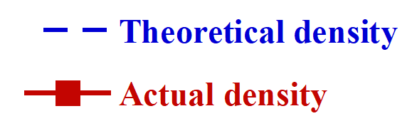
Figure 2. Densities of graphite/graphene/CNT filled PBA composites.
Figure 2 illustrates the density of the composites filled with 7.5wt% graphene and different amount of CNTs at an expense of graphite (Table 1). It was observed that at 0-2wt% CNT, the actual densities of specimens was nearly equal to their theoretical values confirming an exact content of each fillers and no void formation. However, at 2.5wt% of CNTs, a reduction in actual density was observed because the wettability of matrix to wet a greater surface area of CNT dropped thus some void or air gap was generated [11]. It is known that the presence of void decreases the properties of the prepared composite [43]. Consequently, the maximum content of CNT to be filled in graphite/graphene/CNT/PBA composite was 2.0wt%.

3.2 Specific Heat Capacity of Composites
Figure 3 illustrates specific heat capacity of the composite having various CNTs contents. The results obtained showed that there is no significant difference in specific heat capacity of the specimens with increasing CNTs content, because the specific heat capacities of CNTs and graphite are equal. The little difference in theoretical and experimental specific heat capacities of the composites was noticed at low CNTs content. Specific heat capacity shows some anisotropic property. At low CNTs, the particles arranged randomly and freely whereas the particles are packed densely at higher CNTs content causing little lower specific heat capacity. Furthermore, that the specific heat capacity of the composites is-an insensitive property having a linear relationship with filler content.

Figure 3. Specific heat capacities of graphite/graphene/CNTs/PBA composites.

3.3 Thermal Diffusivity of Graphite/Graphene/CNT Filled PBA Composites
Thermal diffusivity is used to calculate thermal conductivity according to equation (4). It is commonly conducted by laser flash method in which the heat propagates from top to bottom of the specimen. Thermal diffusivity values at 25ºC of the PBA composites with varying CNTs content are shown in Table 1 and Figure 4. The thermal diffusivity of the samples increases with increasing the highly thermal conductive CNTs content.
Figure 4. Thermal diffusivities at 25ºC of graphite/graphene/CNT /PBA composites.
For non-metal materials such as carbon-filled composites, heat transports by flow of phonons or lattice vibrational energy. Phonons normally flow through a material through the speed of sound. However, phonon scattering is sometimes occurred to delay flow of phonons and increase heat resistance in a material. This phenomena depends on temperature [26, 44, 45]. Figure 5 illustrates thermal diffusivities of the composites at temperature ranging from 25-180ºC. The results showed that the diffusivities of all specimens decreased with increasing temperature because higher temperature caused more phonon-phonon scattering mechanism and thus increased thermal resistivity of the composite [44, 45]. In addition, the composites filled with higher CNTs content had a higher slope than that of the composites with a lower filler content implying a more temperature sensitivity of the composites with increasing carbon nanotubes content.
Figure 5. Thermal diffusivities of graphite/graphene/CNT/PBA composites with various temperature.

3.4 Thermal Conductivity of Graphite/Graphene/CNT Filled PBA Composites
To increase substantially the thermal conductivity of the polymer matrix, high content of conductive filler is necessary to generate continuously conductive network and minimize heat resistance occurred by three phenomena i.e. phonon-phonon scattering, boundary scattering, and defect scattering [26, 44-46]. The measured values of thermal conductivity are summarized in Table 1.

Table 1. Thermal conductivities of graphite/graphene/CNT filled PBA composites at 25ºC.
Filler content (wt%) |  |  | ρ  (g/cm³) | c_{p}  (J/g·K) | α  (mm²/s) | K  (W/m·K)
Graphite | Graphene | CNT
0.0 | 0.0 | 0.0 | 1.190 | 1.756 | 0.131 | 0.274
76.5 | 7.5 | 0.0 | 1.825 | 0.984 | 8.213 | 14.7
76.0 | 7.5 | 0.5 | 1.821 | 0.990 | 11.836 | 21.3
75.5 | 7.5 | 1.0 | 1.812 | 0.953 | 11.948 | 20.6
75.0 | 7.5 | 1.5 | 1.814 | 0.946 | 12.060 | 20.7
74.5 | 7.5 | 2.0 | 1.820 | 0.965 | 12.115 | 21.3

DOE target > 20 W/m K
Figure 6. Thermal conductivities of graphite/graphene/CNT /PBA composites at 25ºC.
Figure 6 displays the through-plane thermal conductivity of the composite having various CNT content up to 2wt%. The thermal conductivity of the neat PBA was 0.274 W/m·K. The presence of graphite and graphene in the composite promoted thermal pathways, so that thermal conductivity increased to 14.7 W/m·K. The high conductivity was attributed to the high graphite content with large average diameter generating good conductive pathways with low phonon-phonon scattering and low boundary scattering. Graphene having high aspect ratio forms conductive pathways between graphite gaps. The addition of CNTs also increased thermal conductivity of the samples as shown in Table 2. The highest thermal conductivity value of composite was 21.3 W/m·K or about 44 times greater than that of the composite without CNTs. This very high thermal conductivity was obtained because CNTs having such high aspect ratio oriented randomly improving thermal conductivity in three directions [34]. Moreover, CNTs can contact with adjacent graphene and graphite by bridge between those two particles and form conductive network effectively [47]. These phenomenon can increase phonon transfer efficiency through the specimen. The highest obtained thermal conductivity 21.3 W/mK was higher than that of 10.2 W/mK for graphite /PBA composite [26], higher than 8.03 W/mK for graphene/PBA composite [10], higher than 13 W/mK for graphite/CNTs/phenolic composite [34]and and higher than 14.5 for graphite/graphene/PBA composite [32]. In Figure 7, a schematic representation is shown for thermal conduction path between graphite and graphene through CNTs bridging compared to that of the composite without CNTs presented by M. Phuangngamphan [32]. Moreover, the graphite/graphene/CNT/PBA composites have higher conductivities than the requirement set by DOE [16] suggesting that thermal conductivity of bipolar plates must be higher than 20 W/m·K.
It is worth noting that the thermal conductivity determined in this research was through-plane thermal conductivity which is normally much lower than the in-plane value due to anisotropic structure of the filler as studied by X. Tian et al. [48]. The through-plane thermal conductivity is the key property to transport heat out of the cells.
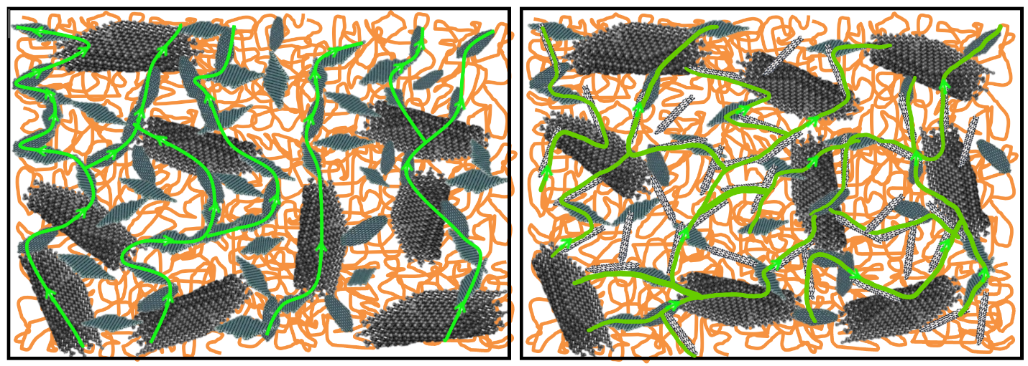
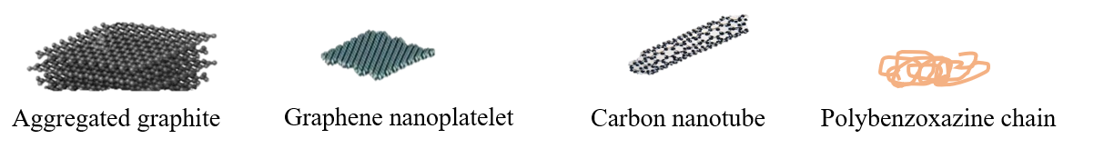
a)
b)

Figure 7. Schematic of thermal conduction path in a) graphite/graphene filled PBA composite from M. Phuangngamphan report [32] b) graphite/graphene/CNT/PBA of this research showing a greater continuous path of the composites than the composite without CNTs resulting in a much greater thermal conductivity.

3.5 Electrical Conductivity of Composites
During the operation of proton exchange membrane fuel cells, electrons are transferred from anode through two bipolar plates to the cathode in order to complete the circuit. Electrical conductivity of bipolar plates is the key property to minimize the plate thickness along with reduced weight and cost [49]. To obtain high electrical conductivity in a polymer composite, the conductive particles must contact to each other as much as possible to generate a continuous conductive pathways for electrons to flow through [50].
DOE target > 100 S/cm
Figure 8. Electrical conductivity of graphite/graphene/CNT /PBA composite at 25ºC.
There are two types of electrical conductivity i.e. through-plane and in-plane. The in-plane conductivity is more important property than the through-plane due to the larger area. Figure 8 shows in-plane electrical conductivity of the composite by varying the CNTs content at an expense of graphite. It was found that the increase of CNTs in the composites resulted in an increase in electrical conductivity. The improvement of this property was attributed to a high aspect ratio of CNTs which generated conductive pathway easily [11, 51, 52]. These types of fillers could overlap and interlace easily and also generated electrical conductive pathway with adjacent graphite and graphene [47, 53]. This phenomenon was also found by S.R. Dhakate et al. in graphite/CNTs/phenolic composite [34] and J. Che et al. in graphite/CNTs/HDPE composite [51]. The highest in-plane electrical conductivity was found to be
364 S/cm in the composite with 2.0wt% filler content which was higher than that of graphite/graphene PBA composite developed by M.Phuangngamphan [32] in which the value meet DOE target as it is required to be higher than >100 S/cm [16].

3.6 Flexural Properties of Graphite/Graphene/CNTs /PBA Composites
Bipolar plates have a duty to protect the membrane and electrodes from external force. The flexural strength of the composite with different CNTs loading are illustrated by Figure 9. For the composite having 0, 0.5, 1, 1.5, and 2wt% CNT content, the strengths were reported to be 28.1, 34.2, 33.7, 39.4, and 41.5 MPa, respectively. The flexural strength is slightly enhanced with the increase of the CNTs content. The greatest enhancement in flexural strength was found at the samples with 2wt% of CNTs which accounted to be about 41% improvement. This is due to higher intrinsic mechanical properties of multi-walled CNTs than those of graphite The load applied to the composite could be transferred to carbon nanotubes efficiency because of high aspect ratio of CNTs [54]. Moreover, their tube-like shape caused a good dispersion in polymer matrix and their structure with kinks and twists can prevent detachment of these fillers from the matrix [55]. This phenomenon also occurred in graphite/CNTs/phenolic composites investigated by S.R.Dhakate et al. [34]. It is interesting that the flexural strengths of the composites even for those in the composite without CNTs were higher than that required by DOE (>25 MPa).
DOE target > 25 MPa
Figure 9. Flexural strengths of graphite/graphene/CNTs/PBA composites with varying carbon nanotubes contents.
The flexural modulus of the specimen show an improvement with increasing CNTs content (Figure 10). The flexural moduli of the composites with 0, 0.5, 1, 1.5, and 2wt% CNTs content were investigated to be 20.9, 36.5, 34.7, 37.7, and 49.7 GPa, respectively. The greatest improvement was observed for the composite having 2wt% of CNTs which was 93% enhancement compared to the sample without CNTs. This enhancement was attributed to the substantial bonding between the matrix and the fillers. Furthermore, it was related to a very high aspect ratio of CNTs, which help the improvement of the modulus of the composite compared to graphite or graphene [55]. The flexural moduli of this research was higher than that of graphite/graphene /PBA composites developed by M.Phuangngamphan [32] which found to be 16.8 GPa and also much greater than values required by DOE (>10 GPa) [16].
DOE target > 10 GPa
Figure 10. Flexural moduli of graphite/graphene/CNTs/PBA composites with varying carbon nanotubes contents.

3.7 Water Absorption of Composites
In the operation of fuel cells, water is normally generated from the electrochemical reactions and flow through bipolar plates. For this reason, water absorption or water uptake of the bipolar plates must be as low as possible to prevent damage within fuel cells. Figure 11 illustrates the relation between water absorption of the composite having different CNT loading. The samples were immersed in water for 0-168 hours or 0-7 days. The water absorption performance of the composite increases with CNTs content due to the greater water absorption of CNT than graphene and graphite fillers as a result of the presence of hydrophilic functional groups such as carboxylic group at the CNT surfaces which confirmed by FTIR spectra of CNTs (see supplementary data).
The larger water absorption properties between 1.0 and 1.5wt% CNT compared to 0.5 and 1.0wt% CNT may be due to the processing ability of the compounds at different CNT content. Some agglomeration of CNT in the composite may occurred at high CNT content of 1-1.5wt% as a result of highly viscous paste like structure during specimen preparation and thus water can penetrate easily. At low CNT content of 0-1wt%, the benzoxazine resin can wet all particles efficiently showing the barrier effect to water and thus water absorption is lower.
DOE target < 0.3 % at 24 h

Figure 11. Water absorption of graphite/graphene/CNT/PBA composites with varying CNTs contents.
This phenomenon also occurred in CNTs reinforced epoxy/glass fiber laminated developed by N.M.Zulfil et al. [56]. However, the water absorption after immersed for 24 hours of all composites filled with CNTs were calculated to be 0.023-0.114% which was still lower than DOE target (<0. 3%) [16].

Table 2. Comparison of properties of composites of this work with those reported in literature.
Properties | Density (g/cm³) | Electrical conductivity (S/cm) |  | Flexural strength (MPa) | Flexural modulus (GPa) | Thermal conductivity (W/mK) | Water absorption (%)
 |  | In plane | Through plane
DOE [16] | 1.9 | > 100 | >20 | >25 | 10 | >20 | <0.3
This research | 1.82 | 364 |  | 41.5 | 49.7 | 21.4  (through plane) | 0.114
Graphite/CNT/phenolic [34] | 1.82 | 178 | 30 | 56 | 14 | 50 (in plane)  13 (through plane)
Graphite/graphene PBA [32] | 1.82 | 323 | - | 54 | 16.8 | 14.5 | < 0.1
GP/CNT/Phenolic resin [57] | 1.845 | 196.7 | - | 57.5 | - | - | -
The relevant properties of graphite/graphene/CNT filled in PBA bipolar plate were compared to other polymer composite bipolar plate systems as seen in Table 2. It is found that bipolar plate developed in this research showed better properties than those of all bipolar plate systems.

3.8 Morphology of Graphite/Graphene/CNT Filled PBA Composites
Morphology of CNTs was observed by a transmission electron microscope as shown in Figure 12. An average diameter of CNTs was measured to be 10.1±2.3 nm where CNT wall was observed to be fringe patterns having the thickness value of 2.52±0.58 nm.
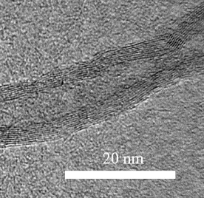
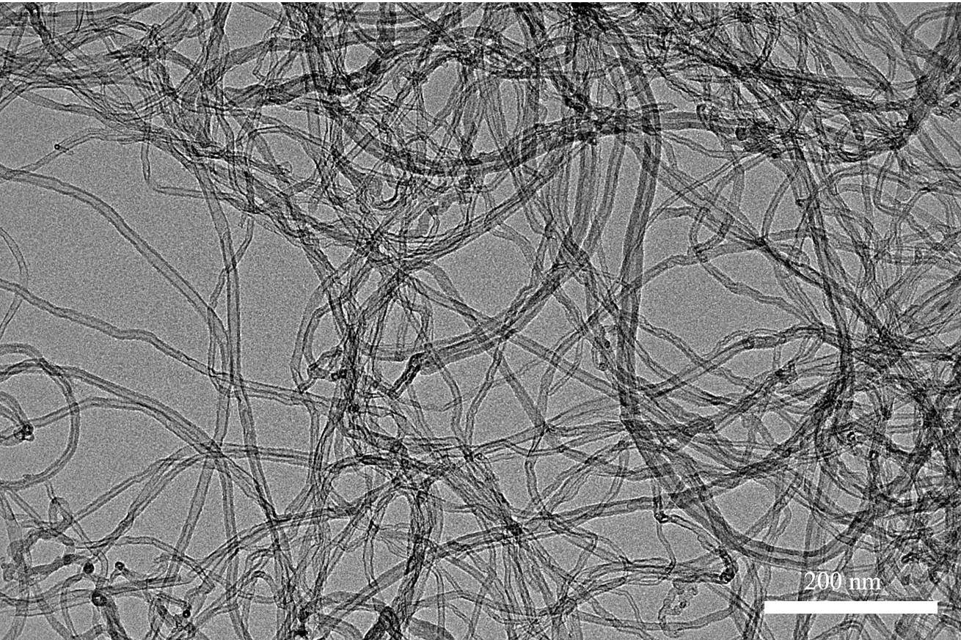
Figures 13(a) to 13(c) reveal micrographs of graphite which large multiple layer of flake-like shape, graphene with stacks of flake-like shape, and carbon nanotubes with large amount of tubes entangle together, respectively.
Figure 13(d) illustrates fracture surface of the neat polybenzoxazine showing a smooth surface. Figures 13(e) to 13(g) show fracture surfaces of PBA composite filled with graphite, graphene, and carbon nanotubes, respectively indicating a well-dispersed of each filler in polymer matrix. Figure 13(h) illustrates the fracture surfaces of the composite filled with 0.5 wt% graphite, graphene and CNT where Figure 13(i) shows those of the composite filled with 74.5, 7.5 and 2 wt% of graphite, graphene and carbon nanotubes, respectively. The figures reveal well-dispersion of all fillers in polymer matrix attributing to a very low-melt viscosity of benzoxazine resin which provided good wettability to all types of fillers. For highly-filled polybenzoxazine composite, the substantial adhesion between the fillers and the matrix were generated. In addition, each filler occurred to improve the properties of the composite such as thermal conductivity, electrical conductivity and flexural properties.
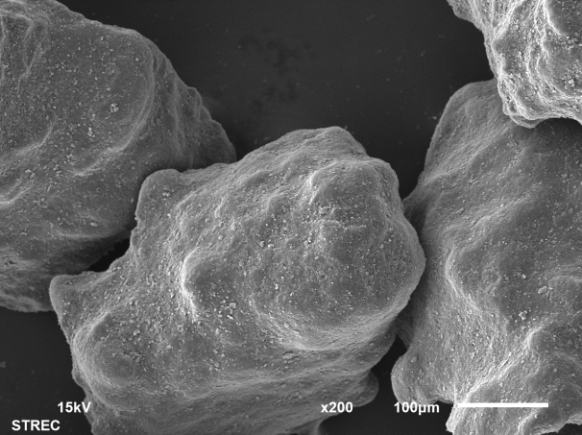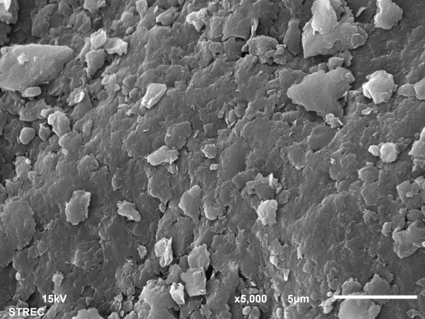
a
b
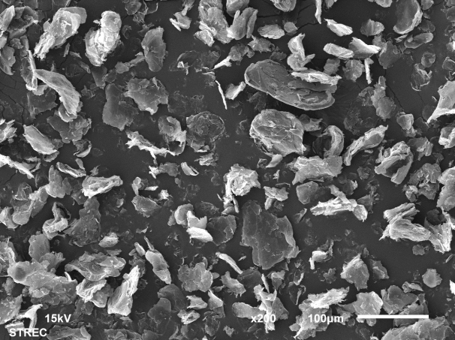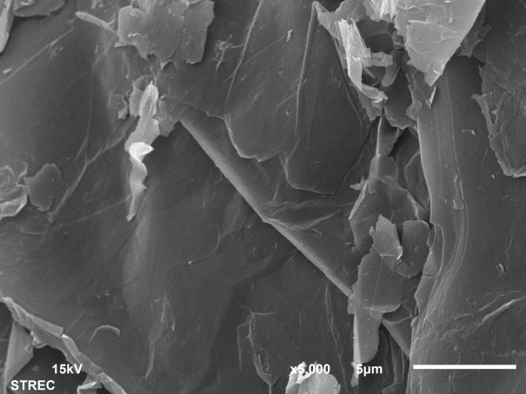
c
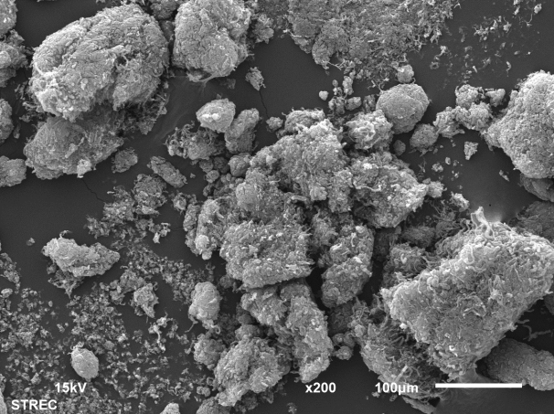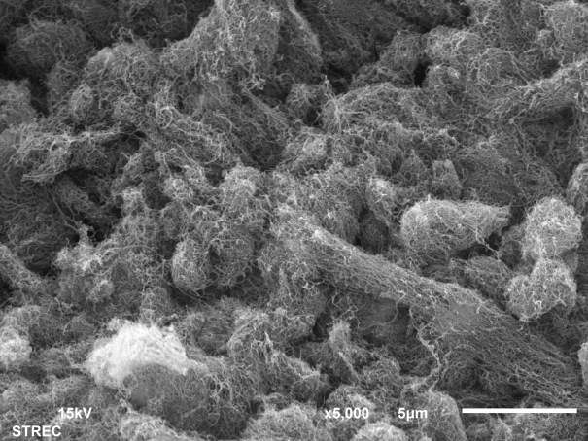
Figure 13. SEM micrographs of a) pure graphite particles, b) pure graphene particles and c) CNT particles.

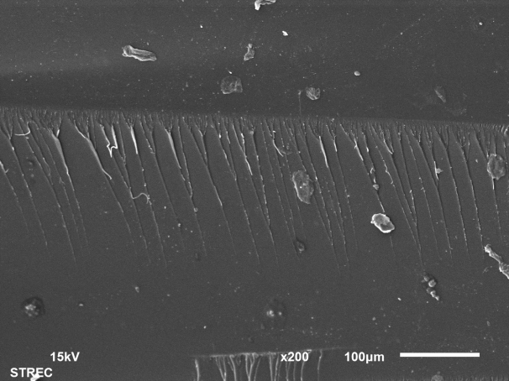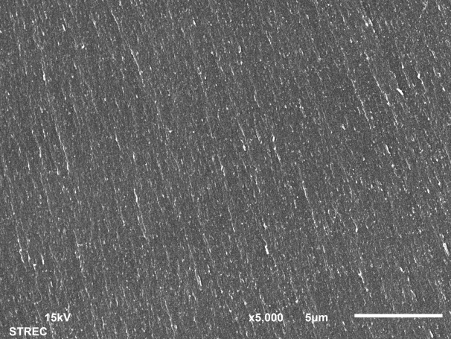
d

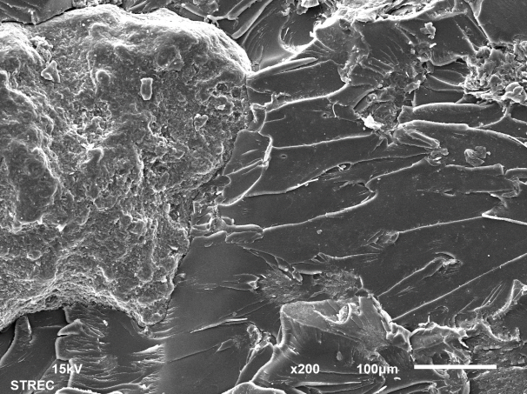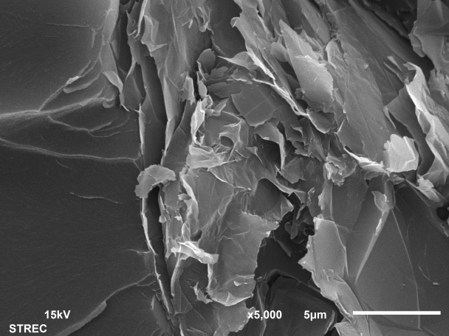
e
graphite
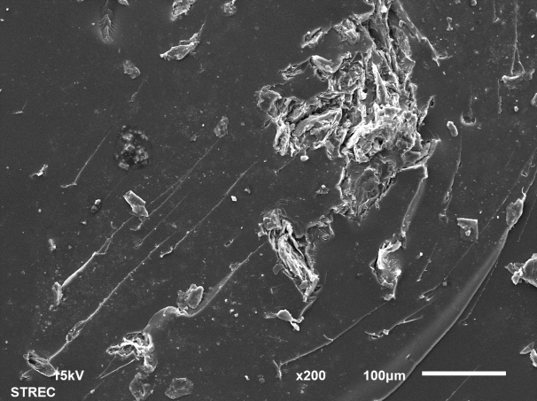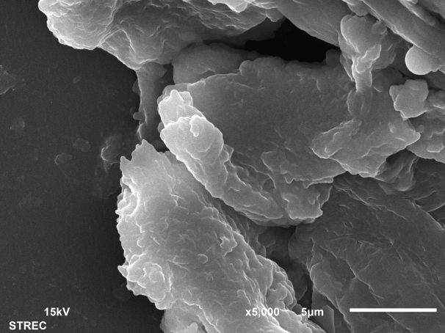
f
graphene
Figure 13. SEM micrographs of fracture surfaces of d) pure PBA e) the 0.5wt% graphite-filled PBA composites and f) 0.5wt% graphene-filled PBA composite

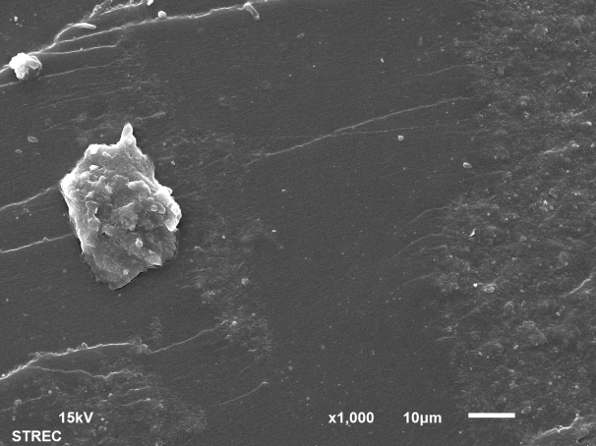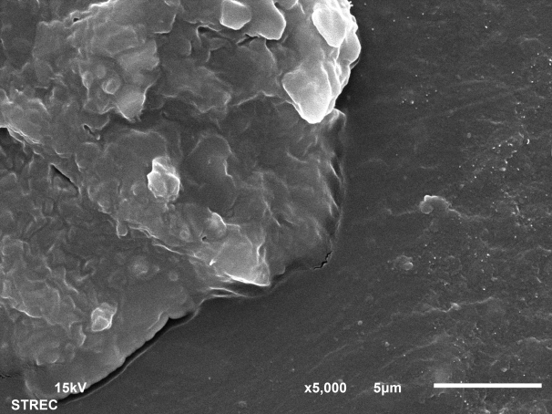
carbon nanotubes
g
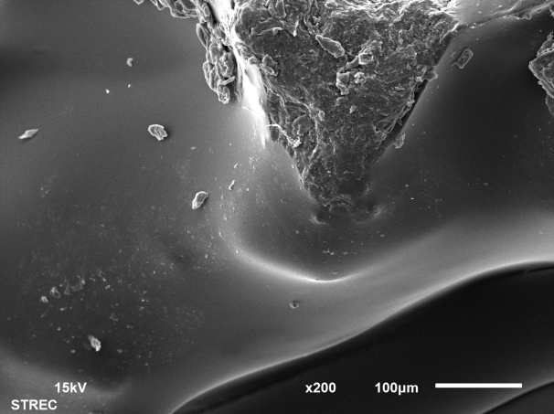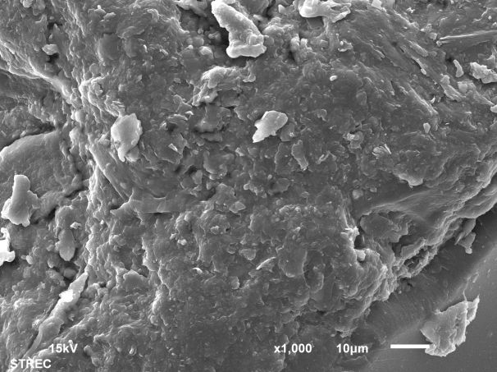
graphene
graphene
carbon nanotubes
graphite
carbon nanotubes
graphite
h
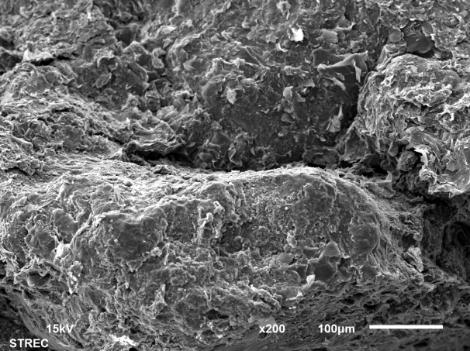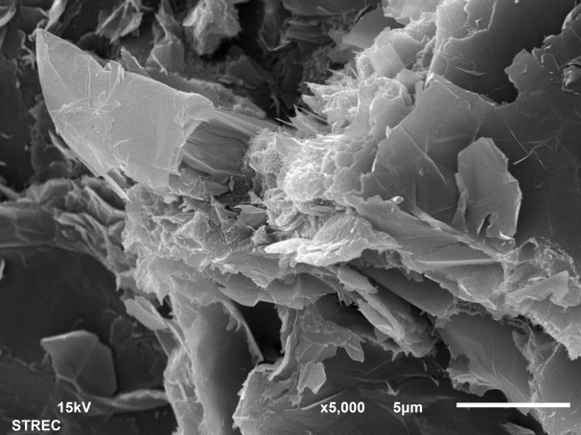
carbon nanotubes
graphene
graphite
i
Figure 13. SEM micrographs of fracture surfaces of the PBA composites: g) 0.5wt% CNT filled PBA composite h) 0.5/0.5/0.5wt% graphite/graphene/CNT filled PBA composite and i) 74.5/7.5/2wt% graphite/graphene/CNT filled PBA composite
CONCLUSION
High filled graphite/graphene/CNTs/PBA composites were developed in this research. The total content of fillers was constant at 84wt% where the content of CNTs was varied from 0-2wt% at an expense of graphite. The thermal and electrical conductivity of the composite filled with CNTs were improved. CNTs having a tubular structure with long length and short diameter can randomly orient in the composite and attached with graphite and graphene efficiently resulting in a great enhancement of thermal and electrical conductivity of the composite. The thermal conductivity of the composite containing CNTs as low as 0.5wt% fulfilled the requirements set by DOE. In addition, electrical conductivity, flexural strength and modulus and water absorption of the composite met those requirements by DOE as well. Such developed graphite/graphene/CNTs/PBA composites are a high potential alternative choice for bipolar plates in PEMFCs.
ACKNOWLEDGEMENT
This work was supported by the research funding from Global Partnership Program, Ministry of Higher Education, Science, Research and Innovation, the National Nanotechnology Center, NSTDA, Ministry of Science and Technology, Thailand through its Research Network NANOTEC (RNN) program and the National Research Council of Thailand (NRCT).
REFERENCES
[1] Peighambardoust SJ, Rowshanzamir S, Amjadi M. Review of the proton exchange membranes for fuel cell applications. Int J Hydrogen Energy. 2010;35:9349-84.
[2] He X, Luan SZ, Wang L, Wang RY, Du P, Xu YY, Yang HJ, Wang YG, Huang K, Lei M. Facile loading mesoporous Co₃O₄ on nitrogen doped carbon matrix as an enhanced oxygen electrode catalyst. Mater Lett. 2019;244:78-82.
[3] Huang K, Zhang L, Xu T, Wei H, Zhang R, Zhang X, Binghui G, Lie M, Yuan Ma J, Liu LM, Wu H. -60 degrees˚C solution synthesis of atomically dispersed cobalt electrocatalyst with superior performance. Nature commun. 2019;10:606.
[4] Qiao J, Xu L, Liu Y, Xu P, Shi J, Liu S, Tian B. Carbon-supported co-pyridine as non-platinum cathode catalyst for alkaline membrane fuel cells. Electrochim Acta. 2013;96:298-305.
[5] Huang K, Guo S, Wang R, Lin S, Hussain N, Wei H, Deng B, Long Y, Lei M, Tang H, Wu H. Two-dimensional MOF/MOF derivative arrays on nickel foam as efficient bifunctional coupled oxygen electrodes. Chin J Catalysis. 2020;41:1754-60.
[6] Huang K, Wang R, Wu H, Wang H, He X, Wei H, Wang S, Zhang R, Lei M, Guo W, Ge B, Wu H. Direct immobilization of an atomically dispersed Pt catalyst by suppressing heterogeneous nucleation at −40 °C. J Mater Chem. 2019;7:25779-84.
[7] Xie L, Zhang R, Cui L, Liu D, Hao S, Ma Y, Du G, Asiri AM, Sun X. High-performance electrolytic oxygen evolution in neutral media catalyzed by a cobalt phosphate nanoarray. Angewandte Chemie. 2017;56:1064-8.
[8] Huang K, Zhao Z, Du H, Du P, Wang H, Wang R, Lin S, Wei H, Long Y, Lei M, Guo W, Wu H. Rapid thermal annealing toward high-quality 2D cobalt fluoride oxide as an advanced oxygen evolution electrocatalyst. ACS Sustain Chem Eng. 2020;8:6905-13.
[9] Kang K, Park S, Ju H. Effects of type of graphite conductive filler on the performance of a composite bipolar plate for fuel cells. Solid State Ionics. 2014;262:332-6.
[10] Plengudomkit R, Okhawilai M, Rimdusit S. Highly filled graphene-benzoxazine composites as bipolar plates in fuel cell applications. Polym Compos. 2014:1-13.
[11] Taherian R. A review of composite and metallic bipolar plates in proton exchange membrane fuel cell: Materials, fabrication, and material selection. Int J Power Sources. 2014;265:370-90.
[12] Du L, Jana SC. Hygrothermal effects on properties of highly conductive epoxy/graphite composites for applications as bipolar plates. J Power Sources. 2008;182:223-9.
[13] Hermann A, Chaudhuri T, Spagnol P. Bipolar plates for PEM fuel cells: A review. Int J Hydrogen Energy. 2005;30:1297-302.
[14] Hwang IU, Yu HN, Kim SS, Lee DG, Suh JD, Lee SH, et al. Bipolar plate made of carbon fiber epoxy composite for polymer electrolyte membrane fuel cells. J Power Sources. 2008;184:90-4.
[15] Vishnyakov VM. Proton exchange membrane fuel cells. Vacuum. 2006;80:1053-65.
[16] http://www1.eere.energy.gov access October 1, 2019
[17] Yi P, Zhang D, Qiu D, Peng L, Lai X. Carbon-based coatings for metallic bipolar plates used in proton exchange membrane fuel cells. Int J Hydrogen Energy. 2019;44:6813-43.
[18] Gao P, Xie Z, Wu X, Ouyang C, Lei T, Yang P, et al. Development of Ti bipolar plates with carbon/PTFE/TiN composites coating for PEMFCs. Int J Hydrogen Energy. 2018;43:20947-58.
[19] Song Y, Zhang C, Ling C-Y, Han M, Yong R-Y, Sun D, et al. Review on current research of materials, fabrication and application for bipolar plate in proton exchange membrane fuel cell. Int J Hydrogen Energy. 2019.
[20] Li W, Jing S, Wang S, Wang C, Xie X. Experimental investigation of expanded graphite/phenolic resin composite bipolar plate. Int J Hydrogen Energy. 2016;41:16240-6.
[21] Dhakate S, Mathur R, Kakati B, Dhami T. Properties of graphite-composite bipolar plate prepared by compression molding technique for PEM fuel cell. Int J Hydrogen Energy. 2007;32:4537-43.
[22] Kimura H, Ohtsuka K, Matsumoto A. Performance of graphite filled composite based on benzoxazine resin. J Appl Polym Sci. 2010;117:1711-1717.
[23] Boyacı San FG, Okur O. The effect of compression molding parameters on the electrical and physical properties of polymer composite bipolar plates. Int J Hydrogen Energy. 2017;42:23054-69.
[24] Ishida H. Process for preparation of other publications benzoxazine compound in solventless system. U.S.: Edison Polymer Innovation Corporation; 1996.
[25] Ishida H, Agag T. Handbook of Benzoxazine. New York: Elsevier; 2011.
[26] Ishida H, Rimdusit S. Very high thermal conductivity obtained by boron nitride-filled polybenzoxazine. Thermochim Acta. 1998;320:177-86.
[27] Jubsilp C, Punson K, Takeichi T, Rimdusit S. Curing kinetics of benzoxazine–epoxy copolymer investigated by non-isothermal differential scanning calorimetry. Polym Degrad Stab. 2010;95:918-24.
[28] Kiskan B, Ghosh NN, Yagci Y. Polybenzoxazine-based composites as high-performance materials. Polym Int. 2011;60:167-77.
[29] Zeng M, Wang J, Li R, Liu J, Chen W, Xu Q, Gu Y. The curing behavior and thermal property of graphene oxide/benzoxazine nanocomposites. Polymer. 2013;54:3107-16.
[30] Dueramae I, Pengdam A, Rimdusit S. Highly filled graphite polybenzoxazine composites for an application as bipolar plates in fuel cells. J Appl Polym Sci. 2013:3909-18.
[31] Plengudomkit R, Okhawilai M, Rimdusit S. Highly filled graphene benzoxazine composites as bipolar plates in fuel cell applications. Polym Compos. 2016;37:1715–27
[32] Phuangngamphan M, Okhawilai M, Hiziroglu S, Rimdusit S. Development of highly conductive graphite-/graphene-filled polybenzoxazine composites for bipolar plates in fuel cells. J Appl Polym Sci. 2018;136:47183.
[33] Adloo A, Sadeghi M, Masoomi M, Pazhooh HN. High performance polymeric bipolar plate based on polypropylene/graphite/graphene/nano-carbon black composites for PEM fuel cells. Renewable Energy. 2016;99:867-74.
[34] Dhakate SR, Sharma S, Chauhan N, Seth RK, Mathur RB. CNTs nanostructuring effect on the properties of graphite composite bipolar plate. Int J Hydrogen Energy. 2010;35:4195-200.
[35] Ghosh A, Goswami P, Mahanta P, Verma A. Effect of carbon fiber length and graphene on carbon-polymer composite bipolar plate for PEMFC. J Solid State Electrochem. 2014;18:3427-36.
[36] Hsiao M-C, Liao S-H, Yen M-Y, Teng C-C, Lee S-H, Pu N-W, et al. Preparation and properties of a graphene reinforced nanocomposite conducting plate. J Mater Chem. 2010;20:8496.
[37] Kakati BK, Sathiyamoorthy D, Verma A. Electrochemical and mechanical behavior of carbon composite bipolar plate for fuel cell. Int J Hydrogen Energy. 2010;35:4185-94.
[38] Pop E, Varshney V, Roy AK. Thermal properties of graphene: Fundamentals and applications. MRS Bulletin. 2012;37:1273-81.
[39] Bastiurea M, Andrei G, Dima D, Murarescu M, Ripa M, Circiumaru A. Determination of specific heat of polyester composite with graphene and graphite by differential scanning calorimetry. Tribology in Industry. 2014;4:419-27.
[40] Smits FM. Measurement of Sheet Resistivities with the Four-Point Probe. The Bell System Technical Journal 1958;37:711-8.
[41] Senna JR. Finite-Size Corrections for 4-Point Probe Measurements 2004.
[42] Pandey AK, Singh K, Kar KK. Thermo-mechanical properties of graphite-reinforced high-density polyethylene composites and its structure–property corelationship. J Compos Mater. 2016;51:1769-82.
[43] German RM. Particle Packing Characteristics, Metel Powder Industries Federation: Princeton; 1989.
[44] Berman R. Thermal Conduction in Solids. Oxford: Clarendon Press; 1976.
[45] Tritt T, M. Thermal Conductivity: Theory, Properties, and Applications. South Carolina: Plenum; 2004.
[46] Rimdusit S, Jubsilp C, Tiptipakorn S. Alloys and Composites of Polybenzoxazines Properties and Application. Singapore: Springer; 2013.
[47] Lu T, Ye H, Zheng A, Xu X, Xu C, Wang H, et al. Hybrid modification of high-density polyethylene with hyperbranched polyethylene-functionalized multiwalled carbon nanotubes and few-layered graphene. J Appl Polym Sci. 2017;134:44848.
[48] Tian X, Itkis ME, Bekyarova EB, Haddon RC. Anisotropic Thermal and electrical properties of thin thermal interface layers of graphite nanoplatelet-based composites. Scientific Reports. 2013;3.
[49] Rungsima Y. Development of electrically conductive thermoplastic composites for bipolar plate application in polymer electrolyte membrane fuel cell : Waterloo; Mater Sci. 2010.
[50] Yeetsorn R, Fowler MW, Tzoganakis C. A review of thermoplastic composites for bipolar plate materials in PEM fuel cells. In: Cuppoletti J, editor. Nanocomposites with Unique Properties and Applications in Medicine and Industry. Rijeka: InTech; 2011. p. 317.
[51] Che J, Wu K, Lin Y, Wang K, Fu Q. Largely improved thermal conductivity of HDPE/expanded graphite/carbon nanotubes ternary composites via filler network-network synergy. Composites Part A. 2017;99:32-40.
[52] Kara S, Arda E, Dolastir F, Pekcan O. Electrical and optical percolations of polystyrene latex-multiwalled carbon nanotube composites. J Colloid Interface Sci. 2010;344:395-401.
[53] Du J, Zhao L, Zeng Y, Zhang L, Li F, Liu P, et al. Comparison of electrical properties between multi-walled carbon nanotube and graphene nanosheet/high density polyethylene composites with a segregated network structure. Carbon. 2011;49:1094-100.
[54] Dumas L, Bonnaud L, Dubois P. Polybenzoxazine nanocomposites: Case study of carbon nanotubes. In: Ishida H, Froimowicz P, editors. Advanced and Emerging Polybenzoxazine Science and Technology. Amsterdam: Elsevier; 2017. p. 767-800.
[55] Zakaria MR, Kudus MHA, Md. Akil H, Mohd MZT. Comparative study of graphene nanoparticle and multiwall carbon nanotube filled epoxy nanocomposites based on mechanical, thermal and dielectric properties. Composites Part B. 2017;119:57-66.
[56] Zulfli NHM, Bakar AA, Chow WS. Mechanical and water absorption behaviors of carbon nanotube reinforced epoxy/glass fiber laminates. J Reinf Plast Compos. 2013;32:1715-21.
[57] Chaiwan P, Pumchusak J. Wet vs. dry dispersion methods for multiwall carbon nanotubes in the high graphite content phenolic resin composites for use as bipolar plate application. Electrochim Acta. 2015;158:1-6.

