Hotel CSR and Job Satisfaction: A Chaordic Perspective

Abstract
Whilst job satisfaction has been extensively investigated as a CSR moderator or outcome, pertinent literature is predominantly silent on the complexity surrounding the formulation of the construct. This study adopts the theory of complexity and examines the combinations of factors leading to hotel employee job satisfaction within a CSR context. Using fuzzy-set Qualitative Comparative Analysis (fsQCA), those factorial combinations that are significant in driving job satisfaction were first identified, whereas semi-structured interviews revealed the relationships that describe such configurations. Necessary Condition Analysis (NCA) was used as complementary to estimate the effects of size of the examined conditions. In total, three solutions were generated: (i) ethical issues and morality; (ii) hotel-related aspects; (iii) employee-related aspects which are supported by the qualitative data. Results indicate that job satisfaction can be stimulated by diverse combinations of hotel employees’ CSR perceptions, moral identity, subjective norms and work engagement, yielding significant theoretical and managerial implications.

Keywords: hotel employees; job satisfaction; CSR perceptions; moral identity; subjective norms; employee engagement

1. Introduction
Corporate Social Responsibility (CSR) is perceived as commonplace in the hospitality industry. Many companies view the adoption of CSR as a competitive necessity that offers numerous benefits including improved financial performance and stronger stakeholder relationships as well as protective effects against stakeholder perceptions during crises (Ghaderi et al., 2019; Kucukusta et al., 2019; Shin et al., 2021). One of the important internal benefits of CSR is employees’ enhanced job satisfaction (Choi & Choi, 2021; Kim et al., 2020; Vlachos et al., 2013) which, in turn, may yield positive effects on companies and employees alike. For instance, the job satisfaction of employees may improve company performance as it stimulates employee productivity and minimises turnover by acting as a motivator to work and a driver of organisational commitment (Kim et al., 2020; Leung & Lin, 2022; Stamolampros et al., 2019; Zopiatis et al., 2014). Likewise, job satisfaction may enhance employee wellbeing and perceived quality of work life as it strengthens the employee-company relationship (Kim et al., 2018; Su & Swanson, 2019).

Job satisfaction is particularly important in high contact service economic sectors such as tourism and hospitality, wherein the behaviour of frontline employees determines customer satisfaction and, consequently, impacts company success (Son et al., 2021; Stamolampros et al., 2019). As such, in recent years the CSR initiatives of hotels have been directed towards their employees (Kim et al., 2017). Hotel employees are recognised as a critical stakeholder supporting CSR initiatives as they are not only responsible for implementing CSR activities (Farmaki, 2019; Wong & Kim, 2020) but may also act as ‘ambassadors to CSR’ by communicating initiatives to customers (Edinger-Schons et al., 2019). Unsurprisingly, job satisfaction has been widely investigated in hospitality studies, as either an outcome or a moderator of CSR (e.g., Kim et al., 2020; Lee et al., 2013). Nonetheless, past studies adopted a linear analysis of the CSR and job satisfaction relationship, failing to acknowledge the complexity with which job satisfaction is formulated. Indeed, Schleicher et al. (2004) have long argued that researchers tend to adopt a simplistic conceptualization and operationalization of job satisfaction in organisational contexts, which remains the case today.

Within a CSR context, job satisfaction emerges as a specific and important function of the interplay of multiple variables related to internal factors, such as the employee’s cognitive and emotional characteristics, as well as external factors including organisational and/or societal influencers. For instance, a foray into CSR literature recognises employee perceptions of organisations’ CSR activities as a significant factor influencing their attitudinal and behavioural responses (Rupp et al., 2006) as well as the quality of the employee-firm relationship (Lee et al., 2013). If employees perceive that their organisation’s CSR activities benefit the society, they are more likely to demonstrate higher job satisfaction and work engagement (Bibi et al., 2021; Slack et al., 2015; Vlachos et al., 2013) as they find their work meaningful (Nazir & Islam, 2020). Job satisfaction resulting from the CSR activities of organisations is generally argued to strengthen work engagement as it motivates employees to work and perform better (Kim & Kim, 2020). Likewise, Sendlhofer (2020) posited that employee CSR perceptions are often driven by socio-psychological mechanisms such as morality. Understanding the moral mechanisms influencing employee CSR perceptions is, therefore, important as these can facilitate employee responses and, by extent, individual and organisational outcomes of CSR (Wang et al., 2017) including job satisfaction. In this context, subjective norms were identified as another influencer on employee perceptions of and responses to CSR (Sandve & Øgaard, 2014) signifying the complexity with which job satisfaction, as an outcome of CSR, is formulated. Even so, previous research has largely overlooked the complexity surrounding the construct.

In response to this research gap, this study adopts complexity theory and evaluates the combinations of factors leading to hotel employee job satisfaction within a CSR context by taking into consideration employee perceptions of their organisation’s CSR, moral identity, subjective norms and work engagement. Complexity theory allows researchers to gain deep insights on the way specific causal antecedents interact as it rests on the tenet that single antecedents are unable to adequately predict an outcome (Woodside, 2017). Thus, complexity theory is an appropriate lens to examine the relationships between outcome conditions and causal antecedents, especially in a complex service-driven context such as tourism and hospitality wherein behaviours are influenced by stakeholder interdependence and dynamic processes (Mohamed et al., 2020). We use a sequential explanatory strategy based on mixed methods, combining quantitative with qualitative data collection (Creswell & Creswell, 2017). Specifically, data were analysed using fuzzy-set Qualitative Comparative Analysis (fsQCA) that has the ability to explore causal recipes (i.e. the predictors’ combinational effects) and Necessary Condition Analysis (NCA) that enables the identification of the factors that are considered essential in order to achieve the job satisfaction of hotel employees in a CSR context. Interviews complemented the research by providing supportive evidence that reveal the relationships able to describe the examined configurations.
Overall, the study makes the following contributions. On a theoretical level, it examines the complexity of job satisfaction in a CSR context on which extant literature is predominantly silent, by providing a better understanding of the formulation of the construct. As such, this study contributes significant findings that may guide hospitality organisations wishing to improve their CSR strategies in terms of internal benefits. The study also offers important insights to destination policymakers as the employee-oriented CSR policies of hotels provide benefits to local communities, considering the fact that employees are part of the local community themselves. On a methodological level, the study makes a contribution through the employment of fsQCA, a method which has only recently been applied in the tourism and hospitality sector, as well as NCA that is novel in the respective field. Moreover, it combines and jointly evaluates the results of fsQCA and NCA with a qualitative interview study, which to the best of our knowledge is a multi-method approach applied for the first time in tourism and hospitality research. Apart from the fact that fsQCA and NCA are newly employed methods in tourism and hospitality, the methodological novelty herein also lies in the aspect that despite the plethora of existing literature on hotel CSR issues, this is the first study that examines the complexity and the generated chaordic systems underlying the formulation of CSR-induced job satisfaction.
2. Literature Review
The interplay of factors influencing CSR-induced job satisfaction is complex. In a CSR context, job satisfaction may emerge as a result of internal and external factors including perceptual and affective characteristics as well as organisation and societal influencers. Even so, pertinent literature is yet to examine this complexity related to job satisfaction driven by the CSR activities of organisations. In responding to this research gap, this study adopts complexity theory to investigate the interplay of factors identified in the literature as influential in shaping job satisfaction in a CSR context. Specifically, the study looks at the interface between job satisfaction and employee perceptions of their organisation’s CSR, moral identity, subjective norms and work engagement.

In the next sections, the concept of CSR is first explained paying particular emphasis on micro-level CSR and the important role of employees in CSR implementation especially in a service setting as that found in the hospitality industry. Then, the concept of job satisfaction as an outcome of CSR is discussed before the need to examine the interaction of job satisfaction with various influencing factors is explained.

2.1 Corporate Social Responsibility (CSR) conceptualization
CSR is a broad and diverse concept which has been credited with a myriad of definitions. Although there is a lack of consensus over the meaning of CSR (Iyer & Jarvis, 2019), two predominant views of the concept may be identified in the literature. First, CSR is conceptualized more widely as the business actions that provide social good beyond the interests of a company and the requirements of law (McWilliams & Siegel, 2001). This societal perspective rests on the tenet that companies have a moral obligation to “do the right thing” for the community and the environment in a way that respects ethical values (Falck & Heblich, 2007). In this regard, Bowen (1953) viewed CSR as a corrective measure to reduce companies’ negative impacts emerging from laisser-faire capitalism. Correspondingly, the moral obligation justification of CSR relates to the normative approach to CSR (Boesso et al., 2013) which proposes that stakeholders should be treated within morally determined parameters (Young & Thyil, 2008). Second, CSR is conceptualized from a narrow perspective which suggests that a company’s only responsibility is to maximize profits for its shareholders (Friedman, 1970). This conceptualization of CSR is linked to the descriptive approach to CSR, with studies investigating the relationship between CSR activities and company performance as a specific outcome of attempts to achieve a “win-win” situation between a company’s profitability and responsibility (Franco et al., 2020; You, 2015).

An approach that reconciles both views is the instrumental approach to CSR which proposes the embeddedness of CSR in corporate strategy in order to maximize the effectiveness of CSR implementation and allow the company to gain a competitive advantage (Boesso et al., 2013). According to Volgger and Huang (2019), the instrumental approach to CSR offers a more pragmatic strategy as it links business goals to normative societal aspects. In this context, Carroll’s (1979) CSR pyramid and Elkington’s (1997) triple bottom line emerged as popular frameworks advocating the instrumental approach to CSR. The first identifies four dimensions of corporate responsibilities (economic, legal, ethical and philanthropic) suggesting that a socially responsible company will attempt to make a profit, adhere to laws, be ethical and behave generously to benefit society (Carroll, 1979). The latter draws from sustainable development theorising and identifies the socio-economic, and environmental dimensions to CSR as a holistic approach guiding companies’ strategy and stakeholder engagement (Elkington, 1997). Typical CSR activities, thus, include amongst others: charity donations, the adoption of environmental management systems and standards, the design of sustainable products and services, human resource initiatives aiming to improve work-life balance and human rights protection (De Roeck & Maon, 2018).

2.2 Micro-level CSR research and employees
The instrumental approach has dominated mainstream and hospitality CSR research (Farrington et al., 2017). Nonetheless, most hospitality studies focused on the macro or meso-level perspectives of CSR investigating impacts on external stakeholders and corporate financial performance (e.g., Babajee et al., 2021; Lee et al., 2018; Theodoulidis et al., 2017). The micro-level aspects of CSR are yet to receive adequate academic attention (Farmaki & Stergiou, 2020) despite the fact that CSR micro-level foundations, which represent the central drivers of responsible business activities (Jones et al., 2017), have been recognised as enhancing macro-level CSR processes (Sendlhofer, 2020). Recently, however, a shift begun towards micro-oriented CSR research in the hospitality domain with pertinent studies focusing on the internal members of an organisation (Guzzo et al., 2020).

In micro-CSR scholarship, the concept of CSR is defined as an organisation’s “context-specific actions and policies that take into account stakeholders’ expectations and the triple bottom line of economic, social and environmental performance” (Aguinis, 2011, p.855). Correspondingly, micro-CSR studies place emphasis on the role of individual actors (Aguinis & Glavas, 2012) and, in particular, on internal stakeholder CSR perceptions and reactions (Rupp et al., 2013). In this context, employees emerge as the protagonists in micro-level CSR research (Kim et al., 2017). Employees are a key stakeholder in CSR, particularly in the tourism and hospitality industry where the inseparability of service delivery and consumption impacts customer satisfaction and, by extent, determines company success (Ko et al., 2019; Serra-Cantallops et al., 2018). As a result, hospitality companies have begun to direct their CSR initiatives towards their employees aiming to benefit from the positive CSR effects upon them.

2.3 Job satisfaction as an outcome of CSR
Arguably, one of the most important and widely researched employee outcomes of CSR is job satisfaction. As it is defined by Locke (1976, p.1304), job satisfaction is “a positive emotional state resulting from the appraisal of one’s job or job experiences”, whilst it represents an important metric of the relationship between an individual and an employer. According to Spector (1997), job satisfaction is a reflection of the contentment of employees with their work which also acts as a work motivation. Job satisfaction comprises of affective, cognitive and behavioural components (Moorman, 1993) which are largely shaped by intrinsic and extrinsic factors including recognition, responsibility, salary and work conditions among others (Martin & Schinke, 1998; O’ Driscoll & Randall, 1999). Hence, employees gain satisfaction if their job fulfils their needs and expectations (Kim et al., 2020).

CSR has been argued to increase job satisfaction directly or indirectly and there are several studies investigating the causal relationship between CSR and job satisfaction, by considering the construct as either a mediator or an outcome of internal and external CSR activities (table 1). In sum, extant literature informs us that the favourably perceived CSR activities of hotels enhance employees’ job satisfaction directly or indirectly by strengthening other variables such as organisational commitment, perceived wellbeing and work meaningfulness; in turn, improving work engagement and employee retention among others.

Table 1: Indicative Literature Table
Author/Date | Focus | Methodology | Findings
Appiah (2019) | Job satisfaction as outcome of community-based CSR activities | Survey/ Multiple Regression | CSR activities are important extrinsic factors of job satisfaction
Kim et al. (2020) | Job satisfaction as an outcome of CSR and quality of work life (QWL) | Survey / SEM | CSR have positive influence on QWL and job satisfaction
Kim et al. (2018) | Job satisfaction as outcome of CSR and quality of work life (QWL) and as a determinant of quality of life (QoL) | Survey / SEM | CSR have positive influence on QWL and job satisfaction while QWL and job satisfaction affect QoL
Kremer (2019) | Impact of CSR on job satisfaction and employee retention | Survey / Multiple Regression | CSR positively affects job satisfaction and employee retention
Kunda et al. (2019) | Job satisfaction as mediator between CSR and organisational citizenship behaviour (OCB) | Survey / Multiple Regression | Employee-centred CSR has a positive effect on job satisfaction; job satisfaction does not mediate CSR-OCB relationship
Lee et al. (2013) | Impact of CSR on organisational trust, job satisfaction and customer orientation | Survey / SEM | CSR positively influences organisational trust, job satisfaction and customer orientation
Trivellas et al. (2021) | Impact of CSR on job satisfaction | Survey / Multiple Regression | Internal CSR positively impacts job satisfaction
Wang et al. (2020) | Effects of CSR on employee engagement, job satisfaction, commitment and organisational citizenship behaviour | Survey / PLS-SEM | Positive relationship found between CSR and examined variables
Youn et al. (2018) | Job satisfaction as mediator between CSR and organisational commitment (OC) | Survey / Regression | Job satisfaction mediates relationship between perceived CSR and OC
Zientara et al. (2015) | CSR effects on job satisfaction, organisational commitment and work engagement | Survey / SEM | Positive relationship between CSR and examined variables

In particular, internal CSR practices aiming at enhancing employee welfare such as training and development programmes (Luu, 2021) increase job satisfaction as they contribute to employee wellbeing and the improvement of working conditions (Kim et al., 2020). Indeed, as CSR nurtures a favourable organisational culture (Wong & Gao, 2014), it is likely that employees’ overall attitudes towards the organisation will improve when employee-oriented CSR practices are implemented (Zientara et al., 2015). Such benefits are particularly important in a labour-intensive industry like hospitality where employees often face difficult work conditions including increased stress and poor salaries (Jung & Yoon, 2014). Likewise, external CSR initiatives may also enhance job satisfaction. When employees believe that their organisations’ actions benefit the society, they are more likely to feel proud working for the organisation and express greater willingness to reciprocate with positive behaviour towards the organisation (Guzzo et al., 2020). Similarly, congruence between organisational and employee values may enhance job satisfaction particularly in a CSR context as employees find their work more meaningful and fulfilling of self-actualization needs (Kim et al., 2020; Nazir & Islam, 2020). Therefore, employees may become more engaged in their work, particularly when favourable work conditions and organisational support exist (Kahn, 1990; Rich et al., 2010). Overall, CSR-induced job satisfaction may lead to greater organisational commitment and work engagement as well as a reduction in employee turnover (Rhou & Singal, 2020; Wang et al., 2020; Youn et al., 2018); in turn improving employee productivity and, consequently, company performance (Ghaderi et al., 2019).

Despite the important insights derived from extant literature, past studies adopted in their totality a linear analytical approach in the investigation of job satisfaction by considering the construct as an outcome or mediator of CSR. A similar tendency is noticed in general hospitality studies examining job satisfaction which treat job satisfaction as a determinant, mediator or outcome (Kong et al., 2018). As a result, CSR-related and general hospitality literature has insofar failed to consider the complex interplay of multiple factors that formulate the construct of job satisfaction. The section below explains the complexity of CSR-induced job satisfaction in relation to a number of variables identified in the literature as important influencers.

2.4 CSR-induced job satisfaction influencers
A foray into CSR research reveals that employee perspectives of their organisations’ CSR influence their respective attitudes and behaviours to CSR (Shin et al., 2021) including job satisfaction. In relation to this point, job satisfaction has been acknowledged as an attitudinal construct (Vlachos et al., 2013) that interacts with CSR perceptions to influence employee behaviour. Specifically, CSR-induced job satisfaction is argued to strengthen work engagement as it motivates employees to work, thus improving employee job performance (Kim & Kim, 2020) and company success. In fact, work engagement which is defined as “a positive fulfilling work-related state of mind characterised by vigour, dedication and absorption” (Schaufeli et al., 2002, p. 74), has been identified as important for organisational success (Shuck & Reio, 2011) as it determines job satisfaction (Glavas, 2016). Yet, other factors emerge as influential on job satisfaction in a CSR context including a person’s moral mechanism as well as subjective norms over the importance of CSR (Sendlhofer, 2020; Sandve & Øgaard, 2014). Indeed, “the concepts of ethics/morality and CSR are not mutually exclusive; rather, they are interrelated and somewhat interdependent” (Joyner and Payne, 2002: 305). Thus, since CSR initiatives are imbued with notions of ethics and morality, the way employees react to these initiatives can be affected by their morality-related characteristics (Rupp et al., 2013) such as their moral identity.

Moral identity refers to the extent to which being moral is crucial to somebody’s self-direction and behaviour (Rupp et al., 2013). Hence, in relation to CSR, moral identity represents an important influencing factor predisposing employees to act ethically and socially responsible in order to support their organisation’s CSR initiatives and, thus, interacts with job satisfaction. Employees with a high moral identity will perceive an organisation’s CSR efforts favourably (Farmaki & Stergiou, 2020; Wang et al., 2017), leading them to become more engaged and satisfied with their work (Afsar et al., 2020; Singhapakdi et al., 2019). Nonetheless, in recent years increasing stakeholder pressure and consumer demand for sustainable behaviour in hospitality and tourism (Khatter et al., 2021) lead to the development of subjective norms which influence people’s decision to engage in socially responsible behaviours (Sandve & Øgaard, 2014). Referring to the perception that a significant individual or group of people will approve and support a specific behaviour (Ham et al., 2015), subjective norms emerge as a motivating force that may encourage employees to behave accordingly to comply with CSR related expectations; thereby, impacting job satisfaction (Lam et al., 2003).

Evidently, there is a multiplicity of factors determining job satisfaction in a CSR context including internal factors related to the employee’s cognitive and emotional characteristics and external factors such as organisational and/or societal influencers. Considering that extant literature largely overlooked how the interplay of these multiple factors influence CSR-induced job satisfaction, this study aims to evaluate the combinations of factors shaping job satisfaction in a CSR context. In so doing, it considers employee perceptions of their organisation’s CSR, moral identity, subjective norms and work engagement as key variables determining employee CSR-induced job satisfaction.

2.5 Chaordic systems and complexity theory
In so doing, we use complexity theory which acknowledges that the world is complex, consisting of various phenomena that cannot be explained in a linear way through cause-and-effect relationships. Complexity theory is rooted in the theory of chaos (Pappas, 2019a), which posits that it is difficult to predict long-term dynamic patterns as even small differences in behaviour can lead to significant varying reactions (Keller, 1993). Specifically, complexity theory suggests that multiple causal solutions emerging from the random interactions of components present in complex systems may be offered to predict an outcome (Kretzschmar, 2015). Complex systems are chaordic (the word ‘chaordic’ comes from ‘chaos vs order’, meaning that even in chaos conditions there is some kind of order) in nature as the complex and dynamic interactions of components lead to the formation of new structures (Schneider & Somers, 2006). These new structures are characterized as encompassing both unpredictability and pattern, namely chaos and order (Olmedo, 2011). Linear examinations of behavioural patterns in service contexts cannot fully capture the complexity of interrelationships, highlighting the need for asymmetric approaches (Papatheodorou & Pappas, 2017).

Complexity theory has been widely adopted to explain the dynamic processes of specific phenomena such as human behaviour (Olya & Al-Ansi, 2018) and has proven particularly useful in service contexts such as tourism and hospitality where there is a close interaction between service provider and customer (Farmaki et al., 2021). By describing nonlinear, dynamic and heterogeneous interactions towards the behavioural and motivational responses of people, complexity theory provides an explanation on the way a specific combination of antecedents can be used as a causal solution for specific phenomena characterised by high levels of complexity (Woodside, 2017). As such, it emerges as an appropriate theoretical lens to explain the complex causal relationships prescribing hotel employee CSR-induced job satisfaction, which depends upon multiple factors.

3. Study tenets
In service research, use of the term ‘tenet’ refers to testable precepts concerned with the identification of complex conditions (Papatheodorou & Pappas, 2017). As such, statistical hypotheses and the metrics of consistency are not involved in the examination of complex conditions; rather, outcome scores are used to establish the adequacy of complex configurations. According to the theory of configuration, the same group of causal factors can yield different outcomes (Ordanini et al., 2014). This study evaluates the combinations of employees’ perceptions of their organisations’ CSR, moral identity, subjective norms and work engagement that influence their job satisfaction. Hence, it evaluates whether binary sets exist or not.

Complexity theory is based on asymmetric analysis and therefore assumes that Y scores are considerably different from the causes of low Y scores (Fiss, 2011). In addition, multiple complex configurations may lead to the same outcome (Woodside, 2017). Following previous research (Pappas, 2019b; Woodside, 2014), six tenets are formulated:

T1: A single attribute can be included in different pathways and, in accordance with the interaction of this specific attribute with other attributes, it can lead to the hotel employee’ job satisfaction.

T2: Recipe principle: The formulation of a condition which is complex (whereby two simple conditions should be included as a bare minimum) leads to an outcome condition that can yield a consistently high score.

T3: Complex configurations can affect the effects of hotel employee perceptions of their job satisfaction.

T4: Different combinations of simple conditions can influence positively or negatively the effects of hotel employee perceptions for job satisfaction.

T5: Equifinality principle: An adequate effect of hotel employees’ perceptions of job satisfaction is not always based on a high score of outcome.

T6: When we have high Y scores, a specific recipe for the effects of hotel employee perceptions upon job satisfaction does not relate to all cases.

4. Methods
An explanatory sequential mixed method research approach was selected to combine quantitative with qualitative data and, thus, provide holistic and detailed insights on a complex phenomenon (Creswell & Creswell, 2017). Using fsQCA, the combinations of factors that are significant in driving job satisfaction are first identified, whilst semi-structured interviews reveal the relationships that describe such configurations (Mikalef et al., 2019; Woodside, 2017).

4.1 Quantitative phase

4.1.1 Respondents
The study took place among employees of year-round hotels in Patras and Athens, Greece, during February and March 2020, using self-administered questionnaires. Data were collected at eight hotels, where one of the researchers had personal contacts that showed interest in the study because they expected to benefit from a better understanding of their CSR activities with regard to employee job satisfaction. Even though this approach introduced an element of convenience in the sampling process, thus restricting representativeness, it also carried the advantage of ease of access to employees, with research assistants being allowed to administer questionnaires in the hotels’ premises. More importantly, it also ensured that the participating hotels were involved in CSR activities, which directly links to the objective of this study. In this context, representativeness was not essential to our analysis because the analyses focus on gaining insights into the complexity underlying the formulation of job satisfaction in a CSR context, rather than producing estimates for the Greek population of hotel employees. Moreover, sample representativeness is not an issue in fuzzy-set methods. As Zhang and Guo (2021, p. 933) explain, unlike traditional linear models, “fsQCA does not rest on an assumption that data are drawn from a given probability distribution. It uses calibrated sets to measure the construct of causal conditions and outcomes, which further reduces sample dependence”. Overall, the employees of three 5-star hotels, two 4-star hotels, and three 3-star hotels completed a questionnaire in their workplace. The last day of data collection was 21st of March, since Greece went under strict lockdown on the 22nd of March due to the Covid-19 pandemic, and the operations of all year-round hotels were suspended as part of the restrictive measures. While the Greek hotels resumed their operations in the middle of June 2020, their employees could not be easily contacted at workplace by outsiders in accordance with the rules for social distancing. Thus, the data presented in this study relates only to the early unfolding of Covid-19 in Greece.

Although the study had a low missing data proportion, list-wise deletion was employed (exclusion of the whole questionnaire) as the most versatile method for handling missing data and reduce research bias (Allison, 2001).

4.1.2 Sample size
Following the study of Akis et al. (1996), the study assumed that the respondents’ perspectives were unknown. Hence, it has undertaken the most conservative response (50% of responses are expected to be positive and 50% negative). The level of confidence was set to a minimum of 95% and, subsequently, the statistical error to a maximum of five percent. According to Sekaran and Bougie, (2013) the cumulative probability (Z) is 1.96 when the overall sample (as in our case) exceeds 20 respondents. The sample size calculation is as follows:

$$N=\frac{Z^{2}(hypothesis)}{S^{2}}⇒N=\frac{{1.96}^{2}(0.5)(0.5)}{{0.05}^{2}}⇒N=384.16$$

In total, 385 hotel employees were randomly approached, in line with specific quotas regarding a position in the hotel (e.g. senior managers, middle managers, junior managers). Of these, 129 refused to participate in the study (initial response rate: 66.5%), mainly because of time constraints and general unwillingness to undertake surveys, while 17 completed questionnaires were removed due to missing values or unvarying responses (Zhang et al., 2018). Thus, the final sample included 239 employees which indicates an effective response rate of 62.1%. The sample was broken down in terms of gender and educational level.

4.1.3 Measures
To maximise content validity, scale development for the constructs was based on prior research. Self-perceived moral identity was taken from Aquino and Reed (2002) and comprised ten items. Participants were instructed to visualise individuals of moral character and then report their attitudes towards these individuals and perceived level of self-similarity to these individuals. A moral character is considered as a caring person showcasing compassion, friendliness, fairness, generousness, kindness, and is helpful, honest, and hardworking. The scale for employee perceptions of a hotel’s CSR was adapted from Park and Levy (2014). It included three dimensions reflecting CSR activities in relation to different stakeholders: environment and community (ten items), employees (seven items), and customers (five items). Notably, recent research suggests that CSR scales organised by stakeholder types rather than responsibility types (e.g. economic, legal) provide a more solid theoretical background (Park & Levy, 2014; Ko et al., 2019). Eighteen items derived from Rich et al. (2010) measured employee engagement, while eight items taken from Tongchaiprasit and Ariyabuddhiphongs (2016) measured job satisfaction. Finally, the scale for subjective norms comprised three items and was adapted from Chen and Tung (2014). All these scales have been found to demonstrate strong psychometric properties in the respective studies across various settings and populations.

The questionnaire consists of (with the exception of socio-demographics) 5-point Likert scale (1 =strongly disagree, 5 = strongly agree) statements. The questionnaire includes six sections: (i) moral identity, (ii) hotel – environment and community, (iii) hotel – employees (iv), hotel – customers, (v) employee engagement, (vi) job satisfaction, and (vii) subjective norms. It also includes two socio-demographic characteristics (gender; education). Initially, the research tool was written in English and then translated into Greek to achieve reliable results in collecting data from non-English-speaking employees. A process of back-translation was employed in order to ensure linguistic consistency (Chen & Boore, 2009). Before launching the full-scale study, the questionnaire was pre-tested on five hotel employees. These pre-tests did not reveal any problems of the questionnaire (i.e., comprehension; structure; flow; duration).

Data were collected by two research assistants, working together as a pair in each city (a total of four people). The completion of each questionnaire lasted approximately 15-20 minutes. To avoid possible respondent bias, some of the items in the scales were reversed. As suggested by Chung and Monroe (2003) all participants were assured that their responses will be anonymous and confidential, and further informed that the analysis would be conducted at the aggregated level to prevent identification of any individual.

3.1.4 Algorithms
In total, 28 individual cases were randomly selected for the study calibration. The evaluation of job satisfaction ‘f_js’ was held by using the following fuzzy-sets: ‘f_g’ for gender, ‘f_e’ for education, ‘f_mi’ for moral identity, ‘f_hec’ for hotel environment and community, ‘f_he’ for hotel employees, ‘f_hc’ for hotel customers, ‘f_ee’ for employee engagement, and ‘f_sn’ for subjective norms.

4.2 Qualitative phase
Semi-structured interviews were performed with hotel employees of the 8 selected hotels between February and March 2020. The participants were selected using purposive sampling whereas care was undertaken to ensure that the sample reflected diversity in terms of age, gender and hotel position (Ritchie et al., 2014). Data saturation was reached at 45 participants whereby no new information was observed in the data (Fuchs & Ness, 2015) and the researchers were confident that, in accordance to the leading questions, adequate evidence for each theme was obtained to reach conclusions. Table 2 illustrates the profile of the participants. The interviews were undertaken by an experienced researcher, lasting approximately 45 minutes each. The interviews were conducted in Greek and then translated in English by a professional translator. The researcher started each interview with general questions that established the profile of the participants before proceeding with questions from a predetermined list that aimed at examining participant perceptions of their moral identity and hotels’ CSR activities as well as their related job satisfaction. Data was analysed by two of the researchers using thematic analysis (Braun & Clarke, 2006). Specifically, three rounds of coding were employed as prescribed by Gioia et al. (2013). First, the interview transcripts were read by each researcher separately to identify key themes; thus, maximising analytical integrity (Farmaki et al., 2020). Following investigator triangulation (Flick, 2000), the initial set of findings were combined and compared to allow for a more objective interpretation of the data. Subsequently, emerging topics were categorised into interrelated themes and refined to allow for sub-categories to emerge (Goulding, 1999). Last, sub-categories were combined with the themes initially identified to validate relationships (Strauss & Corbin, 1990).

Table 2: Profile of Informants

5. Results

5.1 Descriptive statistics and intercorrelations
Table 3 presents the sample’s socio-demographics. As illustrated in Table 3, nearly two thirds of the sample is women, whilst more than half of the respondents are higher education graduates. Table 4 presents the descriptive analysis of the study, as well as the statements used and their codification.
Table 3: Demographics

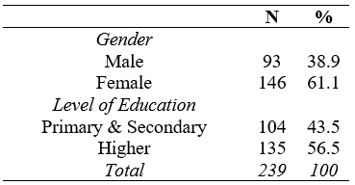

Table 4: Descriptive Statistics

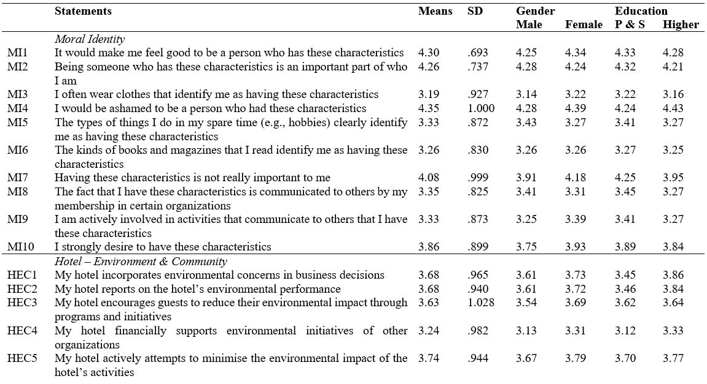
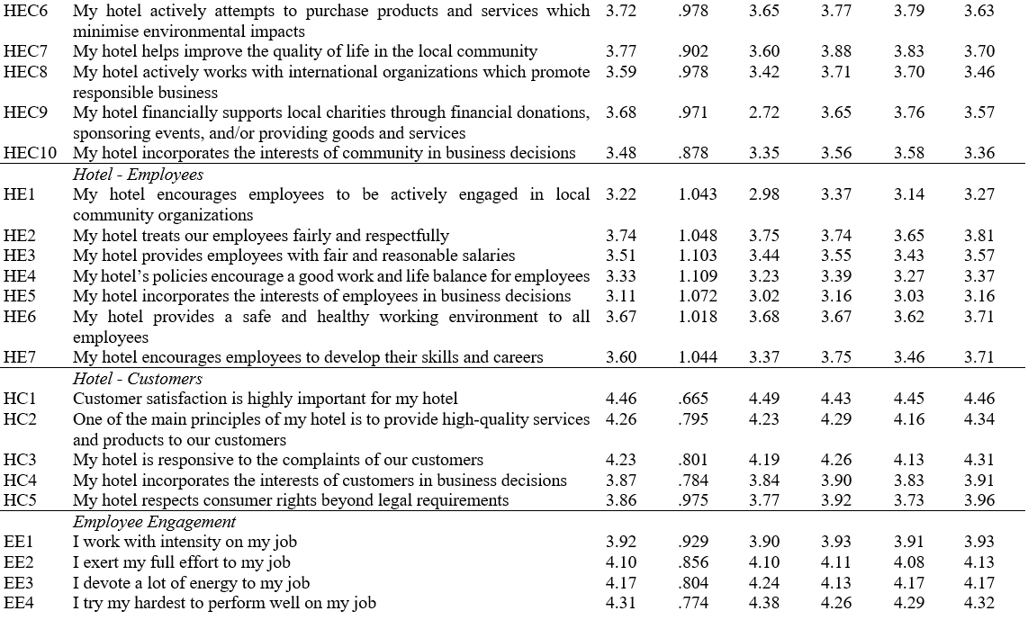
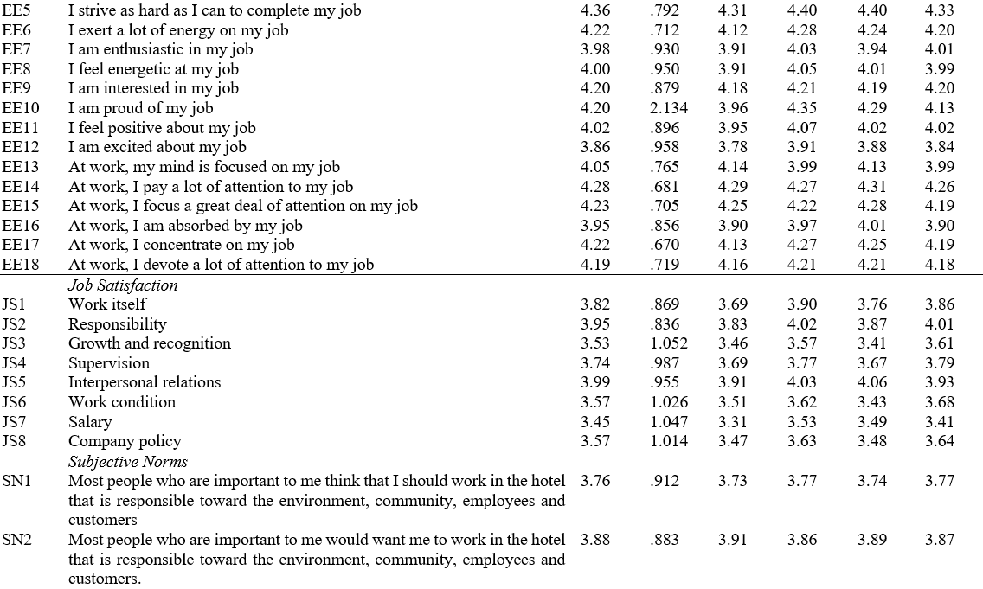

The adequacy of measurements has been evaluated by using factor analysis (Table 5). Since all statements have been adopted from previous research, the study employed CFA (Confirmatory Factor Analysis). Factor loadings lower than .5 have been extracted from further analysis due to low commonality. Each construct showed acceptable levels of internal consistency: the Cronbach’s alpha (A) and Composite Reliability (CR) for all scales were higher than the recommended limit of .70 (Hair et al., 2017). The Average Variance Extracted (AVE) was higher that the acceptable minimum of .5 (Hair et al., 2010), hence the research showcases a good convergent validity.

Table 5: Factor analysis

 | Loadings | A | AVE | CR
Moral Identity |  | .733 | .517 | .834
MI1 | -
MI2 | -
MI3 | -
MI4 | -
MI5 | .696
MI6 | .811
MI7 | -
MI8 | .655
MI9 | .765
MI10 | .557
Hotel – Environment & Community |  | .908 | .515 | .906
HEC1 | .755
HEC2 | .765
HEC3 | .761
HEC4 | .785
HEC5 | .658
HEC6 | .888
HEC7 | .584
HEC8 | .594
HEC9 | .548
HEC10 | .504
Hotel - Employees |  | .903 | .545 | .857
HE1 | -
HE2 | .765
HE3 | .826
HE4 | .731
HE5 | .624
HE6 | .742
HE7 | -
Hotel - Customers |  | .774 | .550 | .810
HC1 | -
HC2 | .733
HC3 | .620
HC4 | .800
HC5 | .614
Employee Engagement |  | .886 | .503 | .936
EE1 | -
EE2 | .731
EE3 | -
EE4 | .581
EE5 | .562
EE6 | .720
EE7 | .765
EE8 | .762
EE9 | -
EE10 | .694
EE11 | .705
EE12 | .746
EE13 | .770
EE14 | .777
EE15 | .704
EE16 | .776
EE17 | .780
EE18 | -
Job Satisfaction |  | .896 | .505 | .888
JS1 | .605
JS2 | .778
JS3 | .714
JS4 | .613
JS5 | .665
JS6 | .741
JS7 | .765
JS8 | .723
Subjective Norms |  | .880 | .736 | .891
SN1 | .818
SN2 | .878
SN3 | .853

Loadings lower than .5 have been extracted from further analysis due to low commonality

According to Skarmeas et al. (2014), the presence of a general asymmetry is indicated when within a correlation matrix all the absolute values do not exceed the threshold of .6. The findings illustrated in Table 6 indicate the existence of general asymmetry and allow the progression to a non-parametric analysis. This is because such findings indicate that the same outcome can be reached by alternative combinations (Woodside, 2013).

Table 6: Correlation Matrix

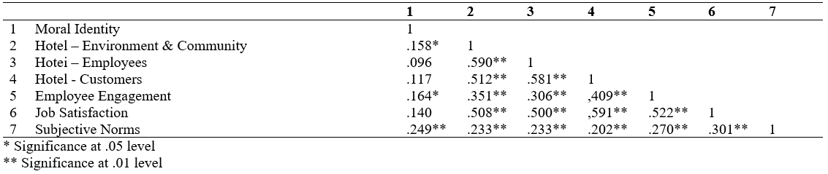
5.2 Sufficient configurations
The study has employed fsQCA for the examination of complexity concerning job satisfaction of hotel employees in a CSR context. Previous research showcases that fsQCA is the most versatile method for the examination of complexity (Olya & Al-Ansi, 2018; Ordanini et al., 2014) and the derived chaordic systems (Pappas, 2021; Pappas & Glyptou, 2021) in tourism and hospitality. Hence, this research has adopted the aforementioned method.

Research has revealed the existence of three pathways able to lead to the same outcome, which in this study is job satisfaction (Table 7). More specifically, the first complex solution (f_g,~f_e,f_mi,f_hec,~f_he,~f_hc,f_ee,f_sn) concerns the inclusion of one (age) of the two examined demographics (age; education), and has high scores of membership in moral identity, hotel – environment & community, employee engagement, and subjective norms. This configuration has the highest consistency (.86927) and the lowest coverage (.40293) of all three sufficient pathways. The second sufficient pathway (~f_g,f_e,~f_mi,f_hec,f_he,f_hc,~f_ee,~f_sn) includes education (one of the two examined socio-demographics) and generates high scores in all the hotel-related simple conditions (environment & community; employees; customers). This sufficient configuration actually has the highest coverage (.43391) of all three accepted pathways. Finally, the third pathway (f_g,f_e,~f_mi,~f_hec,f_he,~f_hc,f_ee,~f_sn) includes both demographics (age; education) and generates high membership scores in hotel – employees, and employee engagement. This solution has the lowest consistency (.82054).

Table 7: Complex solutions for job satisfaction

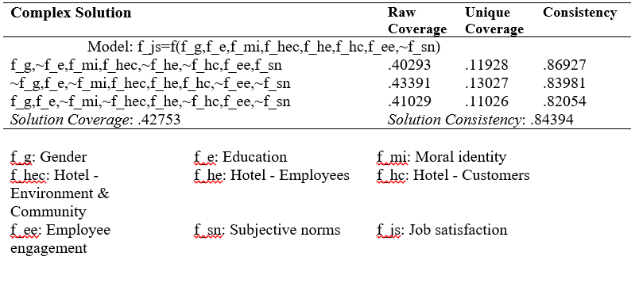
5.3 Size effects
The evaluation of the size effect (d) for each and every simple condition was held by the employment of NCA (Necessary Condition Analysis). Table 8 presents the findings of NCA. The ceiling zone (minimum/maximum values: ce_fdh; cr_fdh) concerns the middle parametric group, where we have the initial display of the zone in reference, and in most cases ce_fdh generates a higher ceiling zone compared with cr_fdh (Dul, 2020). The findings indicate that all the examined conditions generate size effects (small 0<d<.1: moral identity; medium .1≤d<.3: environment and community / employees / customers / subjective norms; large .3≤d<.5: employee engagement). As a result, all the sufficient complex configurations generated by fsQCA should be accepted. A visual illustration of NCA plots is presented in Figure 1.

Table 8: Size Effects

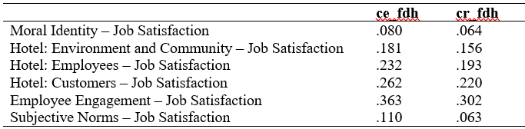

Figure 1: NCA Plots
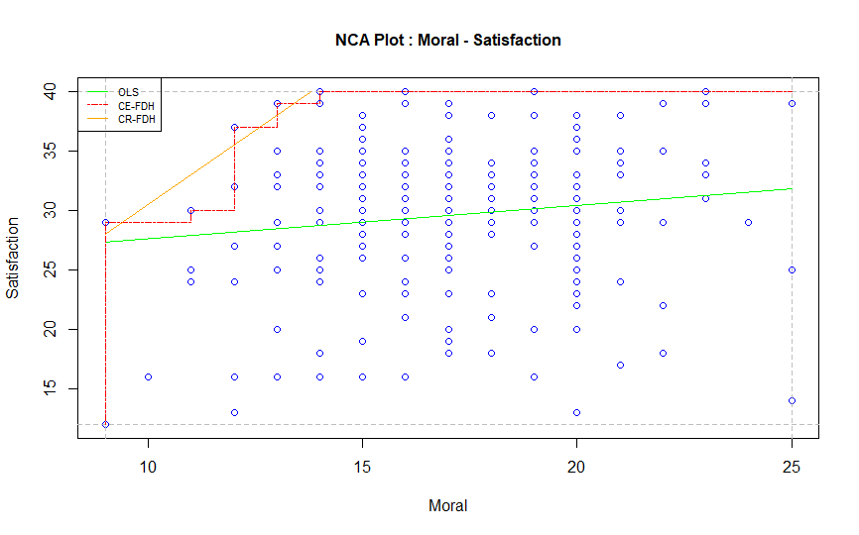
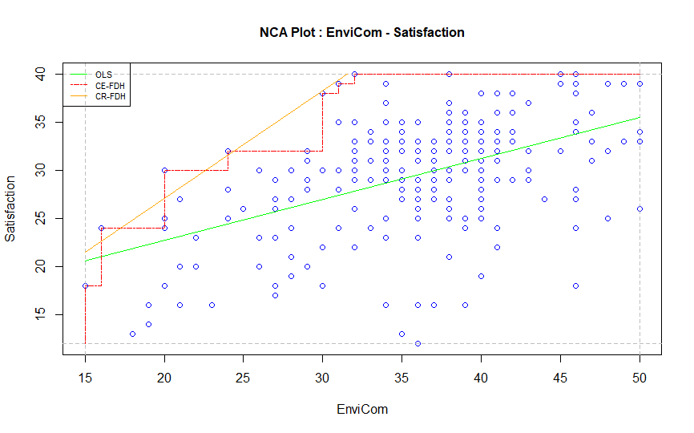
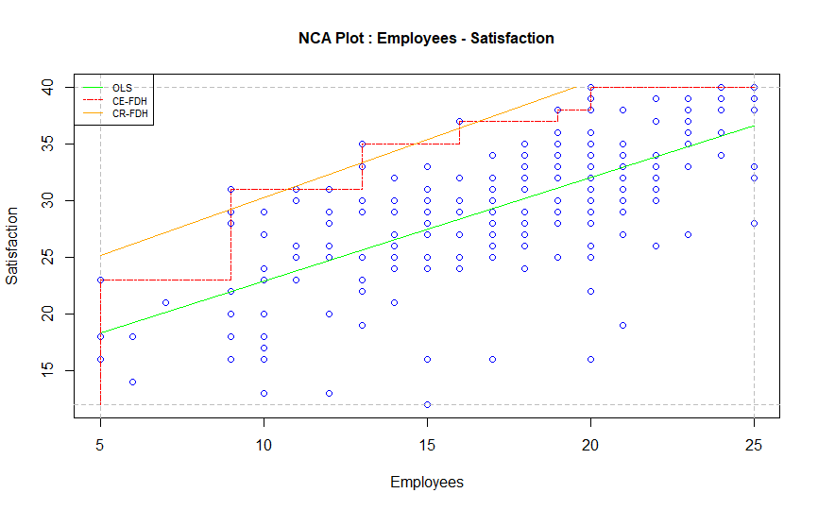
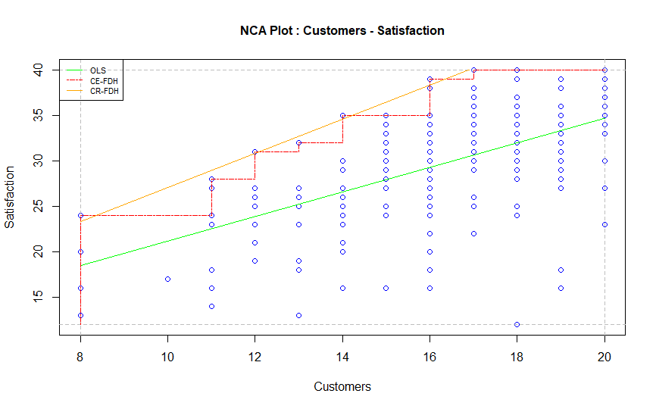
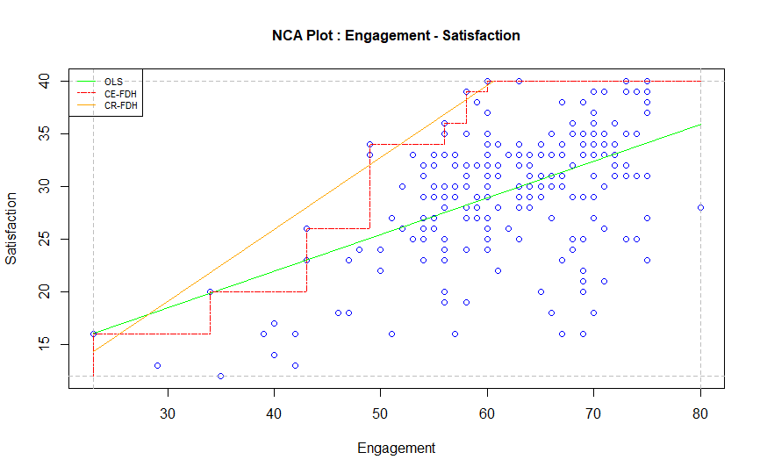
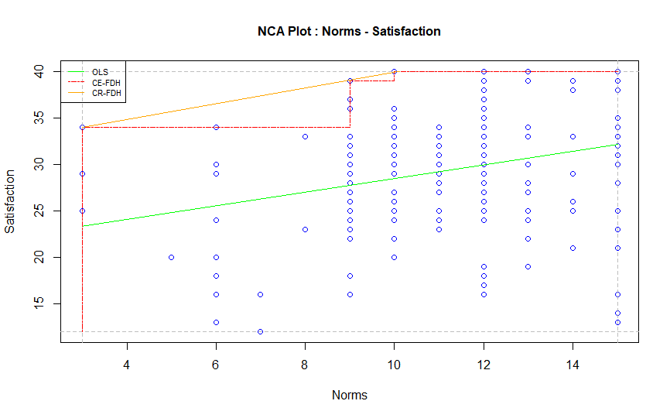

6. Discussion

6.1 Evidence from configurations and interview findings
The quantitative results generate an interesting discussion. As it is showcased in table 7, the first sufficient complex configuration suggests that ethical issues and morality can affect job satisfaction. This finding is in agreement with the perspective of Joyner and Payne (2002), suggesting that CSR and ethics/morality are actually interrelated even if they are considered independent whilst the satisfaction of the employees can very well be affected by these issues (Rupp et al., 2013). As a result, moral identity following specific ethical values within a company can substantially enhance the job satisfaction of employees, since they can add value to the perceived outcome of their work, making them more engaged in their work, especially in the presence of subjective norms. Accounts from employees reflect this interrelationship between morality and job satisfaction as seen below:

“I feel proud to be working in a hotel that is implementing CSR…this shows that it [the company] is morally responsible to others, to its employees, the customers and the society at large…I consider myself to be ethical, so I am satisfied that I work in an organisation that is also ethical.” (P12)

“I get a lot of satisfaction from work, knowing that what I do and what my hotel does contributes to the wellbeing of society and the environment …it motivates me to work because I know that many people including our customers care about such activities.” (P33)

Previous studies such as Kahn (1990) and Rich et al. (2010) provide evidence that appropriate organisational support and favourable work conditions increase the engagement and satisfaction of employees. After all, employee engagement is a crucial factor for organisational success (Shuck & Reio, 2011), especially in the tourism and hospitality industry which is characterised as labour-intensive (Jung & Yoon, 2014). The second generated solution operates under this framework and suggests that hotel-oriented aspects are important for the formulation of job satisfaction. One employee gave an interesting comment supporting this:

“…employees are a hotel’s greatest asset because it is them who interact with customers, so if you support them and provide a good work environment to them, they will be satisfied with their job and perform better.” (P35)

The third sufficient configuration focuses on employee-related issues as an aspect affecting job satisfaction. The work engagement of employees increases their work commitment (Kim & Kim, 2020), leading them to find their work more meaningful (Nazir & Islam, 2019) which ultimately generates higher job satisfaction (Glavas, 2016). Hence, the combination of the issues related with hotel employees and their work engagement appears to be a versatile pathway to job satisfaction. As can be seen below, the interview data supports this solution:

“…every day when I leave from work, I feel satisfied because I know that my job will bring good to the world...I dedicate myself to my work and choose to give ‘my best’ because it makes me happy knowing that what I do matters...” (P15)

“My job can either bring positive impacts or negative impacts. I am motivated to do my job well, to invest in it and be as good as I can. Knowing that my job can exert positive impacts gives me a lot of pleasure.” (P22)

6.2 Confirmation of tenets
The findings confirm all six set tenets. More specifically, as the results reveal each single attribute can be included in a different complex configuration that leads to the same outcome. However, each configuration formulates a different pathway. For example, the simple condition of environment and community (hec) is included in two different solutions (1st: ethical issues and morality; 2nd: hotel-oriented aspects). Moreover, the simple condition of employees (he) appears in the 2nd (hotel-oriented aspects) and 3rd (employee-related issues) solution. These findings confirm the first (T1) tenet suggesting that a single attribute can influence different outcomes, depending on the way this attribute interacts with the other examined attributes.

All generated solutions include more than one simple condition. More specifically, all configurations have an inclusion of a minimum of four attributes. This outcome is also agreeable with previous studies (Pappas, 2019b; Woodside, 2014) thus leading to the confirmation of recipe principle, which is the second set tenet (T2). According to Ordanini et al. (2014), the generated solutions of fsQCA concern: (i) an outcome related with the combination of variables, and (ii) the way the variables are associated within the combination. As presented previously, the research has generated three different pathways that can lead to the same outcome. This confirms the third tenet (T3) indicating that different complex configurations are able to affect the effects of hotel employee perceptions upon job satisfaction.

The study also uses contrarian case analysis, which concerns the inclusion or the exclusion from the generated solutions of the examined attributes. Following Pappas (2018), the contrarian case analysis suggests that although a simple condition may only appear in one solution, none of them should be present in all sufficient configurations. All the examined simple conditions appear in at least one solution, whilst none of them is included in all the generated pathways. As a result, the fourth tenet (T4) is confirmed. The equifinality principle proposes that different pathways are likely to lead to the same outcome (Pappas, 2019b) whilst this is not always the result of a high score of an outcome. The three pathways do not actually generate high scores of outcomes, something that confirms the fifth tenet (T5). Finally, the findings show that the raw coverage varies from .41 to .43, meaning that in all cases it is less than 1. These findings reveal that none of the sufficient configurations is applicable in all cases (Olya and Altinay, 2016), and ultimately leads to the confirmation of the sixth set tenet (T6) which suggests that when there is an existence of high Y scores, a given recipe is not relevant for all cases.

7. Conclusions and Implications

7.1 Conclusions
Although research on the interface between CSR and employee outcomes has been growing in the hospitality domain, the linear analysis adopted by past studies focused on job satisfaction as an outcome or mediator of CSR, overlooking the complex formulation of the construct. To fill this research gap, our study adopts the theory of complexity and evaluates the chaordic effect of the combination of variables identified as key in CSR research – namely, employee CSR perceptions, moral identity, subjective norms, work engagement – on job satisfaction. Specifically, our fsQCA results explain the conditions under which hotel employees with different levels of moral identity and work engagement as well as different perceptions of their organisation’s CSR and different degrees of pressure from others (subjective norms) achieve job satisfaction. As the results showcase there are three sufficient pathways that can lead to CSR-induced job satisfaction: (i) ethical issues and morality, (ii) hotel-oriented aspects, and (iii) employee-related issues.

7.2 Theoretical Implications
The successful examination of the chaordic systems in tourism suggests that linear analyses of behavioural patterns in service contexts cannot always adequately capture sophisticated relationships between different variables. In line with this argument, this study has shown that an alternative approach such as a combination of antecedents as a causal solution for phenomena characterised by complexity (Papatheodorou & Pappas, 2017) is necessary, particularly in the context of the examination of job satisfaction. As such, this study contributes to existing theory as it enhances understanding of how CSR-induced job satisfaction is formulated whilst also advancing knowledge on the concept of job satisfaction in a hospitality context. As Kong et al. (2018) posited, job satisfaction has been examined by hospitality and tourism researchers as a determinant, mediator or outcome in investigations that adopted primarily a linear analytical approach. Nonetheless, as our study has argued, a linear approach in the examination of job satisfaction is limited in its ability to examine the complex interaction of the multiple factors that influence job satisfaction, especially in a CSR context where internal factors (i.e., the employee’s cognitive and emotional characteristics) and external factors including organisational and/or societal influencers emerge as influential.
Methodologically, this complexity has been revealed through the use of fsQCA and NCA, two novel methods in tourism and hospitality research that are usefully applied together with complexity theory. Moreover, the study illustrates that the results of complexity theory can be effectively complemented and reinforced by a more traditional, qualitative research technique such as a thematic analysis. In this respect, the joint application of fsQCA, NCA and qualitative interviews represents a methodological combination which, to the best of our knowledge, is applied for the first time in tourism and hospitality research – thus adding to the novelty of the methodological contribution of the paper.

7.3 Managerial implications
Hotel owners/managers can use the above generated solutions as a guide for recruitment and other important work processes to stimulate the job satisfaction of their employees and, in turn, improve their CSR strategy. Hotels can select any of the sufficient configurations in accordance to their specific needs and characteristics as well as their available resources. More specifically, the companies that perceive ethical issues and morality as the most appropriate aspect for progressing job satisfaction can use the first generated pathway in their recruitment processes. However, if a company prefers to focus on operational and managerial issues it is likely to be more versatile to follow the second solution, since it mainly focuses on hotel-oriented aspects. This can be more applicable in hotels that follow a strictly structured hierarchic organisation that most likely suits large companies than family-owned small and medium sized enterprises (SMEs). On the other hand, if a company is mostly oriented towards human aspects and relationships (e.g., a company heavily dependent upon the local community), it may select the third sufficient configuration as a pathway to achieve job satisfaction. This is because the solution in reference is predominantly (but not exclusively) focusing on employee-related aspects. As such, the societal status and values of the employees within the surrounding community are factors to be considered for such a selection. As it is evident from the above-mentioned solutions, hotel owners/managers have a range of different pathways whilst, if they deem fit, they can also use a combination of those solutions.

Moreover, the study findings offer significant insights to destination policymakers and practitioners as the employee-oriented CSR practices of hotels may be used to benefit local communities as well. Employees are members of the local communities of destinations; hence, CSR organisational activities that maximise job satisfaction and benefit employees’ quality of work life (Kim et al., 2020) will ultimately enhance the well-being of the overall local community. According to Ko et al. (2019), hotel employees perceive CSR as impacting themselves, guests, local communities, the natural environment and hotel owners/investors. If hotel employees are involved in CSR implementation longer-term benefits are likely to result, therefore hotel managers must thoroughly explain to employees the importance of their role in carrying out hotel CSR practices as part of local community development (Bohdanowicz & Zientara, 2009). In this perspective, employees may appreciate the role beyond the organisational level by understanding that the implementation of CSR practices on their behalf may bring benefits at the individual, organisational and institutional level (Johannsdottir & Olaffson, 2015).

7.4 Limitations and suggestions for further research
Despite the contribution of the study in the theoretical, methodological and managerial domain, several limitations should be highlighted. The first limitation concerns the use of fsQCA and NCA, along with their combination with qualitative research as methods of analysis. NCA is a new method employed in tourism and hospitality, whilst fsQCA has only started to be used in this field. Their combination with qualitative research is also something new in the tourism literature. Therefore, further studies need to be performed in order to encapsulate the full potential of such analysis modes. The second limitation concerns the respondents. The fact that the sample strategy for the quantitative survey contained purposive elements puts restrictions on the generality of findings in the sense that it is likely that the selected sample does not represent accurately the wider population. Moreover, in both, quantitative and qualitative research the examined population was hotel employees working in Greece. This means that the findings may be specific to the Greek culture. A similar study in a different outset, therefore, may generate different results. Thus, any attempt to generalize the findings should be cautiously made. At the same time, the increased participation of females in the survey may also represent an area of concern. This either represents an over-representation in the survey sample of women, or their increased participation is a possible reflection of recent findings that “females exhibit higher concern for CSR initiatives” (Marquina & Charles, 2021, p. 1). Considering the latter possibility, an investigation of hotel employee job satisfaction within a CSR context through gender lens may provide a fruitful avenue for future research. Also, social desirability bias could have arisen due to the sensitivity of some questions (e.g. moral identity questions). Finally, both qualitative and quantitative research was held prior to the first wave of the COVID-19 pandemic in Greece. Considering the extensive changes taking place in the industry as a result of the pandemic, future research may generate different outcomes. Therefore, any comparison with future research should take into consideration the rapidly changing business environment of global tourism and hospitality.

References
Afsar, B., Al-Ghazali, B., & Umrani, W. (2020). Corporate social responsibility, work meaningfulness, and employee engagement: The joint moderating effects of incremental moral belief and moral identity centrality. Corporate Social Responsibility and Environmental Management, 27(3), pp. 1264-1278
Aguinis, H. (2011). Organizational responsibility: Doing good and doing well. In S. Zedeck (Ed.), APA Handbook of Industrial and Organizational Psychology (Vol. 3). Washington, DC: American Psychological Association (pp. 855-879).
Aguinis, H., & Glavas, A. (2012). What we know and don’t know about corporate social responsibility: A review and research agenda. Journal of Management, 38(4), pp. 932-968.
Akis, S., Peristianis, N., & Warner, J. (1996). Residents’ attitudes to tourism development: The case of Cyprus. Tourism Management, 17(7), pp. 481-494.
Allison, P. D. (2001). Missing data. Thousand Oaks, CA: Sage Publications.
Appiah, J. K. (2019). Community-based corporate social responsibility activities and employee job satisfaction in the U.S. hotel industry: An explanatory study. Journal of Hospitality and Tourism Management, 38, pp. 140-148.
Aquino, K., & Reed, A. I. (2002). The self-importance of moral identity. Journal of Personality and Social Psychology, 83(6), pp. 1423-1440.
Babajee, R. B., Seetanah, B., Nunkoo, R., & Gopy-Ramdhany, N. (2021). Corporate social responsibility and hotel financial performance. Journal of Hospitality Marketing & Management, pp. 1-21.
Bibi, S., Khan, A., Hayat, H., Panniello, U., Alam, M., & Farid, T. (2021). Do hotel employees really care for corporate social responsibility (CSR): A happiness approach to employee innovativeness. Current Issues in Tourism, pp. 1-18.
Boesso, G., Kumar, K., & Michelon, G. (2013). Descriptive, instrumental and strategic approaches to corporate social responsibility: Do they drive the financial performance of companies differently. Accounting, Auditing and Accountability Journal, 26(3), pp. 399-422.
Bohdanowicz, P., & Zientara, P. (2009). Hotel companies' contribution to improving the quality of life of local communities and the well-being of their employees. Tourism and Hospitality Research, 9(2), 147-158.
Bowen, H. R. (1953). Social Responsibilities of the Businessman. Iowa: University of Iowa Press.
Braun, V., & Clarke, V. (2006). Using thematic analysis in psychology. Qualitative Research in Psychology, 3(2), pp. 77-101.
Carroll, A. B. (1979). A three-dimensional conceptual model of corporate performance. Academy of Management Review, 4(4), pp. 497-505.
Chen, H.-Y., & Boore, J. R. P. (2009). Translation and back‐translation in qualitative nursing research: methodological review. Journal of Clinical Nursing, 19(1-2), pp. 234-239.
Chen, M.-F., & Tung, P.-J. (2014). Developing an extended Theory of Planned Behavior model to predict consumers’ intention to visit green hotels. International Journal of Hospitality Management, 36, pp. 221-230.
Choi, M., & Choi, Y. (2021). Employee perceptions of hotel CSR activities during the COVID-19 pandemic. International Journal of Contemporary Hospitality Management, 33(10), pp. 3355-3378.
Chung, J., & Monroe, G. S. (2003). Exploring social desirability bias. Journal of Business Ethics, 44(4), pp. 291-302.
Creswell, J. W., & Creswell, J. D. (2017). Research Design: Qualitative, Quantitative, and Mixed Methods Approaches. Thousand Oaks: Sage.
De Roeck, K., & Maon, F. (2018). Building the theoretical puzzle of employees’ reactions to corporate social responsibility: An integrative conceptual framework and research agenda. Journal of Business Ethics, 149(3), pp. 609-625.
Dul, J. (2020). Conducting Necessary Condition Analysis. Thousand Oaks: Sage Publications.
Edinger-Schons, L. M., Lengler-Graiff, L., Scheidler, S., & Wieseke, J. (2019). Frontline employees as corporate social responsibility (CSR) ambassadors: A quasi-field experiment. Journal of Business Ethics, 157(2), pp. 359-373.
Elkington, J. (1997). Cannibals with Forks: The Triple Bottom Line of 21st Century. UK: Chapstone Publishing Oxford.
Falck, O., & Helbich, S. (2007). Corporate social responsibility: Doing well by doing good, Business Horizons, 50(3), pp. 247-254.
Farmaki, A. (2019). Corporate social responsibility in hotels: A stakeholder approach. International Journal of Contemporary Hospitality Management, 31(6), pp. 2297-2320.
Farmaki, A., & Stergiou, D. (2020). Corporate social responsibility and employee moral identity: A practice-based approach. Current Issues in Tourism, 24(18), pp. 2554-2572.
Farmaki, A., Hossein, O., & Taheri, B. (2021). Unpacking the complex interactions among customers in online fan pages. Journal of Business Research, 125, pp. 164-176.
Farmaki, A., Miguel, C., Drotarova, M. H., Aleksić, A., Časni, A. Č., & Efthymiadou, F. (2020). Impacts of Covid-19 on peer-to-peer accommodation platforms: Host perceptions and responses. International Journal of Hospitality Management, 91, 102663.
Farrington, T., Curran, R., Gori, K., O’Gorman, K. D. and Queenan, C. J. (2017). Corporate social responsibility: Reviewed, rated, revised. International Journal of Contemporary Hospitality Management, 29(1), pp. 30-47.
Fiss, P. C. (2011). Building better causal theories: A fuzzy set approach to typologies in organization research. Academy of Management Journal, 54, pp. 393-420.
Flick, U. (2000). Episodic interviewing. In: Bauer, M., & Gaskell, G. (Eds.), Qualitative Researching With Text, Image and Sound: A Practical Handbook. London: Sage (pp. 75-92).
Franco, S., Caroli, M. G., Cappa, F., & Del Chiappa, G. (2020). Are you good enough? CSR, quality management and corporate financial performance in the hospitality industry. International Journal of Hospitality Management, 88, 102395.
Friedman, M. (1970). The social responsibility of business is to increase its profits. The New York Times Magazine, 13(1970), pp. 32-33.
Fuchs P. I., & Ness, L. R. (2015). Are we there yet? Data saturation in qualitative research. Qualitative Report, 20(9), pp. 1408-1416.
Ghaderi, Z., Mirzapour, M., Henderson, J. C., & Richardson, S. (2019). Corporate social responsibility and hotel performance: A view from Tehran, Iran. Tourism Management Perspectives, 29, pp. 41-47.
Gioia, G. A., Corley, K. G., & Hamilton, A. L. (2013). Seeking qualitative rigor in inductive research: Notes on the Gioia methodology. Organizational Research Methods, 16(1), pp. 15-31.
Glavas, A. (2016). Corporate social responsibility and organizational psychology: An integrative review. Frontiers in Psychology, 7(144), pp. 1-13.
Goulding, C. (1999). Consumer research, interpretive paradigms and methodological ambiguities. European Journal of Marketing, 33(9/10), pp. 859-873.
Guzzo, R. F., Abbott, J., & Madera, J. M. (2020). A micro-level view of CSR: A hospitality management systematic literature review. Cornell Hospitality Quarterly, 61(3), pp. 332-352.
Hair, J. F., Black, W. C., Babin, B. J., & Anderson, R. E. (2010). Multivariate Data Analysis (7th ed.). Upper Saddle River, NJ: Pearson Education.
Hair, J. F., Hollingsworth, C. L., Randolph, A. B., & Chong, A. Y. L. (2017). An updated and expanded assessment of PLS-SEM in information systems research. Industrial Management & Data Systems, 117(3), pp. 442-458.
Ham, M., Stanić, M., & Freimann, A. (2015). The role of subjective norms in forming the intention to purchase green food. Economic Research-Ekonomska Istraživanja, 28(1), pp. 738-748.
Iyer, G. R., & Jarvis, L. (2019). CSR adoption in the multinational hospitality context: A review of representative research and avenues for future research. International Journal of Contemporary Hospitality Management, 31(6), pp. 2376-2393.
Johannsdottir, L., & Olafsson, S. (2015). “The role of employees in implementing CSR strategies”. In O’ Riordan L., Zmuda, P. & Heinemann S. (Eds.) New perspectives on corporate social responsibility. Springer Gabler, Wiesbaden (pp. 383-409).
Jones, D. A., Willness, C. R., & Glavas, A. (2017). When corporate social responsibility (CSR) meets organisational psychology: New frontiers in micro-CSR research, and fulfilling a quid pro quo through multilevel insights. Frontiers in Psychology, 8, pp. 1-14.
Joyner, B., & Payne, D. (2002). Evolution and implementation: A study of values, business ethics and corporate social responsibility. Journal of Business Ethics, 41(4), pp. 297-311.
Jung, H. S., & Yoon, H. H. (2014). Antecedents and consequences of employees’ job stress in a foodservice industry: Focused on emotional labor and turnover intent. International Journal of Hospitality Management, 38, pp. 84-88.
Kahn, W. A. (1990). Psychological conditions of personal engagement and disengagement at work. The Academy of Management Journal, 33(4), pp. 692-724.
Keller, K. L. (1993). Conceptualizing, measuring, and managing customer-based brand equity. Journal of Marketing, 57(1), pp. 1-22.
Khatter, A., White, L., Pyke, J., & McGrath, M. (2021). Barriers and drivers of environmental sustainability: Australian hotels. International Journal of Contemporary Hospitality Management, 33(5), pp. 1830-1849.
Kim, H., Rhou, Y., Topcuoglu, E., & Kim, Y. G. (2020). Why hotel employees care about Corporate Social Responsibility (CSR): Using need satisfaction theory. International Journal of Hospitality Management, 87, 102505, pp. 1-8.
Kim, H., Rhou, Y., Uysal, M., & Kwon, N. (2017). An examination of the links between corporate social responsibility (CSR) and its internal consequences. International Journal of Hospitality Management, 61, pp. 26-34.
Kim, J., Kim, H.-R., Lacey, R., & Suh, J. (2018). How CSR impact meaning of work and dysfunctional customer behavior. Journal of Service Theory and Practice, 28(4), pp. 507-523.
Kim, M.-J., & Kim, B.-J. (2020). Analysis of the importance of job insecurity, psychological safety and job satisfaction in the CSR-performance link. Sustainability, 12(9), 3515, pp. 1-16.
Ko, A., Chan, A., & Wong, S. C. K. (2019). A scale development study of CSR: hotel employees’ perceptions. International Journal of Contemporary Hospitality Management, 31(4), pp. 1857-1884.
Kong, H., Jiang, X., Chan, W., & Zhou, X. (2018). Job satisfaction research in the field of hospitality and tourism. International journal of Contemporary Hospitality Management, 30(5), pp. 2178-2194.
Kremer, V. (2019). “The impact of CSR on job satisfaction and employee retention in Hungarian hotels”. In Schmidpeter, R., Capaldi, N., Idowu, S. & Herrera, A. S. (Eds.) International Dimensions of Sustainable Management: Latest Perspectives from Corporate Governance, Responsible Finance and CSR. Springer Verlag (pp. 307-327).
Kretzschmar Jr., W. A. (2015). Language and Complex Systems. Cambridge: Cambridge University Press.
Kucukusta, D., Perelygina, M., & Lam, W. S. (2019). CSR communication strategies and stakeholder engagement of upscale hotels in social media. International Journal of Contemporary Hospitality Management, 31(5), pp. 2129-2148.
Kunda, M. M., Ataman, G., & Behram, N. K. (2019). Corporate social responsibility and organizational citizenship behavior. Journal of Global Responsibility, 10(1), pp. 47-68.
Lam, T., Baum, T., & Pine, R. (2003). Subjective norms: Effects on job satisfaction. Annals of Tourism Research, 30(1), pp. 160-177.
Lee, C. K., Kim, J. S., & Kim, J. S. (2018). Impact of a gaming company's CSR on residents' perceived benefits, quality of life, and support. Tourism Management, 64, pp. 281-290.
Lee, E. M., Park, S., & Lee, H. J. (2013). Employee perception of CSR activities: Its antecedents and consequences. Journal of Business Research, 66(10), pp. 1716-1724.
Leung, V. T., & Lin, P. M. (2022). The roles of multiple foci of employee commitments and job satisfaction on creative performance: a study of hotel chefs. International Journal of Hospitality Management, 101, 103107.
Locke, E. A. (1976). The nature and causes of job satisfaction. In Dunnette, M. D. (Ed.), Handbook of Industrial and Organizational Psychology. Chicago, IL: Rand McNally (pp. 1297-1349).
Luu, T. T. (2021). Socially responsible human resource practices and hospitality employee outcomes. International Journal of Contemporary Hospitality Management. 33(3), pp. 757-589.
Marquina, P., & Charles, V. (2021). A Bayesian resampling approach to estimate the difference in effect sizes in consumer social responses to CSR initiatives versus corporate abilities. Corporate Social Responsibility and Environmental Management, pp. 1-20.
Martin, U., & Schinke, S. P. (1998). Organizational and individual factors influencing job satisfaction and burnout of mental health workers. Social Work in Health Care, 28(2), pp. 51-62.
McWilliams, A., & Siegel, D. (2001). Corporate social responsibility: A theory of the firm perspective. Academy of Management Review, 26(1), pp. 117-127.
Mikalef, P., Boura, M., Lekakos, G., & Krogstie, J. (2019). Big data analytics and firm performance: Findings from a mixed-method approach. Journal of Business Research, 98, pp. 261-276.
Mohamed, N., Taheri, B., Farmaki, A., Olya, H. and Gannon, M. J. (2020). Stimulating satisfaction and loyalty: Transformative behaviour and Muslim consumers. International Journal of Contemporary Hospitality Management, 32(9), pp. 2903-2923.
Moorman, R. H. (1993). The influence of cognitive and affective based job satisfaction measures on the relationship between satisfaction and organizational citizenship behaviour. Human Relations, 46(6), pp. 759-776.
Nazir, O., & Islam, J. U. (2020). Influence of CSR-specific activities on work engagement and employees’ innovative work behaviour: An empirical investigation. Current Issues in Tourism, 23(24), pp. 3054-3072.
O’Driscoll, M. P., & Randall, D. M. (1999). Perceived organizational support, satisfaction with rewards, and employee job involvement and organizational commitment. Applied Psychology: An Interview Review, 48(2), pp. 197-209.
Olmedo, E. (2011). Is there chaos in the Spanish labour market? Chaos, solitons & fractals, 44(12), pp. 1045-1053.
Olya, H.G, & Al-Ansi, A. (2018). Risk assessment of halal products and services: Implication for tourism industry. Tourism Management, 65, pp. 279-291.
Olya, H.G., & Altinay, L. (2016). Asymmetric modeling of intention to purchase tourism weather insurance and loyalty. Journal of Business Research, 69(8), pp. 2791-2800.
Ordanini, A., Parasuraman, A., & Rubera, G. (2014). When the recipe is more important than the ingredients: A qualitative comparative analysis (QCA) of service innovation configurations. Journal of Service Research, 17(2), pp. 134-149.
Papatheodorou, A., & Pappas, N. (2017). Economic recession job vulnerability and tourism decision-making: A qualitative comparative analysis. Journal of Travel Research, 56(5), pp. 663-677.
Pappas, N. (2018). Hotel decision-making during multiple crises: A chaordic perspective. Tourism Management, 68, pp. 450-464.
Pappas, N. (2019a). The complexity of consumer experience formulation in the sharing economy. International Journal of Hospitality Management, 77, pp. 415-424.
Pappas, N. (2019b). UK outbound travel and Brexit complexity. Tourism Management, 79, pp. 12-22.
Pappas, N. (2021). COVID19: Holiday intentions during a pandemic. Tourism Management, 84, 104287.
Pappas, N. & Glyptou, K. (2021). Risk-induced competitive productivity in times of recession: A chaordic tourism decision-making perspective. International Journal of Contemporary Hospitality Management, Article in press.
Park, S.-Y., & Levy, S. E. (2014). Corporate social responsibility: Perspectives of hotel frontline employees. International Journal of Contemporary Hospitality Management, 26(3), pp. 332-348.
Rhou, Y., & Singal, M. (2020). A review of the business case for CSR in the hospitality industry. International Journal of Hospitality Management, 84, 102330.
Rich, B. L., Lepine, J. A., & Crawford, E. (2010). Job engagement: Antecedents and effects on job performance. The Academy of Management Journal, 53(3), pp. 617-635
Ritchie, J., Lewis, J., Elam, G., Tennant, R., & Rahim, N. (2014). Designing and selecting samples. In: Ritchie, J., Lewis, J., Nicholls McNaughton, C., & Ormston, R. (Eds.). Qualitative Research Practices: A Guide for Social Science Students and Researchers. London: Sage (pp. 111-145).
Rupp, D. E., Ganapathi, J., Aguilera, R. V., & Williams, C. (2006). Employee reactions to corporate social responsibility: An organizational justice framework. Journal of Organizational Behavior, 27(4), pp. 537-543.
Rupp, D. E., Shao, R., Thornton, M. A., & Skarlicki, D. (2013). Applicants’ and employees’ reactions to corporate social responsibility: The moderating effects of first-party justice perceptions and moral identity. Personnel Psychology, 66(4), pp. 895-933.
Sandve, A., & Øgaard, T. (2014). Exploring the interaction between perceived ethical obligation and subjective norms, and their influence on CSR-related choices. Tourism Management, 42, pp. 177-180.
Schleicher, D. J., Watt, J. D., & Greguras, G. J. (2004). Reexamining the job satisfaction-performance relationship: The complexity of attitudes. Journal of Applied Psychology, 89(1), 165-177.
Schneider, M., & Somers, M. (2006). Organizations as complex adaptive systems: Implications of Complexity Theory for leadership research. The Leadership Quarterly, 17(4), pp. 351-365.
Sekaran, U., & Bougie, R. (2013). Research Methods for Business (6th ed.). West Sussex: John Wiley & Sons.
Sendlhofer, T. (2020). Decoupling from moral responsibility for CSR: Employees’ visionary procrastination at a SME. Journal of Business Ethics, 167(2), pp. 361-378.
Serra-Cantallops, A., Peña-Miranda, D. D., Ramón-Cardona, J., & Martorell-Cunill, O. (2018). Progress in research on CSR and the hotel industry (2006-2015). Cornell Hospitality Quarterly, 59(1), pp. 15-38.
Schaufeli, W. B., Salanova, M., González-Romá, & Bakker, A. B. (2002). The measurement of engagement and burnout: A two sample confirmatory factor analytic approach. Journal of Happiness Studies, 3(1), pp. 71-92.
Shin, H., Sharma, A., Nicolau, J. L., & Kang, J. (2021). The impact of hotel CSR for strategic philanthropy on booking behavior and hotel performance during the COVID-19 pandemic. Tourism Management, 85, 104322.
Shuck, B. and Reio, T. G. (2011). The employee engagement landscape and HRD: How do we link theory and scholarship to current practice? Advances in Developing Human Resources, 13(4), pp. 419-428.
Singhapakdi, A., Lee, D. J., Sirgy, M. J., Roh, H., Senasu, K., & Yu, G. B. (2019). Effects of perceived organisational CSR value and employee moral identity on jib satisfaction: A study of business organisations in Thailand. Asian Journal of Business Ethics, 8(1), pp. 53-72.
Skarmeas, D., Leonidou, C. N., & Saridakis, C. (2014). Examining the role of CSR scepticism using fuzzy-set qualitative comparative analysis. Journal of Business Research, 67(9), pp. 1796-1805.
Slack, R. E., Corlett, S., & Morris, R. (2015). Exploring employee engagement with (corporate) social responsibility: A social exchange perspective on organisational participation. Journal of Business Ethics, 127(3), pp. 537-548.
Son, J. H., Kim, J. H., & Kim, G. J. (2021). Does employee satisfaction influence customer satisfaction? Assessing coffee shops through the service profit chain model. International Journal of Hospitality Management, 94, 102866.
Spector, P. (1997). Job Satisfaction: Application, Assessment, Causes and Consequences. California, CA: Sage.
Stamolampros, P., Korfiatis, N., Chalvatzis, K., & Buhalis, D. (2019). Job satisfaction and employee turnover determinants in high contact services: Insights from Employees’ online reviews. Tourism Management, 75, pp. 130-147.
Strauss, A., & Corbin, J. (1998). Basics of Qualitative Research: Techniques and Procedures for Developing Grounded Theory (2nd ed.). Newbury Park, CA: Sage.
Su, L., & Swanson, S. R. (2019). Perceived corporate social responsibility's impact on the well-being and supportive green behaviors of hotel employees: The mediating role of the employee-corporate relationship. Tourism Management, 72, pp. 437-450.
Theodoulidis, B., Diaz, D., Crotto, F., & Rancati, E. (2017). Exploring corporate social responsibility and financial performance through stakeholder theory in the tourism industries. Tourism Management, 62, pp. 173-188.
Tongchaiprasit, P., & Ariyabuddhiphongs, V. (2016). Creativity and turnover intention among hotel chefs: The mediating effects of job satisfaction and job stress. International Journal of Hospitality Management, 55, pp. 33-40.
Trivellas, P., Dekoulou, P., Polychroniou, P., & Tokakis, V. (2021). Which leadership roles modify employee perceptions of CSR activities? Job satisfaction implications in the case of the tourism industry. International Journal of Quality and Service Sciences, 13(4), pp. 618-636.
Vlachos, P. A., Panagopoulos, N. G., & Rapp, A. A. (2013). Feeling good by doing good: Employee CSR-induced attributions, job satisfaction, and the role of charismatic leadership. Journal of Business Ethics, 118, pp. 577-588.
Volgger, M., & Huang, S. S. (2019). Scoping irresponsible behaviour in hospitality and tourism: Widening the perspective of CSR. International Journal of Contemporary Hospitality Management, 31(6), pp. 2526-2543.
Wang, C., Hu, R., & Zhang, T. C. (2020). Corporate social responsibility in international hotel chains and its effects on local employees: Scale development and empirical testing in China. International Journal of Hospitality Management, 90, 102598.
Wang, W., Fu, Y., Qiu, H., Moore, J. H., & Wang, Z. (2017). Corporate social responsibility and employee outcomes: A moderated mediation model of organisational identification and moral identity. Frontiers in Psychology, 8, pp. 1-14.
Wong, A. K. F., & Kim, S. S. (2020). Development and validation of standard hotel corporate social responsibility (CSR) scale from the employee perspective. International Journal of Hospitality Management, 87, 102507.
Wong, I. A., & Gao, J. H. (2014). Exploring the direct and indirect effects of CSR on organizational commitment. International Journal of Contemporary Hospitality Management. 26(4), pp. 500-525.
Woodside, A. G. (2013). Moving beyond multiple regression analysis to algorithms: Calling for a paradigm shift from symmetric to asymmetric thinking in data analysis and crafting theory. Journal of Business Research, 66(4), pp. 463-472.
Woodside, A. G. (2014). Embrace-perform model: Complexity theory, contrarian case analysis, and multiple realities. Journal of Business Research, 67, pp. 2495-2503.
Woodside, A. G. (2017). Releasing the death-grip of null hypothesis statistical testing (p<.05): Applying complexity theory and somewhat precise outcome testing (SPOT). Journal of Global Scholars of Marketing Science, 27, pp. 1-15.
You, J. (2015). Legal Perspectives on Corporate Social Responsibility. New Delhi: Springer.
Youn, H., Lee, K., & Lee, S. (2018). Effects of corporate social responsibility on employees in the casino industry. Tourism Management, 68, pp. 328-335.
Young, S., & Thyil, V. (2008). A holistic model of corporate governance: A new research framework. Corporate Governance, 8(1), pp. 94-108.
Zhang, H., Wu, Y., & Buhalis, D. (2018). A model of perceived image, memorable tourism experiences and revisit intention. Journal of Destination Marketing & Management, 8, pp. 326-336.
Zhang, Z., & Guo, C. (2021). Still hold aloft the banner of social change? Nonprofit advocacy in the wave of commercialization. International Review of Administrative Sciences, 87(4), pp. 928-943.
Zientara, P., Kujawski, L., & Bohdanowicz-Godfray, P. (2015). Corporate social responsibility and employee attitudes: Evidence from a study of Polish hotel employees. Journal of Sustainable Tourism, 23(6), pp. 859-880.
Zopiatis, A., Constanti, P., & Theocharous, A. L. (2014). Job involvement, commitment, satisfaction and turnover: Evidence from hotel employees in Cyprus. Tourism Management, 41, pp. 129-140.

