The pivotal role of healthcare assistants in pressure ulcer prevention: learning from research in practice
C Hayes, Faculty of Health Sciences and Wellbeing, The Sciences Complex, University of Sunderland, Sunderland, A Fox, Sunderland Clinical Care and Commissioning Group, Sunderland, J Scott-Thomas, South Tyneside Clinical Care and Commissioning Group, Jarrow, Newcastle Upon Tyne ,Y Graham, Faculty of Health Sciences and Wellbeing, The Sciences Complex, University of Sunderland, Sunderland

Abstract
This article reports on the impact of an educational intervention to raise awareness of the avoidance of pressure ulceration as an integral part of the PROACT project. This initiative took place in the north east of England in residential and non-residential care homes from May 2017 to March 2020, with a training programme on the need to raise awareness of the avoidance of pressure ulceration delivered between January 2018 and September 2019. In total, 571 participants took part in the project. Of these, 493 (86%) were health and social care staff, including healthcare assistants, and the other 78 (14%) were public and informal carers. While many participants reported an increased level of confidence following the training programme, many could not bridge the theory–practice gap in terms of being able to articulate how they would prevent the development of pressure ulcers in practice. The study highlights the need for healthcare assistants to refer patients living with the earliest stages of pressure ulceration on to other members of the healthcare team. Daily monitoring should include training about the key risk factors of ulceration, such as capacity for movement and being able to walk around, basic skin examinations and ensuring the continence status of individual patients. Training in the importance of monitoring and reporting weight loss, alongside adequate hydration, is also needed.
Key words
Comorbidity; Incontinence; Infection; Quality of life; Team working; Tissue viability

Key points: Supporting pressure ulceration avoidance in healthcare assistant practice
Key issue | Relevance to healthcare assistant practice | Necessary actions
Prompt identification of the signs and symptoms of pressure ulceration | Healthcare assistants are ideally positioned to notice specific changes in the skin condition and general health of the people for whom they care on a regular basis | Vigilance in relation to:  Redness, swelling, skin soreness or swelling over bony prominences or where the anatomical positioning of the body means an increase of pressure is apparent
Knowledge of the most common anatomical sites for the development of pressure ulceration can help to reduce their development, thus preserving quality of life and the ability to remain mobile longer for vulnerable people | As part of their care of vulnerable people, healthcare assistants should be taught which areas are most susceptible to pressure ulceration at the earliest stages of their appointment as a key worker | Regular monitoring of the following sites for potential development of pressure ulceration:  At the back of the head and ears, the shoulders, the elbows, the lower back and buttocks, the hips, the inner knees, and the heels
Visual observations matter in the early detection of pressure ulceration | Healthcare assistants often have a regular group of vulnerable people with whom they work. This allows them to recognise subtle changes in the skin and pain reported by these people which can characterise pressure ulceration | Discolouration of the skin, particularly redness in the case of pale-skinned people and purple or bluish patches in people with darker skin. The skin may also feel warm, spongey or hard with a degree of pain or itchiness
Communicating with people regularly and monitoring change in their condition is fundamental to the early recognition of pressure ulceration and provision of appropriate clinical intervention | Healthcare assistants are ideally placed to have regular and effective communication with people who are vulnerable to pressure ulceration in practice. They are trusted members of the healthcare team whose relationships with people often ensure they can be trusted with personal information about areas of skin that patients may be hesitant to speak about with others | Using effective communication to relay significant information about changes in the signs and symptoms of pressure ulceration in practice can ensure that they are efficiently addressed by an appropriately qualified member of the multidisciplinary team
People with reduced cognitive capacity, poor eyesight or diminished neurological symptoms as a result of secondary disease processes may not realise they have symptoms of pressure ulceration | Healthcare assistants work regularly with people with several coexisting medical conditions (comorbidities) which means they are ideally placed to support the most vulnerable members of society who may not be able to recognise that they are developing signs and symptoms of pressure ulceration | Being able to act as an additional support for people who may be living with conditions such as dementia, multiple sclerosis or severe vascular disease can ensure that these people are supported in the early recognition of pressure ulceration and the prevention of long-term complications such as prolonged healing or secondary infection

Introduction
Healthcare assistants provide daily care for people whose skin viability is diminished as a result of illness, natural processes of ageing or both. The quality of care received by these people is best evidenced by how often pressure ulcers occur and how they are managed (Anthony et al, 2019). Pressure ulcers place the people living with them at a much greater risk of secondary infections and, in some cases, can lead to severe outcomes such as gangrene, systemic infection and sepsis leading to amputation or death (Deldar et al, 2022). As the number of older adults is predicted to rise exponentially over the next 20 years, the likelihood of having to care for people at risk of developing pressure ulcers will also increase (Jaul et al, 2018). The financial implications for the NHS as a direct consequence of pressure ulceration are significant. Alongside this, and arguably more importantly, pressure ulcers are often accompanied by severe pain and can lead to the occupancy of hospital beds and consequent exposure to other transmittable infections, such as COVID-19 (Vowden and Hill, 2021). It is estimated that, across Europe, that almost one in five people will now develop a pressure ulcer while in hospital and that many of these occur because people do not receive preventative measures from the people caring for them (Wung Buh at al, 2021).
To be able to provide this care, healthcare assistants must be educated in how best to avoid pressure ulceration in their everyday practice and protected learning time in the form of continuing professional development should be designated for this.
Risk factors are individual aspects which might potentially predispose a person to the development of pressure ulceration. If these risk factors are also accompanied by care from healthcare assistants that do not have a basic knowledge of pressure ulcer avoidance and the correct referral pathways in relation to known risk factors, then the potential for developing pressure ulcers increases even further (Sumarno, 2019).
This article uses a study from the north east of England to highlight key areas of focus and learning for healthcare assistant practice and learning development. PROACT is a regional healthcare initiative in the north east of England, which aims to increase the overall awareness of health and social care professionals, patients and carers regarding the typical signs (what can be seen and observed) and symptoms (what is felt and experienced by the person) of pressure ulcers. Visual knowledge of the initial signs and being able to listen to the symptoms that vulnerable people mention is an important part of being able to recognise pressure ulceration development. Not having adequate knowledge of these, alongside not having the capability of being vigilant and seeking help, is a key barrier to the avoidance of suffering, immobility and systemic decline for vulnerable people (Hommel et al, 2017). While there are now huge numbers of policy and practice documents outlining how best pressure ulcers can be avoided, numbers are still increasing in both residential and non-residential care homes each year (Seo and Roh, 2020).
Healthcare assistants have the potential to play a significant role in identifying these signs and symptoms. They often have very close working relationships with people in their care, who may mention something in passing, for example an area of sore skin, or the healthcare assistant may notice a decline in the amount that they are eating or drinking, or how the person is managing their own self-care. All these are important factors and, coupled with the reporting of issues such as incontinence, can make a significant difference in terms of whether a person with predisposing risk factors will eventually develop a pressure ulcer (Gefen, 2018; Charlton, 2020)

Pressure ulcers in healthcare assistant practice
Pressure ulcers pose a significant threat to the overall health and wellbeing of vulnerable people living in care and domiciliary settings. Early detection is crucial to avoid huge financial costs but more importantly to preserve the quality of life and mobility of people at risk of their development (Lindhardt et al, 2020). Immobility leads to the need for rehabilitation and occupational therapy to restore a vulnerable person’s usual physical capability, with increasing age linked to prolonged recovery times (Headlam and Illsley, 2020). Therefore this issue needs addressing to reduce the need for primary care intervention and consequently cost to the NHS and second, and arguably most important, to improve the quality and potentially the longevity of life of those people most at risk of developing pressure ulcers (Jaul et al, 2018). The potential for these lesions to develop secondary infection, cause pain and loss of mobility to already vulnerable people has widely been reported (Bonifant and Holloway, 2019). Secondary risk factors such as reduced capacity for mobility and single or double incontinence increase the likelihood of delayed healing and infection respectively (Pokorná et al, 2019). One positive aspect of raising awareness of the early detection of pressure ulcers is that they are potentially avoidable using relatively straightforward processes of screening and monitoring (Smart and Sibbald, 2020). Healthcare assistants are in an ideal position to integrate some of the monitoring processes for vulnerable people so that early detection of pressure ulceration becomes an integral part of their daily care (Lavallée et al, 2019).
Traditionally, healthcare assistant training often takes place in classrooms away from the frontline of patient care and this can be problematic for many reasons. First, to take teaching into an entirely different context then turn a very practical issue into a theoretical set of teaching notes, can mean that some healthcare assistants do not have the opportunity to apply theory to practice. Teaching practice that is focused on enabling application of knowledge to practice for healthcare assistants is needed in this instance (Sving et al, 2020). Making sure that healthcare assistant training places an emphasis on the need for teamwork in pressure ulcer avoidance is also important, to ensure that quick and effective lines of communication for prompt referral of people can happen, wherever the first signs of pressure ulceration development are detectable.
Table 1 shows the common predisposing risk factors for the development of pressure ulceration, alongside a brief explanation of why this predisposes people to the condition.

Table 1. Risk factors and their impact in the development of pressure ulceration
Risk factor | Impact
Comorbidity | Long-term conditions such as diabetes or lymphatic drainage issues can mean that neurological and vascular issues prevent people from feeling pain. This means that while signs of pressure ulceration are evident, the person may remain unaware of the symptoms.
Reduced dermatological viability | Some medications may predispose people to poor tissue viability and an increased risk of developing pressure ulcers (for example steroids, which are used to reduce inflammation in conditions such as rheumatoid arthritis and other autoimmune conditions). As people age, their skin loses elasticity, which increases their risk of damage by pressures from bony prominences or ill-fitting footwear, for example
Prolonged immobility | The ability to move ensures that venous return can be ensured as the musculature required to walk, squeezes the vessels and returns deoxygenated blood back to the heart Immobility can lead to gravitational oedema and the pooling of deoxygenated fluids in the lower limbs and extremities. This increases pressure over joints and prominences which can contribute to tissue breakdown and pressure ulceration
Incontinence (singular or double) | Incontinence increases the risk of cross infection and causes damage to skin, which may already be vulnerable to breakdown because of skin friability. This is especially important in relation to the development of sacral pressure ulcers on the bony prominences of people who have limited ability to move, given the proximity to faecal and urinary output

Aims of the study
The overall aim of the PROACT initiative was to increase the overall awareness of health and social care workers and carers of the key signs and symptoms of pressure ulcers. This was undertaken to benchmark the impact of the education and training implemented so that the processes and mechanisms involved might be improved by evidence-based information.

Methods
The PROACT project was undertaken from May 2017 to March 2020, with the training programme on the need to raise awareness of the avoidance of pressure ulceration being delivered between January 2018 and September 2019. In total, 571 participants took part in the project. Of these, 493 (86%) were health and social care staff, including healthcare assistants, and the other 78 (14%) were informal carers.
Each education course on avoidance of pressure ulceration lasted 4 hours and was based around policy domain 5 of the NHS Outcomes Framework (Figure 1), which emphasises holistic approaches to the safe and optimal care of patients. Emphasis was placed predominantly on the identification of key risk factors leading to ulceration, namely capacity for movement and being able to walk around, basic skin examinations and ensuring the continence status of individual patients. Alongside this the importance of monitoring and reporting weight loss was highlighted, as well as the need for adequate hydration (Wood, 2019).

Figure 1. NHS Outcomes Framework (Department of Health, 2012)
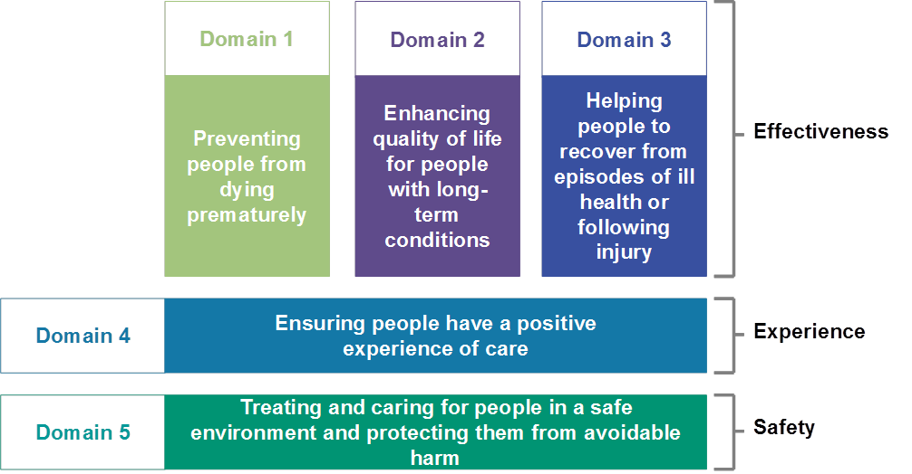

A series of three individual questionnaires was distributed to the carers: just before undertaking the training programme, immediately afterwards and then 3 months after the original training programme. This allowed original knowledge to be benchmarked, so any learning resulting from the training could be highlighted.
All participants gave written informed consent to participate in the research and inclusion criteria detailed in Table 2.
Table 2. Questions and the reason for their inclusion
Question | Relevance to the study
Participant ID numbers | These were allocated to permit the numerical identification of candidates at the initial benchmarking of perceived knowledge of pressure ulcer risk recognition and avoidance, upon completion of the ‘React to Red’ education and training session sessions and 3 months after the initial session.
Gender of the participants | This shows the balance of the healthcare workforce and the numbers and differences in gender within it. It is important to capture this data to highlight areas of inclusivity and diversity of the workforce
Age range of the participants | Again, this was important to capture so that a demographic profile of the healthcare workforce could be captured
Employment status (full time or part time working hours) | Some participants worked either full time, part time or had two or more part-time jobs within and between care homes in the same geographical area. It was important to capture this information, so that people with duplicate or double roles across the geographical area could be accounted for within their different settings
Setting of care | Care settings were recorded to understand where care was being delivered and see if this was related to pressure ulcer avoidance
Self-perceived knowledge base of the participants | Being able to report what the participants perceive their knowledge to be vs what it may be is an important part of recognising training needs and providing support at the frontline of patient care
The listing of predisposing and actual risk factors by participants | This enabled participants to evidence their knowledge in practice and the research team to ascertain whether there was any degree of correlation between what participants thought they knew and what they did know
Participants’ ranking of the importance of designated risk factors | This was important in terms of being able to provide future education and training in line with the needs of the healthcare workforce being targeted within the area of pressure ulcer prevention.
Participant perceptions of those people characteristically at increased risk of pressure ulceration | This determined the focus of education and training for the healthcare workforce and enabled the research team to discern any disparity or irregularity in the recognition of predisposing risk factors to pressure ulceration
Participants’ perceived confidence to identify risk factors | Confidence is a significant issue, since people may be confident in their approach, but if they are not able to recognise signs and symptoms correctly then this confidence may be misplaced
Participants’ perceived capacity to list risk factors associated with the development of pressure ulceration | This enabled the research team to capture the healthcare workforce’s perceptions of risk factors associated with the development of pressure ulcers and to compare this across all data collected for consistency and accuracy
Participants’ knowledge of surface prevention factors | This was used to address gaps in knowledge for integration into education and training curricula
Participants’ capacity to identify which areas are specifically at increased risk of pressure ulceration | The basic anatomical knowledge of staff is important in being able to recognise the most vulnerable parts of the body (bony prominences), or and people who are likely to be weightbearing but immobile for prolonged periods, Educating the workforce on this will help them make better decisions about the health of the people they care for
Participant recognition and knowledge of mobility enablers | Being able to recognise that a person’s capacity to move is linked to their risk of developing pressure ulcers is a pivotal part of reducing rates of pressure ulcer development, so benchmarking participants’ existing ability to recognise mobility enablers is pivotal to the integration of new approaches to education and training
Three actions against dermatological defence of the skin in the avoidance of pressure ulceration | Having a proactive workforce who work to avoid tissue breakdown is essential for the prevention of pressure ulcers in everyday practice. Establishing their ability to apply skin preparations when appropriate is fundamental to this, so that education and training can support their needs
Participant knowledge of optimal nutrition and hydration in relation to risk of ulceration of the skin | Optimal hydration and nutrition are key for the maintenance of healthy, viable skin, which can resist compressional forces and pressure ulceration

The pre-test and post-test evaluation questionnaires were anonymised to preserve the confidentiality of participants. Forms were collected independently by administrative staff from Sunderland and South Tyneside Carer Centres, and only participant numbers were used to match pre-test and post-test questionnaires

Findings and discussion
Several participants worked in multi-agency settings across the geographical boundaries of the study, with some working within and between different care home settings. Turnover of staff was also relatively high, which made it harder to follow up on the benchmarking of the self-perceived knowledge of pressure ulceration avoidance mechanisms in practice (9.8% of staff had left the organisations they were working for within 3 months of the initial benchmarking exercise). However, because this is a regional workforce, many had moved to neighbouring residential and non-residential care settings, which minimally changed the contextual basis of the research. Alongside the pragmatic issues this raises in terms of being able to ensure regular validity of assessment mechanisms, it also raises important issues in terms of the prevention of infection if staff are moving from site to site during the day, something which was best evidenced by the COVID-19 pandemic. This is also significant in terms of the potential for the transmission of secondary infection of wounds within and between residential and non-residential care home settings (Sebrant, 1999). Figure 2 shows the care settings of the research participants in both residential and non-residential care contexts, Figure 3 shows the working hour contracts of participants and Figure 4 the gender of the workforce. These show that there is a predominantly female care workforce, which confirms older research findings. This has important implications for the need to redress the current imbalance in a female dominated workforce and to raise the profile of caring roles as rewarding, inclusive and diverse, especially as younger people consider careers within the healthcare sector (Sullivan et al, 2021).

Figure 2. Care settings of participants in residential and non-residential care. AQ please write out RCH, SCS, EMI in full?
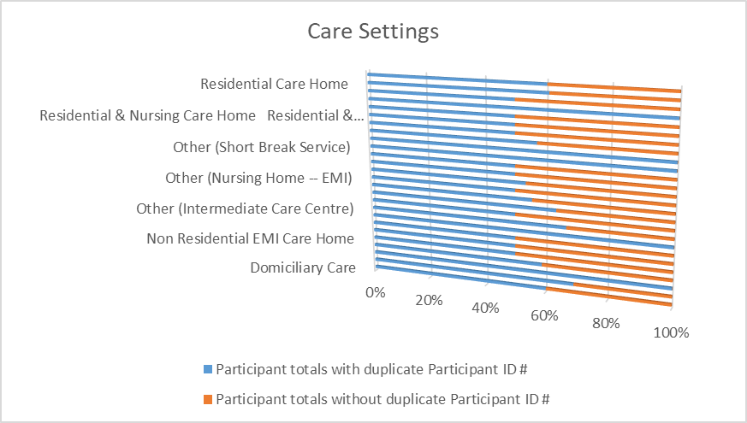
Abbreviation:
EMI – Elderly Mentally Ill

(Elderly Mentally Ill (abbreviated to EMI) in above chart)

Figure 3. Employment status of research participants.

Abbreviations:
P/T Part time
F/T Full time

Incontinence
Many participants knew that both urinary and faecal incontinence were key factors in the potential development of pressure ulcers but 70% of them would not formally report these as areas that needed to be addressed. Since incontinence has a significant impact on the potential development of secondary infection, particularly in patients with sacral pressure ulcers, incontinence ought to be prioritised for address.

Inconsistency in decision making across the workforce
As a collective, participants demonstrated the ambiguity that characterised their knowledge base regarding pressure ulceration. This is a clear indication that future education and training programmes ought to be focused on the identification of the cardinal signs and symptoms of pressure ulceration and emphasis placed on the need for effective communication and prompt referral for specialised intervention from other members of the multidisciplinary team, for example, early referral to nursing staff specialising in incontinence.

The need for strategically designed education and training packages
This research has revealed the need for standardised education and training packages with an element of assessment to ascertain the level of learning of staff across the particular healthcare organisation. For example, the knowledge and capacity of healthcare assistants to identify the need for optimal hydration and nutrition were the two areas of practice in residential and non-residential care home settings which were self-reported as being increased since the initial React to Red training and education session.

Emphasis on teamwork and multi-agency support
Results showed that confidence levels in dealing with the first signs and symptoms of pressure ulceration by staff had not been significantly impacted by the educational intervention, despite the fact staff reported feeling better equipped to deal with these signs and symptoms. This indicated a need for some individualised support for healthcare workers, specifically focused mentorship as an adjunct to learning opportunities (Horton, 2022). This has cost implications for providers, but this needs to be considered in the context of the vast amount of resources spent on the treatment of pressure ulceration each year, and the diminished quality of life that people living with the condition have to endure (Glasper, 2018).
The identification of risk factors and a proactive approach to person-centred support
Participants listed many different risk factors for the development of pressure ulceration but did not align these with the application of knowledge in practice to deal with this. This is a cause for concern and highlights the need for processes of education and training to be modernised and updated and the need to ensure that the processes being used to assess levels of learning are appropriately implemented in practice.

Conclusions
A key means of reducing the incidence of pressure ulceration in people in residential and non-residential care home settings is to increase the basic levels of knowledge of all healthcare staff who care for those predisposed to the condition. The findings of this study reveal a clear gap between what healthcare staff, including healthcare assistants, thought they know vs what they know and issues with their ability to recognise and apply knowledge in practice. The outcomes reveal that education and training for healthcare staff ought to be standardised, to reduce any unnecessary ambiguity, pragmatic and ideally supported by mentorship at the frontline of patient care, where visualisation of the signs of pressure ulceration and recognising symptoms of them might best take place. Healthcare assistants play an invaluable role in the initial identification of risk in relation to the potential development and thus avoidance of pressure ulcers, yet in practice, along with other healthcare staff positions, this role is not given the recognition it so rightly deserves. Being able to better equip healthcare assistants at the frontline of care will be key to optimising the quality and longevity of lives of people living in these settings.
The authors welcome debate of these clinical and educational aspects of care from healthcare assistant practice and hope that this research may encourage healthcare assistants to learn more about a potentially deadly but ultimately avoidable condition.

Acknowledgements
PROACT was funded by Sunderland Clinical Commissioning Group, South Tyneside Clinical Commissioning Group, University of Sunderland and Smith and Nephew. The researchers wish to formally acknowledge the support of the PROACT Steering Group, consisting of representatives from Sunderland Clinical Commissioning Group, South Tyneside Clinical Commissioning Group, University of Sunderland, South Tyneside and Sunderland NHS Foundation Trust, Tyne and Wear Care Alliance, Sunderland City Council, North East Ambulance Service, Cumbria Tyne and Wear Mental Health Foundation Trust, Sunderland Carers Centre, and South Tyneside Carers Centre.
References
Anthony D, Alosoumi D, Safari R. Prevalence of pressure ulcers in long-term care: a global review. J Wound Care 2019;28(11):702–709. https://doi.org/10.12968/jowc.2019.28.11.702https://www.ncbi.nlm.nih.gov/entrez/query.fcgi?cmd=Retrieve&db=PubMed&list_uids=31721671&dopt=Abstract
Bonifant H, Holloway S. A review of the effects of ageing on skin integrity and wound healing. British Journal of Community Nursing 2019;24(Sup3): S28–S33. https://doi.org/10.12968/bjcn.2019.24.Sup3.S28
Charlton, S. (2020). Implementing a ward-based pressure ulcer prevention and management resource in an acute hospital trust. Wounds UK, 16(2).
Deldar R, Suvarnakar A, Sharma K et al. Is total calcanectomy an effective alternative to below-knee amputation in patients with chronic heel wounds? Foot & Ankle Surgery: Techniques, Reports & Cases. 2022:2(1):100145. https://doi.org/10.1016/j.fastrc.2022.100145
Department of Health. (2012). The NHS Outcomes Framework (2013/14).
Gefen, A. (2018). The future of pressure ulcer prevention is here: detecting and targeting inflammation early. EWMA J, 19(2), 7-13.
Glasper A. Problems affecting the continuing professional development of nurses. Br J Nurs 2018;27(12):714–715. https://doi.org/10.12968/bjon.2018.27.12.714https://www.ncbi.nlm.nih.gov/entrez/query.fcgi?cmd=Retrieve&db=PubMed&list_uids=29953283&dopt=Abstract
Headlam J, Illsley A. Pressure ulcers: an overview. Br J Hosp Med 2020;81(12):1–9. https://doi.org/10.12968/hmed.2020.0074https://www.ncbi.nlm.nih.gov/entrez/query.fcgi?cmd=Retrieve&db=PubMed&list_uids=33377838&dopt=Abstract
Hommel A, Gunningberg L, Idvall E, Bååth C. Successful factors to prevent pressure ulcers - an interview study. J Clin Nurs. 2017;26(1-2):182–189. https://doi.org/10.1111/jocn.13465
Horton A. Financialization and non-disposable women: Real estate, debt and labour in UK care homes. Environment and Planning A. Economy and Space 2022;54(1):144–159. https://doi.org/10.1177/0308518X19862580
Jaul E, Barron J, Rosenzweig JP, Menczel J. An overview of co-morbidities and the development of pressure ulcers among older adults. BMC Geriatr 2018;18(1):305. https://doi.org/10.1186/s12877-018-0997-7https://www.ncbi.nlm.nih.gov/entrez/query.fcgi?cmd=Retrieve&db=PubMed&list_uids=30537947&dopt=Abstract
Lavallée JF, Gray TA, Dumville J, Cullum N. Preventing pressure ulcers in nursing homes using a care bundle: A feasibility study. Health Soc Care Community 2019;27(4):e417–e427. https://doi.org/10.1111/hsc.12742https://www.ncbi.nlm.nih.gov/entrez/query.fcgi?cmd=Retrieve&db=PubMed&list_uids=30919525&dopt=Abstract
Lindhardt CL, Beck SH, Ryg J. Nursing care for older patients with pressure ulcers: A qualitative study. Nurs Open 2020;7(4):1020–1025. https://doi.org/10.1002/nop2.474https://www.ncbi.nlm.nih.gov/entrez/query.fcgi?cmd=Retrieve&db=PubMed&list_uids=32587720&dopt=Abstract
Pokorná A, Klugar M, Kelnarová Z, Klugarová J. Effectiveness and Safety of Patient-centred Care Compared to Usual Care for Patients with Pressure Ulcers in Inpatient Facilities: A Rapid Review. EWMA Journal. 2019;20(1):61–70. https://doi.org/10.35279/jewma201905.07
Sebrant U. Being female in a health care hierarchy. On the social construction of gender and leader identity in a work organization having a predominance of women. Scand J Caring Sci 1999;13(3):153–158. https://doi.org/10.1080/02839319950162507https://www.ncbi.nlm.nih.gov/entrez/query.fcgi?cmd=Retrieve&db=PubMed&list_uids=12033119&dopt=Abstract
Seo Y, Roh YS. Effects of pressure ulcer prevention training among nurses in long-term care hospitals. Nurse Educ Today 2020;84:104225. https://doi.org/10.1016/j.nedt.2019.104225https://www.ncbi.nlm.nih.gov/entrez/query.fcgi?cmd=Retrieve&db=PubMed&list_uids=31698290&dopt=Abstract
Smart H, Sibbald RG. Skin care for the protection and treatment of incontinence associated dermatitis (IAD) to minimise susceptibility for pressure injury (PI) development. WCET Journal 2020;40(4):40–44. https://doi.org/10.33235/wcet.40.4.40-44
Sullivan R, McNicholas T, Claffey P, Kenny RA, Briggs R. Unreported urinary incontinence: population-based prevalence and factors associated with non-reporting of symptoms in community-dwelling people ≥ 50 years. Eur Geriatr Med 2021;12(2):405–412. https://doi.org/10.1007/s41999-020-00412-0https://www.ncbi.nlm.nih.gov/entrez/query.fcgi?cmd=Retrieve&db=PubMed&list_uids=33029753&dopt=Abstract
Sumarno AS. Pressure ulcers: the core, care and cure approach. British Journal of Community Nursing, 2019 24(Sup12): S38-S42. https://doi.org/10.12968/bjcn.2019.24.Sup12.S38
Sving E, Fredriksson L, Mamhidir AG, Högman M, Gunningberg L. A multifaceted intervention for evidence-based pressure ulcer prevention: a 3 year follow-up. JBI Evid Implement 2020;18(4):391–400https://www.ncbi.nlm.nih.gov/entrez/query.fcgi?cmd=Retrieve&db=PubMed&list_uids=33570322&dopt=Abstract. https://doi.org/10.1097/XEB.0000000000000239
Vowden K, Hill L. What is the impact of COVID-19 on tissue viability services and pressure ulceration? J Wound Care 2021;30(7):522–531. https://doi.org/10.12968/jowc.2021.30.7.522https://www.ncbi.nlm.nih.gov/entrez/query.fcgi?cmd=Retrieve&db=PubMed&list_uids=34256597&dopt=Abstract
Wood D. Infection prevention in care homes: the role of community nurses. Br J Community Nurs 2019;24(1):16–19. https://doi.org/10.12968/bjcn.2019.24.1.16https://www.ncbi.nlm.nih.gov/entrez/query.fcgi?cmd=Retrieve&db=PubMed&list_uids=30589594&dopt=Abstract
Wung Buh A, Mahmoud H, Chen W, McInnes MD, Fergusson DA. Effects of implementing Pressure Ulcer Prevention Practice Guidelines (PUPPG) in the prevention of pressure ulcers among hospitalised elderly patients: a systematic review protocol. BMJ Open 2021;11(3):e043042. https://doi.org/10.1136/bmjopen-2020-043042https://www.ncbi.nlm.nih.gov/entrez/query.fcgi?cmd=Retrieve&db=PubMed&list_uids=33712523&dopt=Abstract

