Came and Gone? A Longitudinal Study of the Effects of COVID-19 on Tourism Purchasing Intentions

Abstract
The study is based on a multi-year research conducted in three successive years (2019; 2020; 2021). Drawing from three samples (N=507; 463; 488) it longitudinally examines the complexity and the derived chaordic systems of the impact of COVID-19 upon the purchasing intentions of adult Athenian holidaymakers by using fuzzy-set Qualitative Comparative Analysis. In doing so, it evaluates the simple conditions of impact of recession, destination selection, and price and quality risks, also progressing to a complementary examination through Necessary Condition Analysis. The findings generate three pathways (price-quality nexus; financial focus; destination orientation) leading to the same outcome (purchasing intentions), the hierarchy of which changed over time. They also highlight the impact of recession and quality risks as constant necessary conditions, and demonstrate the transformation over time of destination selection and price risks from influential to necessary. The contribution of the study lies in both the theoretical and methodological domains.

Keywords: Coronavirus; chaordic systems; complexity; purchasing intentions; tourism; Athens
- Introduction
The COVID-19 pandemic is considered to be the most devastating crisis humanity has faced since the Second World War. As a result, the pandemic has transformed our way of thinking about societies (Bermes, 2021; Lim et al., 2022) and economies (Islam et al., 2021), forcing governments to build resilience and inclusivity into their governance (OECD, 2021).

The unprecedented COVID-19 global health crisis has also heavily affected the travel and tourism industry. In fact, the Coronavirus pandemic has affected tourism more than any other major economic sector (Pappas and Glyptou, 2021; UNWTO, 2020). Tourism development is expected to remain depressed since travel restrictions are only slowly being lifted, whilst there is a considerable fear (especially in many developing countries) of new waves of infection (United Nations, 2021). This effect has united the tourism sector in attempts to plan and develop a sector-wide response to handling the enormous challenge of the pandemic (UNWTO, 2021a). Consequently, on a scientific level, a plethora of related studies concerning COVID-19 have been conducted and published dealing with various sector related aspects such as management (Ayoko et al., 2021 [COVID-19 research contributions]) education (Salomaa and Caputo, 2021 [research development and innovation])
travel (Boto-García and Leoni, 2022 [COVID-19 exposure]; Matsuura and Hisamitsu, 2022 [domestic travel]; Shin, Nicolau et al., 2022 [decision determinants]), tourism (Cambra-Fierro et al., 2022 [communication influence]; Wieczorek-Kosmala, 2022 [cash-driven resilience]; Zhang et al., 2021 [recovery]), and hospitality (Agag et al., 2022 [post-pandemic behaviour]; Das and Ramalingam, 2022 [product involvement and satisfaction]; Nilashi et al., 2022 [service quality]).
Tourism decision-making has been heavily affected during the pandemic, whilst a new way of thinking concerning tourist purchasing behaviour has emerged (Larios-Gomez et al., 2021; Torres et al., 2021). Due to crisis conditions, the complexity levels concerning tourist purchasing intentions have been exponentially increased ((Formanek and Sokol, 2022; Pappas, 2021) as their consumption patterns have been significantly displaced (Deya-Tortella, 2022). However, the literature is predominantly silent concerning the examination of the tourism complexity generated by COVID-19. Moreover, due to the fact that COVID-19 has only recently invaded our lives (the first confirmed case was reported to the World Health Organisation [WHO] on 31st December 2019 [WHO, 2020]), the tourism literature lacks studies that examine the longitudinal effect of the pandemic. The current research tries to longitudinally examine the tourism complexity of the holidaymakers’ purchasing intentions.

Especially during the pandemic, the purchasing behaviours of consumers have dramatically changed (Truong and Truong, 2022). With special reference to travel and tourism, the purchasing intentions of holidaymakers have entailed high levels of complexity (Pappas, 2021), and this is particularly so for people living in regions that have been battered by recession, which has had a substantial impact upon their disposable income for tourism for several years. Within this context, the aim of this study is to longitudinally examine the impact of COVID-19 upon the purchasing intentions of tourists. Therefore, it focuses on permanent Athenian residents leaving for holidays and their tourism purchasing intentions before (2019) and during (2020; 2021) the pandemic. In order to achieve this, the study includes three researches (2019; 2020; 2021) and investigates the impact of recession, destination selection, and the price and quality risks. Moreover, it includes the examination of three socio-demographics (age; monthly income; travel mode). The study’s theoretical contribution concerns the chaordic examination of holidaymakers’ purchasing intentions and alterations to those intentions during a three-year period, providing a holistic understanding of the effects and impact of COVID-19 upon purchasing intentions. In the methodological domain, the study makes a two-fold contribution. First, it evaluates the complexity of chaordic systems focusing on tourist purchasing intentions by employing fuzzy-set Qualitative Comparative Analysis (fsQCA). This method has only been used in the travel and tourism domain in the last few years. Second, it compares the size effects of the chosen conditions. To do this, it uses Necessary Condition Analysis (NCA), a newly employed method in tourism and services.

- Chaos, complexity and chaordic systems
The control of chaotic conditions in the business environment has been subjected to considerable examination in the last few decades (Du et al., 2009). Chaos theory concerns the dynamic behaviour of specific systems that are very sensitive and dependent upon initial conditions; their diverging trajectories are unpredictable, and they have a complex structure or organisation (Schuldberg, 2011). According to the theory of chaos, management of these systems is actually an illusion since it is impossible to control them directly (Houry, 2012). Hence, managers and decision-makers should only focus on the aspects that permit the emergence of order (Thietart and Forgues, 1995). The theory of complexity emerged from chaos theory and concerns systems that include several structured and interacting agents which, despite the difficulty of making predictions, can subsequently be improved (Zahra and Ryan, 2007). The theories of chaos and complexity suggest that when an organisation reaches the edge of chaos, depending on the forces of stability and instability, it is likely to disconnect from the processes it is used to adopting, and to progress to a new self-organisational order (Smith and Humphries, 2004).

The strong relationship between chaos and complexity has led to the emergence of chaordic systems (Fitzgerald and Van-Eijnatten, 2002). The term ‘chaordic’ is derived from ‘chaord’, which is an amalgamation of ‘chaos’ and ‘order’ (Van-Eijnatten, Putnik, and Sluga, 2007). According to Olmedo and Mateos (2015), a chaordic system has three main features: (i) long-term planning is impossible; (ii) the system is in constant change; and (iii) dramatic changes extensively and substantially influence the system. Therefore, a chaordic system is very sensitive to initial conditions (e.g.: an exogenous shocking event may result to substantial changes in a tourism destination) (Olmedo and Mateos, 2015), and it is characterised by long memory (e.g.: alterations occurred in the past have a continuous effect in the current tourist system) (Lahmiri, 2017), self-organisation (e.g.: The creation of changes and new structures in the elemental roles of tourist behaviour because of specific emergent properties) (Kauffman, Peterson, Samuelsson and Troein, 2003), asymmetry (e.g.: the linearizing characteristics of the tourism system are not similar) (Waz and Waz, 2009), and resilience (e.g.: the ability of a tourist system to adopt to new conditions, and be able to absorb disturbances) (Mycek et al., 2017).

In the tourism domain, during disasters and crises it is imperative for the survival of organisations that they build the highest possible resilience (Pappas, 2021). This is because travel and tourism systems are characterised by complexity, unpredictability and uncertainty, whilst non-linear complexity systems and tourism anarchy dynamics are vital during periods of transition (Mehran and Olya, 2020). Moreover, since the psychology of tourists entails high levels of complexity, it is difficult to calibrate, quantify, justify, and predict their perceptions (Zhai et al., 2019). The literature suggests that during crises and periods of uncertainty, the complexity aspects exponentially increase (Butler, 2021; Saurin, 2021). This also includes the impact of an economic crisis (ant its subsequent recession) to travelers and holidaymakers (Papatheodorou and Pappas, 2017). Moreover, the associated risks (e.g.: price; quality; services) with the decision-making increase the chaordic potential of peoples’ behaviour (Becken and Shuker, 2019; Pappas et al., 2021). As a result during crisis periods the process of destination selection also embeds high levels of complexity (Murray et al., 2022). With special reference to the period of the pandemic, the complexity of consumer behaviour and business operations has been substantially increased (Formanek and Sokol, 2022). This development also concerns the tourism decision-making due to the rapidly changing environment and the high levels of uncertainty in all facets of tourism activity (Pappas and Glyptou, 2021). Therefore, a complexity-based approach (Reddy et al., 2020), and an examination of the derived chaordic systems (Pappas, 2021) can provide a better comprehension of travel and tourist decision-making during periods of uncertainty and instability.

- Study context
In 2008 the Greek economy entered into recession (The World Bank, 2021), which unfolded as an ongoing debt crisis in November 2009 (Polito and Wickens 2012). This crisis combined with, and was further deepened by, several other crises, including political instability, social unrest, and the refugee crisis (Pappas, 2018), but after a decade the country finally managed to return to growth in 2018 (Council on Foreign Relations, 2021). The prolonged economic recession ultimately reduced the Greek GDP by 25 percent (Keramidou and Triantafyllopoulos, 2018), and led to a substantial deterioration in numerous social indicators such as poverty, unemployment and inequality (Chantzaras and Yfantopoulos, 2018).

After two years (2018-2019) of relative normality, whilst Greek society was still facing the socio-economic devastation of the crisis that had unfolded in previous years, a new, more severe challenge had to be faced. At the end of February 2020 the first confirmed COVID-19 case was reported in Greece (APE-MPE, 2020), leading the country into a complete two-month lockdown on 23rd March (Menshouse, 2020), followed by a second lockdown lasting from 7th November 2020 until 7th May 2021 (Hellenic Republic, 2021). As a result, the Greek weak economy was severely hit. More specifically Greek GDP for 2020 was reduced by nine percent (Eurostat, 2021), unemployment reached 16.85 percent (O’ Neill, 2021), and the average annual wage was €16,975 (compared with €21,351 a decade previously) (Clark, 2021). From the COVID-19 health crisis perspective, even though Greece performed very well during the first wave (spring 2020) of the pandemic (Aristotle University, 2020), from the second wave onwards its health system has struggled to cope with the increasing demand for hospitalization and intensive care units. This is exacerbated by the severe cuts in its health system due to a period of austerity that lasted more than a decade (Amnesty International, 2021), and the relatively low vaccination rate (Papantoniou, 2021).

The prolonged Greek recession, combined with the economic crisis due to the pandemic, along with the COVID-19 health crisis and associated travel restrictions, have resulted in a substantial reduction in domestic and outbound Greek tourism (Tsilidis, 2021). More specifically, during 2020, 17.7 percent fewer Greeks travelled for tourism purposes, whilst trips and tourism expenditure by Greeks have reduced by 21.9 and 27.4 percent, respectively (Manifava, 2021). Although in 2021 tourism in Greece has partially recovered, (tourist arrivals have increased by nearly 100 percent, and tourist receipts have increased by 150 percent) (Tornos, 2021), something that expected to also occur during 2022 (Souki, 2022) due to the prolonged recession and the devastating economic effects of COVID-19, the vast majority of Greeks did not actually have the disposable income for tourism in order to be a part of this recovery (Glezakos, 2022).

These factors (COVID-19, the global recession and the health crisis) have affected travel and tourism worldwide. Despite the moderate rebound in international travel during 2021 due to the easing of travel restrictions and the improvement in holidaymaker’s confidence, global tourism is still severely affected, resulting in a 67 percent reduction in international tourist arrivals (UNWTO, 2021b). Therefore, the study context (Greece) is to some extent applicable at an international level, and can provide evidence for the complexity of holidaymakers’ decision-making with regard to their purchasing intentions.

- Study tenets
The service industry uses the term ‘tenet’ to define testable precepts when it identifies conditions characterised by complexity (Pappas and Glyptou, 2021). Tenets do not involve consistency metrics and statistical hypotheses. The reason for this is that the adequacy of a configuration is defined by the scores of the outcome (Wu et al., 2014). According to Ordanini et al. (2014), the theory of configuration indicates that, when we seek to arrange factors, the same set of factors is likely to provide different outcomes.

Following previous research (Caputo et al., 2022; Marzi et al., 2023) this study examines binary set absence or presence by conducting a longitudinal multi-year research concerning the effects of COVID-19 upon the purchasing intentions of holidaymakers. This examination had to consider specific aspects. First, as Fiss (2011) suggests, asymmetric analysis usually embeds causal asymmetry (the recipe principle). Hence, the complexity theory is based on the recipe principle (Weick and Sutcliffe, 2007). Second, following Woodside (2014), the generated pathways should all lead to the same outcome. As a result, the study includes the six set tenets (T) formulated by previous research (indicatively please read Pappas and Glyptou [2021], and Woodside [2014]):

T1: The interaction of a single antecedent with other antecedents can lead to different decisions related to the effect of COVID-19 upon tourist purchasing intentions.

T2: When a minimum of two simple conditions are included (generation of a complex condition) an outcome with a consistently high score can occur. This tenet concerns the ‘recipe’ principle.

T3: Interactions characterised by complexity are likely to involve an effect of COVID-19 upon tourist purchasing intentions.

T4: The way simple conditions interact through different combinations can involve a positive or negative effect of COVID-19 upon tourist purchasing intentions.

T5: An adequate effect of COVID-19 upon tourist purchasing intentions does not necessarily imply a high outcome score. This tenet concerns the ‘equifinality’ principle.

T6: The appearance of a high Y score does not imply the relevance of a given recipe for all cases.

- Methods

5.1 Respondents
The study was conducted at Athens International Airport, “Eleftherios Venizelos”, at the beginning of the peak Greek tourist season (June) in three successive years (2019; 2020; 2021). The respondents were adult permanent residents of Athens, leaving to go on holiday. Self-administered questionnaires were distributed to the holidaymakers. The time taken to fill in each questionnaire was estimated to be a maximum of 10 minutes. List-wise deletion was applied to remove partially completed questionnaires. According to Raghunathan (2020), this is the most versatile method for missing data handling.

5.2 Sample
Since the perceptions of the respondents were unknown, the study calculated the sample size by adopting the most conservative perspective (50/50), meaning that half of all respondents were expected to express a positive attitude, and the other half a negative one. Since the sample was to include more than 20 holidaymakers, the cumulative probability (Z) is 1.96 (Sekaran and Bougie, 2020). According to Akis et al. (1996), the sample had to include a maximum five percent statistical error, with a subsequent minimum 95 percent confidence level. As a result, the sample size was estimated as follows:

$N=\frac{Z^{2}(hypothesis)}{S^{2}}⇒N=\frac{{1.96}^{2}(0.5)(0.5)}{{0.05}^{2}}⇒N=384.16$ (1)

As follows from a study by Kumar et al. (1990), calculation of the sample size does not depend on the overall population size, since the error is determined by the sample size.

The sample size was rounded to a minimum acceptable number of 400, and doubled to a total of 800 people who would be asked to participate in the research. The doubling was carried out to ensure that a sufficient number of useful responses (N>400) was collected. The response rate was 63.4 percent for 2019 (507 useful questionnaires collected), 57.9 percent for 2020 (463 useful responses gathered), and 61 percent for 2021 (488 useful questionnaires collected).

5.3 Data and Measures
As mentioned above, the first piece of research was conducted in 2019, the year before the COVID-19 outbreak. Thus, the questionnaire did not include COVID-19 related items. It consisted of 28 five-point Likert scale statements (1: Strongly disagree; 5: Strongly agree) derived from previous research (Table 3). More specifically, the five items concerning the impact of recession were adopted from Thrane and Farstad (2011) and Alegre et al. (2013). The six statements focusing on destination selection were taken from the studies of Moufakkir (2014) and Mak (2017). The seven items concerning price risks derived from the studies of Pappas (2017), and Shapiro, Reams and So (2019). The five aspects included in quality risks were adopted from Sun (2014). Finally, the five statements concerning purchasing intention were taken from the studies of Wu et al. (2015), and Pappas (2016). The study also included three categorical questions focused on age (18-35; 36-50; over 50), monthly income (€1000 or less; over €1000) and travel (domestic; abroad). Concerning monthly income, the rounded threshold of €1000 was set because, during 2018, the average Greek monthly income was €1060.45 (Trading Economics, 2019).

‘SPSS 20.0’ software was used to produce the descriptive statistics and to complete the factor analysis. The ‘fsQCA’ software was used for the examination of the complex configurations by employing fuzzy-set Qualitative Comparative Analysis (fsQCA), and the size effects were measured using ‘R Studio’ software and employing Necessary Condition Analysis (NCA).

The mixed method involved in fsQCA uses quantitative data and provides a combination of quantitative empirical testing and qualitative inductive reasoning (Longest and Vaisey, 2008). fsQCA is considered as the most appropriate method to b used for the evaluation of complexity aspects ((Olya and Al-Ansi, 2018; Ordanini et al., 2014). The research also evaluates the existence (inclusion or exclusion) of a simple condition (negated set), as suggested by Woodside and Zhang (2013). When a simple condition is absent, the symbol “∼” is used.

As Ordanini et al. (2014) indicate, the calculation of the consistency and coverage are estimated by using the following formulas:

(2)
(3)
For the respondents , is the score of membership in the configuration X and the membership score concerns the outcome condition.

As a complementary method, NCA was used for the identification of necessary conditions. The complementary employment of NCA is important since it highlights the necessity of the examined simple conditions, and can define whether an a generated solution is valid (inclusion of at least one necessary condition in the complex configuration).

Skarmeas et al. (2014) indicate that the use of fsQCA can be justified only when the study is characterised by general asymmetry, meaning that the correlational values between its simple conditions should be less than 0.6. The correlations for this study are presented in Table 1, illustrating the existence of general asymmetry. Following Woodside (2013), such results provide an indication that the causal conditions are likely to produce the same outcome. This longitudinal research aims to longitudinally (prior to and during the pandemic) evaluate the effects of COVID-19 upon the tourism-related purchasing intentions of Athenian holidaymakers. This will be achieved through the examination of causal recipes (complex conditions of the antecedents under evaluation) of: (i) impact of recession; (ii) destination selection; (iii) price risks; and (iv) quality risks. It also includes the examination of age, monthly income, and travel. Finally, it involves the complementary use of NCA for the examination of size effects and their ability to lead to the desired outcome.

Table 1: Correlation matrix

 | 2019 | 1 | 2 | 3 | 4 | 5
1 | Impact of Recession | 1
2 | Destination Selection | -.038 | 1
3 | Price Risks | -.132* | .078 | 1
4 | Quality Risks | -.001 | .009 | .077 | 1
5 | Purchasing Intention | -.042 | -.021 | -.011 | .020 | 1
 | 2020 | 1 | 2 | 3 | 4 | 5
1 | Impact of Recession | 1
2 | Destination Selection | -.057 | 1
3 | Price Risks | .012 | .000 | 1
4 | Quality Risks | -.022 | .031 | .012 | 1
5 | Purchasing Intention | -.022 | -.044 | -.022 | -.018 | 1
 | 2021 | 1 | 2 | 3 | 4 | 5
1 | Impact of Recession | 1
2 | Destination Selection | -.071 | 1
3 | Price Risks | -.047 | -.059 | 1
4 | Quality Risks | .013 | .022 | .009 | 1
5 | Purchasing Intention | .009 | -.062 | .063 | -.060 | 1

* Correlation is significant at .01 level

5.4 Algorithms
Over all three researches (2019; 2020; 2021), 42 individual cases were randomly selected and used to calibrate the study. As indicated by Ragin (2008), for each causal condition the membership was graded between zero (non-membership) and one (full membership), and accordingly established the thresholds of: (i) non-membership (ii) crossover point, and (iii) full membership. As Marzi et al. (2023) suggest, the original values were set to: (i) five percent for non-membership (ii) 50 percent for crossover points, and (iii) 95 percent for full membership. The purchasing intentions of the Athenian holidaymakers ‘f_pi’ were examined through the fuzzy-sets of age ‘f_a’, income ‘f_i’, travel ‘f_t’, impact of recession ‘f_ir’, price risks ‘f_pr’, quality risks ‘f_qi’, and destination selection ‘f_ds’.

- Results
Table 2 presents the socio-demographics of the samples for all three researches (2019; 2021; 2021). The examined socio-demographics concern age (18-35; 36-50; over 50), monthly income (€1000 or less; over €1000), and travel mode (domestic; abroad). Table 3 illustrates the full statements used, and the descriptive statistics of the study.

Table 2: Socio-demographics
 | Travel Mode |  |  |  | Total
 | Domestic |  | Abroad
 | N | % | N | % | N | %
2019
Age
18-35 | 125 | 61 | 80 | 39 | 205 | 40,4
36-50 | 94 | 52,2 | 86 | 47,8 | 180 | 35,5
Over 50 | 77 | 63,1 | 45 | 36,9 | 122 | 24,1
Monthly Income (in €)
0-1000 | 199 | 72,6 | 75 | 23,4 | 274 | 54
Over 1000 | 97 | 41,6 | 136 | 58,4 | 233 | 46
Total | 296 | 58,4 | 211 | 41,6 | 507 | 100
2020
Age
18-35 | 178 | 49.3 | 34 | 33.3 | 212 | 45.8
36-50 | 121 | 33.5 | 42 | 41.2 | 163 | 35.2
Over 50 | 62 | 17.2 | 26 | 25.5 | 88 | 54.0
Monthly Income (in €)
0-1000 | 219 | 60.7 | 55 | 53.9 | 274 | 59.2
Over 1000 | 142 | 39.3 | 47 | 46.1 | 189 | 40.8
Total | 361 | 100 | 102 | 100 | 463 | 100
2021
Age
18-35 | 108 | 34.4 | 51 | 29.3 | 159 | 32.6
36-50 | 134 | 42.7 | 77 | 44.3 | 211 | 43.2
Over 50 | 72 | 22.9 | 46 | 26.4 | 118 | 24.2
Monthly Income (in €)
0-1000 | 119 | 37.9 | 56 | 32.2 | 175 | 35.9
Over 1000 | 195 | 62.1 | 118 | 67.8 | 313 | 64.1
Total | 314 | 100 | 174 | 100 | 488 | 100

Table 3: Descriptive statistics

Statements |  |  |  |  |  |  |  |  |  | Overall Means |  | Age |  |  |  |  |  | Monthly Income (in €) |  |  |  | Travel
 |  |  |  |  |  |  |  |  |  |  |  | 18-35 |  | 36-50 |  | 50+ |  | 0-1000 |  | 1000+ |  | Domestic |  | Overseas
 |  | 2019
 |  | Impact of Recession
IR1 |  | The impact of the current recession on my income has negatively affected my expenditure for tourism purposes. |  |  |  |  |  |  |  | 4.18 |  | 4.27 |  | 4.01 |  | 4.29 |  | 4.22 |  | 4.13 |  | 4.17 |  | 4.19
IR2 |  | The impact of the current recession on my employment security has negatively affected my expenditure for tourism purposes. |  |  |  |  |  |  |  | 3.64 |  | 4.05 |  | 3.72 |  | 2.85 |  | 3.69 |  | 3.59 |  | 3.61 |  | 3.69
IR3 |  | The current recession has affected the duration of my holidays due to the financial cost involved. |  |  |  |  |  |  |  | 4.36 |  | 4.38 |  | 4.28 |  | 4.44 |  | 4.44 |  | 4.26 |  | 4.35 |  | 4.36
IR4 |  | The current recession has affected my preferences for destination selection due to the financial cost involved. |  |  |  |  |  |  |  | 4.08 |  | 4.21 |  | 4.09 |  | 3.86 |  | 4.17 |  | 3.99 |  | 4.11 |  | 4.05
IR5 |  | The current recession has affected my selection of the means of travel due to the financial cost involved. |  |  |  |  |  |  |  | 3.20 |  | 3.50 |  | 3.04 |  | 2.93 |  | 3.39 |  | 2.98 |  | 3.29 |  | 3.07
 |  | Destination Selection
DS1 |  | It is important to me to select a safe destination. |  |  |  |  |  |  |  | 4.09 |  | 3.89 |  | 4.00 |  | 4.56 |  | 4.03 |  | 4.16 |  | 4.04 |  | 4.16
DS2 |  | It is important to me to select a clean destination. |  |  |  |  |  |  |  | 4.24 |  | 4.11 |  | 4.17 |  | 4.56 |  | 4.17 |  | 4.32 |  | 4.20 |  | 4.29
DS3 |  | It is important to me to select a destination where the locals are friendly. |  |  |  |  |  |  |  | 4.21 |  | 4.33 |  | 4.29 |  | 3.89 |  | 4.21 |  | 4.21 |  | 4.21 |  | 4.21
DS4 |  | It is important to me to select a destination with lots of culture. |  |  |  |  |  |  |  | 3.91 |  | 4.22 |  | 3.86 |  | 3.48 |  | 3.99 |  | 3.82 |  | 3.96 |  | 3.84
DS5 |  | It is important to me to select an expensive destination. |  |  |  |  |  |  |  | 1.87 |  | 1.78 |  | 1.89 |  | 2.01 |  | 1.67 |  | 2.11 |  | 1.72 |  | 2.09
DR6 |  | It is important to me to select a relaxing destination. |  |  |  |  |  |  |  | 3.86 |  | 3.41 |  | 3.94 |  | 4.49 |  | 3.73 |  | 4.01 |  | 3.77 |  | 3.98
 |  | Price Risks
PR1 |  | I think about the risk of not having made a good purchase bearing in mind the price I pay. |  |  |  |  |  |  |  | 3.67 |  | 3.55 |  | 3.71 |  | 3.83 |  | 3.48 |  | 3.89 |  | 3.61 |  | 3.75
PR2 |  | I consider the risk that the tourist product/service I purchased was not reasonably priced. |  |  |  |  |  |  |  | 3.50 |  | 3.44 |  | 3.52 |  | 3.59 |  | 3.38 |  | 3.66 |  | 3.48 |  | 3.54
PR3 |  | The potential risks when purchasing tourist products/services with similar features from different companies whose prices are very different, are high. |  |  |  |  |  |  |  | 3.53 |  | 3.37 |  | 3.61 |  | 3.70 |  | 3.33 |  | 3.77 |  | 3.45 |  | 3.64
PR4 |  | The price is the main criterion for my purchasing decision. |  |  |  |  |  |  |  | 3.95 |  | 3.84 |  | 3.89 |  | 4.22 |  | 3.93 |  | 3.97 |  | 3.98 |  | 3.91
PR5 |  | Purchasing a tourist product/service involves a considerable price risk due to the amount of money associated with it. |  |  |  |  |  |  |  | 3.41 |  | 3.30 |  | 3.54 |  | 3.41 |  | 3.30 |  | 3.54 |  | 3.38 |  | 3.46
PR6 |  | The financial risk involved when purchasing tourist products/services is high. |  |  |  |  |  |  |  | 3.67 |  | 3.56 |  | 3.70 |  | 3.81 |  | 3.57 |  | 3.79 |  | 3.62 |  | 3.73
PR7 |  | There is a high risk with tourist products/services that I will not receive the value for money I desire. |  |  |  |  |  |  |  | 3.71 |  | 3.61 |  | 3.75 |  | 3.80 |  | 3.61 |  | 3.82 |  | 3.67 |  | 3.75
 |  | Quality Risks
QR1 |  | I am cautious about the overall quality when trying new tourist products/services. |  |  |  |  |  |  |  | 4.07 |  | 3.92 |  | 3.97 |  | 4.48 |  | 4.07 |  | 4.08 |  | 4.09 |  | 4.05
QR2 |  | I am cautious about the overall quality when trying different tourist products/services. |  |  |  |  |  |  |  | 3.96 |  | 3.80 |  | 3.89 |  | 4.33 |  | 3.95 |  | 3.97 |  | 3.98 |  | 3.94
QR3 |  | I entrust my purchase to a tourist brand I usually buy from than purchasing something I am not very sure of. |  |  |  |  |  |  |  | 4.10 |  | 4.00 |  | 4.04 |  | 4.37 |  | 4.09 |  | 4.12 |  | 4.13 |  | 4.07
QR4 |  | I never buy a tourist product/service I do not know about at the risk of making a mistake. |  |  |  |  |  |  |  | 3.94 |  | 3.79 |  | 3.88 |  | 4.28 |  | 3.93 |  | 3.95 |  | 3.96 |  | 3.91
QR5 |  | When buying a tourist product/service I consider the potential risk of it not being delivered as promised. |  |  |  |  |  |  |  | 3.89 |  | 3.69 |  | 3.82 |  | 4.31 |  | 3.87 |  | 3.90 |  | 3.90 |  | 3.87
 |  | Purchasing Intention
PI1 |  | I am likely to book a specific tourist product/service. |  |  |  |  |  |  |  | 4.02 |  | 3.98 |  | 4.06 |  | 4.03 |  | 4.00 |  | 4.05 |  | 4.04 |  | 4.00
PI2 |  | I am likely to recommend a specific tourist product/service to my friends. |  |  |  |  |  |  |  | 4.14 |  | 4.04 |  | 4.22 |  | 4.19 |  | 4.09 |  | 4.20 |  | 4.14 |  | 4.14
PI3 |  | I am likely to make another booking of a tourist product/service if I am satisfied with a specific one. |  |  |  |  |  |  |  | 4.22 |  | 4.19 |  | 4.24 |  | 4.23 |  | 4.19 |  | 4.24 |  | 4.22 |  | 4.21
PI4 |  | My willingness to buy a tourist product/service from the same sellers is high. |  |  |  |  |  |  |  | 3.93 |  | 3.89 |  | 3.95 |  | 3.95 |  | 3.91 |  | 3.94 |  | 3.95 |  | 3.90
PI5 |  | If satisfied, it is likely that I will purchase a tourist product/service from the same sellers in the near future. |  |  |  |  |  |  |  | 3.82 |  | 3.81 |  | 3.84 |  | 3.80 |  | 3.80 |  | 3.84 |  | 3.85 |  | 3.78
2020 |  |  |  |  |  |  |  |  |  |  | 2021
 | Over. Means |  | Age |  |  | M. Income (in €) |  | Travel |  |  | Over. Means |  | Age |  |  |  |  |  | M. Income (in €) |  |  |  | Travel
 |  |  | 18-35 | 36-50 | 50+ | 0-1000 | 1000+ | Dom. | Overs. |  |  |  | 18-35 |  | 36-50 |  | 50+ |  | 0-1000 |  | 1000+ |  | Dom. |  | Overs.
Impact of Recession
IR1 | 3.90 |  | 4.03 | 3.96 | 3.47 | 3.94 | 3.84 | 3.93 | 3.79 |  | 4.28 |  | 4.60 |  | 4.27 |  | 3.88 |  | 4.27 |  | 4.29 |  | 4.32 |  | 4.22
IR2 | 3.68 |  | 3.82 | 3.74 | 3.22 | 3.76 | 3.56 | 3.70 | 3.60 |  | 4.19 |  | 4.48 |  | 4.18 |  | 3.81 |  | 4.18 |  | 4.19 |  | 4.22 |  | 4.14
IR3 | 3.62 |  | 3.71 | 3.72 | 3.23 | 3.76 | 3.42 | 3.63 | 3.60 |  | 4.40 |  | 4.63 |  | 4.40 |  | 4.08 |  | 4.39 |  | 4.40 |  | 4.42 |  | 4.35
IR4 | 3.52 |  | 3.38 | 3.80 | 3.35 | 3.67 | 3.31 | 3.53 | 3.47 |  | 4.40 |  | 4.69 |  | 4.44 |  | 3.93 |  | 4.45 |  | 4.36 |  | 4.44 |  | 4.32
IR5 | 3.65 |  | 3.78 | 3.72 | 3.23 | 3.73 | 3.55 | 3.68 | 3.55 |  | 2.90 |  | 2.95 |  | 3.17 |  | 2.36 |  | 2.73 |  | 3.00 |  | 2.98 |  | 2.76
Destination Selection
DS1 | 4.57 |  | 4.56 | 4.56 | 4.64 | 4.55 | 4.60 | 4.58 | 4.54 |  | 4.01 |  | 3.94 |  | 4.04 |  | 4.04 |  | 4.03 |  | 4.00 |  | 3.99 |  | 4.03
DS2 | 4.71 |  | 4.69 | 4.71 | 4.75 | 4.69 | 4.73 | 4.70 | 4.73 |  | 4.11 |  | 4.02 |  | 4.16 |  | 4.15 |  | 4.14 |  | 4.10 |  | 4.11 |  | 4.11
DS3 | 4.00 |  | 3.97 | 3.90 | 4.25 | 3.90 | 4.14 | 4.00 | 3.99 |  | 3.95 |  | 3.88 |  | 4.02 |  | 3.92 |  | 3.99 |  | 3.93 |  | 3.97 |  | 3.91
DS4 | 3.68 |  | 3.63 | 3.62 | 3.90 | 3.56 | 3.85 | 3.69 | 3.65 |  | 3.73 |  | 3.66 |  | 3.82 |  | 2.66 |  | 3.74 |  | 3.72 |  | 3.75 |  | 3.70
DS5 | 1.67 |  | 1.66 | 1.67 | 1.69 | 1.63 | 1.72 | 1.68 | 1.62 |  | 2.20 |  | 2.36 |  | 2.15 |  | 2.07 |  | 2.50 |  | 2.03 |  | 2.31 |  | 2.00
DR6 | 4.28 |  | 4.27 | 4.25 | 4.37 | 4.21 | 4.39 | 4.34 | 4.09 |  | 4.15 |  | 4.08 |  | 4.18 |  | 4.17 |  | 4.17 |  | 4.13 |  | 4.13 |  | 4.18
Price Issues
PR1 | 3.88 |  | 3.85 | 3.90 | 3.90 | 3.84 | 3.94 | 3.88 | 3.85 |  | 3.97 |  | 3.82 |  | 3.98 |  | 4.15 |  | 3.98 |  | 3.96 |  | 3.96 |  | 3.99
PR2 | 4.10 |  | 4.17 | 4.01 | 4.11 | 4.12 | 4.07 | 4.11 | 4.09 |  | 4.08 |  | 3.93 |  | 4.07 |  | 4.29 |  | 4.09 |  | 4.07 |  | 4.06 |  | 4.10
PR3 | 3.74 |  | 3.69 | 3.79 | 3.77 | 3.70 | 3.79 | 3.76 | 3.69 |  | 3.94 |  | 3.74 |  | 3.93 |  | 4.21 |  | 3.89 |  | 3.96 |  | 3.92 |  | 3.97
PR4 | 3.50 |  | 3.52 | 3.55 | 3.34 | 3.47 | 3.53 | 3.52 | 3.42 |  | 3.72 |  | 3.60 |  | 3.75 |  | 3.82 |  | 3.74 |  | 3.71 |  | 3.73 |  | 3.70
PR5 | 3.76 |  | 3.73 | 3.79 | 3.77 | 3.71 | 3.84 | 3.76 | 3.75 |  | 4.07 |  | 3.98 |  | 4.05 |  | 4.20 |  | 4.09 |  | 4.05 |  | 4.05 |  | 4.09
PR6 | 4.06 |  | 4.05 | 4.02 | 4.15 | 4.02 | 4.11 | 4.07 | 4.01 |  | 3.75 |  | 3.57 |  | 3.79 |  | 3.92 |  | 3.73 |  | 3.76 |  | 3.76 |  | 3.74
PR7 | 4.17 |  | 4.19 | 4.13 | 4.22 | 4.14 | 4.23 | 4.20 | 4.09 |  | 3.87 |  | 3.74 |  | 3.87 |  | 4.05 |  | 3.87 |  | 3.87 |  | 3.87 |  | 3.87
Quality Issues
QR1 | 3.31 |  | 2.96 | 3.48 | 3.85 | 3.34 | 3.27 | 3.32 | 3.28 |  | 3.24 |  | 3.02 |  | 3.36 |  | 3.30 |  | 3.21 |  | 3.25 |  | 3.20 |  | 3.29
QR2 | 3.53 |  | 3.21 | 3.63 | 4.10 | 3.56 | 3.48 | 3.52 | 3.55 |  | 3.32 |  | 3.18 |  | 3.43 |  | 3.34 |  | 3.31 |  | 3.33 |  | 3.30 |  | 3.36
QR3 | 3.69 |  | 3.43 | 3.72 | 4.26 | 3.75 | 3.60 | 3.68 | 3.74 |  | 3.35 |  | 3.18 |  | 3.45 |  | 3.40 |  | 3.34 |  | 3.36 |  | 3.33 |  | 3.39
QR4 | 3.13 |  | 2.76 | 3.33 | 3.68 | 3.14 | 3.12 | 3.13 | 3.16 |  | 3.37 |  | 3.19 |  | 3.47 |  | 3.44 |  | 3.35 |  | 3.39 |  | 3.35 |  | 3.42
QR5 | 3.62 |  | 3.38 | 3.67 | 4.11 | 3.65 | 3.58 | 3.63 | 3.62 |  | 3.07 |  | 2.89 |  | 3.19 |  | 3.10 |  | 3.03 |  | 3.09 |  | 3.03 |  | 3.15
Purchasing Intention
PI1 | 3.96 |  | 3.94 | 4.02 | 3.89 | 3.97 | 3.95 | 3.95 | 4.00 |  | 3.48 |  | 3.42 |  | 3.46 |  | 3.58 |  | 3.55 |  | 3.43 |  | 3.51 |  | 3.41
PI2 | 3.83 |  | 3.77 | 3.95 | 3.74 | 3.81 | 3.85 | 3.82 | 3.86 |  | 3.67 |  | 3.64 |  | 3.67 |  | 3.69 |  | 3.79 |  | 3.59 |  | 3.68 |  | 3.65
PI3 | 4.05 |  | 4.04 | 4.08 | 4.03 | 4.04 | 4.06 | 4.03 | 4.13 |  | 3.58 |  | 3.54 |  | 3.58 |  | 3.62 |  | 3.66 |  | 3.53 |  | 3.61 |  | 3.51
PI4 | 3.65 |  | 3.65 | 3.69 | 3.59 | 3.63 | 3.69 | 3.63 | 3.73 |  | 3.55 |  | 3.52 |  | 3.51 |  | 3.67 |  | 3.62 |  | 3.51 |  | 3.59 |  | 3.49
PI5 | 3.44 |  | 3.45 | 3.41 | 3.48 | 3.37 | 3.55 | 3.42 | 3.51 |  | 3.58 |  | 3.58 |  | 3.55 |  | 3.63 |  | 3.65 |  | 3.54 |  | 3.61 |  | 3.53

Since the formulation of the research tool (questionnaire) was based on previous studies, Confirmatory Factor Analysis (CFA) was employed. Following the study by Farmaki and Pappas (2022), no further analysis was made for loadings lower than .5 (2019 – IR5, DS4, DS5; 2020 – IR3, IR4, DS5; 2021 – IR5, DS5), with the aim of achieving higher efficiency. In all three researches, Cronbach’s Alpha (A) was higher than the minimum acceptable level of .7 (Nunally, 1978). As highlighted in Table 4, the Average Variance Explained (AVE) generated sufficient convergent validity (minimum acceptable >.5; Kim, 2014), whilst Composite Reliability (CR) was always higher than AVE (Huang et al., 2013). Therefore, the findings indicate acceptable internal consistency (A), validity (AVE) and reliability (CR) levels.

Table 4: Loadings, consistency, validity and reliability

 | 2019 |  |  |  | 2020 |  |  |  | 2021
Statements | Loadings | A | AVE | CR | Loadings | A | AVE | CR | Loadings | A | AVE | CR
Impact of Recession |  | .746 | .589 | .849 |  | .845 | .676 | .862 |  | .938 | .814 | .946
IR1 | .833 |  |  |  | .874 |  |  |  | .942
IR2 | .594 |  |  |  | .814 |  |  |  | .885
IR3 | .860 |  |  |  | LC |  |  |  | .933
IR4 | .755 |  |  |  | LC |  |  |  | .845
IR5 | LC |  |  |  | .775 |  |  |  | LC
Destination Selection |  | .762 | .601 | .855 |  | .796 | .519 | .843 |  | .861 | .688 | .916
DS1 | .857 |  |  |  | .677 |  |  |  | .931
DS2 | .851 |  |  |  | .675 |  |  |  | .836
DS3 | .584 |  |  |  | .811 |  |  |  | .877
DS4 | LC |  |  |  | .746 |  |  |  | .675
DS5 | LC |  |  |  | LC |  |  |  | LC
DR6 | .778 |  |  |  | .683 |  |  |  | .807
Price Risks |  | .894 | .617 | .918 |  | .901 | .648 | .927 |  | .927 | .729 | .949
PR1 | .892 |  |  |  | .932 |  |  |  | .971
PR2 | .743 |  |  |  | .780 |  |  |  | .898
PR3 | .774 |  |  |  | .843 |  |  |  | .902
PR4 | .694 |  |  |  | .592 |  |  |  | .690
PR5 | .821 |  |  |  | .851 |  |  |  | .869
PR6 | .782 |  |  |  | .843 |  |  |  | .744
PR7 | .776 |  |  |  | .749 |  |  |  | .871
Quality Risks |  | .921 | .761 | .941 |  | .925 | .743 | .935 |  | .933 | .795 | .951
QR1 | .958 |  |  |  | .884 |  |  |  | .968
QR2 | .875 |  |  |  | .925 |  |  |  | .902
QR3 | .876 |  |  |  | .817 |  |  |  | .883
QR4 | .841 |  |  |  | .809 |  |  |  | .859
QR5 | .806 |  |  |  | .871 |  |  |  | .842
Purchasing Intention |  | .907 | .729 | .930 |  | .827 | .595 | .879 |  | .951 | .838 | .963
PI1 | .952 |  |  |  | .874 |  |  |  | .974
PI2 | .846 |  |  |  | .788 |  |  |  | .844
PI3 | .812 |  |  |  | .786 |  |  |  | .907
PI4 | .867 |  |  |  | .749 |  |  |  | .938
PI5 | .781 |  |  |  | .642 |  |  |  | .908

LC: Extracted due to low commonality (<.5)

6.1 Sufficient configurations
The same three solutions appeared in all three researches (fsQCA results are presented in Table 5). However, the hierarchy of the generated consistencies (from higher to lower value) of the generated configurations has changed. More specifically, the hierarchy in the first two researches (2019; 2020) is the same, but it was changed in the last (2021) one. More specifically, for the 2019 and 2020 researches, the solution with the highest consistency (.852 and .857, respectively) (~f_a,f_i,f_t,f_ir,~f_ds,f_pr,f_qr) includes high income scores for the socio-demographics of income and travel mode, and for the simple conditions of the impact of recession and price and quality risks. This configuration appears to have the second highest consistency (.838) in the 2021 research. The 2019 and 2020 fsQCA analyses indicate that the pathway with the second highest consistency (.830; .862) includes high outcome scores for the socio-demographics of age and income, and the antecedents of the impact of recession and price risks (f_a,f_i, ~f_t,f_ir,~f_ds,f_pr,~f_qr). This solution emerges as the one with the highest consistency (.842) for the 2021 research. All three researches generate the sufficient configuration (f_a, ~f_i,f_t,~f_ir,f_ds,~f_pr,f_qr ), including high outcome scores for age, travel mode, destination selection and quality risks, as the one with the lower consistency (.807; .803; .820).

Table 5: Sufficient configurations

2019
Complex Solution | Raw Coverage | Unique Coverage | Consistency
Model: f_pi=f(f_a,f_i,f_t,f_ir,f_ds,f_pr,f_qr)
~f_a,f_i,f_t,f_ir,~f_ds,f_pr,f_qr | .406 | .121 | .852
f_a,f_i, ~f_t,f_ir,~f_ds,f_pr,~f_qr | .432 | .135 | .830
f_a, ~f_i,f_t,~f_ir,f_ds,~f_pr,f_qr | .417 | .112 | .807
Sol. Coverage: .422 Sol. Consistency: .831
2020
Complex Solution | Raw Coverage | Unique Coverage | Consistency
Model: f_pi=f(f_a,f_i,f_t,f_ir,f_ds,f_pr,f_qr)
~f_a,f_i,f_t,f_ir,~f_ds,f_pr,f_qr | .445 | .119 | .857
f_a,f_i, ~f_t,f_ir,~f_ds,f_pr,~f_qr | .426 | .125 | .862
f_a, ~f_i,f_t,~f_ir,f_ds,~f_pr,f_qr | .407 | .124 | .803
Sol. Coverage: .428 Sol. Consistency: .829
2021
Complex Solution | Raw Coverage | Unique Coverage | Consistency
Model: f_pi=f(f_a,f_i,f_t,f_ir,f_ds,f_pr,f_qr)
f_a,f_i, ~f_t,f_ir,~f_ds,f_pr,~f_qr | .415 | .146 | .842
~f_a,f_i,f_t,f_ir,~f_ds,f_pr,f_qr | .427 | .101 | .838
f_a, ~f_i,f_t,~f_ir,f_ds,~f_pr,f_qr | .403 | .117 | .820
Sol. Coverage: .419 Sol. Consistency: .835

f_pi: Purchasing Intention | f_ir: Impact of Recession | f_qi: Quality Risks | f_a: Age
f_ds: Destination Selection | f_pr: Price Risks | f_i: Income | f_t: Travel

6.2 Size effects
The size effects (d) of the conditions under evaluation were examined using NCA. The indicators of ce_fdh and cr_fdh constitute the ceiling zone in the parametric middle group, determining the higher and lower X and Y values (Dul, 2020). Usually, ce_fdh generates a higher value than cr_fdh (Dul, 2020). The results (Table 6; Figure 1) suggest that the 2019 research generated small size effects (0<d<.1) for the impact of recession, destination selection and quality risks, whilst price risks did not appear to have size effects (d=0). The 2020 results generate small size effects for the impact of recession and quality risks. The impact of recession and price risks had no size effects. Conversely, the 2021 findings include size effects for all simple conditions. More specifically, the effects for destination selection and price risks are small, and for the impact of recession and quality risks are medium (.1<d<.3).

Table 6: Size effects
2019 | ce_fdh | cr_fdh
Impact of Recession - Purchasing Intention | .062 | .031
Destination Selection - Purchasing Intention | .067 | .043
Price Risks - Purchasing Intention | .000 | .000
Quality Risks - Purchasing Intention | .071 | .043
2020
Impact of Recession - Purchasing Intention | .083 | .042
Destination Selection - Purchasing Intention | .000 | .000
Price Risks - Purchasing Intention | .000 | .000
Quality Risks - Purchasing Intention | .039 | .020
2021
Impact of Recession - Purchasing Intention | .181 | .090
Destination Selection - Purchasing Intention | .037 | .019
Price Risks - Purchasing Intention | .025 | .013
Quality Risks - Purchasing Intention | .061 | .039

Figure 1: NCA plots
2019
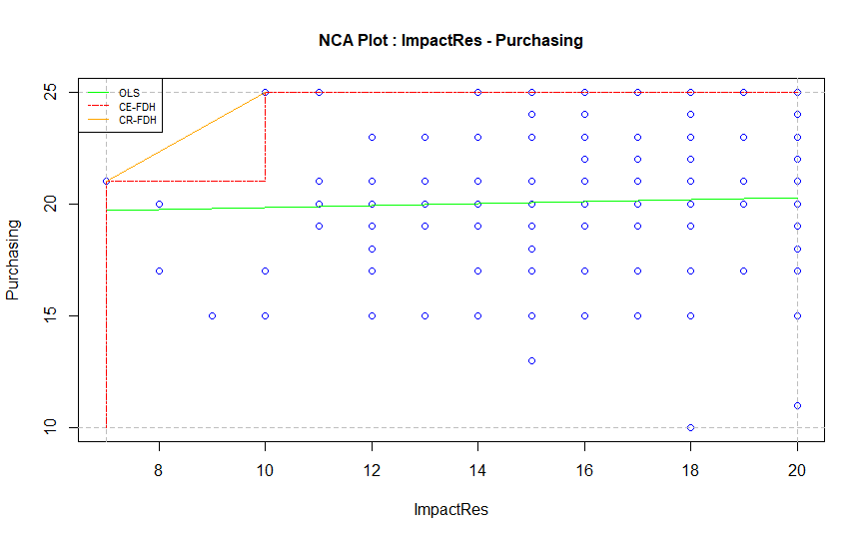 | 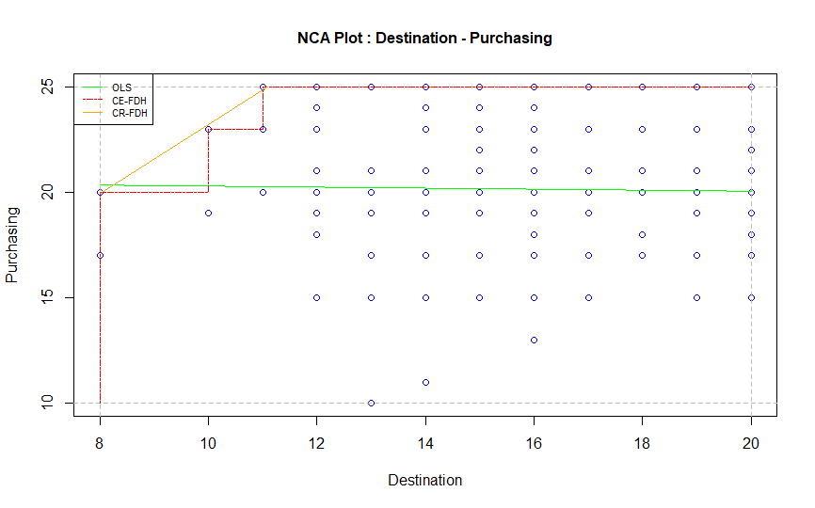
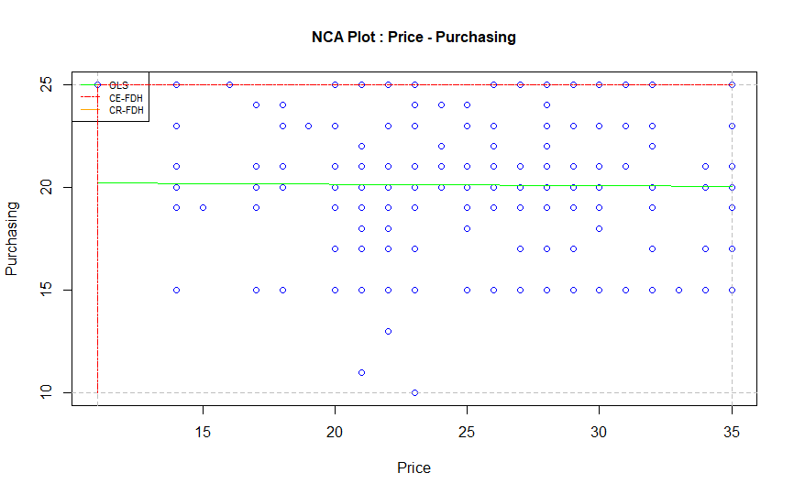 | 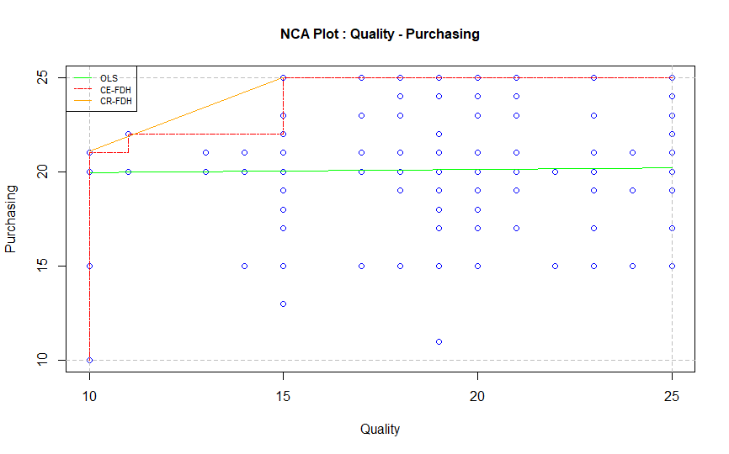
2020
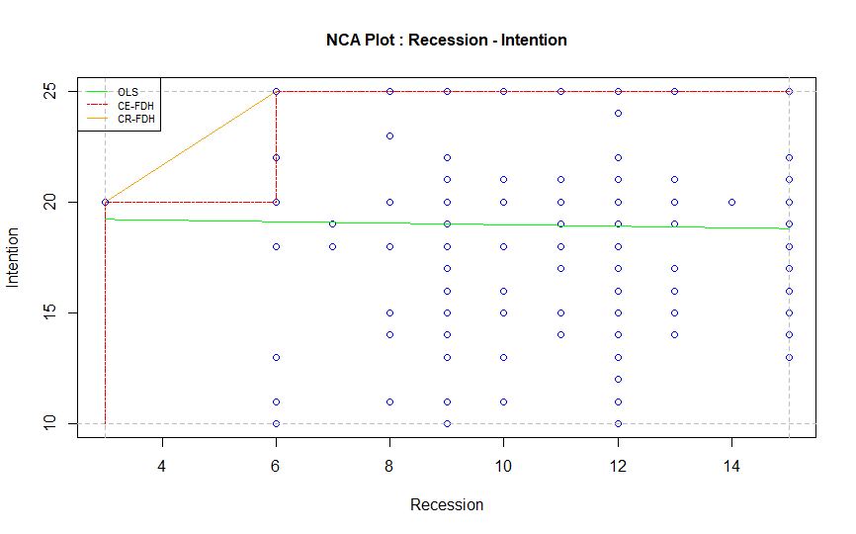 | 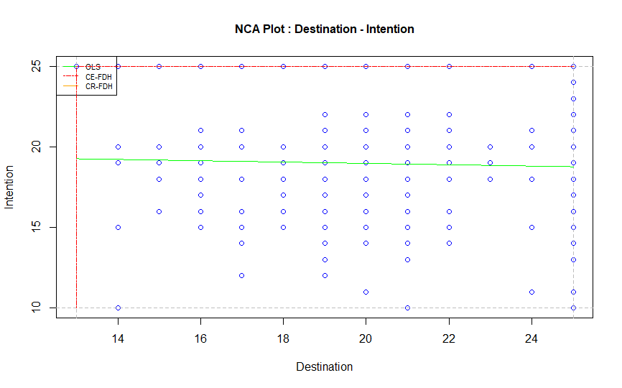
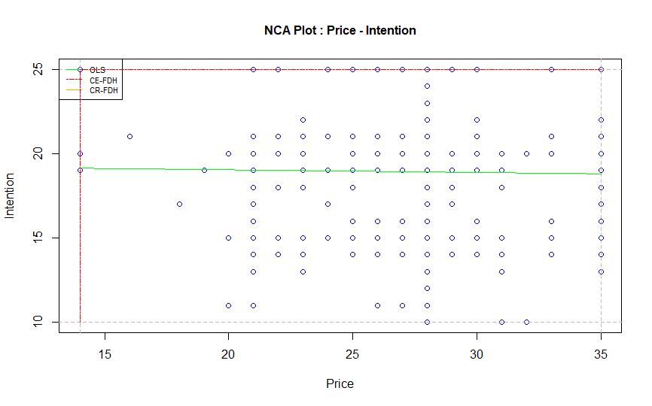 | 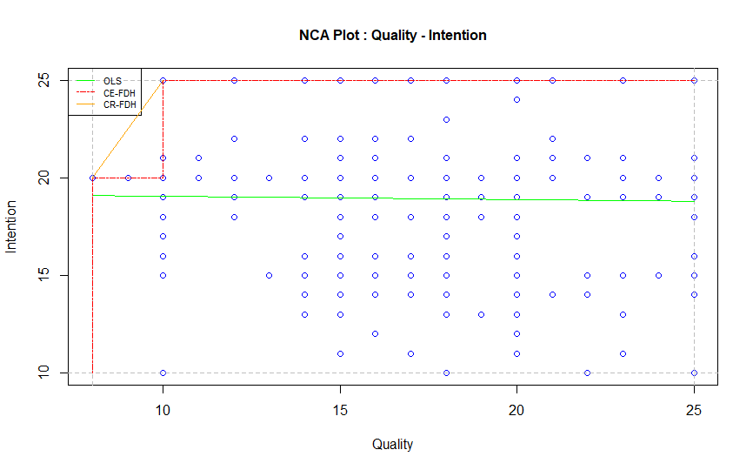
2021
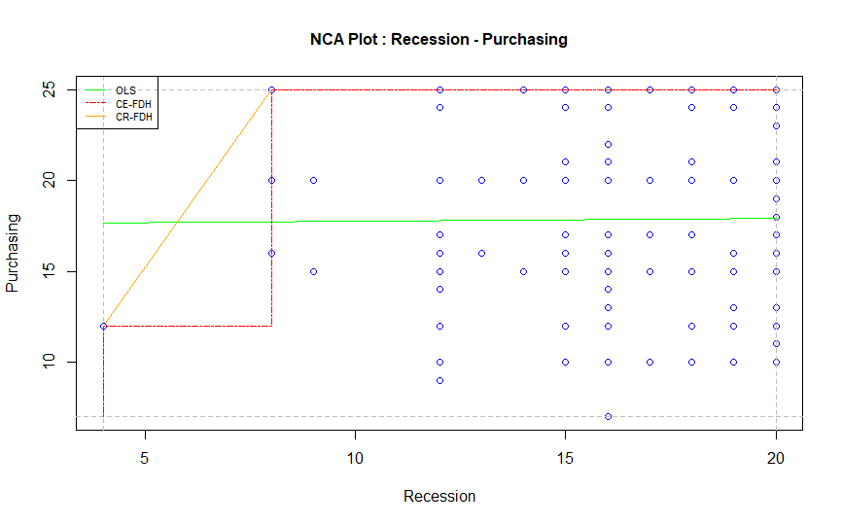 | 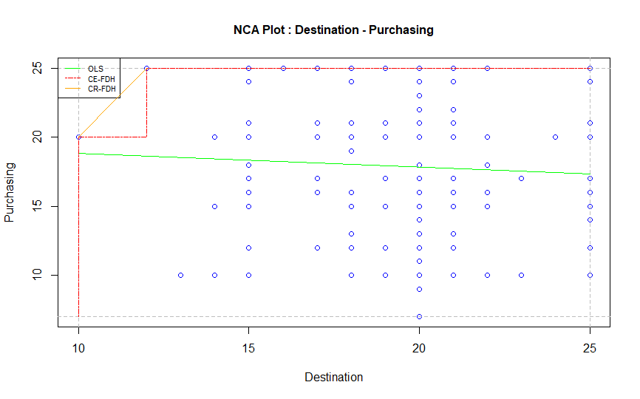
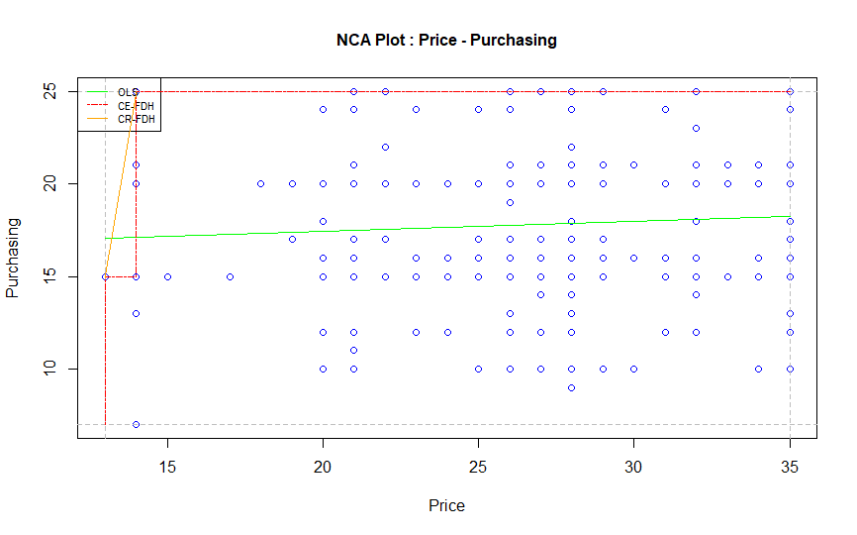 | 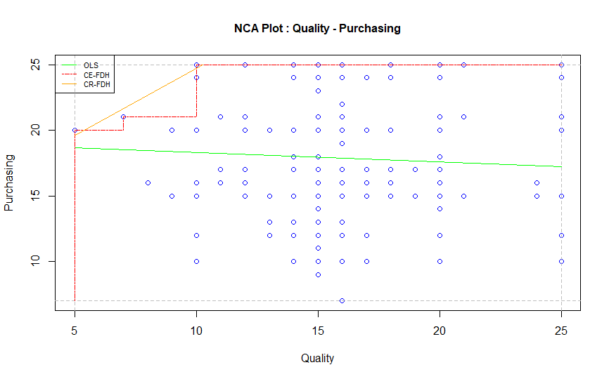

According to ERiM (2022), when examining complexity the presence of at least one necessary condition is important, otherwise the outcome will not occur. Based upon the findings, all three sufficient configurations in all three researches include at least one simple condition that generates size effects. In terms of the 2019 research, price risks although not necessary, contribute to the pathways in which they are included, to achieve the desired outcome (purchasing intention). The same applies to the 2020 research in terms of the simple conditions of destination selection and price risks. Conversely, in the 2021 research, the existence of all simple conditions is necessary for the holidaymakers to reach purchasing intention.

- Discussion

7.1 Sufficient configurations
The fsQCA results of all three researches (and their evaluation over time) meet the study’s aim, illustrating the longitudinal impact of COVID-19 upon tourist purchasing intentions. In the first two researches (2019; 2020) the first solution reveals that the price and quality nexus (impact of recession; price risks; quality risks), including the socio-demographics of income and travel mode, affect the purchasing intentions of holidaymakers. For the 2019 study this can be explained by the fact that it was the first year of economic growth after a prolonged recession that had lasted for a decade (Council on Foreign Relations, 2021). In 2020, the economic crisis returned due to COVID-19, severely affecting the Greek economy (Clark, 2021; Eurostat, 2021; O’ Neill, 2021). However, concerning 2021, this pathway is positioned as the second generated solution, surpassed by the configuration that had a financial focus (impact of recession; price risks). This can be explained from the perspective that the optimistic view the holidaymakers had during 2019 (exiting recession) and 2020 (effective handling during the first wave of the pandemic [Aristotle University, 2020]), was replaced (2021 research) by the considerable negative effects of the pandemic on the Greek economy in the previous year, and the realization that the socio-economic effects of COVID-19 are not short-term but will continue for some time. In all three researches, the third pathway concerns the orientation of the destination (destination selection; quality risks) including the socio-demographics of age and travel mode. It is apparent that destination characteristics (combined with quality) can still affect the purchasing decisions of holidaymakers. However, in all three researches this configuration appears to have the lower consistency, indicating the priority of the price-quality nexus and the financial focus amongst holidaymakers.

Another interesting aspect concerning the generated solutions is the existence of size effects (NCA). In all three researches, the impact of recession and quality risks generates size effects. In terms of each research separately, the 2019 results reveal that price risks, although significant, are not considered necessary (no size effects identified) to achieve the desired outcome (purchase intention). The 2020 research also included destination selection as the second simple condition that does not generate size effects. Conversely, in the 2021 findings all the examined antecedents generated low (destination selection; price risks; quality risks) or medium (impact of recession) size effects. These findings reveal the dominance of the impact of recession and quality risks upon the holidaymakers’ decision-making throughout time. They also highlight that, as COVID-19 effects are prolonged, the simple conditions that were not previously (2019; 2020) considered necessary for reaching the desired outcome (purchasing intentions), have now (2021) becoming essential to the holidaymakers’ formulation of decisions, and without them the desired outcome cannot be reached. This indicates that, as time passes, consumers have become more demanding and cautious in their decisions, and are considerably influenced by the socio-economic and health aspects of the COVID-19 crisis. Hence, it can be said that the effects of the pandemic upon purchasing intentions will continue to impact decision-making as long as both crises (socio-economic; health) continue. Therefore, even if the health crisis ceases to exist (hopefully within 2022), the socio-economic impact will continue to affect travel and tourism for a much longer period of time.

7.2 Confirmation of tenets
In all three researches (2019; 2020; 2021) the findings confirm the set tenets. The results confirm the first tenet (T1), since each of the four examined simple conditions (impact of recession; destination selection; price risks; quality risks) and the three socio-demographics are included in at least one of the generated sufficient configurations that lead to the same outcome (holidaymakers’ purchasing intention). Moreover, each of the sufficient pathways includes at least two of the antecedents. More specifically, the first solution (second in the 2021 research), focusing on price and quality aspects, includes three simple conditions (impact of recession; price risks; quality risks). The second generated solution (first in the 2021 research) embeds the antecedents of impact of recession and price risks. The third sufficient configuration includes destination selection and quality risks. These findings lead to the confirmation of the second tenet (T2). Regardless for the moment of the solution hierarchy, all the researches generate three pathways (S1: price-quality nexus; S2: financial focus; S3: destination orientation), which means that the third tenet (T3) is also confirmed. All the simple conditions under examination (including the three socio-demographics) are included in at least one sufficient configuration. Conversely, none of them appears to generate a high outcome score in all pathways. Hence, the findings confirm the contrarian case analysis (T4). The holidaymakers’ purchasing intention (desired outcome) can be met from all three generated solutions. On the other hand, none of those solutions has a high outcome score (coverage), but only partially covers the examined samples. This leads to the confirmation of the equifinality principle (T5). The moderate outcome score of each solution indicates that none of them applies in all cases, leading to the confirmation of the sixth tenet (T6).

7.3 Managerial implications
The employment of fsQCA and the complementary use of NCA have revealed three solutions (price-quality nexus; financial focus; destination orientation) that can also be taken under consideration in a managerial level.

The results indicate that, as time has passed, the COVID-19 socio-economic and health crisis has increased its impact upon holidaymakers’ decision-making. Considering that the socio-economic crisis will last much longer than the health crisis generated by the pandemic, the tourism and hospitality industry needs to focus on two different aspects. First, the industry needs to create the appropriate health and safety conditions to regain consumer trust. This could include upgraded sanitation processes, continuous monitoring of health conditions, tailored services focused on health aspects, and collaboration between different enterprises and organisations. Second, tourism and hospitality enterprises should focus on upgrading the added value of products and services (with special reference to quality issues and risks), whilst in parallel they should try to minimize the monetary costs of their offerings.

Another aspect is the necessity for further and stronger collaboration between the tourism and hospitality companies and the central State. The economic crisis (and its social dimensions) generated by COVID-19 cannot be handled by the industry alone. Several strategies and policies need to be jointly strengthened and employed such as the advancement of social and responsible tourism, the formulation of a legislative framework safeguarding tourists’ health issues, collaboration for the achievement of the fastest possible economic recovery, and the more equal distribution of tourism economic benefits to local communities. Considering that an ineffective resolution to a crisis can generate multiple and maybe more severe crises (Pappas, 2018), the strengthening of the collaboration between the tourism industry and the State is pivotal. An effective joint effort could minimize the impact of pandemic-related crises, restore consumer trust, and establish a relevant business and operational normality.

One more aspect that needs to be considered is international collaboration. The pandemic has proven that no country alone can handle such severe conditions. If such crises are not appropriately and consistently handled worldwide, they cannot be resolved (United Nations, 2021). It is time to understand that, due to transport intensity and technological advancements, we now live in a ‘global village’. This means that crises that were once considered local or regional (e.g. epidemics, recessions, environmental degradation) have the potential to become global. Since tourism is an industry with globalized operations and is consequently defined by an international perspective, it could play a significant role in the establishment of this international understanding and be used to strengthen international collaboration.

- Conclusions
This multi-year research (2019; 2020; 2021) has examined the longitudinal chaordic systems of COVID-19 upon the purchasing intentions of adult Athenian holidaymakers. In the theoretical domain the study contributes to our understanding of the complexity of purchasing intentions and their evolution over time. From a methodological perspective the contribution concerns the examination of the chaordic systems and their concomitant complexity through the use of fsQCA, a method that has only recently begun to be used in tourism and services. Furthermore its contribution concerns the complementary employment of NCA for the identification of size effects; this is a new method in the service sector. The results generate three pathways (price-quality nexus; financial focus; destination orientation) that are able to lead to the desired outcome (purchase intention). They also highlight the necessity to take into account the impact of recession and quality risks over time (evaluation of size effects), and the transformation of destination selection and price risks from desirable to necessary factors. Finally, the study provides several managerial implications, related to the findings, for future consideration.

Regardless of the contribution of this study, a number of limitations should be taken into consideration. To begin with, the longitudinal aspects of the impacts of COVID-19 need to be continually examined in future research. This is because the pandemic is the most severe crisis that not only tourism, but humanity, has faced since the Second World War. In addition, the pandemic and its impacts are evolving rapidly, reshaping the business environment with unprecedented speed. Hence, longitudinal research concerning aspects such as destination strategies, tourist safety perceptions, the perspectives of locals regarding tourism, and the progression of a more responsible and sustainable formulation of tourist products and services is strongly suggested. Second, this research has focused on the perspectives of adult Athenian holidaymakers over a three-year period. Similar research in another region or country may generate different results. Therefore, we should be cautious when deciding whether to replicate or generalize the presented findings. Third, the study longitudinally evaluates the complex perspectives of holidaymakers. A comparison of such results with a similar evolution of perceptions concerning tourism stakeholders and decision-makers could provide a more holistic view of the chaordic impacts of COVID-19. Finally, the research included the socio-demographics of age, monthly income, and travel mode. The inclusion and examination of other characteristics such as level of education, marital (and family) status, and travel frequency may assist us to further comprehend the complex formulation of holidaymakers’ perspectives.

As is apparent from the research findings, even when the health crisis aspect of the pandemic is over, the socio-economic crisis will continue to substantially affect the travel and tourism industry in forthcoming years. This was the first time in history that, regardless of country, humanity has had to face, at the same time, a common enemy. Unfortunately, this is far from over. As repeatedly stated by the scientific community, the ultimate challenge faced by humanity in the near future is climate change (Aliyari et al., 2021; Coelho, et al., 2021; Tjärnemo and Södahl, 2015), because it is also connected with increasingly severe epidemics and pandemics (Semenza and Paz, 2021). The paradigm developed in response to the COVID-19 pandemic could become our means to understanding that humanity needs to act now and needs to be united. It is time to understand that our survival depends on our collaboration, and our efforts to find common pathways for our common future.

References
Agag, G., Abdul-Danhab, S., Shehawy, Y.M., et al., 2022. Impacts of COVID-19 on the post-pandemic behaviour: The role of mortality threats and religiosity. Journal of Retailing and Consumer Services, 67, 102964.
Akis, S., Peristianis. N., Warner, J., 1996. Residents’ attitudes to tourism development: the case of Cyprus. Tourism Management, 17(7), 481-494.
Alegre, J., Mateo, S., Pou, L., 2013. Tourism participation and expenditure by Spanish households: The effects of the economic crisis and unemployment. Tourism Management, 39, 37-49.
Aliyari, F., Bailey, R.T., Arabi, M., 2021. Appraising climate change impacts on future water resources and agricultural productivity in agro-urban river basins. Science of the Total Environment, 788, 147717.
Amnesty International, 2021. Greece: COVID-19 crisis exposes urgent need to bolster austerity-ravaged health system. https://www.amnesty.org/en/latest/news/2020/04/greece-covid-crisis-exposes-urgent-need-to-bolster-austerity-ravaged-health-system/ (Accessed 5 December 2021)
APE-MPE, 2020. The first case of Coronavirus in Greece – positive sample in Thessaloniki. Published 26/02/2020, https://www.amna.gr/home/article/434170/To-proto-krousma-koronaiou-stin-Ellada (Accessed 21 November 2021) [In Greek]
Aristotle University, 2020. Research for the first COVID-19 wave in Greece. Aristotle University of Thessaloniki, Published 3/11/2020, https://www.auth.gr/press/28538/ (Accessed 4 December 2021) [in Greek]
Ayoko, O. B., Caputo, A., Mendy, J., 2021. Management research contributions to the COVID-19: a bibliometric literature review and analysis of the contributions from the Journal of Management & Organization. Journal of Management & Organization, 27(6), 1183-1209.
Becken, S., Shuker, J., 2019. A framework to help destinations manage carbon risk from aviation emissions. Tourism Management, 71, 294-304.
Bermes, A., 2021. Information overload and fake news sharing: A transactional stress perspective exploring the mitigating role of consumers’ resilience during COVID-19. Journal of Retailing and Consumer Services, 61, 102555.
Boto-Garcia, D., Leoni, V., 2022. Exposure to COVID-19 and travel intentions: Evidence from Spain. Tourism Economics, 28(6), 1499-1519.
Butler, S.D., 2021. Impacted publics’ perceptions of crisis communication decision making. Public Relations Review, 47, 102120.
Cambra-Fierro, J., María Fuentes-Blasco, M., Gao, L.X., et al., 2022. The influence of communication in destination imagery during COVID-19 Journal of Retailing and Consumer Services, 64, 102817.
Caputo, A., Schiocchet, E., Troise, C., 2022. Sustainable business models as successful drivers in equity crowdfunding. Business Strategy & the Environment, 31(7), 3509-3522.
Chantzaras, A.E., Yfantopoulos, J.N., 2018. Financial protection of households against health shocks in Greece during the economic crisis. Social Science and Medicine, 211, 338-351.
Clark, D., 2021. Average annual wages in Greece 2000-2020. Statista, Published 23/07/2021, https://www.statista.com/statistics/416209/average-annual-wages-greece-y-on-y-in-euros/ (Accessed 28 November 2021)
Coelho, S., Rafael, S., Lopes, D., et al., 2021. How changing climate may influence air pollution control strategies for 2030? Science of the Total Environment, 758, 143911.
Council on Foreign Relations, 2021. Greece’s debt. https://www.cfr.org/timeline/greeces-debt-crisis-timeline (Accessed 5 December 2021)
Das, M., Ramalingam, M., 2022. What drives product involvement and satisfaction with OFDs amid COVID-19? Journal of Retailing and Consumer Services, 68, 103063.
Deya-Tortella, B., Leoni, V., Ramos, V., 2022. COVID-led consumption displacement: A longitudinal analysis of hotel booking patterns. International Journal of Hospitality Management, 107, 103343.
Du, J., Huang, T., Sheng, Z., 2009. Analysis of decision-making in economic chaos control. Nonlinear Analysis: Real World Applications, 10(4), 2493-2501.
Dul, J., 2020. Conducting Necessary Condition Analysis. Sage Publications, Thousand Oaks.
ERiM, 2022. Reduction of complexity. https://www.erim.eur.nl/necessary-condition-analysis/about-nca/nca-philosophy/reduction-of-complexity/ (Accessed 27 March 2022)
Eurostat, 2021. GDP and main components (output, expenditure and income). https://ec.europa.eu/eurostat/databrowser/view/NAMA_10_GDP__custom_78848/bookmark/table?lang=en&bookmarkId=7681260e-2f75-4cd7-a153-02fc89543f2c (Accessed 25 May 2022)
Farmaki, A., Pappas, N., 2022. Poverty and tourism decision-making: A chaordic perspective. International Journal of Contemporary Hospitality Management, 34(3), 1012-1036.
Fiss, P.C., 2011. Building better casual theories: A fuzzy set approach to typologies in organizational research. Academy of Management Journal, 54(2), 393-420.
Fitzgerald, L.A., Van-Eijnatten, F.M., 2002. Reflections: chaos in organizational change. Journal of Organizational Change Management, 15(4), 402-411.
Formanek, T., Sokol, O., 2022. Location effects: Geo-spatial and socio-demographic determinants of sales dynamics in brick-and-mortar retail stores. Journal of Retailing and Consumer Services, 66, 102902.
Glezakos, M. 2022. Greek summer without Greeks: The two sides of the coin. Business Daily, Published 31/08/2022, https://www.businessdaily.gr/apopseis/69645_elliniko-kalokairi-horis-ellines-oi-dyo-opseis-toy-toyrismoy (Accessed 15 October 2022) [In Greek]
Hellenic Republic, 2021. 49th observatory progress report. Published 17/05/2021, https://covid19.gov.gr/49i-ekthesi-proodou-paratiritiriou/ (Accessed 21 December 2021) [In Greek]
Houry, S.A., 2012. Chaos and organizational emergence: Towards short term predictive modeling to navigate a way out of chaos. Procedia Systems Engineering, 3, 229-239.
Huang, C.C., Wang, Y.M., Wu, T.W., et al., 2013. An empirical analysis of the antecedents and performance consequences of using the Moodle platform. International Journal of Information and Education Technology, 3(2), 217-221
Islam, T., Pitafi, A.H., Arya, V., et al., 2021. Panic buying in the COVID-19 pandemic: A multi-country examination. Journal of Retailing and Consumer Services, 59, 102953.
Kauffman, S., Peterson, C., Samuelsson, B., et al., 2003. Random Boolean net-work models and the yeast transcriptional network. In: Proceedings of the National Academy of Sciences of the United States of America, 100(25), 14796–14799.
Keramidou, I., Triantafyllopoulos, L., 2018. The impact of the financial crisis and austerity policies on the servicequality of public hospitals in Greece. Health Policy, 122, 352-358.
Kim, J.H., 2014. The antecedents of memorable tourism experiences: The development of a scale to measure the destination attributes associated with memorable experiences. Tourism Management, 44, 34-45.
Kumar, V., Leone, R.P., Aaker D.A., et al., 2020. Marketing research. 13th Eds., Wiley, New York.
Lahmiri, S., 2017. On fractality and chaos in Moroccan family business stock returns and volatility. Physica A, 473, 29-39.
Larios-Gomez, E., Fischer, L., Penalosa, M., et al., 2021. Purchase behavior in COVID-19: A cross study in Mexico, Colombia, and Ecuador. Heliyon, 7, e06468.
Lim, W.M., Aggarwal, A., Dandotiya, R., 2022. Marketing luxury services beyond affluence in the new normal: Insights from fine dining during the coronavirus pandemic. Journal of Retailing and Consumer Services, 66, 102936.
Longest, K., Vaisey, S., 2008. Fuzzy: A Program for performing Qualitative Comparative Analyses (QCA) in STATA. The STATA Journal, 8(1), 79-104.
Mak, A.H.N., 2017. Online destination image: Comparing national tourism organisation's and tourists' perspectives. Tourism Management, 60, 280-297.
Manifava, D., 2021. During 2020, the Greeks have reduced their travels and overnights. Kathimerini, Published 31/07/2021, https://www.kathimerini.gr/economy/561451411/meiosan-taxidia-kai-ekanan-ligoteres-dianyktereyseis-oi-ellines-to-2020/ (Accessed 05 December 2021)
Marzi, G., Fakhar Manesh, M., Caputo, A., Pellegrini, M.M, Vlacic, B., 2023. Do or do not. Cognitive configurations affecting open innovation adoption in SMEs. Technovation, 119, 102585.
Matsuura, T., Saito, H., 2022. The COVID-19 pandemic and domestic travel subsidies. Annals of Tourism Research, 92, 103326.
Mehran, J., Olya, H., 2020. Canal boat tourism: Application of complexity theory. Journal of Retailing and Consumer Services, 53, 101954.
Menshouse, 2020. The reason that Greece has less cases than the country with the best health system worldwide. https://menshouse.gr/epikerotita/123645/o-logos-poy-i-ellada-echei-ligotera-kroysmata-apo-ti-chora-me-to-kalytero-systima-ygeias-ston-kosmo (Accessed 21 November 2021) [In Greek]
Moufakkir, O., 2014. What’s immigration got to do with it? Immigrant animosity and its effects on tourism. Annals of Tourism Research, 49, 108-121.
Murray, N., Lynch, P., Foley, A., 2022. Strategic nets in tourism destinations: Investigating the learning processes underpinning dynamic management capabilities. Industrial Marketing Management, 106, 363-375.
Mycek, P., Contreras, A., Le Maître, O., et al., 2017. A resilient domain decomposition polynomial chaos solver for uncertain elliptic PDEs. Computer Physics Communications, 216, 18-34.
Nilashi, M., Abumalloh, R.A., Minaei-Bidgoli, B., et al., 2022. Revealing travellers’ satisfaction during COVID-19 outbreak: Moderating role of service quality. Journal of Retailing and Consumer Services, 64, 102783.
Nunnally, J.C., 1978. Psychometric theory. 2nd Eds. New York: McGraw-Hill.
O’Neill, A. (2021). Unemployment rate in Greece 2020. Statista, Published 30/06/2021, https://www.statista.com/statistics/263698/unemployment-rate-in-greece/ (Accessed 28 January 2022)
OECD, 2021. Building a resilient recovery: Emerging stronger from the COVID-19 pandemic. Organisation for Economic Co-operation and Development, https://www.oecd.org/coronavirus/en/ (Accessed 7 December 2021)
Olmedo, E., Mateos, R., 2015. Quantitative characterization of chaordic tourist destination. Tourism Management, 47, 115-126.
Olya, H., & Al-Ansi, A., 2018. Risk assessment of halal products and services: Implication for tourism industry. Tourism Management, 65, 279-291.
Ordanini, A., Parasuraman, A., Rubera, G., 2014. When the recipe is more important than the ingredients: A Qualitative Comparative Analysis (QCA) of service innovation configurations. Journal of Service Research, 17(2), 134-149,
Papantoniou, S., 2021. Vaccination: Prefectures in Northern Greece – The regions with less than 50% vaccination rates. Kathimerini, Published 19/10/2021, https://www.kathimerini.gr/politics/561545980/emvoliasmos-sto-mikroskopio-nomoi-sti-voreia-ellada-oi-perioches-me-pososto-kato-apo-50/ (Accessed 4 December 2021) [In Greek]
Papatheodorou, A., Pappas, N., 2017. Economic Recession Job Vulnerability and Tourism Decision-Making: A Qualitative Comparative Analysis. Journal of Travel Research, 56(5), 663-677.
Pappas, N., 2016. Marketing strategies, perceived risks, and consumer trust in online buying behaviour. Journal of Retailing and Consumer Services, 29, 92-103.
Pappas, N., 2017. The complexity of purchasing intentions in peer-to-peer accommodation. International Journal of Contemporary Hospitality Management, 29(9), 2302-2321.
Pappas, N., 2018. Hotel decision-making during multiple crises: A chaordic perspective. Tourism Management, 68, 450-464.
Pappas, N., 2021. COVID19: Holiday intentions during a pandemic. Tourism Management, 84, 104287.
Pappas, N., Caputo, A., Pellegrini, M. et al., 2021. The complexity of decision-making processes and IoT adoption in accommodation SMEs. Journal of Business Research, 131, 573-583.
Pappas, N., Glyptou, K., 2021. Accommodation decision-making during the COVID-19 pandemic: Complexity insights from Greece. International Journal of Hospitality Management, 93, 102767.
Polito, V., Wickens. M., 2012. A model-based indicator of the fiscal stance. European Economic Review, 56(3), 526-551.
Raghunathan, T., 2020. Missing data analysis in practice - Chapman and Hall/CRC interdisciplinary statistics series. CPC Press, Boca Raton.
Ragin, C.C., 2008. Redesigning Social Inquiry: Set Relations in Social Research. University of Chicago Press.
Reddy, M.V., Boyd, S.W., Nica, M., 2020. Towards a post-conflict tourism recovery framework. Annals of Tourism Research, 84, 102940.
Salomaa, M. Caputo, A., 2021. Business as usual? Assessing the impact of the COVID-19 pandemic to research, development and innovation (RDI) activities of universities of applied sciences. Tertiary Education and Management, 27, 351-366.
Saurin, T.A., 2021. A complexity thinking account of the COVID-19 pandemic: Implications for systems-oriented safety management. Safety Science, 134, 105087.
Schuldberg, D., 2011. Chaos theory and creativity. Encyclopedia of Creativity, 183-191.
Sekaran, U., Bougie, R., 2020. Research methods for business: A skill building approach. 8th Eds., Wiley and Sons, Chennai.
Semenza, J.C., Paz, S., 2021. Climate change and infectious disease in Europe: Impact, projection and adaptation. The Lancet Regional Health – Europe, 9, 100230.
Shapiro, S.L., Reams, L., So, K.K.F., 2019. Is it worth the price? The role of perceived financial risk, identification, and perceived value in purchasing pay-per-view broadcasts of combat sports. Sport Management Review, 22(2), 235-246.
Shin, H., Nicolau, J.L., Kang, J., et al., 2022. Travel decision determinants during and after COVID-19: The role of tourist trust, travel constraints, and attitudinal factors. Tourism Management, 88, 104428.
Skarmeas, D., Leonidou, C.N., Saridakis, C., 2014. Examining the role of CSR skepticism using fuzzy-set qualitative comparative analysis. Journal of Business Research, 67, 1796-1805.
Smith, A. Humphries, C., 2004. Complexity theory as a practical management tool: A critical evaluation. Organization Management Journal, 1(2), 91-106.
Souki, S. 2022. Prediction for 20 billion Euros from tourism for 2022. Newmoney, Published 24/06/2022, https://www.newmoney.gr/roh/palmos-oikonomias/tourismos/provlepsi-gia-esoda-20-dis-evro-apo-ton-tourismo-to-2022 (Accessed 15 October 2022) [In Greek]
Sun, J., 2014. How risky are services? An empirical investigation on the antecedents and consequences of perceived risk for hotel service. International Journal of Hospitality Management, 37, 171-179.
The World Bank, 2021. GDP growth (annual %) – Greece. https://data.worldbank.org/indicator/NY.GDP.MKTP.KD.ZG?locations=GR (Accessed 17 December 2021)
Thietart, R., Forgues, B., 1995. Chaos theory and organization. Organization Science, 6(1), 19-31.
Thrane, C., Farsad, E., 2011. Domestic tourism expenditures: The non-linear effects of length of stay and travel party size. Tourism Management, 32(1), 46-52.
Tjärnemo, H., Södahl, L., 2015. Swedish food retailers promoting climate smarter food choices—Trapped between visions and reality? Journal of Retailing and Consumer Services, 24, 130-139.
Tornos, 2021. Greek tourism 2021: Over 10 billion tourist receipts and 14 million the visitors. Published 22/12/2021, https://www.tornosnews.gr/statistics/54490-ellhnikos-toyrismos-2021-me-eispraxeis-ano-ton-10-diseyro-kai-14-ekat-toyriston-kleinei-h-chronia.html (Accessed 16 October 2022) [In Greek]
Torres, E.N., Ridderstaat, J., Wei, W., 2021. Negative affectivity and people’s return intentions to hospitality and tourism activities: The early stages of COVID-19. Journal of Hospitality and Tourism Management, 49, 89-100.
Trading Economics, 2019. Greece average monthly salary. https://tradingeconomics.com/greece/wages (Accessed 19 March 2019).
Truong, D., Truong, M.D., 2022. How do customers change their purchasing behaviors during the COVID-19 pandemic? Journal of Retailing and Consumer Services, 67, 102963.
Tsilidis, L., 2021. Vital need to support tourist offices until June 2022. Tornos News, Published 30/11/2021, https://www.tornosnews.gr/permalink/54107.html (Accessed 4 December 2021) [In Greek]
United Nations, 2021. Economic recovery under threat amid surging COVID cases and lagging vaccination in poorer countries. https://www.un.org/en/desa/wesp-mid-year-update-2021 (Accessed 7 January 2022)
UNWTO, 2020. COVID19: Putting people first. United Nations World Tourism Organisation, https://www.unwto.org/tourism-covid-19 (Accessed 24 May 2020)
UNWTO, 2021a. COVID19: Putting people first. United Nations World Tourism Organisation, https://www.unwto.org/tourism-covid-19 (Accessed 20 December 2021)
UNWTO, 2021b. International tourism and COVID-19. United Nations World Tourism Organisation, https://www.unwto.org/international-tourism-and-covid-19 (Accessed 4 December 2021)
Van-Eijnatten, F.M., Putnik, G.T., Sluga, A., 2007. Chaordic systems thinking for novelty in contemporary manufacturing. CIRP Annals - Manufacturing Technology, 56(1), 447-450.
Waz, P., Waz, D.B., 2009. Asymmetry coefficients as indicators of chaos. Acta Physica Polonica A, 116(6), 987-991.
Weick, K.E., Sutcliffe, K.M., 2007. Managing the unexpected: Resilient performance in an age of uncertainty. San Francisco: Jossey-Bass.
WHO, 2020. Rolling updates on coronavirus disease (COVID-19). World Health Organisation. https://www.who.int/emergencies/diseases/novel-coronavirus-2019/events-as-they-happen (Accessed 20 May 2020)
Wieczorek-Kosmala, M., 2022. A study of the tourism industry's cash-driven resilience capabilities for responding to the COVID-19 shock. Tourism Management, 88, 104396.
Woodside, A.G., 2013. Moving beyond multiple regression analysis to algorithms: Calling for adoption of a paradigm shift from symmetric to asymmetric thinking in data analysis and crafting theory. Journal of Business Research, 66(4), 463-472.
Woodside, A.G., 2014. Embrace•perform•model: Complexity theory, contrarian case analysis, and multiple realities. Journal of Business Research, 67, 2495-2503.
Woodside, A.G., Zhang, M., 2013. Cultural diversity and marketing transactions: Are market integration, large community size, and world religions necessary for fairness in ephemeral exchanges? Psychology and Marketing, 30(3), 263-276.
Wu, K., Vassileva, J., Noorian, Z., et al., 2015. How do you feel when you see a list of prices? the interplay among price dispersion, perceived risk and initial trust in Chinese C2C market. Journal of Retailing and Consumer Services, 25, 36-46.
Wu, P.L., Yeh, S.S., Huan, T.C., et al., 2014. Applying complexity theory to deepen service dominant logic: Configural analysis of customer experience-and-outcome assessments of professional services for personal transformations. Journal of Business Research, 67(8), 1647-1670.
Zahra, A., Ryan, C., 2007. From chaos to cohesion—Complexity in tourism structures: An analysis of New Zealand’s regional tourism organizations. Tourism Management, 28(3), 854-862.
Zhai, X., Zhong, D., Luo, Q., 2019. Turn it around in crisis communication: An ABM approach. Annals of Tourism Research, 79, 102807.
Zhang. H., Song, H., Wen. L., et al., 2021. Forecasting tourism recovery amid COVID-19. Annals of Tourism Research, 87, 103149.

