Article
Prospects for Islamic Home Finance in the UK: An Assessment with Partial Least Square Structural Equation Modelling
Tanveer Ahmed ¹*, Sarkar Kabir ², Aqsa Aziz ³ , Yahaya Alhassan ⁴
¹ Faculty of Business, Law and Tourism, University of Sunderland in London, 197 Marsh Wall, London E14 9SG, United Kingdom; tanveer.ahmed@sunderland.ac.uk
² Faculty of Business and Law, Coventry University, Priory Street, Coventry, CV1 5FB, United Kingdom; ac5892@coventry.ac.uk
³ Faculty of Business and Law, Coventry University, Priory Street, Coventry, CV1 5FB, United Kingdom; bsx215@coventry.ac.uk
⁴ Faculty of Business, Law and Tourism, University of Sunderland in London, 197 Marsh Wall, London E14 9SG, United Kingdom; yahaya.alhassan@sunderland.ac.uk
* Correspondence: tanveer.ahmed@sunderland.ac.uk

Abstract: Previous studies assessing the prospects for Islamic home finance in the UK appear to be outdated, predominantly limited to the one-sided views of Islamic scholars/customers without the support of a sound conceptual framework, thereby lacking any research rigour. This study developed an up-to-date conceptual framework constituting four predicting constructs (extendibility, accessibility, affordability and authenticity) — and the target construct prospects (for Islamic home finance in the UK). The framework was assessed by utilising a sample of 144 industry experts (mortgage consultants), deriving their experience (high vs. low) as a categorical variable. The path analysis suggests that accessibility had a significant effect on the prospects for Islamic home finance in the UK, whereas the impact of affordability was insignificant. In contrast, authenticity had the strongest direct effect on the prospects. The multi-group analysis discovered no significant differences between experienced and novice mortgage consultants in relation to the impact of predicting constructs (e.g., affordability, accessibility) on the prospects (for Islamic home finance in the UK). The importance–performance matrix analysis (IPMA) identified authenticity as the high-priority development area, whereas affordability-related attributes of Islamic home finance were found in a low-priority zone. The results and findings of this study provide new and extensive insights into the field of Islamic home finance and contribute to the extant literature in this domain.
Keywords: Islamic home finance; Islamic mortgages; ethical home finance, PLS-SEM

1. Introduction
In the last 10 years, there has been exceptional growth in Islamic finance even though it is an evolving industry, and this has been a period of financial and economic uncertainty. This is evidenced by the recent ICD-Refinitiv report which projects that global Islamic finance assets will reach $3.69 trillion by 2024, more than double the assets recorded in 2012 ($1.76 trillion) [1]. The increase in Islamic finance is due to the huge rise in demand from the Middle East and other Muslim countries, as well as from other non-Muslim countries across the world [1, 2]. The UK has also recognised the appeal of Islamic finance and in 2013 the UK government established an Islamic Finance Task Force (IFTF) to promote London as a European hub for this sector. As a measure of the success, Islamic banks in the UK have expanded and now have assets of over £5bn [3]. However, it must be pointed out that the reported growth in Islamic home finance has been somewhat anecdotal. According to the recent figure, merely 2,500-3,000 residential and buy-to-let Islamic mortgages are issued in the UK each year [4]. This growth seems to be quite discouraging, bearing in mind that Islamic housing finance has been freely available since 2004 when the UK’s first standalone Sharia’h- compliant bank, Al Rayan Bank (formerly known as Islamic Bank of Britain) started its operation in the country. Moreover, the withdrawal of Lloyds and HSBC from the Islamic home finance market in 2010 and 2012 respectively has raised questions about the prospects for Islamic home finance in the UK.
Globally, Islamic Finance has moved from experimental and amorphous phases into the metamorphosis stage [5] and is becoming an alternative option due to its principles based on partnerships and fairness. The equitable nature of Islamic home finance makes it unique and promotes a healthier and more stable financial system. ​Despite this, there appears to have been very little upward trend in the UK. Nevertheless, with the rapidly changing financial environment, the government’s ambitious plan to promote London as an Islamic finance hub and the changing attitude of consumers towards ethical finance, there may be a change in the prospects for Islamic home finance in the UK. This scenario presents an opportunity to explore the prospects of Islamic finance in the UK in the current context. Over the decades, Islamic home finance has attracted considerable attention in the Islamic Finance literature. In the context of the UK, a number of empirical studies [6, 7, 8] have attempted to assess the challenges, scope, potential and demand for Islamic home finance. However, these studies and other vast majority of the extant studies [9, 10, 11] failed to take account of opinions voiced by independent and industry-led experts. Similarly, other studies [12, 13, 14, 15,16,17) adopted a one-size-fits-all approach by focusing on an overall picture of Islamic finance without any real emphasis on Islamic home finance. Some secondary research that solely focused on Islamic home finance (6, 18) is essentially out of date owing to changes in the demographic landscape of the Muslim population and developments in the financial environment.

As the current literature has a high degree of sampling bias (i.e., mono-religious bias with Muslim customers and Islamic scholars) and ill-conceived participants (e.g., low socio-economically active Muslim customers), it raises doubts as to its reliability, generalisability and practical relevance. This also begs the question of how financial experts view the prospects of Islamic home finance. Furthermore, most of these studies suffer from a lack of a strong theoretical framework. Taken together, these limitations have created huge and important gaps in the literature on Islamic home finance. Unlike the majority of previous studies that were narrowly confined to customer segment, community or small geographical area, and overly reliant on non-industry experts, this research shifts this focus and examines the perspectives of the most neglected yet important stakeholders: fully qualified FCA-approved mortgage consultants. Similarly, it is important to consider the advent of new entrants and government efforts to bring Islamic banks into the mainstream market, as well as changes to the Muslim demographic and variability in the financial environment over the last decade (e.g., the sub-prime mortgage crisis). With this in mind, this study takes account of the impact of these events through the lens of mortgage brokers’ lived experience to assess whether the past episodes, and the transformation of Islamic home finance over the years, has had any significant effect on their views regarding its long-term prospects in the UK. In the following sections we discuss the theoretical background and hypotheses development of the research framework, evaluation of the measurement and structural models, data analysis, results, discussion and future directions.
2. Theoretical background and hypotheses development
2.1. Prospects (for Islamic Home Finance in the UK)

This is the key target construct in the conceptual framework. This construct refers to the extent to which there is a significant demand and the overall future prospects for Islamic home finance in the UK. Four latent constructs, namely accessibility, affordability, authenticity, and extendibility, and experience as a categorical moderating variable is hypothesised which are expected to influence the prospects (for Islamic Home Finance in the UK). These key constructs and moderating variable are sequentially discussed below.

2.2 Accessibility
Accessibility as a latent variable in conceptual framework refers to the extent to which Islamic home finance in the UK is readily accessible (and comprehensible) to potential clients. The literature suggests [19, 10, 17) that poor understanding of Islamic home finance, a lack of basic knowledge of its uses, and little awareness of its availability are key determinants affecting its success in the UK. Although the UK government actively promoted Islamic finance through various platforms, such as the Islamic Finance Task Force and the UK Islamic Finance Secretariat, which meant that the UK was a forerunner in the development of Islamic finance, its accessibility still remains a challenge within the UK home financing market. One reason is the withdrawal of two major high street banks (Lloyds and HSBC) and another key player Bristol and West from the Islamic home financing market, severely damaging the awareness and accessibility of Islamic home finance. This has left the majority of products to be offered by small banks, who already struggle to market Islamic home finance to the minority Muslim community [20].

The accessibility of Islamic finance has also suffered due to poor financial literacy amongst many Muslims in the UK, with many struggling to fully understand the fundamental basics of Islamic home finance [19]. According to Statista [21] 14.2% of Muslims in England and Wales have no qualifications, whereas 15% are educated at a secondary level (i.e. GCSE), making it difficult for them to comprehend the fundamentals of Islamic home finance. Further, the low levels of understanding of the imams (mosque leaders) have also restricted the accessibility of Islamic home finance who in many cases, are unable to explain the fundamentals of Islamic home financing to the Muslim community. This is further exacerbated by Islamic banks’ employees, who on occasions, fail to adequately explain the structure of the Islamic home finance products they offer to potential customers [22].

Other studies, for example [23] have also considered accessibility to be one of the most important factors for British Muslim banking customers in the UK. The findings of [10] also conclude that Islamic finance predominantly caters for the rich class and with poor accessibility for less affluent Muslims. Indeed, Islamic home finance has become a niche product, which has led to the inaccessibility of wide-ranging Islamic home finance products to the diverse Muslim community in the UK [16]. In the same manner, [24] found accessibility to be a concern for potential Muslim customers, acting as a real impediment to the prospects for Islamic home finance. In a nutshell, the accessibility of Islamic home finance is restricted by the scarcity of high street banks offering home financing, limited choice of product availability and poor financial literacy amongst the Muslim community in the UK. Thus, this validates the research hypothesis that:
H₁: Accessibility casts a significant positive impact on the prospects for Islamic home finance.
2.3. Affordability
This exogenous construct in the conceptual framework refers to the extent to which Islamic home finance is affordable or cost-effective for UK home finance customers. The commonly held belief that Islamic home finance is generally more expensive than interest- based home finance is well founded. Apparently, the instinct of a large number of UK Muslims is to avoid dealing with conventional home finance [27]. However, they are often dismayed by the cost of Islamic home finance in comparison to conventional mortgages. There is a consensus amongst the literature that reinforces this view. For example, a study [24] claims that Muslim customers were deterred from proceeding with Islamic home financing due to the higher cost of repayments. The study further refers to the need for a higher deposit as an added factor that makes Islamic home finance unaffordable for many potential customers. Another study [10] concludes that UK Muslims prefer Islamic finance, but its affordability (such as the need for a higher deposit) deters less affluent UK Muslims. On a similar note, it is suggested that Islamic home purchase plans are expensive and require a minimum 20% deposit for securing home finance in a market in which Muslims are disproportionately poor [9]. Other studies [22, 28, 13] also attribute higher costs as the key factor for the low uptake of Islamic home finance in the UK.
One of the key reasons for this discrepancy is due to the higher additional expenses that Islamic home finance providers must bear, such as the administration and legal cost as well as paying fees to Sharia’h scholars [29]. Similarly, the funding cost of Islamic banks are often higher because, unlike conventional banks, Islamic banks do not create money out of nothing or borrow funds at low interest rates either from the Bank of England or wholesale money markets. Instead, Islamic bank mainly rely on customer savings accounts to fund home financing. This results in paying higher returns to deposit holders, which in turn makes Islamic home finance more expensive [19, 7, 30]. These claims provide sufficient support to hypothesise that:
H₂: Affordability has a positive significant effect on the prospects for Islamic home finance.
2.4. Authenticity
This construct in the context of conceptual framework refers to the extent to which Islamic home finance is perceived as bona fide and trustworthy. This reflective latent construct is measured using three items. The issue of trust can be defined as a “customer’s confidence in the quality and reliability of the services offered” [31]. In marketing and promoting Islamic products, trustworthiness is highly expected as authenticity or ethical principles encapsulate the core foundation of Islamic jurisprudence [32].
The fallout from the sub-prime crisis of 2007–2009 has drastically transformed the dynamics of the financial market. On the one hand, it severely undermined the reputation and gains of the conventional banking sector. More than ten years on from the financial crisis and the financial services industry at large is still struggling to regain the trust of customers [33]. On the other hand, the sub-prime crisis has revived the relationship between financial stability and Islamic banking due to a focus on principles of partnership, transparency and fairness [34]. These principles aid the construction of a healthier and more stable financial system. This has been evident during the recent subprime financial crisis, which left Islamic financial institutes largely unscathed in terms of budgetary losses [35, 36]. Attracted by ethical values, non-Muslims have also begun to apply for Islamic financial products and services (37, 38, 37] with evidence in Hong Kong, Singapore, Luxembourg, South Africa, and the UK [2].
In the UK, the development of Islamic finance has followed industry trends that lean towards more profitable investment and commercial aspects, with less priority shown towards retail finance. As evidence, the UK’s first standalone Sharia’h-compliant bank, Al Rayan Bank (formerly known as Islamic Bank of Britain) had a total gross home financing fund of just £311.6 million by the end of fiscal year 2015, despite the bank beginning its operations in 2004 [40]. The most apparent fault of the Islamic home finance industry has been its failure, in the eyes of observant Muslims, to comply with the basic ethical principles of Islamic jurisprudence [32]. For example, previously Islamic banks in the UK routinely used LIBOR as a benchmark to determine the profit rate on their products, casting a shadow of excessive uncertainty on Islamic home finance products that might be considered gharar. It is observed that “banks are promoting debt-based products as ‘Islamic’ even though they do not adhere to the riba injunction” [41] (p. 234). Similarly, it is argued [42] that characterising Islamic banks as a brand promoting honesty, trustworthiness and fairness in modern economies risks adverse comparison with the actual values practiced by Islamic financial institutes driven by economic pressures to compete with their conventional counterparts.
These observations further tarnish the authenticity of Islamic home finance products, already struggling to gain trust in the UK market. Thus, Muslims in Britain face a dilemma in the sense that they are left with two options: i.e., either use a financial product that they find offensive to their religious principles, or choose an alternate, more Shari’ah-compliant arrangement, which may not be 100% compliant to the dictates of Islam [32]. Another study [16] concluded that many potential UK customers believe Islamic banks tend to exploit the weakness of religiously-conscious consumers, and there is a lack of trust regarding Islamic banks’ actual practices vis-a vis what they claim to do, as well as a degree of misconception among non-Muslims over Islamic banking activities. It is contended that Islamic home finance in the UK is somehow detached from the Muslim community, particularly the less affluent segment, which has added to the mistrust in Islamic home finance [10]. There is also a general perception that Islamic home finance in the UK is mainly judged on the basis of legal compliance rather than its religious permissibility as a pure Islamic financial contract [22]. Some of the renowned Islamic scholars (e.g., Shaykh Akram Nadwi and Shaykh Haitham Al-Haddad) have also shown mistrust in Islamic home finance, claiming that it is not truly Sharia’h compliant, and more like conventional finance dressed up in a religious garb [30]. Hence, this research hypothesises that:
H₃: Authenticity has a positive significant effect the prospects for Islamic home finance.
2.5.Extendibility
Extendibility refers to the extent to which Islamic home finance is easily extendible to potential clients. The extendibility of Islamic home finance has become a cause of concern for many potential UK customers. This issue is largely attributed to a lack of liquidity and a careful risk appraisal carried out by Islamic banks. Generally, conventional banks are able to lend out cash by borrowing from the wholesale money market, whereas ethical Islamic finance is much more reliant on its more costly depositors’ savings accounts, to provide cash for lending [43, 7]. Therefore, to fulfil its role as a partner rather than merely a lender, Islamic banks arguably assess risks more deeply, or certainly assess risks differently in a more personalised manner to monitor effectively the use of funds by borrowers for the mutual benefits of all stakeholders [36]. The double assessment of risk by both the financier and the borrower injects greater discipline into the system and restrains excessive lending and borrowing [44]. There is no doubt that this principle safeguarded banks during the sub-prime crisis [45, 36]. However, this conservative approach to business has raised questions over the extendibility of Islamic home finance, particularly in the UK market. It is not surprising that a study conducted by [8] found that many potential Muslim clients interested in home financing did not proceed due to a perception that success may be difficult, because of the strict criteria applied. Studies [19] and [46] also conclude that the home finance process is perceived by the Muslim community to be overly complicated, placing the complex structure of Islamic finance beyond the understanding of customers who have previously lacked engagement with financial institutions or who may be financially illiterate.

Despite the efforts of the UK government and Islamic banks to streamline the process and bring Islamic home finance closer to conventional home finance, it is yet to be considered as an easily extendible product. This perception mainly appears to be attributed due to the inaccessibility of Islamic home finance in the UK market. This demonstrates that the complex nature, and strict and tighter criteria (extendibility issues) associated with Islamic home finance that are largely attributed to the lack of liquidity and careful risk appraisal, directly affect the accessibility of Islamic home financing, which in turn affects the prospects for Islamic home finance.
Therefore, it is logical to assume that extendibility does affect the prospects for Islamic home finance, but such influence is handled through accessibility. Hence, this study views extendibility as a determinant of accessibility in the conceptual framework, whereby accessibility acts as an intervening variable between extendibility and the prospects for Islamic home finance. Thus, this study formulates the following hypotheses:
H₄: Extendibility casts a significant positive impact on the accessibility of Islamic home finance.
H₅: Accessibility mediates the relationship between extendibility and prospects for Islamic home finance.

2.6. Experience
Experience is also treated as a categorical variable in the conceptual framework and is measured by the number of years a participant has worked in the home financing industry. The concept of experience refers to the practical wisdom accumulated through an individual’s knowledge gained from what he or she has observed, encountered, or undergone over a specific number of years.
It is evident that Islamic home finance was largely untouched in the course of the sub-prime crisis [45, 36] and has been transformed over the years. Therefore, disregarding the moderating effect of experience would jeopardise the credibility of the findings and may lead to a false prediction of the industry’s prospects. Consequently, this research assumes that mortgage brokers with life-time knowledge (i.e., > 10 years’ industry experience) and first-hand experience of the sub-prime crisis, and who worked through the transformation of Islamic home financing, would be likely to assess the prospects for Islamic home finance significantly differently from novice mortgage consultants (<10 years’ experience) who had not experienced the subprime crisis in their professional career. This proposition allowed us to explore whether the sustainability of Islamic home finance during the subprime crisis has influenced the perception of in mortgage brokers towards its prospects in the UK’s market. Therefore, this research hypothesises that:
H_{6:} Experience will have a significant categorical moderating effect on the relationship among model constructs.
Based on the above hypotheses and constructs, the following conceptual framework has been developed showing constructs and their relationship, represented as a structural model in Figure 1.
Figure 1. Conceptual Framework
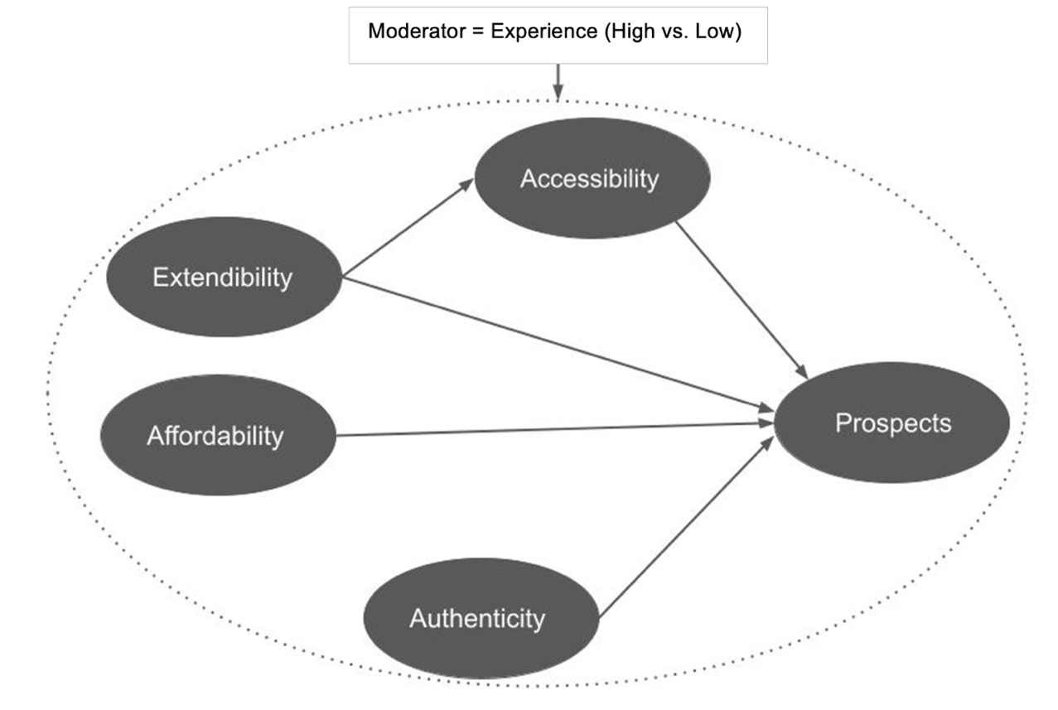
Following development of the conceptual framework, we utilised the PLS model in SmartPLS 3.0 to estimate the significance of the relationship between the proposed constructs and how well the model explains the target construct: prospects for Islamic home finance in the UK.

3. Methodology
3.1 Scale development and instrument
Primarily, the study employed a quantitative approach using the survey method. Prior to collecting data, we developed a new measurement scale due to the lack of an existing suitable scale that adequately measures the variables of interest of this study. This process involved producing a list of scale items through a systematic literature review, interacting with mortgage brokers, brainstorming with subject experts and carrying out content analysis of reports. To ensure a solid scale to measure the proposed constructs all items were also reviewed by three highly experienced and renowned scholars in the field of scale development, structural equation modelling and Islamic finance. The final items and their corresponding constructs are attached in Appendix (A). All items that measure the constructs were measured using a 10-point Likert scale, with a range of 1–10 (1= strongly disagree, 10= strongly agree).

3.2. Data Collection
We collected data using the purposive sampling method through an on-line channel (Qualtrics) and in-person. A total of 155 responses were collected from FCA (Financial Conduct Authority) certified mortgage brokers across the country, the majority from the Greater London region. A total of 11 responses were discarded due to missing values and inconsistent response patters, leaving a total sample of 144. The sample size also complied with the required minimum threshold for PLS-SEM analysis (i.e., between 110-120 participants) based on 10-times, R², F² rule and G-Power computation. The final data was divided based on mortgage brokers’ experience level (high = >10 years and low experience = <10 years). The mortgage brokers who had over 10 years’ experience in the mortgage market were found to be 76 (53%) in comparison to those who had less than 10 years’ experience in the industry consisting 68 (47%) participants. Sample characteristics are shown in Table 1 below.
Table 1. Sample Characteristics
Industry Experience (Years)
> 10 years | 76 | 53%
< 10 years | 68 | 47%
Total Sample | 144 | 100%

4. Data Analysis and Results
The proposed research model was empirically assessed by applying a two stage PLS-SEM approach, i.e., measure model assessment and structural model assessment. One of the key reasons for using PLS-SEM was that on one hand, PLS-SEM allows us to test causal relationships among constructs, while on the other hand at the same time provides an opportunity to predict and derive recommendations for strategic decision making [47].

4.1. Measurement Model Assessment
The first stage of data analysis (measurement model assessment) involved assessing indicators loading, internal consistency reliability, composite reliability, convergent validity and discriminant validity. All outer loadings for each indicator were found to be above the recommended threshold of 0.70 [47] except for the indicator prosp_1 (outer loadings: 0.695). However, this item has been retained, since the other loadings scored high to complement the convergent validity (AVE) and composite reliability (CR) of the construct. All constructs surpassed the widely recommended cut-off thresholds, i.e., Cronbach’s alpha values between 0.7 – 0.9, composite reliability values between 0.70 – 0.9 (definitely not above 0.95), and rho (ρ_{A}) values of 0.7 or higher. Only the extendibility construct’s composite reliability found to be slightly above the ideal threshold (0.90) but at the same time below the problematic threshold of 0.95, thus representing overall good internal consistency reliability.
The convergent validity of the constructs was evaluated by measuring the Average Variance Extracted (AVE) values. The AVE values of all constructs i.e., accessibility (0.625), affordability (0.614), authenticity (0.731), extendibility (0.800) and prospects (0.626) exceeded the acceptable level of 0.5, thus confirming the convergent validity. The results of all items' loadings, reliability and convergent validity of the measurement model are listed in Table 2.
Table 2. Indicator’s loadings, Reliability and Convergent Validity of the Measurement Models
Latent Variable | Items | Loadings | Convergent Validity  (AVE) | Composite Reliability  (CR) | rho (ρ_{A}) | Cronbach’s Alpha  (α)
Accessibility | ﻿access_1 | 0.738 | 0.625 | 0.909 | 0.887 | 0.880
 | access_2 | 0.739
 | access_3 | 0.883
 | access_4 | 0.826
 | access_5 | 0.775
 | access_6 | 0.771
Affordability | afford_1 | 0.845 | 0.614 | 0.864 | 0.816 | 0.792
 | afford_2 | 0.824
 | afford_3 | 0.753
 | afford_4 | 0.706
Authenticity | authen_1 | 0.874 | 0.731 | 0.891 | 0.821 | 0.816
 | authen_2 | 0.883
 | authen_3 | 0.806
Extendibility | extend_1 | 0.841 | 0.801 | 0.923 | 0.901 | 0.876
 | extend_2 | 0.911
 | extend_3 | 0.929
Prospects | prosp_1 | 0.695 | 0.627 | 0.869 | 0.834 | 0.801
 | prosp_2 | 0.753
 | prosp_3 | 0.886
 | prosp_4 | 0.820
We assessed discriminant validity using the most commonly used Fornell-Larcker metric and heterotrait-monotrait (HTMT) ratio of correlations. The results of Fornell–Larcker criterion indicated the square root value of each construct’s AVE is greater than its correlations with other constructs, thus indicating the attainment of discriminant validity (see Table 3).
Table 3. Discriminant Validity (Fornell–Larcker Criterion)
Latent Variables | Accessibility | Affordability | Authenticity | Extendibility | Prospects
Accessibility | 0.791
Affordability | 0.389 | 0.784
Authenticity | 0.320 | 0.422 | 0.855
Extendibility | 0.501 | 0.734 | 0.377 | 0.895
Prospects | 0.407 | 0.312 | 0.539 | 0.363 | 0.791

Discriminant validity based heterotrait-monotrait (HTMT) ratio of correlations also found to be satisfactory. Although there is still no universally agreed threshold for HTMT values, some researchers for example [48] and [49] suggests a cut off value of 0.85 and 0.90 respectively. In our case, as seen in Table 4, the maximum HTMT value found to be 0.87, which is between the conservative value of HTMT_85 and the liberal value of HTMT_90, therefore indicating acceptable discriminant validity among constructs.
Table 4. Discriminant Validity (HTMT)
Latent Variables | Accessibility | Affordability | Authenticity | Extendibility | Prospects
Accessibility
Affordability | 0.453
Authenticity | 0.370 | 0.537
Extendibility | 0.551 | 0.876 | 0.45
Prospects | 0.468 | 0.367 | 0.641 | 0.419
Besides examining the HTMT ratios, the HTMT inference criterion has also been assessed to ensure that the lower and upper bounds of the confidence interval (CI) of HTMT does not contain a value of 1 on any construct. The results computed from 5,000 bootstrap samples revealed that neither of the confidence intervals included a value of 1. For example, the lower and upper bounds of the confidence interval of HTMT for the relationship between extendibility and affordability or prospects and authenticity were 0.775, 0.95, 0.456 and 0.78 respectively. This established that at the HTMT liberal threshold of 0.90, which already supported discriminant validity, the confidence interval results of the HTMT criterion as shown in Table 5 also substantiated the discriminant validity of the constructs.
Table 5. Confidence Intervals for HTMT
Relationship between constructs | Original Sample (O) | Sample Mean (M) | Bias | 2.50% | 97.50%
Extendibility -> Affordability | 0.876 | 0.877 | 0.001 | 0.775 | 0.959
Prospects -> Authenticity | 0.641 | 0.642 | 0 | 0.456 | 0.780
Extendibility -> Accessibility | 0.551 | 0.553 | 0.002 | 0.348 | 0.709
Authenticity -> Affordability | 0.537 | 0.539 | 0.002 | 0.306 | 0.738
Prospects -> Accessibility | 0.468 | 0.479 | 0.012 | 0.308 | 0.610
Affordability_ -> Accessibility | 0.453 | 0.458 | 0.005 | 0.244 | 0.638
Extendibility -> Authenticity | 0.450 | 0.452 | 0.002 | 0.224 | 0.637
Prospects -> Extendibility | 0.419 | 0.432 | 0.013 | 0.257 | 0.572
Prospects -> Affordability | 0.367 | 0.398 | 0.031 | 0.188 | 0.525
Authenticity -> Accessibility | 0.370 | 0.379 | 0.009 | 0.179 | 0.564

4.2. Structural Model Assessment
Prior to testing the hypothesised relationships among constructs, we carried out collinearity assessment to ensure that the two hypothesised variables are not causally related and measure the same construct [47, 50]. Results revealed no serious issue of multicollinearity (see Table 6), since all values were lower than 3 as proposed by [51].

Table 6. Collinearity Assessment
 | Accessibility | Affordability | Authenticity | Extendibility | Prospects
Accessibility |  |  |  |  | 1.372
Affordability |  |  |  |  | 2.29
Authenticity |  |  |  |  | 1.264
Extendibility | 1 |  |  |  | 2.466
Prospects

4.3. Path Coefficients (β)
Following collinearity assessment and bootstrapping procedure with 5,000 subsamples was carried out to test the direct path coefficients (β) and proposed hypotheses. The results revealed that accessibility (β = 0.224, t-value = 3.277) and authenticity (β = 0.444, t-value = 5.287; p <0.001) have a significantly direct effect on the prospects for the Islamic home finance industry, thus supporting Hypotheses 1 and 3. The results also revealed that extendibility (β = 0.501, t-value = 6.466, p <0.001) has a significant effect on accessibility, thereby substantiating Hypothesis 4. However, the bootstrapping results did not support the hypothesised relationship between affordability and prospects (β = -0.052, t-value = 0.480) indicating no significant direct effect of affordability on the prospects for Islamic home finance.
The PLS structural model results also indicate that authenticity (0.444) has the strongest effect on the prospects followed by accessibility (0.224), whereas extendibility found to have a strong effect (0.501) on the accessibility construct (see Table 7).
Table 7. Hypothesis Testing: Bootstrapping Results for Direct Relationships
Hypothesis | Relationships | Beta (β) | T Value | P Value | 95% Confidence Intervals | Decisions
H₁ | Accessibility -> Prospects | 0.224 | 3.277 | 0.001 | [0.088 -0.353] | Supported
H₂ | Affordability -> Prospects | -0.052 | 0.480 | 0.631 | [-0.298-0.132] | Not  supported
H₃ | Authenticity -> Prospects | 0.444 | 5.287 | 0.00 | [0.268 -0.599] | Supported
H₄ | Extendibility -> Accessibility | 0.501 | 6.466 | 0.00 | [0.327-0.632] | Supported
Note: Two tailed test
The above results are visually displayed in Figure 2 below, where paths have been highlighted using relative t values, vividly representing the level of the significance of the path relationships across constructs.
Figure 2. Graphical Representation of the Path Coefficients
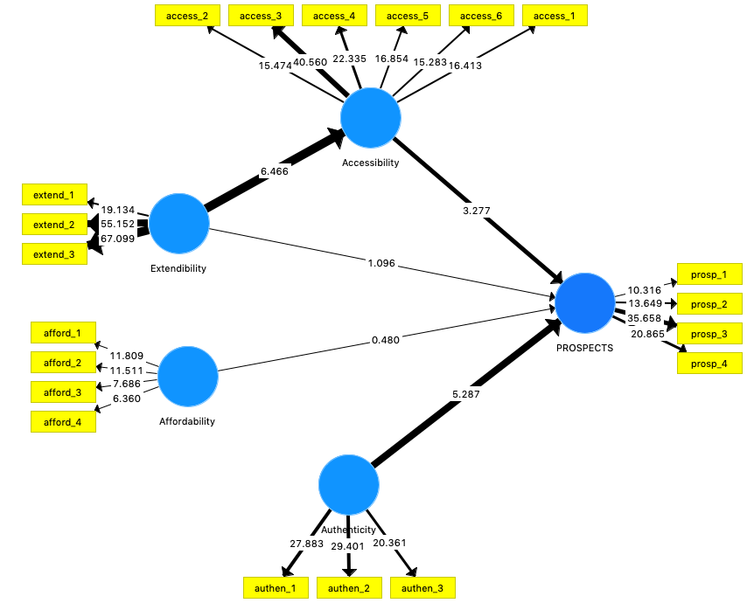
The overall R² value (0.358) of the main construct of interest, prospects (for the Islamic home finance industry), found to have a high level of explanatory power or predictive accuracy (see Figure 3). This suggests that the four constructs authenticity, affordability, extendibility and accessibility together explain 35.8% of the variance of the endogenous construct prospects for Islamic home finance in the UK.
Figure 3. PLS Path Model Estimation of R²
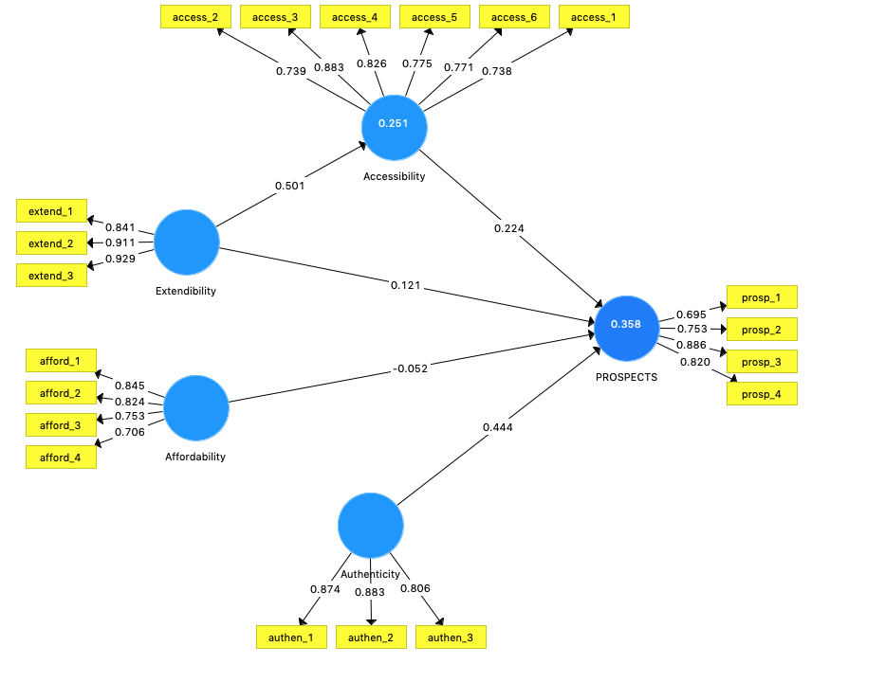
The study also evaluated the effect size (f²) to determine whether the relevant impact of a specific predictor construct on the endogenous construct is in fact meaningful or not. As shown in Table 8, accessibility has a small effect (0.057) on the prospects, whereas affordability has almost no effect (0.002) on the prospects. In contrast, extendibility and authenticity have fairly large effect sizes (f²) on the endogenous variables such as accessibility and prospects, i.e., 0.336 and 0.243 respectively. In addition to the effect size (f²), the predictive power or relevance (Q²) of the research model was also assessed through blindfolding procedure considering the main purpose of using PLS-SEM is prediction. In a structural model, Q² values greater than 0 for a certain endogenous reflective latent construct ensure that the model demonstrates good predictive power [52, 53]. The results of the blindfolding procedure indicated (see Table 8) Q² value larger than 0, thus providing clear support for the model’s predictive power. Apart from Q² assessment, the study further examined the q² effect sizes, derived from the Q² value. According to [47] “this (q² effect sizes) is a measure to assess the relative predictive relevance of a predictor construct on an endogenous construct” (p.325). Following the guidelines (see note in Table 8 below), it can be said that, with the exception of the affordability variable, other exogenous constructs found to have small to medium q² effect sizes on the endogenous variables [54]. To provide an overall picture of the results, all the above tests have been tabulated in Table 8.
Hypothesis | Relationships | Beta (β) | T Value | P Value | 95% Confidence Intervals | Decision
 |  |  |  |  |  |  | f² | q²
H₁ | Accessibility -> Prospects | 0.224 | 3.277 | 0.001 | [0.088 -0.353] | Supported | 0.057 | 0.028
H₂ | Affordability -> Prospects | -0.052 | 0.48 | 0.631 | [-0.298-0.132] | Not supported | 0.002 | 0.001
H₃ | Authenticity -> Prospects | 0.444 | 5.287 | 0.000 | [0.268 -0.599] | Supported | 0.243 | 0.111
H₄ | Extendibility -> Accessibility | 0.501 | 6.466 | 0.000 | [0.327-0.632] | Supported | 0.336 | 0.147
Notes:
R² (Accessibility 0.251; Prospects = 0.358)
R² values: 0.02, 0.13 and 0.26 considered as weak, moderate and substantial respectively (Cohen, 1988)
Q² (Accessibility 0.147; Prospects = 0.209) 0.02 < Q² < 0.15 = weak predictive power; 0.15 < Q² < 0.35 = moderate predictive power; Q² > 0.35 strong predictive power
Effect size (f²) impact indicators are according to Cohen (1988), f² values: 0.35 (large), 0.15 (medium) and 0.02 (small)
q² effect size; 0.02 small; 0.15 medium; 0.35 large
Table 8. Direct Relationships for Hypothesis Testing

5. Mediation Analysis
This section focuses on analysing the indirect effect, Hypothesis 5 - the impact of extendibility on the prospects for Islamic home finance via accessibility. To test the mediation path, a two-step approach was followed by applying a bootstrapping procedure. The bootstrapping results gave an empirical t-value of 2.763 for the indirect effect (0.117) of the extendibility→ prospects relationship yielding a p value of 0.006 (significant). In the next step, we tested the significance of the direct effect from extendibility to prospects. As shown in Table 9, the relationship between extendibility to prospects was found to be statistically non-significant (t = 1.096). Following the mediation analysis, it can be concluded that accessibly fully mediates the relationship between extendibility and prospects, which means only the indirect effect via the mediator, accessibility, exists. In other words, the effect of the variable extendibility to prospects is completely transmitted through accessibility, thus supporting H₅.
Table 9. Significance Analysis of the Direct and Indirect Effects
 | Relationship | Direct Effect | T Value | P Value | 95% CI | Significance (p<0.05)? | Decision
H₅ | Extendibility -> Prospects | 0.121 | 1.096 | 0.273 | [-0.073-0.368] | No | Supported^
 | Extendibility -> Prospects | Indirect Effect | T Value | P Value | 95% CI | Significance (p<0.05)?
 |  | 0.117 | 2.763* | 0.006 | [0.045-0.204] | Yes
Two tailed test, * t> 1.96
^ Indirect-only mediation or full mediation: the indirect effect is significant, but the direct effect is not significant.

6. Multi-Group Analysis
One of the key objectives of this study was to examine the impact of experience (as a moderator) among the structural path relationships. Prior to conducting the MGA, the Measurement Invariance of Composite Models (MICOM) was executed as recommended in the literature (47, 55, 56]. The MICOM procedure consisted of three steps: (1) configural invariance; (2) compositional invariance and (3) the equality of composite mean values and variances. To achieve configural invariance we ensured that each measurement model employed the similar items across all data groups and all measurement items were incorporated in the latent variables across all groups. Similarly, all indicators’ data were treated identically across all groups including the coding, all outliers were detected and treated in a similar manner. Finally, all algorithm settings and optimisation criteria were applied identically to verify that differences in the group- specific model estimate do not arise from different algorithm settings.
To examine compositional invariance a permutation test in Smart-PLS was carried out which assesses and compares the composite scores of two groups to establish whether the correlation “c” varies substantially from the empirical distribution of cu (denoted by the 5.00% quantile) [47, 56]. In simple terms, compositional invariance requires that the correlation c is equal to 1 [57].
The MICOM results (see Table 10) suggest the establishment of the compositional invariance across all constructs in experienced vs. less experienced group as all original correlations are found to be equal to or larger than the quantile correlations of 5.0% as visible in the 5% column. In addition, p values higher than 0.05 also support this finding, meaning the correlation is not significantly lower than 1. This also means that partial measurement invariance has been established. This allows us to proceed with comparing the standardised path coefficients across the groups by applying multi-group analysis with confidence.
Table 10. Compositional Invariance Group (High vs. Low Experience)
 | Original Correlation | Correlation Permutation Mean | 5.00% | Permutation p-Values
Accessibility | 0.999 | 0.995 | 0.982 | 0.895
Affordability | 0.969 | 0.964 | 0.915 | 0.318
Authenticity | 0.991 | 0.995 | 0.981 | 0.181
Extendibility | 0.997 | 0.998 | 0.993 | 0.187
Prospects | 0.998 | 0.992 | 0.977 | 0.825
In order to establish whether the full invariance has been achieved, the composite means and variances were examined in Step 3 of the MICOM procedure in SmartPLS. If there are no significant differences in mean values and (logarithms of) variances across the groups, then full measurement invariance is claimed to be established [55, 57]. To check whether even full measurement invariance holds, full measurement invariance (composite equality), was conducted in PLS-SEM.
To establish the equal means and variances, the mean original differences and variance original differences should fall between the lower (2.5%) and upper (97.5%) boundaries of the 95% confidence interval of the scores’ mean differences [57]. As it can be seen in Table 11, that the original difference in mean values falls within the range of the lower and upper boundaries. For example, for authenticity, the original difference in mean values is -0.028, which is within the corresponding confidence interval with a lower boundary of -0.353 and upper boundary of 0.308. In addition, Permutation p -Values (0.867) further supports this finding for authenticity and every other construct (i.e., accessibility = 0.862; affordability = 1.000; extendibility = 0.187; and prospects = 0.749) in the PLS path model as all p values are considerably larger than 0.05.

Table 11. Equality of Composite (Mean Values and Variances)
Constructs | Mean - Original Diff  (high exp – low exp) | Mean - Permutation Mean Diff  (high exp – low exp) | 95% confidence interval | Permutation Values | Variance - Original Diff  (high exp – low exp) | Variance - Permutation Mean Diff  (high exp – low exp) | 95% confidence interval | Permutation  Values
Accessibility | 0.024 | -0.001 | [-0.319 - 0.312] | 0.862 | -0.081 | -0.003 | [-0.557 - 0.478] | 0.742
Affordability | 0.000 | -0.006 | [-0.345 - 0.318] | 1.000 | 0.433 | 0.021 | [-0.498 - 0.533] | 0.098
Authenticity | -0.028 | -0.011 | [-0.353 - 0.308] | 0.867 | 0.521 | 0.012 | [-0.428 - 0.484] | 0.022
Extendibility | -0.216 | -0.007 | [-0.336 - 0.320] | 0.187 | -0.042 | 0.005 | [-0.411 - 0.426] | 0.849
Prospects | -0.057 | -0.005 | [-0.318 - 0.308] | 0.749 | -0.032 | 0.006 | [-0.396 - 0.384] | 0.872

However, when comparing the analogous results for the composite variances (variance original difference) to the lower (2.5%) and upper (97.5%) confidence interval. It was noticed that the variance original difference value (0.521) for the construct authenticity did not fall within the 95% confidence interval (-0.428 - 0.484). Therefore, the construct did not meet the guidelines for establishing full invariance. Hence, the partial measurement invariance has been established paving the way for the feasibility of multi-group analysis. Consequently, multi-group analysis was conducted to identify meaningful and significant differences in multiple relationship across group-specific results. Prior to carrying out multi-group analysis, a bootstrapping analysis using 5,000 subsamples on each group was conducted to analyse the path coefficient of each group. The group specific results (see Tables 12 and 13) for the more experienced group (>10 years’ experience) revealed a significant impact of accessibility (β = 0.282, t = 2.983) and authenticity (β = 0.322, t = 3.05, p <0.05) on the prospects, whereas extendibility was found to have a strong impact on the accessibility construct, i.e., t = 6.478 and p < 0.001.
Table 12. Path Coefficients (Experience > 10 years)
Paths | Beta (β) | 95% confidence interval | T Value | P Value
Accessibility -> Prospects | 0.282 | [0.091 - 0.463] | 2.983* | 0.003
Affordability -> Prospects | 0.078 | [-0.264 - 0.378] | 0.482 | 0.630
Authenticity -> Prospects | 0.322 | [0.115 - 0.530] | 3.050* | 0.002
Extendibility -> Accessibility | 0.595 | [0.393 - 0.750] | 6.478* | 0.000
Extendibility -> Prospects | 0.087 | [-0.24 - 0.460] | 0.491 | 0.624
* denotes significance, t value > 1.96

Table 13. Path Coefficients (Experience < 10 years)
Paths | Beta (β) | 95% confidence interval | T Value | P Value
Accessibility -> Prospects | 0.152 | [-0.028 - 0.364] | 1.541 | 0.123
Affordability -> Prospects | -0.062 | [-0.557 - 0.260] | 0.305 | 0.76
Authenticity -> Prospects | 0.551 | [0.297 - 0.717] | 5.337* | 0.00
Extendibility -> Accessibility | 0.432 | [0.178 - 0.616] | 3.763* | 0.00
Extendibility -> Prospects | 0.135 | [-0.112 - 0.475] | 0.911 | 0.362
* denotes significance, t value > 1.96
In contrast, the path coefficients of the subsample of the less experienced group (<10 years’ experience) showed a non-significant effect of accessibility, affordability and extendibility on the prospects whereas authenticity exerted the strongest effect (t = 5.337, p <0.001) on the prospects. Similarly, extendibility showed a relatively strong effect on the accessibility construct. These effects are also evident from each group’s structural model where significant effects can be seen in thicker lines (see Figures 4 and 5. (There may be slight differences between the Tables’ and Figures’ structural path coefficients due to the bootstrapping procedure).
Figure 4. Structural Path Coefficients (Group = Experience >10 Years)
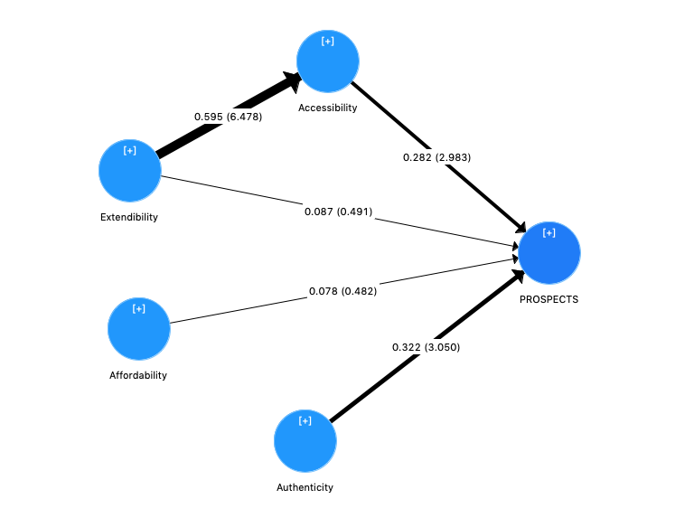
Figure 5. Structural Path Coefficients (Group = Experience <10 Years)
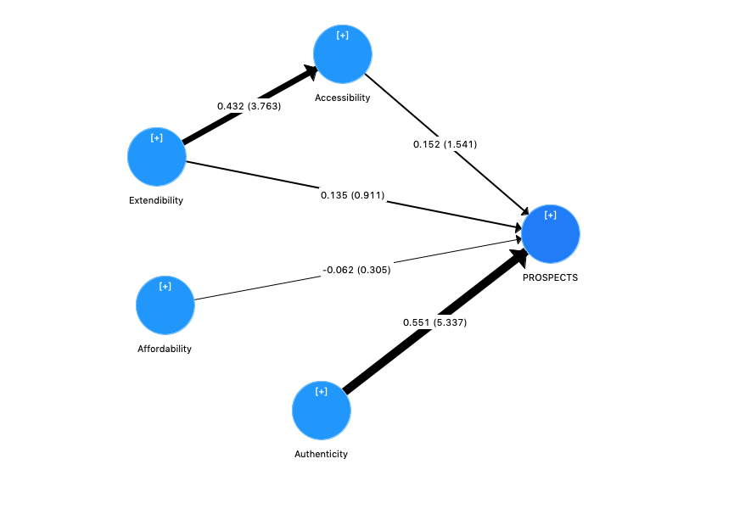
The results of multi-group analysis applying widely adopted [58] Welch-Satterthwait t test in Table 14 and 15 reveal that all path coefficients were found to be insignificant, i.e. p > 0.05. Thus, Hypothesis 6 that there is a statistically significant difference among all path coefficients for highly experienced mortgage brokers (>10 years’ exp) versus less experienced mortgage brokers (<10 years’ exp) is not supported.
Table 14. Parametric Test (High- vs. Low-Experience Group)
 | Path relationships | (β)-diff (Exp >10 Yrs - Exp <10 Yrs) | t-Value (Exp >10 Yrs vs. Exp <10 Yrs) | p-Value (Exp>10 Yrs vs. Exp <10 Yrs)
H₆ | Accessibility -> Prospects | 0.130 | 0.950 | 0.344 ^{Nsig}
 | Affordability_ -> Prospects | 0.141 | 0.546 | 0.586 ^{Nsig}
 | Authenticity -> Prospects | -0.229 | 1.554 | 0.122 ^{Nsig}
 | Extendibility -> Accessibility | 0.163 | 1.141 | 0.256 ^{Nsig}
 | Extendibility -> Prospects | -0.047 | 0.205 | 0.838 ^{Nsig}
Nsig. denotes p>0.05

Table 15. Welch's t-test (High- vs. Low-Experience Group)
 | Path relationships | (β)-diff (Exp >10 Yrs - Exp <10 Yrs) | t-Value (Exp >10 Yrs vs. Exp <10 Yrs) | p-Value (Exp>10 Yrs vs. Exp <10 Yrs)
H₆ | Accessibility -> Prospects | 0.130 | 0.949 | 0.346 ^{Nsig}
 | Affordability_ -> Prospects | 0.141 | 0.541 | 0.590 ^{Nsig}
 | Authenticity -> Prospects | -0.229 | 1.561 | 0.123 ^{Nsig}
 | Extendibility -> Accessibility | 0.163 | 1.134 | 0.261 ^{Nsig}
 | Extendibility -> Prospects | -0.047 | 0.208 | 0.836 ^{Nsig}
Nsig. denotes p>0.05
7. Importance Performance Matrix Analysis (IPMA)
As an extension to the above results, we also ran a post-hoc importance- performance matrix analysis (IPMA) to analyse the importance and performance of each construct against the prospects (for Islamic home finance in the UK). The importance-performance matrix analysis of path modelling results support to identify areas of improvement that can consequently be focused upon with marketing strategies, policy making or management decision making [59]. The standardised values, the total effects (importance) and index values (performance), are shown in Table 16.
Table 16. Data for the Importance-Performance Map for Prospects
Construct | Importance (Total Effects) | Performance (Index Values)
Accessibility | 0.261 | 32.02
Affordability | -0.064 | 35.242
Authenticity | 0.419 | 46.138
Extendibility | 0.258 | 33.414
(Average) | 0.21 | 36.7

We synchronised the above values to create the importance-performance matrix. The overall average values for the importance of the assessed constructs have been inserted on the horizontal (x) axis, while the overall performance average values of the evaluated constructs entered on the vertical (y) axis. The combined mean values of the importance (0.21) and performance (36.7) of all constructs were selected as the convergence point of the (x) and (y) axes in the IPMA grid, from which four quadrants could be described.

The constructs are then examined according to the placement in the importance-performance matrix i.e. the corresponding quadrant in which the constructs are positioned. A visual inspection of the IPMA chart (see Figure 6) revealed that authenticity has a particularly high importance of 0.419 and relatively high performance (46.13), as compared to other constructs. This indicates that the participants value this construct as the most relevant to the prospects for the Islamic home finance.
Figure 6. Importance-Performance Map for the Target Construct: Prospects (for IHF* in the UK)
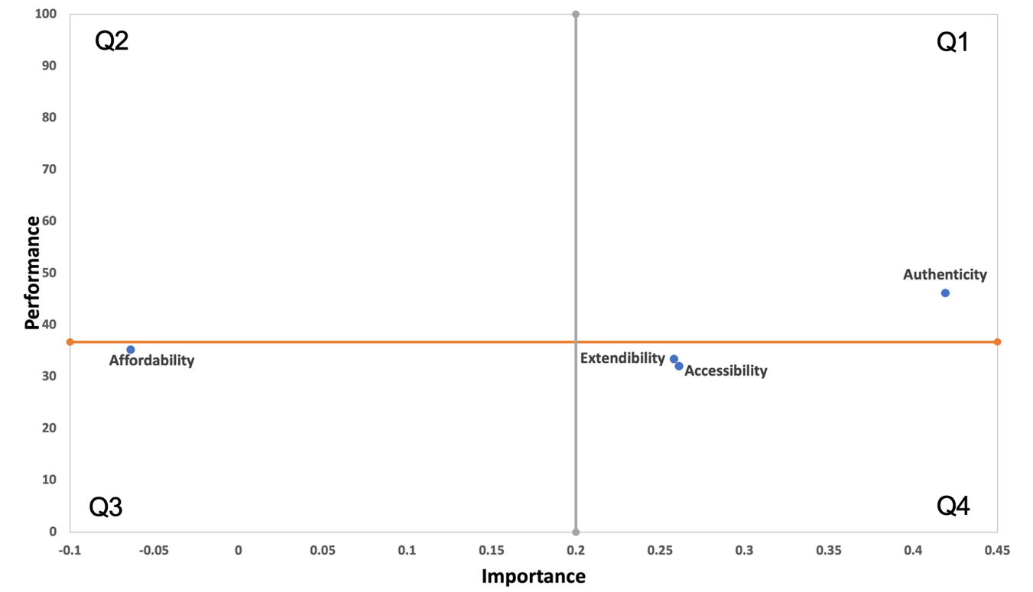
*Islamic Home Finance
8. Discussion

The path analysis revealed that H₁ accessibility had a positive significant effect on the prospects for Islamic home finance in the UK. The standardised path coefficient for H₁ was (β = 0.224, t-value = 3.277) supported the relationship between accessibility and the prospects for the Islamic home finance in the UK. This result corroborates with previous studies [7, 8, 60] that minorities are particularly vulnerable to access to finance, claiming accessibility is a serious issue for potential Muslim customers and acts as a real impediment to the prospects for Islamic home finance. For anyone, being a homeowner is an important component of wealth acquisition that can increase one’s status and standing in a society. The lack of access to home finance to potential Muslims customers may significantly hinder their household wealth and aggravate social exclusion of Muslims in the UK’s society [61].

The findings of H₁ also confirms the arguments that the accessibility is one of the most important factors for British Muslims, especially for less affluent Muslims [16, 23].This result is also in line with the study [19] which claimed that accessibility still presents a huge challenge for Islamic banks, especially when a quarter of the Muslim population possess no qualifications and lack financial literacy skills, with many struggling to comprehend the fundamental basics of Islamic home finance. This finding is discouraging for the UK government which, despite its efforts to bring Islamic home finance into the mainstream sector, face severe grassroot problems that are inherent within the Muslim market segment.
The second hypothesis, that affordability has a positive significant effect on the prospects for Islamic home finance in the UK, was not supported. Surprisingly, this finding contradicts the commonly held view that Islamic home finance is more expensive than conventional home financing. To date, the vast majority of studies have frequently claimed affordability as being one of the key impediments to the prospects for Islamic home finance in the UK. For example, studies [7, 8, 10, 13, 25, 28] unanimously claimed that Islamic home finance is perceived as more expensive than conventional home finance. The finding of the second hypothesis also opposes views that one of the greatest concerns for British Muslims is the inability to pay the higher initial deposit required by Islamic banks, arguing that higher cost is one of the main reasons for the low uptake of Islamic home finance among Muslims [7, 19].
Based on the outcome of the path relationship between affordability and the prospects for Islamic home finance, it can be established that, despite being a relatively new entrant in the financial sector, the cost-related aspects of Islamic home finance are no longer considered to be a significant issue. However, to date, Islamic banks have not capitalised on this feature due to perception from customers that Islamic home finance is an expensive product. This finding provides a good platform to Islamic banks, financial community and policy makers to propagate this positive shift that has been commonly associated with Islamic home finance since its inception in the UK.
The standard coefficient of H₃, authenticity, is found to have the strongest direct effect (β = 0.444, t-value = 5.287; p <0.001) on the prospects for Islamic home finance in the UK, thus supporting the proposed hypothesis. This finding endorses the findings of [10, 32] that the most apparent fault of the Islamic home finance industry has been its failure, in the eyes of observant Muslims, to comply with the basic ethical principles of Islamic jurisprudence, which has added to the mistrust of Islamic home finance in the UK. This finding is quite alarming for Islamic banks, especially when it is derived from the perspective of mortgage brokers. Given the fact that the vast majority of UK customers purchase home finance products through mortgage brokers, this poses a serious threat to the Islamic home finance industry in the UK as the views of mortgage brokers may negatively influence customers' decision-making process. It is also quite surprising that, despite the fact that Islamic home finance largely avoided the subprime crisis and revived the relationship between financial stability and Islamic banking due to its focus on principles of partnership, transparency and fairness [34], it is still struggling to gain trust not only among potential customers, but also among the industry’s’ experts in the UK. Hypothesis 4, that extendibility has a positive significant effect on accessibility, and hypothesis 5, that the effect of extendibility on the prospects for Islamic home finance is mediated by the accessibility, have both been supported by this research. This finding supports the view [19] that the extendibility of Islamic home finance has become a cause of concern for many potential UK customers, which is largely attributed due to the careful risk appraisal and complexity involved in Islamic home finance.
This issue is mainly due to the conservative approach taken by Islamic banks. Unlike conventional banks that are able to lend cash by borrowing from the wholesale money markets, ethical Islamic finance is much more reliant on utilising its depositors’ savings accounts (7, 8, 43]. Therefore, to fulfil its role as a partner rather than merely a lender, Islamic banks arguably assess risks more deeply, or certainly assess risks differently in a more personalised manner to effectively monitor the use of funds by borrowers for the mutual benefits of all stakeholders [36]. There is no doubt that the double assessment of risk by both the financier and the borrower injects greater discipline into the system and restrains excessive lending and borrowing [44], and that this principle safeguarded banks during the subprime crisis [35, 36]. However, this rigid approach to business raises questions over the extendibility of Islamic home finance, particularly in the UK market which strongly affects the accessibility of Islamic home finance (β = 0.501, t-value = 6.46) which (accessibility) in turn eventually affects the prospects for Islamic home finance in UK. These findings pose an immense challenge for small Islamic banks with limited resources. On one hand, Islamic banks face a dilemma, for being restrictive makes Islamic home finance less extendible, while on the other hand small Islamic banks target the Muslim market where one fourth of the population is financially illiterate and struggles to comprehend the fundamentals of Islamic home finance.
Hypothesis 4, can be linked to findings that found that many potential Muslim clients interested in home financing do not access due to a perception that success may be difficult, because of the strict criteria applied by the Islamic banks [8]. Hypothesis 4 also reinforces the view that the home finance process is overly complicated, thus placing the complex structure of Islamic finance beyond the understanding of customers who have previously lacked engagement with financial institutions or who may be financially illiterate [62]. Similar support is argued that Islamic home finance is not only considered to be overly complicated, but can also be difficult to secure, raising questions over the extendibility of Islamic home finance [19]. This signifies that extendibility acts as a key determinant to the accessibility of Islamic home finance and also indicates that the effect of extendibility on the prospects for Islamic home finance is transmitted through accessibility. In other words, accessibility as a mediator plays an important underlying mechanism in the relationship between extendibility and the prospects for Islamic home finance. This has also been supported by the H₅ path relationship showing the significant indirect effect of extendibility on the prospects for Islamic home finance (t = 2.763) via the accessibility construct, while the relationship between extendibility > prospects was found to be statistically non-significant (t = 1.096; p > 0.05).
With regard to Hypothesis 6, that experience will have a significant categorical moderating effect on the relationship among the model constructs, was also unexpectedly found to be insignificant across all relationships between the high- and low-experience groups. Thus, H₆ was not supported. The uniformity of the perception between experienced and novice mortgage brokers also provided us more accurate assessment of the Islamic home finance in the UK. This also reflects that the transformation, resilience, and sustainability of Islamic home financing over the years have not led to any significant differences in the industry’s experts’ opinions towards its prospects in the UK.
The study also conducted a post-hoc importance-performance matrix analysis (IPMA) to explore the performance and importance of each construct on the prospects for Islamic home finance so that policy makers and key stakeholders can take appropriate actions. Interestingly, the authenticity construct fell in Quadrant 1 of the IPMA plot (see Figure 6). This demonstrates that the mortgage brokers attached particularly high importance (0.419) and relatively high performance (46.13) to the authenticity of Islamic home finance, as compared to the other constructs. This is possibly a good sign for Islamic banks, as the industry’s experts believe that authenticity performs relatively well against other constructs. It is also the most relevant factor to the prospects for Islamic home finance. Based on this outcome, the policy makers should strive to preserve the authenticity construct with continued investments, as this could offer a potential competitive advantage for Islamic home finance. The accessibility and extendibility constructs fell in Quadrant 4, ‘concentrate here’, the most critical area of the priority matrix. This means that these constructs were considered very important by the mortgage brokers (importance scores of 0.261 and 0.258 respectively), but with a lower average level performance (32.02 and 33.41 respectively). Any constructs situated in this quadrant are considered to be performing less well than expected, representing major deficiencies in the products offered and posing a serious challenge to their competitiveness. Thus, Islamic banks and policymakers should implement urgent corrective measures with the highest investment priority to improve the performance levels of accessibility and extendibility.
In contrast, the affordability construct landed in Quadrant 3, a low priority area. This signifies that the mortgage brokers considered this construct to be of low priority in the current scenario. This translates that the affordability (cost-related) attributes of Islamic home financing perform well (35.24), although not exceptionally well, and is considered to be relatively unimportant to mortgage brokers in the current scenario. This outcome suggests that the management or policy makers within Islamic banks should not be overly concerned with affordability and should focus instead on other constructs, such as extendibility and accessibility constructs.
The findings of this study have started a fresh debate in the research community. The research model developed and assessed should not be envisaged as an ultimate framework, but instead as a start towards an optimal framework. The constructs incorporated in the research model were derived from the literature – the researchers’ and experts’ opinions and logic that may not form a comprehensive set of constructs and may be expanded on by others. The findings of this study can also be cross examined and compared by employing different seasonal participants such as bankers, academics, property lawyers and scholars who are experts in the field of Islamic home finance. In addition, the proposed conceptual model might be applied (with relevant modifications) in other nations, especially those with similar demographic settings i.e., Germany, France, Singapore, and the USA. Finally, although this study is up to date, the findings may vary due to the constantly changing economic and financial environment. In this case, further research would be needed in the wake of the fluctuating economic and financial events.

REFERENCES
- ICD-Refinitiv. (2020). Islamic finance development report 2020: Progressing through adversity. https://www.zawya.com/ifg- publications/report/20201208110406294.pdf/?refKey=IFG-fbae0a6e-b0e2-4800- ba30-c2f700bcf6d8
- IMF. (2017). The IMF and Islamic finance. https://www.imf.org/external/themes/islamicfinance/
- Hauser, A. (2020, December). Why Islamic finance has an important role to play in supporting the recovery from Covid – and how the Bank of England’s new alternative liquidity facility can help. Bank of England. https://www.bankofengland.co.uk/-/media/boe/files/speech/2020/why-islamic- finance-has-an-important-role-to-play-in-supporting-the-recovery-from- covid.pdf?la=en&hash=58B28008CE026D33B0590F7DB5CDA84DAE723CAD
- Khan, I. (2022, May 31). Islamic Mortgages in The UK in 2022: The Definitive Guide. https://www.islamicfinanceguru.com/articles/islamic-finance/islamic-mortgages-uk-2021-definitive-guide
- Ahmed, K. (2022, April 22). Islamic finance almost complete change of form. Pakistan & Gulf Economist. Retrieved 10 September 2022, from https://www.pakistangulfeconomist.com/2022/04/18/islamic-finance-almost-complete-change-of-form/
- Masood, O., Chichti, J. E., Mansour, W., & Amin, Q. A. (2009). Role of Islamic mortgage in UK. International Journal of Monetary Economics and Finance, 2(3/4), 366. https://doi.org/10.1504/ijmef.2009.029069
- Tameme, M. E. M. (2009). Demand and supply conditions of Islamic housing finance in the United Kingdom: Perceptions of Muslim clients (Thesis). Durham University. http://etheses.dur.ac.uk/77/
- Tameme, M., & Asutay, M. (2012). An empirical inquiry into marketing Islamic mortgages in the UK. International Journal of Bank Marketing, 30(3), 150–167. https://doi.org/10.1108/02652321211222531
- Galadima, W. M. (2015). Islamic finance in the United Kingdom (Thesis). Newcastle University.
- Hersi, W. M. (2009). The role of Islamic finance in tackling financial exclusion in the UK (Thesis). Durham University. http://etheses.dur.ac.uk/23/
- Masood, O., & Bellalah, M. (2013). Islamic mortgages. In M. Bellalah & O. Masood (Eds.), Islamic Banking and Finance (pp. 215–260). Cambridge Scholars Publisher.
- Akbar, S., Shah, S. Z. A., & Kalmadi, S. (2012). An investigation of user perceptions of Islamic banking practices in the United Kingdom. International Journal of Islamic and Middle Eastern Finance and Management, 5(4), 353–370.
- Dar, H. A. (2004). Demand for Islamic financial services in the UK: Chasing a mirage? Economics Research Paper, 4(11), 1–25. https://dspace.lboro.ac.uk/dspace-jspui/bitstream/2134/335/3/TSIJ.pdf
- Hussain, M. (2014). Performance and potential of Islamic finance: A contextual study in the UK. Journal of Shi’a Islamic Studies, 7(4), 441–510. https://doi.org/10.1353/isl.2014.0038
- Khan, S. (2012). Islamic finance in the UK: Non-Muslims’ perception and awareness. Lap Lambert Academic Publishing.
- Riaz, U. A. (2014). Perceptions and experiences of British-based Muslims on Islamic banking and finance in the UK (Thesis). University of Dundee. http://discovery.dundee.ac.uk/portal/en/theses/perceptions-and-experiences-of- britishbased-muslims-on-islamic-banking-and-finance-in-the-uk(6acc43af-1fac- 4994-9aa3-e165056fe80c).html
- Riaz, U., Burton, B., & Monk, L. (2017). Perceptions on the accessibility of Islamic banking in the UK—Challenges, opportunities and divergence in opinion. Accounting Forum, 41(4), 353–374. https://doi.org/10.1016/j.accfor.2017.10.002
- Matthews, R., Tlemsani, I., & Siddiqui, A. (2003). Recent developments in the market for Islamic mortgages: Theory and practice. Review of Islamic Finance, 14, 49–65.
- Ahmed, T., Kabir, S., & Aziz, A. (2020). Exploring the prospects for Islamic home finance in the UK: Evidence from the industry practitioners’ perspective. International Journal of Business & Society, 21(1), 353–368.
- Fry, A. (2014). Challenging conditions in UK retail for Islamic finance. https://kae.com/ideabank/challenging-conditions-in-uk-retail-for-islamic-finance/
- Statista. (2022, September 5). Education levels of Muslims in England and Wales in 2018. Retrieved September 10, 2022, from https://www.statista.com/statistics/870899/education-levels-of-muslims-in-england-and-wales/
- Benamraoui, A., Boukrami, E., Dafgard, C., & Karbhari, Y. (2020). An empirical investigation of the regulatory and non-regulatory challenges of the UK Islamic retail banking. Journal of Islamic Business and Management (JIBM), 10(02), 303–322. https://doi.org/10.26501/jibm/2020.1002-002
- Abdullrahim, N., & Robson, J. (2017). The importance of service quality in British Muslim’s choice of an Islamic or non-Islamic bank account. Journal of Financial Services Marketing, 22(2), 54–63. https://doi.org/10.1057/s41264-017-0025-6
- Tameme, M., & Asutay, M. (2012). An empirical inquiry into marketing Islamic mortgages in the UK. International Journal of Bank Marketing, 30(3), 150–167. https://doi.org/10.1108/02652321211222531
- Amin, M. (2017, March 26). Why Islamic mortgages normally cost more than conventional mortgages. http://www.mohammedamin.com/Islamic_finance/Why- Islamic-mortgages-cost-more.html
- Alam, I., & Seifzadeh, P. (2020). Marketing Islamic financial services: A review, critique, and agenda for future research. Journal of Risk and Financial Management, 13(1), 1–19. https://doi.org/10.3390/jrfm13010012
- Amin, H. (2017). Consumer behaviour of Islamic home financing: Investigating its determinants from the theory of Islamic consumer behaviour. Humanomics, 33(4), 517–548. https://doi.org/10.1108/H-12-2016-0102
- Cumbo, J. (2005). Lloyds’ Islamic mortgage increases buyers' choices. Financial Times. http://www.ft.com/cms/s/0/435f8b62-9d9c-11d9-a227- 00000e2511c8.html?ft_site=falcon&desktop=true
- Gordon, M. (2020, December 22). What is an Islamic mortgage? Comparethemarket. https://www.comparethemarket.com/mortgages/content/islamic-mortgages/
- Saleem, H. (2021, February 24). Are Islamic mortgages cheaper? IslamicFinanceGuru. Retrieved 29 May 2021, from https://www.islamicfinanceguru.com/islamic-mortgage-faq/are-islamic-mortgages-cheaper/
- Garbarino, E., & Johnson, M. S. (1999). The different roles of satisfaction, trust, and commitment in customer relationships. Journal of Marketing, 63(2), 70. https://doi.org/10.2307/1251946
- Zakariyah, L. (2012). Legal maxims and Islamic financial transactions: A case study of mortgage contracts and the dilemma for Muslims in Britain. Arab Law Quarterly, 26(3), 255–285. https://doi.org/10.1163/15730255-12341240
- Chater, N. (2015). Mind the gap: Restoring consumer trust in financial services. [Financial Services Compensation Scheme]. http://www.fscs.org.uk/globalassets/press-releases/20151111-fscs-trust-white- paper-final.pdf
- Hasan, M., & Dridi, J. (2011). The effects of the global crisis on Islamic and conventional banks: A comparative study. Journal of International Commerce, Economics and Policy, 02(02), 163–200. https://doi.org/10.1142/S1793993311000270
- Iqbal, Z., & Mirakhor, A. (2011). An introduction to Islamic finance: Theory and practice. Wiley.
- Warde, I. (2012). Status of the Global Finance Industry. In C. R. Nethercott & D. M. Eisenberg (Eds.), Islamic finance: Law and practice (1st ed.). Oxford University Press.
- Alam, I., & Seifzadeh, P. (2020). Marketing Islamic financial services: A review, critique, and agenda for future research. Journal of Risk and Financial Management, 13(1), 1–19. https://doi.org/10.3390/jrfm13010012
- Lee, Y. N. (2017, December 20). Islamic finance is becoming so attractive that even non-Muslims want in. CNBC. Retrieved 7 January 2021, from https://www.cnbc.com/2017/12/19/sukuk-islamic-finance-grows-in-non-muslim-countries.html
- Saiti, B., Ardo, A. A., & Yumusak, I. G. (2019). Why non-Muslims subscribe to Islamic banking? Qualitative Research in Financial Markets, ahead-of(ahead-of-print), ahead-of-print. https://doi.org/10.1108/qrfm-01-2018-0005
- Al Rayan Bank. (2015). Al Rayan Bank posts a profit and announces its strongest performance to date. Al Rayan Bank. https://www.alrayanbank.co.uk/useful-info- tools/about-us/latest-news/jan-dec-2015/al-rayan-bank-posts-a-profit-and- announces-its-strongest-performance-to-date
- Yap, K. B. (2011). Islamic Banking: The Convergence of Religion, Economic Self- interest and Marketing. In Ö. Sandıkcı & G. Rice (Eds.), Handbook of Islamic Marketing. Edward Elgar Publishing.
- Kuran, T. (2006). Islamism and economics: Policy prescriptions for a free society. In S. Behdad & F. Nomani (Eds.), Islam and the everyday world: Public policy dilemmas. Routledge.
- Ethica. (2017). Ethica’s handbook of Islamic finance. http://www.ethicainstitute.com/Ethica-Handbook-of-Islamic-Finance-2017.pdf
- Chapra, M. U. (2011). The global financial crisis: Can Islamic finance help? In J. Langton, C. Trullols, & A. Q. Turkistani (Eds.), Islamic Economics and Finance. Palgrave Macmillan.
- Iqbal, Z., & Mirakhor, A. (2006). An introduction to Islamic finance: Theory and practice (2nd ed.). Wiley.
- Amin, M. (2010b, September 1). The UK Islamic banking scene. http://www.mohammedamin.com/Islamic_finance/UK-Islamic-banking-scene.html
- Hair, J. F., Hult, G. T. M., Ringle, C. M., & Sarstedt, M. (2017). A primer on partial least squares structural equation modeling (PLS-SEM) (2nd ed.). Sage.
- Kline, R. B. (2011). Principles and practice of structural equation modeling (3rd ed.). Guilford Press.
- Gold, A. H., Malhotra, A., & Segars, A. H. (2001). Knowledge management: An organizational capabilities perspective. Journal of Management Information Systems, 18(1), 185–214. https://doi.org/10.1080/07421222.2001.11045669
- Wong, K. K.-K. (2019). Mastering partial least squares structural equation modeling (PLS-SEM) with SmartPLS in 38 hours. iUniverse.
- Hair, F., Risher, J. J., Sarstedt, M., & Ringle, C. M. (2019). When to use and how to report the results of PLS-SEM. European Business Review, 31(1), 2–24.
- Chin, W. W. (1998). The partial least squares approach for structural equation modeling. In G. A. Marcoulides (Ed.), Modern methods for business research (pp. 295– 336). Lawrence Erlbaum Associates, Publishers.
- Henseler, J., Ringle, C. M., & Sinkovics, R. R. (2009). The use of partial least squares path modeling in international marketing. In R. R. Sinkovics & P. N. Ghauri (Eds.), New challenges to international marketing (pp. 277–319). Emerald Group Publishing Limited. https://doi.org/10.1108/S1474-7979(2009)0000020014
- Cohen, J. (1988). Statistical power analysis. Lawrence Erlbaum Associates. Cohen, J. (1992). A power primer. Psychological Bulletin, 112(1).
- Hair, J. F., Sarstedt, M., Ringle, C. M., & Gudergan, S. P. (2018). Advanced issues in partial least squares structural equation modeling. Sage.
- Matthews, L. (2017). Applying multigroup analysis in PLS-SEM: A step-by-step process. In H. Latan & R. Noonan (Eds.), Partial least squares path modeling: Basic concepts, methodological issues and applications. Springer.
- Henseler, J., Ringle, C. M., & Sarstedt, M. (2016). Testing measurement invariance of composites using partial least squares. International Marketing Review, 33(3), 405–431. https://doi.org/10.1108/IMR-09-2014-0304
- Keil, M., Saarinen, T., Tan, B. C. Y., Tuunainen, V., Wassenaar, A., & Wei, K.-K. (2000). A cross-cultural study on escalation of commitment behavior in software projects. Management Information Systems Quarterly, 24(2), 299–325.
- Höck, C., Ringle, C. M., & Sarstedt, M. (2010). Management of multi-purpose stadiums: importance and performance measurement of service interfaces. International Journal of Services Technology and Management, 14(2/3), 188. https://doi.org/10.1504/ijstm.2010.034327
- Deku, S., Kara, A., Smith, K., & Xia, M. (2022). Ethnic minorities’ access to mortgages in the UK: The undesirable impact of the great financial crisis. Finance Research Letters, 45, 102183. https://doi.org/10.1016/j.frl.2021.102183
- Kara, A., & Molyneux, P. (2016). Household access to mortgages in the UK. Journal of Financial Services Research, 52(3), 253–275. https://doi.org/10.1007/s10693-016-0246-1
- Amin, M. (2010a, June 21). Why has retail Islamic banking not taken off in the UK? http://www.mohammedamin.com/Islamic_finance/Why_has_retail_Islamic_banki ng_not_taken_off_in_the_UK.html

Appendix A
Constructs and Corresponding Measurement Items
Accessibility
Item 1 | Islamic home finance is conveniently accessible to potential clients
Item 2 | There is now more awareness of the existence of Islamic home finance
Item 3 | Islamic home finance products are easily understandable to the majority of potential clients
Item 4 | The majority of potential clients are familiar with the concept of Islamic home finance
Item 5 | The majority of potential clients have a basic knowledge of the underlying contract in Islamic home finance
Item 6 | The majority of potential clients are aware of the overall terms and conditions of Islamic home finance
Extendibility
Item 1 | Islamic home finance has relatively lenient approval criteria
Item 2 | It is easy for a potential client to secure Islamic home finance
Item 3 | Islamic home finance involves simple procedures from start to finish
Affordability
Item 1 | Islamic home finance is affordable for the majority of customers
Item 2 | Islamic home finance is comparatively inexpensive
Item 3 | Islamic home finance requires a small initial deposit
Item 4 | The arrangement fees for Islamic home finance are relatively low
Authenticity
Item 1 | Islamic home finance in the UK complies with Islamic jurisprudence
Item 2 | Islamic home finance is genuinely a Shariah-compliant finance product
Item 3 | Islamic home finance is a more ethical mode of finance
Prospects (for Islamic home finance in the UK)
Item 1 | There is a significant demand for Islamic home finance in the UK
Item 2 | Islamic home finance is appealing to all faiths and beliefs
Item 3 | The long-term prospects for Islamic home finance are good
Item 4 | Islamic home finance is compatible with Western financial markets, such as the UK’s

