New nanocomposites based on poly(benzoxazine-co-epoxy) matrix reinforced by novel graphene single and mixed blend fillers
Dwane E. Cossey¹, Stephen A. Hodge², Panagiotis G. Karagiannidis^{1*}
¹School of Engineering, Faculty of Technology, University of Sunderland, Sunderland, SR6 0DD, United Kingdom
²Versarien Plc, Cheltenham, GL51 9LT, United Kingdom
*Correspondence: Panagiotis.Karagiannidis@sunderland.ac.uk

Abstract
We report new nanocomposites with poly(benzoxazine-co-epoxy) matrix reinforced with 1wt% graphene. Curabox 24-111, a benzoxazine resin was copolymerised with Epilok 60-566, a mixture of epoxy resins. Copolymerization was also carried out in the presence of different graphene powders namely Nanene-001 and Nanene-002, used as single fillers and as mixture (relative weight ratio 70:30 or 30:70). DSC results showed the addition of either single filler caused a delay in polymerisation and an increase in the exothermic peak temperature of the curing reaction with a related reduction in ΔH_{Total.} compared to the neat copolymer. Copolymerisation showed a 38% reduction and 24% increase in tensile modulus (E) compared to the neat polybenzoxazine and epoxy polymer, with a respective 18% and 30% reduction in tensile strength (TS). Nanocomposites with 0.7wt% Nanene-002 + 0.3wt% Nanene-001 showed the highest increase of 35% in TS, a 1.6% reduction in E and 36% increase in elongation at break (EB) compared to the neat copolymer matrix. Samples with 1wt% Nanene-001 showed the largest reduction of 21% in E, a 27% increase in TS and a 45% increase in EB. Additionally, TGA thermographs showed a 22℃ increase in the onset of degradation (300℃ to 322℃) improving the materials thermal stability.
Keywords
Graphene; Benzoxazine; Graphene Nanocomposites; Differential Scanning Calorimetry; Thermogravimetric Analysis; Mechanical Properties.

1. Introduction
There is a need for further lightweighting of transport vehicles for aerospace, automotive, construction and military aiming energy saving and net zero emissions. Polymer-matrix nanocomposites are a class of materials, including thermoplastics (1), (2), (3), (4), (5), (6) and thermosets, researched and developed for aerospace and ballistic applications (7), (8), (9), (10), (11) construction and structural applications (12), (13), (14) and successfully used to replace heavier metal components (15), (16), (17), (18), (19), (20). In these systems, the polymer matrix (a thermoplastic or a thermoset) is combined with one or more reinforcing agents. Reinforcing materials evolved over time from micro to nano-fillers providing higher surface area and interaction with the matrix, resulting in better performance at lower weight loading. More recently, graphene and related materials (GRMs) have attracted significant attention in academia and many industry sectors as excellent nanofillers (21), (22), (23), (24).
Benzoxazines (BOZs), also named polybenzoxazine (PBOZs) precursors, form a relatively new class of thermosetting addition-cured phenolic resins, being developed, and extensively studied progressively more in recent years. BOZs possess many desirable characteristics such as close to zero volumetric shrinkage or expansion on curing (polymerisation and crosslinking) (21) and give PBOZs with excellent mechanical properties (25), high char yield on decomposition (22), low fire-smoke toxicity (FST), low water absorption (26), excellent resistance to both chemicals and UV light, and high glass transition temperature (T_{g}) with a relatively low cross-linking density (22). However, there are drawbacks associated with their use, e.g. high curing temperature (200ºC or higher), difficulty in processing and brittleness of the prepared PBOZs (27), (28).
It has been suggested that copolymerisation of BOZs with other thermosetting resins (29), (30), (31), (32), (33) with the addition of reinforcing agents, such as inorganic fillers (34), (35) or carbon fibres (36), (35) can overcome the shortcomings of neat BOZs. Study of curing of BOZ-graphene oxide (GO) which contained 1wt% GO showed a maximum curing rate 14min earlier than that of the neat resin (22). More recently graphene nanofillers have gained popularity on account of their exceptional mechanical and thermal properties (37), (23).
Curing studies of various BOZ resins has shown great potential in reducing the process time and the energy required (21), (22). It is reported in ref (26) that an increase in the isothermal cure temperature results in a substantial reduction in vitrification time and an increase in the degree of cure. At curing temperature 170°C the degree of cure was 80% while at 210°C the value was 99%.
In recent years the improvements in the mechanical and thermal properties of neat PBOZ and PBOZ-epoxy (EP) copolymer systems have been investigated using a range of fillers as reinforcement (38), (27), (39). It is reported in ref (38) that using an EP, and a biobased BOZ resin doped with boron graphene (BG), at EP 85wt%, BOZ 13wt% and BG 2wt%, showed a decrease of 48% in the curing peak heat release and an increase in impact strength of 22%. Additionally, the incorporation of the BOZ and BG was shown to increase T_{g} by up to 12%, improve the flame retardancy and improve the thermal stability compared to the neat EP system material. Novel materials that exhibit improvements in mechanical and thermal performance, as well as a reduction in energy required for manufacture would be in high demand in the many industries stated.
The reported work involves the development of a new polymer matrix by copolymerisation of Curabox 24-111, a PBOZ precursor based on Bisphenol-A, aniline, and formaldehyde, with Epilok 60-566, a mixture of EP resins. The curing of BOZ and EP has been shown an increase of cross-linking density and T_{g} (29), (40), (35), (41), (30), (42). This matrix was then reinforced with the use of two nanofillers, namely Nanene-001 and Nanene-002. Mechanical testing was extended to include two novel mixed blend graphene fillers. A good quality uniform dispersion was achieved with the use of toluene as a solvent medium which was evident from mechanical testing.

2. Experimental

2.1 Materials
Bisphenol-A based BOZ resin (Curabox 24-111) and the low viscosity EP resin Epilok 60-566 were obtained from Bitrez Group Limited (UK). The Curabox 24-111 is a PBOZ precursor, based on bisphenol A, aniline, and formaldehyde. According to the manufacturer after thermal curing the prepared PBOZ has a tensile modulus (E) of 4.6 GPa, tensile strength (TS) of 55 MPa and a 2% elongation at break (EB). The Epilok 60-566 when cured with an amine e.g., Curamine 32-494 curing agent at 100:30 wt/wt shows an E of 2.3 GPa, TS of 65 MPa with a 5% EB. In the present work only the Epilok 60-566 was used without amine.
Two different graphene powders were supplied by Versarien namely Nanene-001 and Nanene-002. Nanene-001 is a high quality few-layer graphene powder with D50 less than 4 layers and D50 lateral size x: 1.46μm y: 1.12μm. Nanene-002 is a graphene nanoplatelet powder with large lateral dimensions, D50 x: 2.16μm y: 1.78μm and D50 less than 14.5 layers. Toluene (C7H8) CAS: 108-88-3 with laboratory purity grade was used as a solvent medium for Nanene-002: Nanene-001 dispersion prior to introduction to the BOZ-EP blend. A high temperature silicone (HTS) from DWR plastics UK was used to manufacture the specimen moulds for tensile tests. The use of HTS eliminated the requirement for any release agent, its flexibility enabled the easy release of samples from the mould.

2.2 Nanocomposites development and manufacture
The weight ratio of BOZ-EP resins used was 50:50, 80g of each resin was used for a standard 8 sample batch and was chosen due to its low viscosity and the increased processability, when compared to other studied ratios. The miscibility of the two used resins allowed the successful copolymerisation (curing) of resins.
Attempts were made first to disperse graphene powders directly into the BOZ-EP resins solution, using a mechanical stirrer which produces high shear forces. However, the samples prepared did not show any increase in mechanical properties most probably due to non-uniform dispersion of graphene powders in the viscous resins and formation of graphene agglomerates.
To produce a more uniform dispersion the graphene powders were first dispersed in 25ml of toluene and placed in an ultrasonication bath for 25 mins at room temperature (RT). The resin solution was weighed prior to the addition of the graphene-toluene solution to provide a base weight for confirming complete removal of the solvent, this solution was then added to the resin’s solution (Figure 1). High shear mixing was used to remove the toluene over incremented range of 500rpm – 1000rpm. The combined solution, toluene-free was then placed in a vacuum chamber to fully degas before introduction to the moulds. The amount of toluene used is just a fraction of that required to pre-solvate Curabox 24-111. Using toluene as a solvent medium optimised the dispersion of GRM’s and substantially increased the mechanical properties compared to shear mixing graphene powders directly into the neat resins.

2.3 Characterisation by DSC
DSC scans of the studied materials were carried out using a DSC Q10 from ΤΑ Instruments. Samples ~20-30mg were weighted and sealed into aluminium hermetic DSC pans. The sample pan was then put in the DSC cell previously maintained at RT. All DSC runs were carried out under N₂ atmosphere. Non-isothermal scans of BOZ, EP, BOZ-EP resins and BOZ-EP-graphene nanocomposites were recorded from RT 20ᵒC up to 450℃ at heating rate 2℃/min. An isothermal scan was performed on BOZ-EP resins at 180ᵒC for 2 h and 200ᵒC for 2 h followed by cooling the sample back to RT; then a dynamic run was carried out at a heating rate of 10ᵒC/min up to 450ᵒC.

2.4 Thermogravimetric Analysis
Samples for thermogravimetric analysis (TGA) were selected and prepared from the tensile samples after mechanical testing. The thermal stability of the single PBOZ and EP polymers, PBOZ-EP copolymer and graphene nanocomposite systems were investigated by TGA using a TGA55 thermogravimetric analyser from TA Instruments. Measurements were taken from 20ᵒC to 850ᵒC at a heating rate of 10ᵒC/min under N₂ flow.

2.5 Tensile testing
Tensile tests were performed using a universal testing machine Zwick Roell Z010 with a load cell of 10kN at RT with a crosshead speed of 5mm/min. Moulds were manufactured for the dog bone shape specimens using HTS eliminating the need for any additional release agent whilst providing superb dimensional stability with just 0.08% shrinkage on curing. Tensile samples were produced following the methodology shown in Figure 1. The curing schedule followed was heating at 180℃ for 2 h then further heating at 200℃ for a further 2 h.
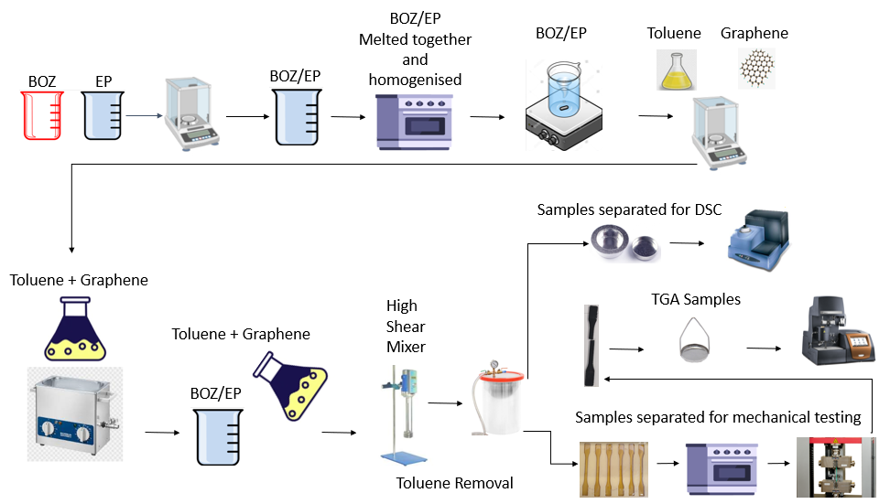
Figure 1. Preparation of BOZ-EP copolymer and BOZ-EP-Graphene samples for DSC characterisation and cured PBOZ-EP, PBOZ-EP-Graphene for TGA and tensile testing.

2.6 SEM Characterisation
SEM imaging was conducted using a Hitachi S3000-N. Samples were submerged in liquid nitrogen and shattered. These were mounted on an aluminium SEM specimen stub using carbon adhesive discs; stubs and carbon adhesives purchased from Agar Scientific, UK. An approximate 8nm sputter coat was applied using an Agar Scientific AGB7340 Manual Sputter Coater with a gold/palladium target.

3. Results and Discussion
3.1 Curing investigation by dynamic DSC
Figure 2 shows the DSC thermographs of BOZ Curabox 24-111, EP Epilok 60-566 and BOZ-EP resins recorded in the temperature range 20 up to 450℃ at a heating rate of 2℃/min. The initial cure temperature (T_{init}), the peak maximum temperature (T_{max}), final (T_{final}) and T_{final} -T_{init} for all studied materials are summarised in Table 1. The T_{max} corresponds to the temperature with the maximum curing rate dα/dt (min⁻¹) where α is the degree of conversion. It can be seen in Figure 2 that both resins exhibit two distinctive exothermic curing peaks. It is therefore expected that the curing reaction of BOZ-EP consists of a minimum of two curing stages. The neat BOZ shows an endothermic peak at 40ᵒC which is the melting of the resin and one exothermic symmetrical curing peak starting at 125℃ up to 281℃ (labelled as peak 1 in Figure 2), revealing that the curing process follows a single kinetics mechanism attributed to the polymerisation of BOZ via the heterocyclic ring opening. The neat EP shows an exothermic peak starting at 293℃ and ending at 351℃ (labelled as peak 2), which is due to homo-polymerisation of the EP forming an ether link as similarly reported in Ref (41). The copolymerisation of BOZ with EP shows a non-symmetrical exothermic peak (labelled as peak 3) starting at 128℃ up to 256℃ which can be deconvoluted into two Lorentzian peaks. The first peak is due the homopolymerisation of BOZ; the phenolic hydroxyl groups generated by thermal curing of the BOZ resin were reported (41) to function as a hardener for EP polymerization. Therefore, for the second exothermic peak it was speculated to be the possible reaction corresponded to the side reaction, such as etherification reaction between a hydroxyl group of polymerized BOZ resin and an epoxide to form an ether bond and a new formed hydroxyl group (41). An additional peak is observed in the BOZ-EP at 244℃ (labelled as peak 4), which is most probably due to the homopolymerisation of EP occurring at lower temperature in the reaction mixture BOZ-EP than in EP alone.
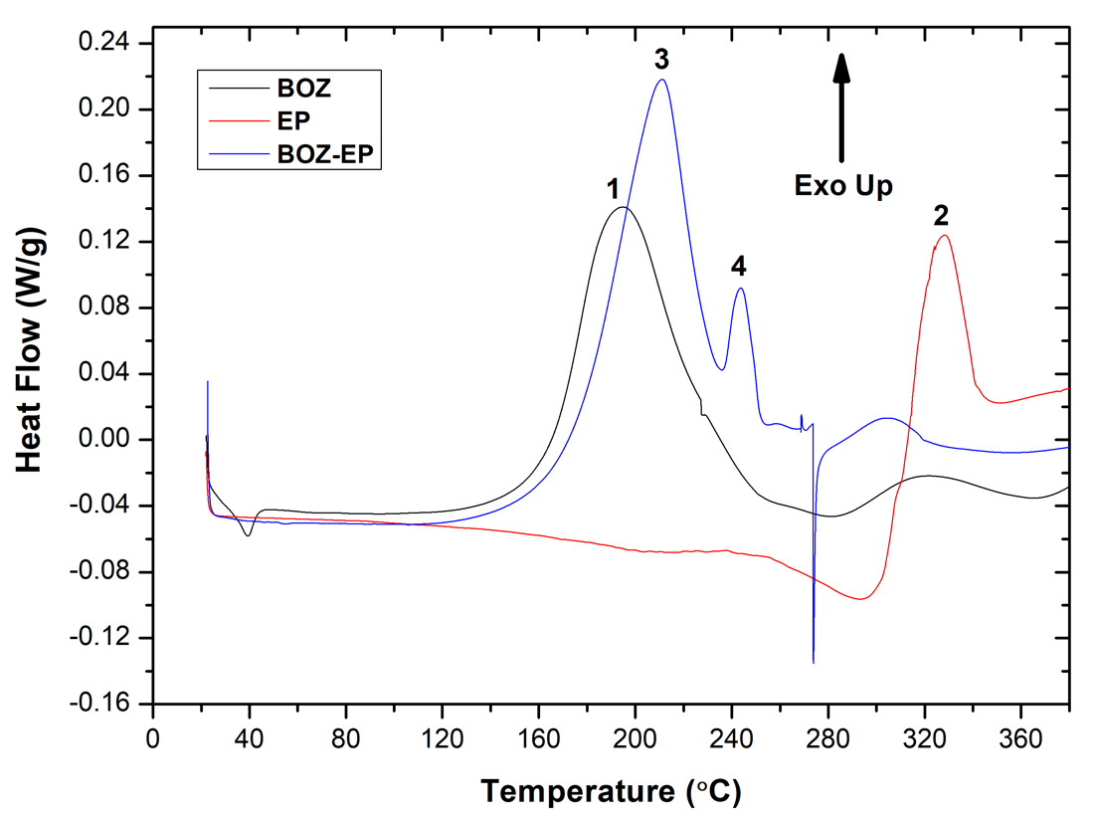Figure 2. Non-isothermal DSC of the individual PBOZ and EP systems, PBOZ-EP copolymer at a heating rate of 2℃/min, under N₂ flow, showing exothermic peaks of the curing reactions.

Table 1. Characteristic temperatures of curing for the systems under study obtained under non-isothermal conditions at a heating rate of 2℃/min
Sample | T_{init} (°C) | T_{final}  (°C) | T_{final}-T_{int}  (°C) | T_{peak-1}  (°C) | T_{peak-2}  (°C)
BOZ | 125 | 281 | 156 | 195 | -
EP | 293 | 351 | 58 | 328 | -
BOZ-EP | 128 | 256 | 128 | 211 | 244
BOZ-EP with 1wt Nanene-001 | 126 | 254 | 128 | 220 | 248
BOZ-EP with 1wt% Nanene-001 | 127 | 260 | 133 | 221 | 252
BOZ-EP with 0.7wt% Nanene-002 0.3wt%Nanene-001 | 134 | 255 | 121 | 215 | 247

Figure 3 shows the DSC thermographs of the neat BOZ-EP resin, and the nanocomposites with the single Nanene-001 and Nanene-002 and 1wt% or 0.7wt% Nanene-002 + 0.3wt% Nanene-001. The neat BOZ-EP shows a sharp endothermic peak at 274ᵒC and is probably due to decomposition of part of the copolymer structure. The addition of both graphene powders as single fillers or mixed filler blend delays the curing reaction (22). This delay is less evident in the mixed Nanene-001: Nanene-002 blend than nanocomposites with a single filler content (Figure 3). The BOZ-EP with single Nanene-001 or Nanene-002 filler showed the curing exothermic peak shifted to relatively higher temperature of 10ᵒC and 9ᵒC respectively, (Table 1) compared to the neat resins. The smallest shift of 4ᵒC was observed in the mixed Nanene-001 and Nanene-002 filler, which could be attributed to a better-quality dispersion (Figure 8b) within the copolymer matrix due the different lateral sizes of the graphene flakes. This is supported by SEM imaging showing a high-quality uniform dispersion of the mixed blend nanofiller within the copolymer matrix, and by the measured mechanical properties. Additionally, curing of this system was seen to take place over the shortest temperature range of 121ᵒC, significantly shorter compared to the neat copolymer and single filler systems, (Table 1) further demonstrating the positive effect of the mixed Nanene-001 and Nanene-002 fillers.

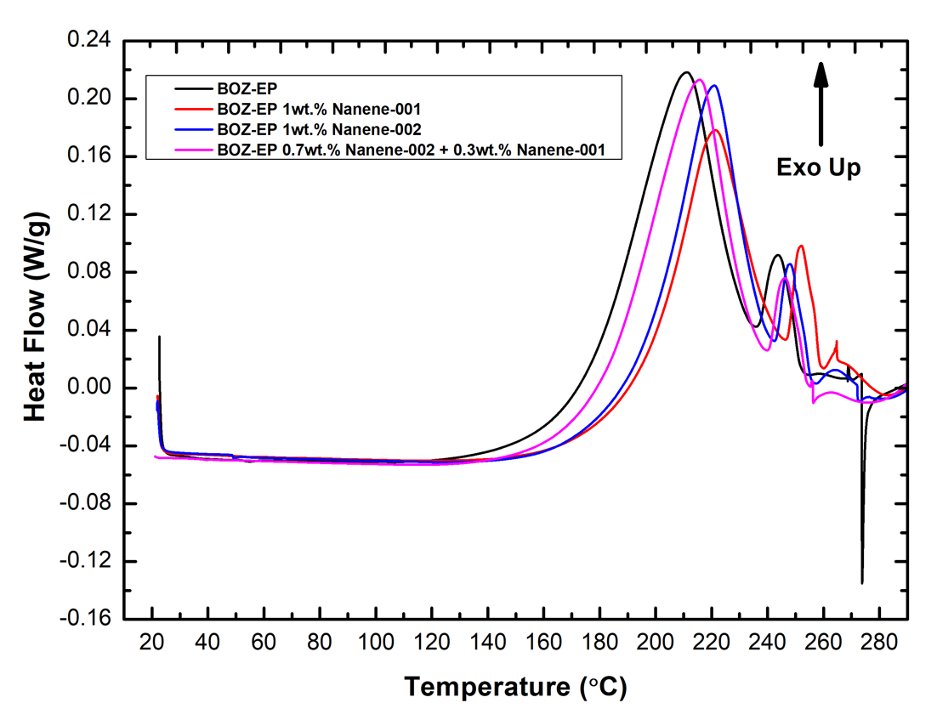
Figure 3. Non-isothermal DSC of the BOZ-EP resin and nanocomposites with single Nanene-001, Nanene-002 and 0.7wt% Nanene-002+ 0.3wt% Nanene-001; at a heating rate of 2ᵒC/min, under N₂ flow, showing exothermic peaks of the curing reaction.

The total curing enthalpy ΔH_{Total} (J/g) values of all studied samples were calculated through non-isothermal DSC runs at a heating rate of 2ᵒC/min for the individual BOZ and EP systems (Figure 2) in addition to the developed neat BOZ-EP, and the nanocomposite with 0.7wt% Nanene-002 and 0.3wt% Nanene-001, (Table 2). The ΔHTotal (J/g) was determined for the neat BOZ-EP resin and composite with nanofillers by deconvolution and integration of the peak-1 and peak-2 correspondingly. A reduction in ΔH_{Total} of 2.5% was measured in the BOZ-EP with 0.7wt% Nanene-002 + 0.3wt% Nanene-001 vs neat BOZ-EP (Table 2).

Table 2. Exothermic heat of curing (ΔΗTotal) for the individual systems, copolymer, and copolymer with 0.7wt% Nanene-002 + 0.3wt% Nanene-001 obtained under non-isothermal conditions at a heating rate of 2ᵒC/min
BOZ, EP, BOZ-EP resins, and Nanocomposites | ΔH _{Total} (J/g)
BOZ | 342.8
EP | 94.6
BOZ-EP 1:1 wt/wt | 379.3
BOZ-EP with 0.7wt% Nanene-002 0.3wt% Nanene-001 | 370
BOZ-EP with 1wt% Nanene-002 | 261.3
BOZ-EP with 1wt% Nanene-001 | 238.4

3.2 Curing investigation by isothermal DSC
Isothermal DSC at 180ᵒC and 200ᵒC each for a 2 h period, (Figure 5a) were run to replicate the used curing schedule followed by the cooling back to RT of the neat copolymer and a dynamic run at 10ᵒC/min to check for any residual cure peak. To confirm the complete curing of the material a standard dynamic run at a heating rate of 10ᵒC/min was compared with the dynamic run at 10ᵒC/min, (Figure 5b) following the 2 isothermal DSC runs. The absence of any residual cure peak verifies the complete curing of the material using the stated curing schedule.

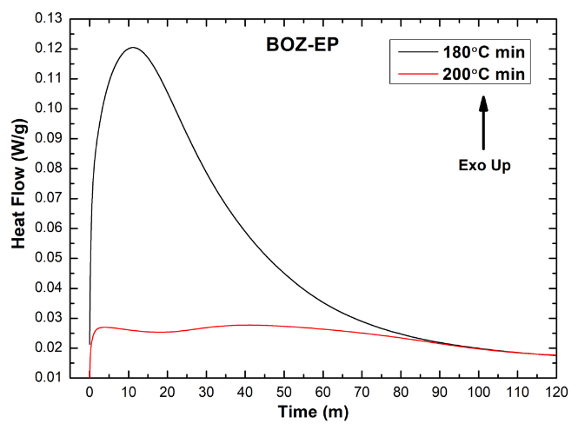 | 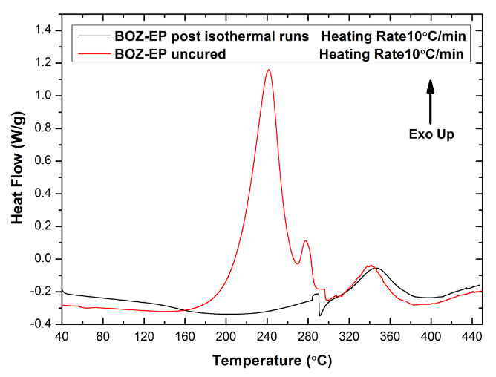
Figure 4. (a) A two-stage replication of the curing schedule used; 2h at 180ᵒC followed by 2h at 200ᵒC (b) Comparison of a dynamic DSC recorded after the isothermal runs and comparison with a dynamic obtained from an uncured sample both at a heating rate 10ᵒC/min, under N₂ flow.

3.3 Thermogravimetric Analysis (TGA)
TGA curves for the neat PBOZ, neat PBOZ-EP copolymer, copolymer with single Nanene-001 filler and 0.7wt% Nanene-002+ 0.3wt% Nanene-001 mixed nanofillers are presented in Figure 5.
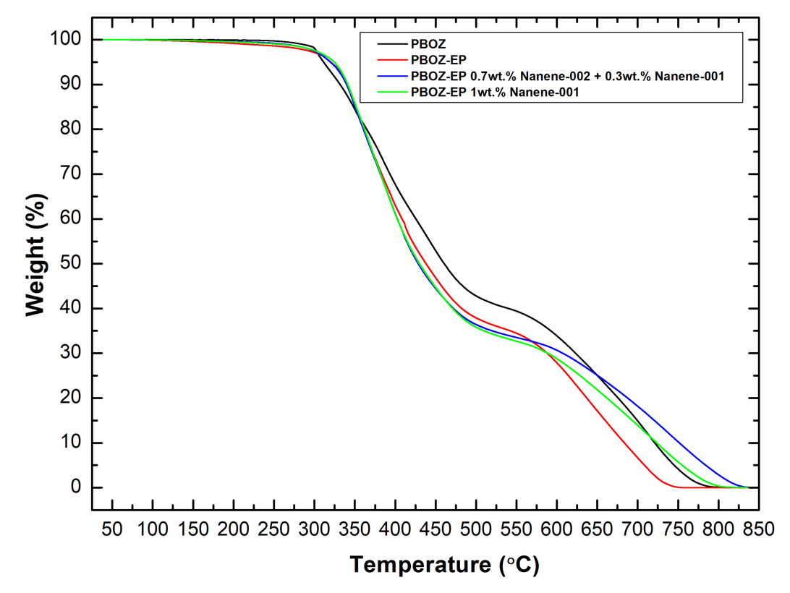
Figure 5. TGA curves obtained from neat PBOZ, PBOZ-EP 1:1 wt/wt and nanocomposite systems with a mixed blend filler 0.7wt% Nanene-002 + 0.3wt% Nanene-001 and a single filler at 1wt% Nanene-001 at a heating rate of 10C/min, under N₂ flow.

At a 5% weight loss the corresponding initial decomposition temperature (T_{init}) was observed to increase by 14ᵒC from 311ᵒC for the neat PBOZ to a maximum 325ᵒC for the single Nanene nanofiller system (Table 3). The neat PBOZ-EP and 0.7wt% Nanene-002 0.3wt% Nanene-001 mixed nanofiller systems also showed an improvement of 10ᵒC and 9ᵒC respectively. This improvement in thermal stability can be observed to extend to 10% weight loss for all systems to a maximum 341ᵒC compared to 332ᵒC for the neat PBOZ (Figure 5). At 50% weight loss the thermal stability of all systems drops by a maximum temperature of 31ᵒC compared to 460ᵒC for the neat PBOZ system (Table 3), (Figure 5).
Table 3. Characteristic temperatures of degradation
PBOZ-EP and Nanocomposites | T_{onset} (°C) | T_{end} (°C) | Te-To  (°C) | T_{5%} (°C) |  | T_{10%} (°C) |  | T_{50%} (°C)
PBOZ | 300 | 489 | 189 |  | 311 |  | 332 |  | 460
PBOZ-EP | 317 | 514 | 197 |  | 321 |  | 339 |  | 438
PBOZ-EP 0.7wt% Nanene-002 + 0.3wt% Nanene-001 | 320 | 510 | 190 |  | 320 |  | 340 |  | 429
PBOZ-EP 1wt% Nanene-001 | 322 | 517 | 195 |  | 325 |  | 341 |  | 430

3.4 Mechanical properties
PBOZ-EP tensile samples were produced, and the results obtained from mechanical testing formed baseline values for the different nanocomposite systems. Nanene-001 filler showed the highest decrease in E of 21% (Figure 6a). An increase in TS was measured in both single Nanene-001 and Nanene-002 nanofiller systems (Figure 6b) with a respective 27% and 21% improvement with the single Nanene measuring the most significant increase in EB (Figure 6c) of 45%. This demonstrates a good uniform dispersion of the smaller lateral size filler at this specific loading produces a material with superior strength and elastic properties compared to the neat copolymer system.

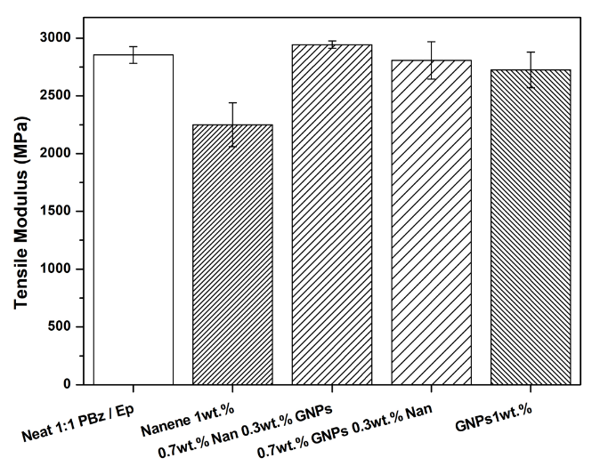 | 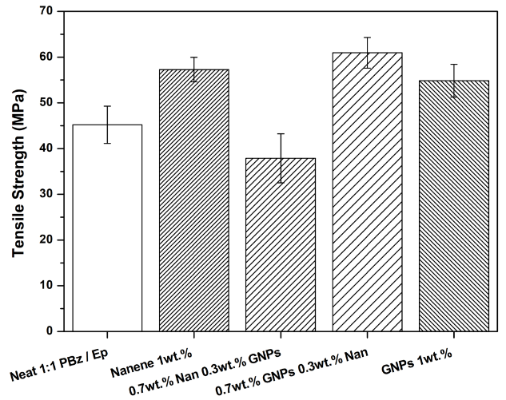
(a) | (b)
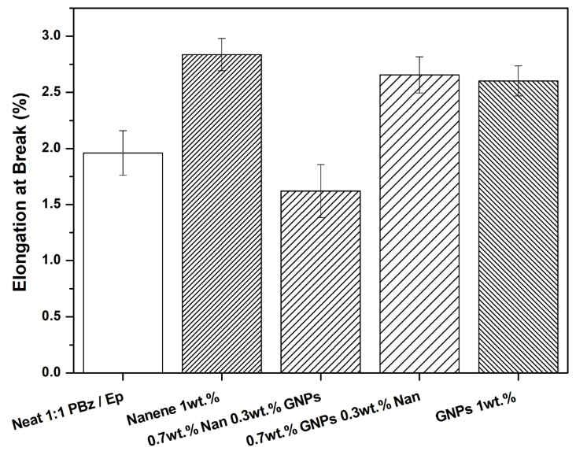
(c)
Figure 6. (a) Tensile modulus (b) Tensile Strength (c) Elongation at break

Copolymers of BOZ and EP resins (1:1 wt/wt) showed a 18% and 30% drop in the TS compared to the respective single BOZ and EP resin systems, values obtained from the technical datasheets provided. The loss in tensile strength through copolymerisation was recovered and increased by 35% in addition to a 36% increase in the EB using the best 0.7wt% Nanene-002 + 0.3wt% Nanene-001 mixed lateral size nanofillers whilst the E showed a negligible 1.6% reduction. Such a negligible change in E (Figure 6a) with significant improvements in strength (Figure 6b) and EB (Figure 6c) are attributed to the uniform dispersion of the mixed graphene powders and strong interactions and stress distribution between the mixed graphene powders and copolymer matrix.
The mechanical properties comparison of the above two systems with mixed blend nanofillers demonstrates not only the positive influence of graphene in the copolymer matrix with respect to TS and EB but the possibilities for further material optimisation with the introduction of a specific ratio mixed lateral size nanofillers.
Similar reductions in E and strength was reported by (43) using a PBOZ-CER (cycloaliphatic epoxy) copolymer. Additionally, an increase in TS of 20% and 37% respectively from the base copolymer system was reported using a 1.8wt% and 0.9wt% GNPs dispersed via ultrasonication and three-roll milling. Furthermore, a significant increase in the E of 46% and 55% was observed at the above loadings and related dispersion methods. However, this increase in E also saw a reduction in the EB at all Nanene-002 loadings (43). This is in contrast to the current work, which showed the above stated improvements in strength and EB, with a negligible change in the E.

3.5 SEM Analysis
The cryogenic fracture surfaces of the neat PBOZ-EP copolymer and mixed blend nanofillers were evaluated by SEM to assess the quality of dispersion within the copolymer matrix. SEM images of PBOZ-EP, PBOZ-EP 0.7wt% Nanene-002 + 0.3wt% Nanene-001 and PBOZ-EP 0.7wt% Nanene-001 + 0.3wt% Nanene-002 are presented in Figures 7a to 7c. Figure 7a shows the neat PBOZ-EP copolymer fracture surface morphology with a smooth surface showing minimum deformation, characteristic of brittle materials (27), (37). PBOZ-EP with 0.7wt% Nanene-002 + 0.3wt% Nanene-001 (Figure 7b) shows an even uniform distribution with random orientation of the Nanene-002 and Nanene-001 in the best performing mixed nanofiller blend with the highest TS. A similar uniform dispersion was reported in a PBOZ-Nanene-002 system by (37).

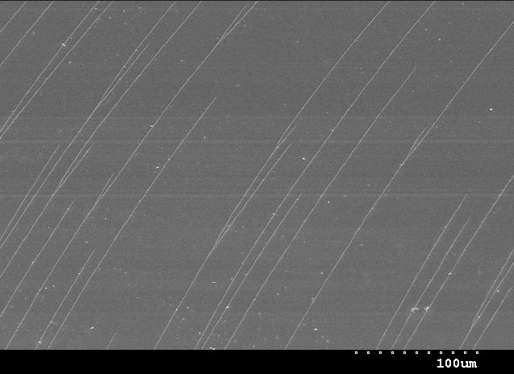 | 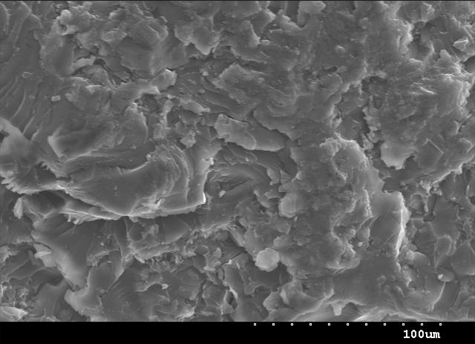
(a) | (b)
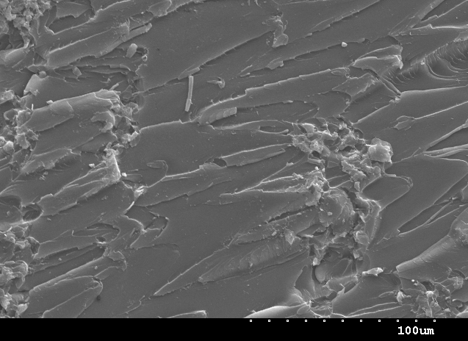
(c)
Figure 7. SEM micrographs obtained from (a) PBOZ-EP (b) PBOZ-EP 0.7wt% Nanene-002 + 0.3wt% Nanene-001 (c) PBOZ-EP 0.7wt% Nanene-001 + 0.3wt% Nanene-002.

In contrast to this is the poor homogeneity of the worst performing 0.7wt% Nanene-001 + 0.3wt% Nanene-002 mixed nanofiller (Figure 7c) where multiple large agglomerates of Nanene-001 and Nanene-002 can be observed, (43). The large agglomerates in the current work are a result of the incorrect ratio of the different lateral size nanofillers and the way they interact during ultrasonication in solvent and subsequent blending with the PBOZ-EP copolymer leaving areas of material predominantly made up of the matrix which is evident by the fracture surface.

4. Conclusions
In the current work, five series of novel PBOZ-EP copolymer and nanocomposites were prepared, comprising of the neat copolymer, two single filler and two mixed filler blends. It was found that pre-dispersion of the graphene powders in toluene significantly improves the quality of dispersion, confirmed by SEM imaging, within the copolymer. It was shown by DSC that the addition of either single filler caused a delay in polymerisation and an increase in exothermic peaks temperature of the curing reaction with a related reduction in ΔH_{Total.} compared to the neat copolymer. The delay in polymerisation, increased shift in exothermic peak temperature and reduction in (ΔH_{Total.}) for the 0.7wt% Nanene-002 0.3wt% Nanene-001 mixed nanofiller blend were less in comparison. Additionally, through TGA it was shown that copolymerisation and the addition of graphene improved the thermal stability of the material through the range of 300ᵒC – 350ᵒC compared to the neat PBOZ system. The PBOZ-EP-0.7wt% Nanene-002 + 0.3wt% Nanene-001 samples measured the highest improvement in TS, a negligible reduction in E and a significant increase in EB. The single nanofiller systems also measured increased TS and EB demonstrating the positive effect of the graphene powders as a reinforcement. The improvements in TS and the substantial increase in elastic properties through the addition of graphene powders demonstrate these nanocomposites to be viable materials for manufacturing.

Acknowledgments
The authors would like to thank Bitrez Ltd for providing the Curabox 24-111 and Epilok 60-566 resins.
Conflicts of Interest: The authors declare no conflicts of interest.

References
1. Redondo E, Muñoz J, Pumera M. Green activation using reducing agents of carbon-based 3D printed electrodes: Turning good electrodes to great. Carbon. 2021 Apr 30;175:413–9.
2. Roy S, Srivastava SK, Pionteck J, Mittal V. Mechanically and Thermally Enhanced Multiwalled Carbon Nanotube–Graphene Hybrid filled Thermoplastic Polyurethane Nanocomposites. Macromol Mater Eng. 2015;300(3):346–57.
3. Yashtulov NA, Lebedeva MV, Patrikeev LN, Zaitcev NK. New polymer-graphene nanocomposite electrodes with platinum-palladium nanoparticles for chemical power sources. Express Polym Lett. 2019;13(8):739–48.
4. Lin F, Xiang Y, Shen HS. Temperature dependent mechanical properties of graphene reinforced polymer nanocomposites – A molecular dynamics simulation. Compos Part B Eng. 2017 Feb 15;111:261–9.
5. Ma L, Yu B, Qian X, Yang W, Pan H, Shi Y, et al. Functionalized graphene/thermoplastic polyester elastomer nanocomposites by reactive extrusion-based masterbatch: preparation and properties reinforcement. Polym Adv Technol. 2014;25(6):605–12.
6. Pusty M, Shirage PM. Insights and perspectives on graphene-PVDF based nanocomposite materials for harvesting mechanical energy. J Alloys Compd. 2022 May 25;904:164060.
7. Vidya, Mandal L, Verma B, Patel PK. Review on polymer nanocomposite for ballistic & aerospace applications. Mater Today Proc. 2020 Jan 1;26:3161–6.
8. Nitin MS, Suresh Kumar S. Ballistic performance of synergistically toughened Kevlar/epoxy composite targets reinforced with multiwalled carbon nanotubes/graphene nanofillers. Polym Compos. 2022;43(2):782–97.
9. Benzait Z, Trabzon L. A review of recent research on materials used in polymer–matrix composites for body armor application. J Compos Mater. 2018 Sep 1;52(23):3241–63.
10. Termonia Y. Speed of sound and ballistic resistance of nanocomposite films. Polym Compos. 2012;33(9):1525–9.
11. Pol MH, Liaghat G, Hajiarazi F. Effect of nanoclay on ballistic behavior of woven fabric composites: Experimental investigation. J Compos Mater. 2013 Jun 1;47(13):1563–73.
12. Tate JS, Akinola AT, Kabakov D. Bio-based Nanocomposites: An Alternative to Traditional Composites. J Technol Stud. 2009 Fall;35(1):25–32.
13. Hu K, Kulkarni DD, Choi I, Tsukruk VV. Graphene-polymer nanocomposites for structural and functional applications. Prog Polym Sci. 2014 Nov;39(11):1934–72.
14. Sajjan AM, Banapurmath NR, Shivayyanavar NM, Kulkarni AS, Shettar AS. Development and characterization of silicon carbide incorporated graphene amine-based polymer nanocomposites for structural applications. IOP Conf Ser Mater Sci Eng [Internet]. 2018 Jun [cited 2022 Nov 20];376(1). Available from: https://www.proquest.com/docview/2556937774/abstract/269E3D6AEDE24698PQ/1
15. Kashiwagi T, Douglas JF, Du F, Winey KI, Harris RH, Shields JR. Nanoparticle networks reduce the flammability of polymer nanocomposites. Nat Mater. 2005;4(12):928–33.
16. Fu L, Li K, Qin H, Hou J, Zhang X, He G, et al. Sandwich structured iPP/CNTs nanocomposite foams with high electromagnetic interference shielding performance. Compos Sci Technol. 2022 Mar 22;220:109297.
17. Kuang T, Chang L, Chen F, Sheng Y, Fu D, Peng X. Facile preparation of lightweight high-strength biodegradable polymer/multi-walled carbon nanotubes nanocomposite foams for electromagnetic interference shielding. Carbon. 2016 Aug;105:305–13.
18. Sushmita K, Madras G, Bose S. Polymer Nanocomposites Containing Semiconductors as Advanced Materials for EMI Shielding. ACS Omega. 2020 Mar 17;5(10):4705–18.
19. Osokoya O. An evaluation of polymer composites for car bumper beam. Int J Automot Compos. 2017 Jan 1;3:44.
20. Galos J, Best AS, Mouritz AP. Multifunctional sandwich composites containing embedded lithium-ion polymer batteries under bending loads. Mater Des. 2020 Jan 5;185:108228.
21. García-Martínez V, R.Gude M, Calvo S, Martínez-Miranda MR, Ureña A. Influence of graphene nanoplatelets on curing kinetics and rheological properties of a benzoxazine resin. Mater Today Commun. 2020 Sep 1;24:100990.
22. Zeng M, Wang J, Li R, Liu J, Chen W, Xu Q, et al. The curing behavior and thermal property of graphene oxide/benzoxazine nanocomposites. Polymer. 2013 May 24;54(12):3107–16.
23. Plengudomkit R, Okhawilai M, Rimdusit S. Highly filled graphene-benzoxazine composites as bipolar plates in fuel cell applications. Polym Compos. 2016;37(6):1715–27.
24. Elmarakbi A, Karagiannidis P, Ciappa A, Innocente F, Galise F, Martorana B, et al. 3-Phase hierarchical graphene-based epoxy nanocomposite laminates for automotive applications. J Mater Sci Technol. 2019 Oct;35(10):2169–77.
25. Wang X, Zong L, Han J, Wang J, Liu C, Jian X. Toughening and reinforcing of benzoxazine resins using a new hyperbranched polyether epoxy as a non-phase-separation modifier. Polymer. 2017 Jul 14;121:217–27.
26. García-Martínez V, Gude MR, Ureña A. Understanding the curing kinetics and rheological behaviour of a new benzoxazine resin for carbon fibre composites. React Funct Polym. 2018 Aug;129:103–10.
27. Dayo AQ, Ma R kun, Kiran S, Zegaoui A, Cai W an, Shah AH, et al. Reinforcement of economical and environment friendly Acacia catechu particles for the reduction of brittleness and curing temperature of polybenzoxazine thermosets. Compos Part Appl Sci Manuf. 2018 Feb 1;105:258–64.
28. Mei Q, Wang H, Tong D, Song J, Huang Z. A Novel Acetylene-Functional/Silicon-Containing Benzoxazine Resin: Preparation, Curing Kinetics and Thermal Properties. Polymers. 2020 May;12(5):999.
29. Ke W, Rumin W, Jinfang Z. Curing Kinetics of Hybrid Networks Composed of Benzoxazine and Multifunctional Novolac Epoxy. Int J Polym Sci. 2015;2015:1–8.
30. Rimdusit S, Ishida H. Development of new class of electronic packaging materials based on ternary systems of benzoxazine, epoxy, and phenolic resins. Polymer. 2000 Oct;41(22):7941–9.
31. Wang Y, Wu W, Link to external site this link will open in a new window, Drummer D, Liu C, Tomiak F, et al. Improvement of thermal conductivity and mechanical properties for polybenzoxazine composites via incorporation of epoxy resin and segregated structure. Mater Res Express [Internet]. 2020 Sep [cited 2022 Nov 22];7(9). Available from: https://www.proquest.com/docview/2583432517/abstract/8EDF1468BE584A91PQ/1
32. Ishida H, Ohba S. Thermal analysis and mechanical characterization of maleimide-functionalized benzoxazine/epoxy copolymers. J Appl Polym Sci. 2006;101(3):1670–7.
33. Liu C, Sun M, Zhang B, Zhang X, Li J, Wang L, et al. Preparation and properties of acetylene-terminated benzoxazine/epoxy copolymers. React Funct Polym. 2017 Nov 1;120:98–103.
34. Ghouti HA, Zegaoui A, Derradji M, Cai W an, Wang J, Liu W bin, et al. Multifunctional Hybrid Composites with Enhanced Mechanical and Thermal Properties Based on Polybenzoxazine and Chopped Kevlar/Carbon Hybrid Fibers. Polymers. 2018 Dec;10(12):1308.
35. Kiskan B, Ghosh NN, Yagci Y. Polybenzoxazine-based composites as high-performance materials. Polym Int. 2011;60(2):167–77.
36. Del Saz-Orozco B, Ray D, Kervennic A, McGrail PT, Stanley WF. Toughening of carbon fibre/polybenzoxazine composites by incorporating polyethersulfone into the interlaminar region. Mater Des. 2016 Mar;93:297–303.
37. García-Martínez V, Gude MR, Calvo S, Ureña A. Enhancing an Aerospace Grade Benzoxazine Resin by Means of Graphene Nanoplatelets Addition. Polymers. 2021 Jan;13(15):2544.
38. Guo W, Wang X, Gangireddy CSR, Wang J, Pan Y, Xing W, et al. Cardanol derived benzoxazine in combination with boron-doped graphene toward simultaneously improved toughening and flame retardant epoxy composites. Compos Part Appl Sci Manuf. 2019 Jan 1;116:13–23.
39. Wang X, Li N, Wang J, Li G, Zong L, Liu C, et al. Hyperbranched polyether epoxy grafted graphene oxide for benzoxazine composites: Enhancement of mechanical and thermal properties. Compos Sci Technol. 2018 Feb 8;155:11–21.
40. Xu M, Yang X, Zhao R, Liu X. Copolymerizing behavior and processability of benzoxazine/epoxy systems and their applications for glass fiber composite laminates. J Appl Polym Sci. 2013;128(2):1176–84.
41. Jubsilp C, Punson K, Takeichi T, Rimdusit S. Curing kinetics of Benzoxazine–epoxy copolymer investigated by non-isothermal differential scanning calorimetry. Polym Degrad Stab. 2010 Jun;95(6):918–24.
42. Chou TY, Tsai HY, Hsu CH, Yip MC. Fabrication and characteristics of graphene-reinforced silver nanowire/polybenzoxazine/epoxy copolymer composite thin films. Polym Int. 2018;67(8):1081–93.
43. Barjasteh E, Narongdej P, Shipley W, Denk J. Development and characterization of graphite nanoplatelets filled copolymer of benzoxazine and epoxy. Polym Compos. 2020;41(9):3528–40.

