‘A great prop of the school’: The place of Sunderland Church High School in understanding Eileen O’Shaughnessy

This paper will explore the relevance of Sunderland Church High School for Girls in understanding the life and beliefs of Eileen O’Shaughnessy. It will take account of education reforms, and look at how the influential head teacher, Miss Ironside, instigated changes in the school that benefited Eileen and led to her studying at Oxford University before working in London. The love of education that Ironside instilled returned to Eileen in the early 1930s and contributed to her enrolling on an MA which in turn led to her meeting Eric Blair. The skills and resourcefulness that she started to develop at Sunderland Church High set her in good stead to survive as a single woman in the 1930s. Drawing on archive material, the paper will show how Eileen embraced school life, and how her teachers perceived and encouraged Eileen in her formative years.
Key words: Eileen O’Shaughnessy, educational reform, gender and education, single women, First World War.

The place of Sunderland Church High School in understanding Eileen O’Shaughnessy
Angela Smith
University of Sunderland, UK.

Eileen Maud O’Shaughnessy was born in South Shields, in the North-East of England. While her Irish-born parents had moved around the United Kingdom through her father’s job, South Shields was to be the first location where they would settle for any length of time; the Tyneside town providing a stable place to bring up their two children. From here, Eileen’s life might have followed the path of similarly well brought-up middle class young ladies to marriage and motherhood had it not been for two things: the First World War, and Eileen’s burning ambition to do as well as, if not better than, her elder brother. Sylvia Topp’s excellent biography of Eileen (2020), dwells upon the disappointment Eileen felt at the conclusion of her university studies, where the academic post her abilities warranted was denied by a dominant culture of misogyny. However, this led to Eileen taking up work in London, before then re-entering academic study ten years after graduating. It was through this return to study that she encountered Eric Blair, the man she was to marry. Eileen and Eric Blair met at a party hosted by a mutual friend and married within a year. Out of the thwarted dreams of her early career, Eileen entered a life where she came to have huge influence on some of the most famous literary works in English in the 20th century.

But what influences pervaded the early part of Eileen’s journey from South Shields to London, by way of Oxford? This has been a question that is difficult to answer, since the school Eileen attended from 1915-1924, Sunderland Church High School for Girls, closed in 2017 with records scattered or destroyed. However, enough can be retrieved to give us a picture of just what was so attractive about the school that inspired Eileen to travel by train and tram every day to attend.

This article will therefore look at the school in the context of Eileen’s time, and will explore how the influence of the head teacher helped form the ambitious, out-going, confident young lady who went to Oxford.

Gender and education
Britain only made education compulsory and free for the under 12s in 1870 when the Education Act was finally passed after many years of debate in parliament. The Act provided free education for boys and girls. Prior to this, education had been provided on an ad hoc basis, often guided by long-standing assumptions that girls would find no benefit in education beyond basic literacy, numeracy and practical household management. Indeed, young women were considered to lack femininity if they exhibited intelligence beyond their domestic remit, a stereotype that had a long history and was central to the patriarchal ideology of the time. We still have the legacy of this bias against learned women built into our Higher Education system, where an undergraduate degree is styled a Bachelors degree, with the next tier of qualification called a Masters. Prior to the 1870 act, there was no opportunity for women to go on to a higher level of education in the UK, as no universities would countenance their admission. Whilst the Act placed no restraint on boys and girls being educated together, it remained that most of the fee-paying schools continued to teach genders separately, thereby reproducing the stereotypes of boys being educated to go into the world of work that included business, science, and the military, while training girls to run a household (either their own or someone else’s). The division of what were considered to be appropriate subjects by gender was largely unchanged across the social classes, perhaps with greater opportunities for resources being the only advantage enjoyed by girls from wealthier homes.

If we look at Sunderland Church High School at this time, we can see that it was following the pattern of traditional gender stereotypes. Sunderland Church High School was one of four independent (that is to say, not state-funded) schools in the area, run by the Church of England under the management of a board of trustees attached to the Church Schools Company. These catered for a new middle class to arise over the course of the 19th century, able to pay for educational advantage. Other Church High schools opened around the same time in 1884 and 1885: those in Newcastle and Gateshead were closer to South Shields, with a third further afield in Durham. As was usual in such schools, girls and boys were educated separately, to different curriculums. However, this reinforced gender division, with the middle-class girls being educated in ‘accomplishments’ such as needlework, music, painting and dancing, with additional focus on skills that would allow them to manage a household and children. Contrarily, boys benefited from an education that mirrored the Classics taught in the longer established and upper-class public school system, with additional subjects in the sciences and engineering that reflected the emerging middle-class occupations. To give this gender division context, it is estimated that only one in fifty middle-class women entered such paid employment on leaving school (Holden 2007).

By the beginning of the 20th century, attitudes were starting to change, partly mirroring the rise in arguments for women’s rights that were to dominate public action in the century’s first decades, typified by the disparate movements demanding women’s right to the vote (Vicinus 1985). Sunderland Church High School was not immune from these challenges to gender roles, and it seems these were amplified within the school under the influential head teacher, Miss Ethel Ironside. In the next section, we will suggest that Miss Ironside’s reputation as a moderniser, pursing a more progressive approach to teaching and learning, may well have been a factor in Mr and Mrs O’Shaughnessy’s decision to send Eileen to that school rather than any of the others that were perhaps in easier reach.

The New Woman as Head Teacher
Miss Ironside was educated at Cheltenham Ladies’ College, where the renowned Miss Beale had already educated young women in a range of subjects that would be comparable with the studies of young men. Such young women were the first to go to university, aided by many of the ‘new’ universities’ willingness to offer degrees to women. Revealing a deeper set cultural misogyny, the most esteemed and ancient universities, Oxford and Cambridge, were still some years away from allowing female students to graduate (Oxford was the first to break cover and offer degrees to women in 1920, whilst Cambridge held on until 1948). Ironside took a teaching qualification at London University and began a career that would eventually lead her to Sunderland.

When Miss Ironside arrived at Sunderland Church High School in 1905, the school was in something of a crisis with only 53 pupils were registered. This was partly explained by local competition in the opening of a Higher Grade School (the forerunner of the later secondary schools) in Sunderland in 1890, charging a nominal fee of just tuppence a week. While fees at Church High varied according to such factors such as the additional classes the girls attended and whether they had a sister already in the school, fees were markedly higher than those required for the Higher Grade School.

Ironside could be accurately described as a ‘new woman’ of this period. The term ‘new woman’ derives from Henry James and his irreverent modern heroines Isabel Archer and Daisy Miller. Israel explains that:

Unlike the average bohemian or bachelor girl, the new woman possessed a leftist intellectual pedigree. Her attitudes and beliefs were descended from the elite early feminists [and in the United States] the single blessed spinsters of the Civil War ere and later reformers who’d helped found or been among the first to attend the women’s colleges. (2002: 114)

Miss Ironside regularly took part in sports activities with the girls (including swimming and hockey), as well as teaching sciences and mathematics. She was also familiar with ‘modern’ teaching techniques, advocating the Froebel Kindergarten methods at the school. In 1911, Ironside was obliged to defend this system of education to parents whose chief concerns were the delivery of rapid results. At that time she commented that: ‘Those who trust their children to the care of the Kindergarten must be content to await patiently the results which must ultimately show themselves in quickness of observations and intelligent grasp of subjects’ (in Sayers 1984: 27). In terms of her overall project, Ironside was setting up the school to have a steady progression of girls from Kindergarten up to Senior, and encouraging parents to ‘stick with the system’ for the duration.

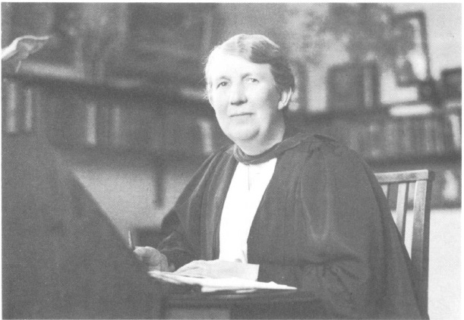
Miss Ethel Ironside in the 1930s. Reproduced courtesy of Audrey M. Sayers.

At her first prize giving event in 1908, Miss Ironside set out what would become her philosophy on educating the young women in her charge:

Our highest hope is to send out into the world a race of women of sane balanced mind, able to take a keen and intelligent interest in all that is going forward, proud of their nation because not ignorant of its great history, wide minded and no insular because they know something of languages and peoples other than their own, imperially minded because they have been taught of the responsibilities and duties of a citizen of such an Empire as that of Great Britain, eager to read and form judgements for themselves, able to appreciate beauty with both eye and ear, able to reason, able to listen; in short, women with training, and not ignorant, gossiping idle beings, whose chief fault, nay, misfortune, is in being the possessors of ill-stocked minds. What are going to be the problems with this this generation of girls will have to grapple in their turn is not the point; the thing is that they shall be taught to use wisdom along whatever path they may be sent – and wisdom the beginning of which is fear of the Lord. (quoted in Sayers 1984: 28)

If we look at the details of what Ironside is promoting in this address, we will see the school represented as a collective endeavour under her leadership, geared to confront the damaging stereotypes associated with women. The stereotypical qualities accorded to women are expressed baldly, as ‘ignorant, gossiping idle beings’. In patriarchal society, men are associated with rational thought and temperance, with women assumed to deficient in such attributes. Ironside presents an opposing view: that the girls at Sunderland Church High School will be ‘of sane balanced mind’ and will not conform to any disobliging female stereotype. The underlying assumption is education afforded to boys equips them with knowledge of the world that was useful beyond the home. Ironside’s framing of this as a ‘misfortune’, with the deliberate correction from ‘chief fault’, propels her stated commitment that it is through education that women can do good in this world, rather than being confined to the home. The girls will also be engaged with the outside world, in arriving at a considered and informed view of matters of shared concern and public importance. This refutes the stereotype of female domesticity, where the concerns of the woman are associated with the private word whilst those of men are associated with the ‘public sphere’.

In terms of addressing these public concerns, the mention of Empire has considerable contemporary resonance. It would have been just five years since the end of the Boer Wars, a time when the British army had not won the quick, decisive victory predicted. It is also preparing the young women of the school to take an active role in the maintenance of imperial power

Identity and Ethos in the School
In 1907, one of the first things Ironside did was to introduce a school uniform that comprised box-pleated gym tunics, white blouses and ties. This helped create a sense of unity amongst the girls, identifying themselves as belonging to the same school. It also helped ameliorate the snobbery that Ironside had observed amongst some of the girls who regarded their clothing as indicating social class. The uninform initiated by Ironside continued to adapt to fashion and cultural acceptability, and only known photograph of Eileen when at school is one that shows her wearing the version of this uniform adopted after 1907, with the slightly shorter skirt.

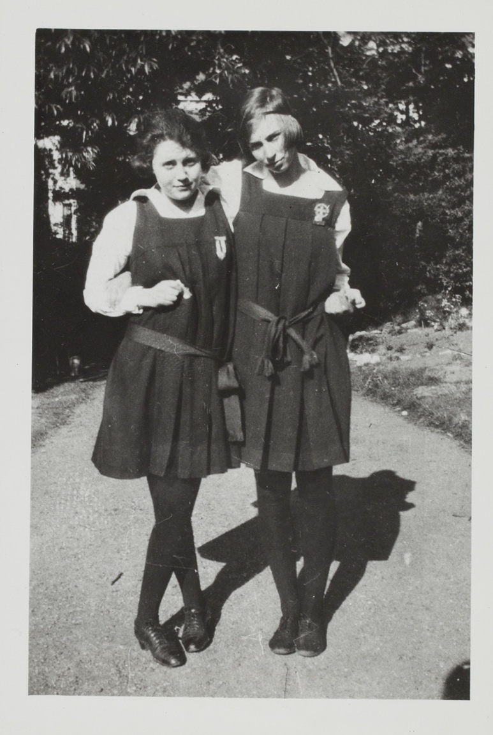
Eileen (left) with a friend. Photography reproduced courtesy of the Orwell Collection, UCL.

A still more tangible instance of Ironside’s commitment to an ethos of equality and virtue were the links that she made between the school and the local Royal Infirmary. There, the girls were engaged in charitable work such as sewing garments to distribute in the children’s ward, and raising funds through ‘Entertainments’ which included staging plays, concerts, and hosting tea parties. These activities met with such success that they were quickly adopted by the other Church High Schools in the region. The school also formed teams in netball, tennis, swimming and hockey, playing in regional tournaments against teams from other high schools.

Of course, many of these activities, including sewing and holding tea parties, remain within conventional gender boundaries. Furthermore, traditional subjects were still on the curriculum. Needlework, singing and painting, for example, were all still taught, although there was less emphasis on these subjects. However, the girls were organised in teams and entered local competitions in singing and music. We can see, for example, that the North of England Music tournament in 1922 awarded the school’s Senior Girls’ Choir second place, a choir that included Eileen O’Shaughnessy (although her first name appears as ‘Elsie’ in the school magazine, The Chronicle, for this). It is fair to say that the pupil’s identification with their gender is encouraged, including an understanding of the expectations and conventions this involves. However, the articulation of this awareness with advocacy and action remains apparent. For example, in 1909, Ironside introduced the debating society, for whom the first topic was ‘That women should have the vote and be equal with men’. The motion was carried. If we look at the topic of the debate, it is more than just Votes for Women: it includes the point that gender equality beyond enfranchisement is also at issue. It was followed soon by a parade through Sunderland in support of female enfranchisement, with a group of girls from Sunderland Church High taking part wearing placards reading: ‘Votes for Women’; all supported by the Ironside.

As our interest in the adult life of a former pupil should make clear, any sense of identity and ethos ought to last beyond school years. A sense of continuity and investment in each girl was further emphasised by the creation of the Old Girls’ Guild in 1908, which involved inviting former pupils to engage with the school at various points and in various capacities. The Guild grew, with alumni continuing to be members for many years after leaving school, some of them from their new homes in distant lands. They would also come into Eileen’s life as we shall see shortly.

These new innovations might have appeared alarming to the more conservative parents in the area, but it must also be said that, just as many gender conventions remain in school activities, so too the traditional subjects in the arts retained a place in the curriculum. Thus outwardly the school could be presented as progressive, confident and industrious whilst maintaining elements of female decorum.

By 1912, numbers had risen to 142, and had risen still further to 230 the following year. New premises were bought for use by the school in the surrounding area of Ashbrooke, including the development of additional boarding accommodation in Clifton Hall.

The war years: 1914-1918
Most organisations that included women and girls engaged in ‘war work’ that was domestically-orientated. This was primarily in the form of knitting and sewing parties providing a steady supply for garments. Sunderland Church High School was no different. The girls took foods, sweets and stationery to wounded men in the Royal Infirmary, and ‘adopted’ six prisoners of war in Germany (sending them letters and parcels on a weekly basis). Senior girls and staff joined the Sunderland branch of the Red Cross and the Voluntary Aid Detachment (VAD). Near-by Hammerton Hall had been commissioned as a hospital for officers, whilst the Royal Infirmary was the destination of ordinary service personnel. There, Sayers (1984: 36) describes how senior girls volunteered as VADs and worked as housemaids and cooks, comprising almost the entire staff in these roles. Even though the usual image of the VAD is the glamorised nurse, it is clear that the middle-class young women of Church High were willing to occupy roles that would have been more associated with servants in their own homes.

The school also continued established activities in drama, tea parties, and garden parties for wounded soldiers. In 1917, they had 400 guests at one such event. Overall, we can see the school was whole-heartedly engaging with the war on the home front.

It was into the midst of this engagement that Eileen O’Shaughnessy had arrived at school in 1915. School work was not greatly disrupted by the war, and at the time Eileen entered the school, it was about to adopt the Durham School Certificate (1917) which was the local examination board qualification equivalent to GCSE today. Eileen was one of seven girls in her year to successfully take the Durham School Certificate in 1921. It seems she was embracing the opportunities it gave her as part of her route to university.

1917 also saw the introduction of the House system. This was done, according to the former teachers interviewed by Sayers (1984 37-8) to help foster a greater sense of cooperation and enthusiasm throughout the school, from the kindergarten up to the Seniors. The decision was taken to follow the system of there being four ‘houses’ that was already well-established in boys’ fee-paying schools. The girls at Sunderland Church High were divided up according to where they lived, using quadrants on a map. The houses were given names taken from the initials of the school motto Timor Domini Principium Sapientiae (TDPS): Tiger (red), Drake (green), Panther (purple) and Swift (blue). In her announcement reported in The Chronicle, Miss Ironside noted that these ‘represent suitable animals or birds as emblems, in addition to being the name of four Destroyers’ (November 1918). By dent of her home address falling into the northern quadrant of the roughly-divided local map that Ironside used, Eileen found herself in Swift House. In this way, the school continued to modernise at a pace, and Eileen was able to take advantage of this (the school report for 1923 notes she is ‘full of loyal interest in the life of the school’). It is also a model of cultural education adopted by the other Church High Schools in the region around this time, but their houses were less imaginatively named: usually these were colours, rather than the well-thought-through animals linked to the school motto that Miss Ironside instigated.

In 1918, when some women had finally been granted the right to vote in Britain, Miss Ironside urged her girls:

to use it with knowledge and balance and judgement, forming a definite opinion not grounded on prejudice or superficiality; there must be sincere study of religious, political and social subjects, and all women who have been High School girls ought to be ready to lay things quite clearly before women less well educated than themselves. (cited in Sayers 1984: 26)

Again, we can see Ironside sustaining her rejection of restrictive gender stereotypes. The girls at Sunderland Church High would be educated to possess knowledge that was beyond the domestic domain and include ‘political and social subjects’ (along with the expected religious emphasis that goes with any school set up by a religious organisation). The quotation also marks the girls as being apart from the majority of their sex who are ‘less well educated’ in these areas, thus she is presenting the girls as being superior in knowledge but not arrogant with it. Their knowledge is to be put to good use when voting. Although in 1918 only a minority of women could vote, these would have been middle-class, propertied women such as the girls who attended the school could expect to be.

We can thus see that Miss Ironside set about modernising the school, both in its organisation (such as the introduction of the House system), but also in its curriculum, with the emphasis on ‘political and social subjects’ beyond the domestic domain. In encouraging debate and engaging with the wider community, the school was out-ward looking and progressive. This continued into the period of the First World War, with the curriculum’s expansion to include a route into university entrance through the Durham University Certification examination. Miss Ironside’s influence resulted in a large increase in numbers enrolling at a time when State-run schools were encroaching on the independent school territories. For example, the boys’ Church High School in Sunderland closed around 1910 as parents chose to send their sons to the Higher Grade School, later Bede School, in Sunderland, and similar ones in the Tyneside area.

The fact that Ironside was introducing a broader curriculum for the girls at the time of the First World War shows she is aware of the future necessity for them to earn a living for themselves without being reliant on a husband to support them. The prescience of Ironside’s changes can be seen in retrospect to have been very timely. The inter-war years, years saw young women such as Eileen O’Shaughnessy completed their school education and go to university then to earn their own way in life as single women.

Single women in the interwar years

Single women in the interwar years, women who had never married, reached record numbers as the consequences of the First World War became clear in terms of marriage statistics. Up until 1918, it was generally assumed that a single woman was either a widow, or else had been deemed unfit for marriage (Bell and Yans 2008: 10). The First World War changed this as the first mass industrialised war, bringing with it mass carnage amongst men of marriageable age. If we look at census data, we can see quite clearly.

Unmarried 25-25 years
(by population in hundreds of thousands)
 | 1911 | 1921
Men | 1,091 | 894
Women | 1,109 | 1,158
“Shortfall” | 18 | 264

This huge increase in the imbalance between the number of men and women of conventional marriageable age would have been even more pronounced for middle-class women such as those who attended Sunderland Church High, as the death rates for middle-class men were proportionally higher in the First World War. This has been said to stem from a combination of the cavalier notion of officers ‘leading from the front’ and, in the war’s early years, distinctive differences in the uniforms of officers from those worn by ordinary soldiers, marking them out more clearly for enemy snipers.

As Holden (2007) has commented in relation to the tracking of these statistics, more than half of the women who were single in 1921 had not married by the time of the 1931 census. Although the percentage of women who were unmarried (including never married and widowed) in 1921 was remarkably high, this was mostly caused by the huge rise in the number of women widowed by the war. By 1931, however, the number of widows had returned to a level comparable with 1911 as most of them had remarried (Smith 2013). This greater likelihood of having no male head of household who could support them was something many young middle-class women became alert to as the attritional realities of the war unfolded. Rosamund Essex’s (1977) oral history of this time records testimony from women from middle-class backgrounds that reveals they were warned by schools and universities about the shortage of men and that they should make career choices with this in mind. This chimes with the changes Miss Ironside made to the curriculum and culture of Sunderland Church High around the time of Eileen O’Shaughnessy. In fact, Ironside’s report in the November 1917 Chronicle directly addresses this. She warns against the lure of short-term war work in banks and offices, and cites government concerns of a looming teacher shortage. She writes there is an:

urgent necessity of women training for Education, [encouraging in particular] girls who were in doubt as to whether they out to spend money on Oxford or Cambridge when they could quite well be earning a weekly salary with no training at all […] If she has a special love for small children, she should certainly take the Froebel Course, and if for older children she must begin working as soon as may be for an entrance to one of the Universities, or if possible for a scholarship.
(The Chronicle, November 1917)

Whilst teaching is seen here as the most desirable profession for young women, the need to gain a university education is marked out for special attention because of the financial implications. To better enable girls to go to university, Miss Ironside instigated a system of scholarships. These were specifically aimed at girls who would go to Oxford or Cambridge universities. At that time, even though neither university allowed women to graduate, the value perceived of an education offered at these two universities was temptation enough to apply. Such was the esteem, the school allocated a mistress to coach potential entrants: Eileen’s coach was Miss Dyer, the mistress who also edited The Chronicle as well as teaching English and Latin.

The first scholarship was set up in 1918, and was funded by the Old Girls’ Guild. This was open to any girl who applied to go any university in the UK and would pay £30 per year. The scholarship was not awarded every year, but the school record book shows that Eileen was awarded it in both 1925 and 1926. The Old Girls’ Scholarship shows the changes Ironside had made in the school in bringing a greater sense of collaboration and responsibility, even after leaving school. The criteria for the awarding of the scholarship was not financial need (which would have been rather odd, given the fact that this is a fee-paying school and attracted affluent middle-class families), but rather for exceptional promise.

A second scholarship was instituted in 1919: the Everett Scholarship. This had been funded by the Everett family who donated a £1,000 War Loan to the school for the scholarship as thanks-giving offering for the safe return of their son (a former Old Boy at the now-closed Boys’ School) from the war. The daughter, Dorothy, had been an Old Girl and she continued to manage the scholarship for many years, ensuring it was safely invested and able to keep up with rising costs. To begin with, Oxbridge entrants were eligible for a grant of £20 per year for three years. Like the Old Girls’ Scholarship, this was based solely on academic merit.

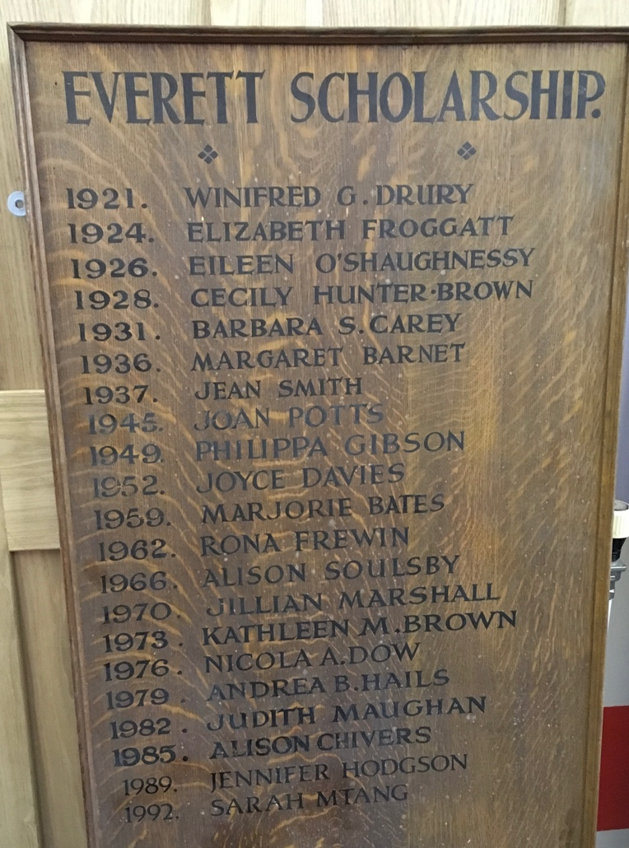
Honours Board for Everett Scholarship.

In setting up financial incentives to apply to university, the school was encouraging its young women to prepare themselves such that their education could be of value beyond the home. In perusing the carved wooden prize boards at the school, it is noticeable that Eileen O’Shaughnessy is the only person whose name appears on plaques for both the Old Girls’ Scholarship and the Everett Scholarship. Granted, the 1930s saw a change in rule so that any one individual could hold only one scholarship at a time. Nonetheless, it does show us something of the exceptional student who was Eileen O’Shaughnessy. In keeping with this, her list of achievements whilst at the school is remarkable:

Head girl
Head prefect
Swift House captain
Sub-editor of Chronicle
Sub-librarian
President of the League of Nations Branch.
Whitaker Thompson Memorial Prize
This latter prize is named after Mr Whitaker Thompson, who had been Chairman of the Church Schools Company for many years and had left a small legacy in the form of this prize in his will. The prize was open to entrants from all the Church High Schools in the region, so Eileen’s success in winning this particular prize hints at her talents being recognized more widely than in just Sunderland Church High.
As Swift House Captain too, Eileen can be glimpsed as a motivational and enthusiastic leader. In The Chronicle for November 1923, she welcomes newcomers to Swift House as a place which ‘not only realizes but practices the ideal of fellowship and co-operation’. In lamenting the lack of success on the sporting field in the previous year, she goes on in a voice that hints at later socialist beliefs: ‘Unity is strength’.
Overall, it seems Eileen’s leadership and organizational qualities were recognized throughout the school, not just in Swift House. Her editing of the school magazine hints at Eileen’s future life as editor of Orwell’s work. Furthermore, we can also see her interest in politics and international affairs in her involvement in the League of National branch, something that she might well have drawn on as a common interest with Orwell when they first met.

University and beyond
Eileen went to St Hugh’s College, Oxford in the autumn of 1924 to study English Literature. This is recorded in Miss Ironside’s column in The Chronicle in June 1924:

Eileen O’Shaughnessy has brought great honour to the School with her English Bursary of £20 per annum for three years at S. Hugh’s College, Oxford; and Margaret Ellis also with her entrance to S. Hugh’s on her History Scholarship paper. We congratulate them most heartily, and their coaches, Miss Dyer and Miss Curran.

The Chronicles from November 1924 continues in the same tone, describing Eileen and two other university-bound former girls as ‘real props of the school’. The bright, enthusiastic outstanding schoolgirl embraced university life, supported in part by the scholarships she had won from Sunderland Church High as well as the Oxford bursary, which in her case was for £20 per annum for three years. As Topp’s biography of Eileen shows, she did well at Oxford, but the university was only just starting to allow female students to graduate and residual misogyny meant very few female students graduated with a First. Eileen herself fell victim to this, meaning that her initial dream to spend her days immersed in Literature, teaching it at Oxford, were not to be realised. Instead, she tried her hand at teaching.

Teaching was by far the most popular profession for single women at that time, indeed it had been her mother’s pre-marriage occupation. By 1931, it was estimated that more than half of the single professional women aged 35-45 in the UK were teachers: that is one in eleven women who were in paid employment. Until 1944, married women would be obliged to resign their posts. Another option for the highly educated young women was in the civil service, which again had a marriage bar in place until 1946 (or until 1973 for the Foreign Service) (Civilservantorg.uk). Exacerbating the injustice still further, women at this time earned on average 60-80% less than men for doing the same or a comparable job. This gender disparity continued well into the latter part of the century and it took the efforts of Second Wave feminist in the 1960s to bring about political action for equal pay. Education could only help so far, in a context in which society was still orientated towards a patriarchal stance.

Representations of single women

Given Eileen’s great love of literature, and in order to emphasise the broader context alluded to at the end of the last section, it will be useful to look at how single women were represented in texts of this time. By and large, these fell into one of three categories, all reflecting in different ways the patriarchal society of the time.

- Marriage as an institution must be strongly reinforced, and single women are therefore viewed as “imaginary widows” bereaved by the war;
- Single women are a danger to society, with no husband to control them (these are often represented as “flappers” in popular imagination);
- Single women who are sexually repressed and thus untrustworthy or otherwise unreliable.

The image of the widow or quietly grieving fiancé occupies the margins of literature at this time. She is represented as the living legacy of the dead of the First World War. Her position of moral purity and sacrifice makes her suitable for work in teaching, where she comes to occupy the pages of school stories of the period, a photo of a young solider, framed in black, quietly sitting on her desk.

Contrarily, the Bright Young Things of the 1920s are seen to dance away the nights, attempting to blot out the horror of the recent war with parties and cocktails. As Israel (2002) has shown, the care-free flapper is a stock character in literature at this time, as well as in the newfangled movies where actors such as Clara Bow and Louise Brooks became internationally famous in films that followed the same narrative: care-free, single woman meets and then marries handsome, wealthy man. She is thus contained and made “respectable” by being absorbed into the patriarchal norm after enjoying a period of relative freedom and independence.

The final category is one that we find in many books of this period, where the image of the prudish, frigid spinster is presented as being symbolic of an intimate (and, by extension, domestic) rather than economic problem, particularly for middle-class women. We can see that this is the category of single woman that Orwell himself writes about. In The Clergyman’s Daughter (1935), he refers to the ‘abnormality’ of the spinster who resists marriage because of some deep-rooted sexual trauma (pp 76-77).

Yet, whilst Eileen’s general cheerfulness and sense of humour might have seen her regarded as akin to a flapper, it is clear that she herself acknowledged a deeper desire to comply with patriarchal order. In a letter to a friend, quoted by Topp (2020), Eileen jokes that she will marry the first man to ask her if she is still single at 30.

Eileen had never settled on a steady job after leaving Oxford, but had built a reputation as an excellent editor as well as contributing occasional pieces of freelance journalism. She had registered as an Old Girl at Sunderland Church High when she left the school in 1924. When the school came to celebrate its 50th anniversary in 1934, it used the Old Girls network to solicit contributions to a special edition of the school magazine, The Chronicle, that year. There seems to have been no specific request as to the nature of the contribution, as the published magazine is a mixture of personal recollections, school history pieces, and a couple of poems. One of these poems is by Eileen: ‘A Century’s End: 1984’. This poem looks back at the previous half century of the school and then hypothesizes about a less certain future 50 years ahead. This poem is now thought to have been influential in Orwell choosing ‘Nineteen Eighty-Four’ as the title to his best-known book (Coniam 1999). Thus the Old Girls Guild from Sunderland Church High not only helped support Eileen during her university years, but may inadvertently may have influenced one of the most famous titles in 20th century literature.

Eileen’s fateful decision to return to study, taking an MA in Psychology, led to her meeting Eric Blair at a party of a mutual friend. Whilst she never finished her MA, choosing instead to set up home with her new husband before they both headed off to Spain in 1936, the enquiring mind and lively sense of fun that had first been recognized by her teachers at Sunderland Church High certainly set her in good stead for the life she spent at wife of George Orwell, at which point the conventional biographies pick up.

Conclusions

On its own, a study of this period of the twentieth-century at Sunderland Church High School would reveal the role of individual and institutional agency in fostering a generation of inspired women, determined to establish their democratic rights. However, this also provides an insight into the formative influence on Eileen O’Shaughnessy; her willingness to extend her efforts and the Headteacher’s construction of a progressive school culture and ethos.

The changes in society that occurred in relation to gender in the first decade of the 20th century made it more acceptable for middle class women to go out to work, but this was still treated as employment until an offer of marriage came up. The education system took longer to change, with gender divisions in subjects showing an emphasis on domesticity for girls and industry and business for boys. Sunderland Church High School was one of the first to offer a valuable education for girls that could open up paid employment for them. This was largely done under the guidance of Ethel Ironside, whose arrival in 1907 heralded changes in the school that included its culture and structure as well as curriculum.

Perhaps it is this air of progressiveness that proved enticing for the O’Shaughnessys when they were looking for a school to send their precocious young daughter to in 1917. Eileen certainly seems to have thrived at the school, with the opportunities it offered sowing the roots of what we know her life became later. There are the organizational abilities and leadership that she exhibits in managing her and Orwell’s life, allowing him to work on his novels, and particularly in rescuing him from Spain (which he writes about in Homage to Catalonia).

Her editing work on The Chronicle was invaluable experience that she continued when at Oxford and then took to a whole new level when she started editing Orwell’s work. Her influence on what we regard as being his greatest work can only be understood when, as Topp points out, we see the original manuscripts she typed and annotated. These are all skills she started to develop at Sunderland Church High. Her engagement with politics was embedded in the curriculum, but clearly seen to be active in her role as President of the League of Nations Branch (that being another of the progressive ideas to come from the ever-inventive Ironside). Eileen also benefitted from the financial cushion of the two scholarships she was awarded when at Oxford.

The least that can be said is that Eileen was in the right place at the right time. She arrived at Sunderland Church High at the point where Ironside’s innovations and developments were at their most inventive and industrious. She was equipped with knowledge and skills to survive as a single woman in the inter-war years, skills and knowledge that allowed her to supplement that household income after her marriage. The Old Girls network, and the sense of comradery that Ironside fostered in the school inspired to Eileen writing a poem that could be said to have influenced one of the greatest novels in English in the 20th century, and certainly instilled a creative and progressive spirit that can only now be fully understood.

References
Bell, Rudolph and Virginia Yans (2008) (eds) Women on their Own: interdisciplinary perspectives on being single. New Brunswick, Rutgers University Press.
Civilservantorg.uk Women in the Civil Service: a history. https://www.civilservant.org.uk/women-history.html [Accessed 27 July 2022]
Conaim, Sally (1999) Orwell and the Origins of Nineteen Eighty-Four. Times Literary Supplement, December 31, 1999.
Essex, Rosamund (1977) Woman in a Man’s World. London, Sheldon Press.
Holden, Katherine (2007) The Shadow of Marriage: singleness in England 1914-60. Manchester, Manchester University Press.
Israal, Betsy (2002). Bachelor Girl: the secret history of single women in the twentieth century. New York, William Morrow.
Sayers, Audrey B. (1984) Sunderland Church High School for Girls: a centenary history. Privately printed.
Smith, Angela (2013) Discourses Surrounding British Widows of the First World War. London, Bloomsbury.
Topp, Sylvia (2020) Eileen: the making of George Orwell. London, Unbound.
Vicinus, Martha. (1985) Independent Women: work and community for single women 1850-1920. London, Virago.

Primary sources
The Chronicle (School magazine for Sunderland Church High School)
November 1917
November 1918
June 1922
November 1923
June 1924
November 1924
June 1934

Additional primary sources from Sunderland Church High’s archive held at Sunderland Antiquarian Society are reproduced with the consent of that organisation.

