Sustainable Branding: Leveraging Big Data and Business Analytics for Excellence
Vishnu Syam V Syamlal  DBA, MBA, BBM  1906860@student.uwtsd.ac.uk\ | Dr. John-Paul Okeoma Okeke  Ph.D., MA, BSc, PGCert, ALTHE, SFHEA, ILM  Okeoma.Okeke@sunderland.ac.uk | Dr. Dennis Gabriel Pepple  PhD, MSc, BSc, PGCRM, PGCAPHE, SFHEA, Academic MCIPD, CMBE  d.pepple@uwtsd.ac.uk

Abstract: This conference paper explores the distinctive nature of sustainable branding in the market research industry, focusing on its alignment with the Sustainable Development Goals (SDGs). Through an Inductive research approach for multi-faceted phenomena using a priori coding, the study investigates the impact of sustainable branding supported by big data and business analytics in the market research industry. Findings from semi-structured interviews with 38 industry professionals reveal that sustainable branding, aligned with the SDGs, enhances brand image, fosters customer loyalty, and provides a competitive advantage. The research highlights the relevance of sustainable branding in addressing social and environmental challenges outlined by the sustainability goals through SDGs. A new framework for sustainable branding in data-driven companies is presented, emphasizing components such as understanding customers' sustainability preferences, establishing clear sustainability goals, developing brand strategies, and targeted communication and product offerings. The findings provide valuable recommendations for leveraging sustainable branding, big data, and business analytics in market research.

Keywords: Sustainable branding, Inductive a priori Model, Sustainable Development Goals (SDGs), Brand Image, Big data, Business analytics, Market research industry.

Introduction: In recent years, the concept of sustainable branding has gained significant traction in the business world. Sustainable branding involves designing and communicating products or services in ways that positively impact the environment, society, and the economy (Merendino et al., 2018). This research aims to delve into the role of sustainable branding in the market research industry and explore how the integration of big data and business analytics can enhance its effectiveness.

One example that contextualizes the ideas of how big data and business analytics can enhance sustainable branding is the use of data-driven insights to identify consumer preferences and behaviours related to sustainability using the United Nations Sustainable Development Goals (SDGs) (Hassani et al., 2021). By analysing vast amounts of data, companies can gain valuable insights into their target audience's attitudes, beliefs, and purchasing patterns (Currie et al., 2020). This information allows them to tailor their sustainable branding efforts more effectively, aligning their messaging and product offerings with the specific needs and preferences of their customers (Awan, 2021).

Sustainable branding has emerged as a prominent trend in recent years, driven by a variety of factors that have transformed marketing (Erevelles et al., 2016). Consumer awareness and demand for sustainable and ethical practices have significantly increased, prompting businesses to integrate sustainability into their brand identity and values (Hsiung et al., 2021). In response to this consumer shift, companies are recognizing the importance of incorporating sustainability into their business strategies as a means to stay competitive and maintain relevance in the marketplace (Nielsen & Neergaard, 2018).

The trend towards sustainable branding has been gaining momentum over the past decade, with a notable increase in companies adopting sustainable practices and communicating them to their target markets. This trend has been fuelled by various factors, including heightened environmental consciousness, changing societal norms, and increased regulatory focus on sustainable business practices (Zimon et al., 2020). As consumers become more informed and concerned about sustainability, businesses across industries are recognizing the need to incorporate sustainable branding into their marketing strategies to remain appealing and relevant to their target markets for building a sustainable brand image (Arbouw et al., 2019).

Certain target markets exhibit a greater level of concern for sustainability, and their preferences and behaviours warrant attention (Currie et al., 2020). Additionally, niche markets such as eco-conscious consumers, organic product enthusiasts, and socially responsible investors prioritize sustainability in their decision-making process (O'Rourke & Ringer, 2016). Acknowledging these particular target markets and their heightened concerns about sustainability can inform companies' strategic approaches to sustainable branding and help them effectively target and engage with these consumer segments (Jraisat et al., 2022).

By exploring the impact of sustainable branding, big data, and business analytics on the market research industry, this study aims to shed light on the synergies and opportunities that exist in integrating these elements. Understanding the effectiveness of sustainable branding, as empowered by data-driven insights and analytical approaches, can provide valuable insights and guidance for companies seeking to enhance their branding strategies and resonate with increasingly sustainability-focused consumers.

Literature Review: Sustainable branding has gained significant attention in marketing and business research, encompassing social and environmental sustainability integration into business practices (Panda et al., 2020). This review explores the role of sustainable branding in the market research industry and examines how big data and analytics can enhance its effectiveness, aligning with the main themes of sustainability partnerships and initiatives, brand insights and performance evaluation, customer engagement and loyalty, and operational efficiency and cost effectiveness.

Integrating Sustainable Development Goals (SDGs) into sustainable branding initiatives is crucial for aligning business efforts with global sustainability objectives. Scholars have emphasized the use of big data and analytics to gain customer insights and tailor branding strategies accordingly (Merendino et al., 2018). By incorporating the SDGs into the framework, researchers can explore how the integration of big data and analytics enhances sustainable branding efforts, creating a competitive edge in the market research industry.

Examining customer preferences is essential in sustainable branding. Understanding customers' sustainability preferences through data sources and techniques is a key component of the new framework (Component 1). Additionally, establishing clear sustainability goals and communicating them to stakeholders is crucial (Component 2). Scholars have highlighted the positive influence of sustainable branding aligned with the SDGs on customer perception and brand image (Iglesias et al., 2019). This aligns with the value alignment and authenticity elements of the framework (Component 3).

Specific target markets, such as environmentally and socially conscious millennials and Gen Z consumers, prioritize sustainability and the SDGs (Sharmin et al., 2020). Sustainable branding strategies that consider these target markets and engage in collaboration with stakeholders and customers (Component 4) can create a competitive edge through effective communication and product offerings.

While sustainable branding and the integration of big data and analytics hold promise, there is a need for research that explicitly explores their application in the market research industry. Incorporating the SDGs into a theoretical framework allows for a comprehensive understanding of leveraging sustainable branding, big data, and analytics to position brands for equity in the market research industry.

In summary, this literature review highlights the importance of sustainable branding, big data, and analytics in the market research industry. By incorporating the SDGs, businesses can position their branding strategies for equity, gain a competitive edge through data-driven insights, and align with the framework's four components. Understanding these dynamics contributes to the overarching goal of achieving sustainable development objectives while providing valuable insights for researchers, businesses, and policymakers.

Methodology: This study employs an Inductive research approach to investigate the impact of sustainable branding, big data, and business analytics in the market research industry. The methodology has been modelled to address the specific concerns of market research industry and provide clearer justifications.

Research Design: An a priori inductive approach is adopted to explore the research objectives and develop insights into the multi-faceted phenomenon under investigation. This approach is justified by the need for critical thinking and reflection in the context of sustainable development (Strachan et al., 2021). By employing an inductive research approach, this study aims to generate new theoretical insights and knowledge regarding the relationship between sustainable branding, big data, and business analytics.

Sampling: The study sample consists of 38 participants selected from the market research industry based on their expertise and experience in sustainability, branding, big data, and business analytics. Purposive sampling is employed to ensure that participants have relevant knowledge and insights related to the research topic. The criteria for participant selection are aligned with the study objectives, ensuring that the sample includes individuals with a comprehensive understanding of the impact of sustainability, branding, big data, and business analytics in the market research industry.

Data Collection: Semi-structured interviews are conducted with the selected participants to gather qualitative data. The interviews are designed to explore the participants' experiences, perspectives, and insights regarding the impact of sustainable branding, big data, and business analytics in the market research industry. The interviews are conducted in a flexible manner, allowing for in-depth exploration of the research topic and providing space for participants to share their unique viewpoints and experiences.

Data Analysis: The data analysis process follows a thematic analysis approach. Initial a priori codes are developed based on the research questions and the theoretical framework. These codes provide a structure for the analysis and ensure that relevant themes and patterns are captured. The thematic analysis involves a systematic and iterative process of coding, categorizing, and interpreting the data to identify key themes and patterns that emerge from the interviews. This approach allows for a comprehensive exploration of the data and facilitates the identification of meaningful insights related to sustainable branding, big data, and business analytics.

Reporting Methodology: To enhance the reporting of this research, which integrates interdisciplinary perspectives, a novel reporting methodology called the "Inductive A priori model" is employed. This reporting model, previously developed as part of doctoral research, aims to provide clarity and rigor in presenting the research findings.

The Inductive A Priori model is a two-phase approach designed for research that uses Inter-disciplinary perspectives. In Phase 1, researchers formulate research questions and identify relevant areas related to those questions. This phase involves extracting initial data from a thematic framework using a priori coding, which helps shape specific interview questions and reduces data complexity. In Phase 2, the a priori conceptual framework is refined, and a model is developed to explore the relationships between variables. The reporting methodology associated with this model ensures transparency, reproducibility, and reliability of the research findings.

Reporting Methodology Using 'Inductive A priori Model'

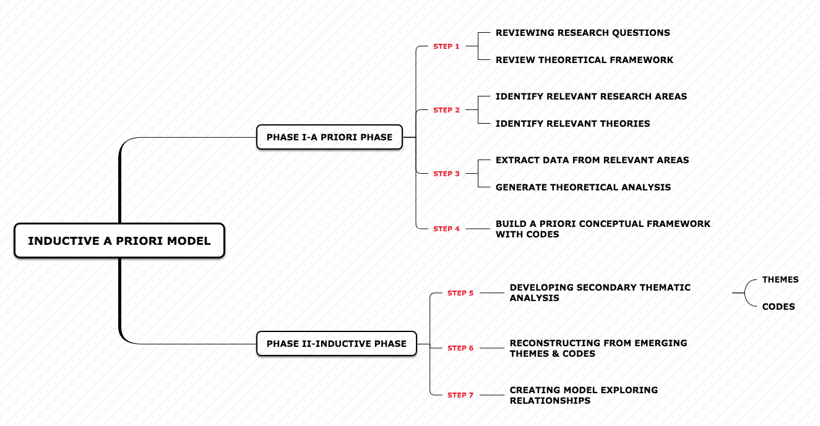
Source: Created by V S Vishnuvinayak Syamlal (2023)

The study strongly supports the use of the Inductive A Priori model for Inter-disciplinary perspectives of the research, emphasizing the significance of interdisciplinary collaboration and the integration of knowledge from various fields. A priori codes were developed from the research questions and theoretical framework for the interview process to gain insights into the phenomenon (Nunes & Al-Mamari, 2008) and also helps to reduce the complexities associated with multidisciplinary research (Pepple et al., 2022). The Inductive A priori model offers a structured framework for organizing and presenting the research process, data analysis techniques, and key findings. It ensures transparency and coherence in reporting the complex and multi-disciplinary nature of this study.

Findings: The findings of this study significantly contribute to the existing body of knowledge, providing novel insights that extend and refine prior theories and studies in the field. The research highlights the paramount importance of sustainable branding strategies supported by big data and business analytics in the market research industry, positioning them as crucial factors for achieving brand equity and gaining a competitive edge.

The first theme, Sustainability Partnerships and Initiatives, underscores the significance of collaborative efforts with stakeholders in establishing sustainable branding goals and initiatives. Through a comprehensive understanding of customers' sustainability preferences obtained via various data sources and techniques, companies can effectively develop brand strategies that align with customers' values. This alignment leads to improved brand performance evaluation, strengthening the brand's position in the market research industry (Rathore, 2023).

The second theme, Brand Insights and Performance evaluation, emphasizes the transformative power of big data and business analytics in uncovering profound customer insights. By leveraging these insights, data-driven companies can tailor their branding and marketing strategies to meet customers' evolving needs, resulting in enhanced brand performance evaluation and a competitive edge in the industry (Iglesias et al., 2019).

The third theme, Customer engagement and Loyalty, highlights the critical role of value alignment, authenticity, innovation, and collaboration in developing effective brand strategies. By establishing clear sustainability goals and effectively communicating them to customers, companies can engage their target audience and foster long-term loyalty. These elements contribute to the creation of a strong brand equity, solidifying the brand's position within the market research industry (Ajah & Nweke, 2019).

The fourth theme, Operational efficiency and Cost-effectiveness, elucidates the broader implications of sustainable branding. Embracing sustainable practices not only addresses environmental and social concerns but also leads to operational enhancements such as optimized supply chain operations, waste reduction, and overall cost savings. These improvements contribute to increased operational efficiency and profitability for organizations, further strengthening their competitive advantage (Mageto, 2021).

By recognizing and capitalizing on the synergies between sustainable branding, big data, and business analytics, companies can strategically position themselves within the market research industry. This study highlights the transformative potential of integrating these interconnected factors, offering a comprehensive framework that drives growth and long-term sustainability. The research outcomes have significant implications for practitioners, researchers, and policymakers, emphasizing the necessity of adopting sustainable practices and harnessing the power of data-driven approaches to thrive in the dynamic business environment of today.

Discussion: The findings of this study highlight the strategic significance of sustainable branding in establishing and enhancing brand equity within the market research industry. By forming sustainability partnerships and implementing initiatives, companies can align their branding goals with the values and preferences of their target customers. Understanding customers' sustainability preferences through data sources and techniques allows for the development of tailored brand strategies, fostering a strong brand image and positioning companies as leaders in sustainability (Rathore, 2023). This positioning not only enhances brand equity but also drives customer loyalty, ultimately contributing to long-term success in the industry.

Sustainable Branding Strategy Creating Competitive Edge through Big Data and Analytics:
The integration of big data and business analytics into sustainable branding strategies empowers companies to gain deeper insights into customer behaviour and preferences. By leveraging these insights, data-driven companies can customize their branding and marketing strategies, gaining a competitive edge in the market research industry (Iglesias et al., 2019). The ability to analyse and utilize data effectively enables companies to anticipate market trends, identify emerging opportunities, and deliver targeted offerings that resonate with customers. This data-driven approach enhances the overall brand performance evaluation and reinforces the competitive position of companies in the industry.

The framework proposed in this study comprises four key components: understanding customers' sustainability preferences, establishing clear sustainability goals, developing brand strategies, and targeted communication and product offerings. Data-driven companies can leverage various data sources and techniques to gain a comprehensive understanding of customers' sustainability preferences, enabling them to align their brand values with customer expectations (Ajah & Nweke, 2019). By establishing clear sustainability goals and effectively communicating them to customers, companies can engage their target audience and foster long-term loyalty. Developing brand strategies based on the key elements of value alignment, authenticity, innovation, and collaboration ensures the delivery of consistent and impactful sustainability messages. Additionally, collaboration with stakeholders and customer engagement allows companies to refine their communication and product offerings, further enhancing their brand equity and market position.

Proposed Framework for Sustainable branding for data-driven companies
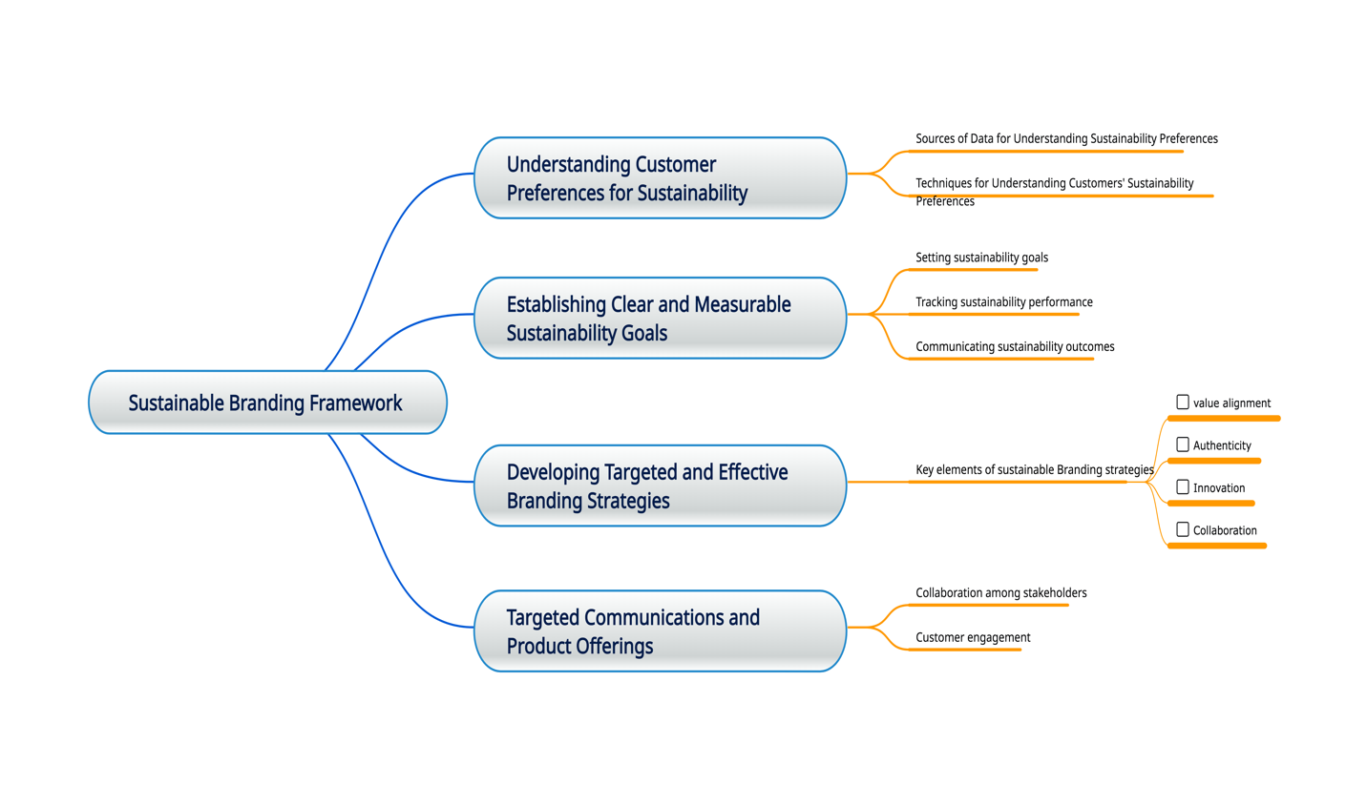
Source: Created by V S Vishnuvinayak Syamlal (2023)

Conclusion: The discussion highlights the transformative potential of sustainable branding, big data, and business analytics within the market research industry. Companies that strategically position themselves by leveraging these interconnected factors gain a competitive advantage and drive growth in the dynamic business landscape. The integration of sustainability initiatives not only attracts conscious consumers but also results in operational efficiency improvements and cost savings (Mageto, 2021). Furthermore, data-driven insights enable companies to adapt their branding strategies to meet evolving customer needs, ensuring long-term success.

The implications of this study extend to practitioners, researchers, and policymakers. Practitioners can use the framework presented here to guide their sustainable branding strategies, enhancing brand equity and competitiveness in the market research industry. Researchers can build upon these findings by exploring additional dimensions of sustainable branding and evaluating its impact on various industries. Policymakers can consider the importance of sustainability in fostering economic growth and encourage the adoption of data-driven approaches to support sustainable business practices.

References:

Arbouw, P., Ballantine, P. W., & Ozanne, L. K. (2019). Sustainable brand image: An examination of ad–brand incongruence. Marketing Intelligence & Planning, 37(5), 513-526.

Arslan, I.K., 2020. The importance of creating customer loyalty in achieving sustainable competitive advantage. Eurasian Journal of Business and Management, 8(1), pp.11-20.

Ajah, I.A. and Nweke, H.F., 2019. Big data and business analytics: Trends, platforms, success factors and applications. Big Data and Cognitive Computing, 3(2), p.32.

Currie, B. A., French, A. D., & Ülkü, M. A. (2020). Sustainability, Big Data, and Consumer Behavior: A Supply Chain Framework. Big Data Analytics in Supply Chain Management (pp. 109-132). CRC Press.

Erevelles, S., Fukawa, N. and Swayne, L., 2016. Big Data consumer analytics and the transformation of marketing. Journal of business research, 69(2), pp.897-904.

Giebe, C., Hammerström, L., & Zwerenz, D. (2019). Big data & analytics as a sustainable customer loyalty instrument in banking and finance.

Gioia, D. A., Corley, K. G., & Hamilton, A. L. (2013). Seeking qualitative rigor in inductive research: Notes on the Gioia methodology. Organizational Research Methods, 16(1), 15-31.

Hassani, H., Huang, X., MacFeely, S., & Entezarian, M. R. (2021). Big data and the united nations sustainable development goals (UN SDGs) at a glance. Big Data and Cognitive Computing, 5(3), 28.

Hsiung, T., Cheng, Y., & Han, Z. (2021). Sustainable Partnership: Operational Condition Analysis for Brand Value Co-Creation. Sustainability, 13(12), 6516.

Iglesias, O., Markovic, S., Singh, J.J. and Sierra, V., 2019. Do customer perceptions of corporate services brand ethicality improve brand equity? Considering the roles of brand heritage, brand image, and recognition benefits. Journal of business ethics, 154, pp.441-459.

Jraisat, L., Jreissat, M., Upadhyay, A., Sajjad, F., & Balodi, K. C. (2022). Paradox of strategic partnerships for sustainable value chains: Perspectives of not‐for‐profit actors. Business Strategy and the Environment, 31(7), 3491-3508.

Long, G., Clough, E., & Rietig, K. (2019). A study of partnerships and initiatives registered on the UN SDG partnerships platform.

Mageto, J., 2021. Big data analytics in sustainable supply chain management: A focus on manufacturing supply chains. Sustainability, 13(13), p.7101.

Mantere, S., & Ketokivi, M. (2013). Reasoning in organization science. Academy of Management Review, 38(1), 70-89.

Merendino, A., Dibb, S., Meadows, M., Quinn, L., Wilson, D., Simkin, L. and Canhoto, A., 2018. Big data, big decisions: The impact of big data on board level decision-making. Journal of Business Research, 93, pp.67-78.

Mhlanga, R., Gneiting, U., & Agarwal, N. (2018). Walking the Talk: Assessing companies' progress from SDG rhetoric to action.

Nielsen, L. H., & Neergaard, P. (2018). Value creation from strategic partnerships between companies and NGOs. Stakeholders, Governance and Responsibility (). Emerald Publishing Limited.

Nunes, M. B., & Al-Mamari, S. H. (2008a). Inductive approaches using a priori coding in information systems research: a discussion. Paper presented at the Proceedings of the 7th European Conference on Research Methodology for Business and Management Studies, 63- 72.

O'Rourke, D., & Ringer, A. (2016). The impact of sustainability information on consumer decision making. Journal of Industrial Ecology, 20(4), 882-892.

Panda, T.K., Kumar, A., Jakhar, S., Luthra, S., Garza-Reyes, J.A., Kazancoglu, I. and Nayak, S.S., 2020. Social and environmental sustainability model on consumers’ altruism, green purchase intention, green brand loyalty and evangelism. Journal of Cleaner production, 243, p.118575.

Pepple, D., Makama, C., & Okeke, J. (2022). Knowledge management practices: A public sector perspective. Journal of Business Research, 153, 509-516.

Rathore, B., 2023. Integration of Artificial Intelligence& It’s Practices in Apparel Industry. International Journal of New Media Studies (IJNMS), 10(1), pp.25-37.

Sharmin, F., Sultan, M. T., Badulescu, A., Bac, D. P., & Li, B. (2020). Millennial tourists’ environmentally sustainable behavior towards a natural protected area: An integrative framework. Sustainability, 12(20), 8545.

Strachan, S., Logan, L., Willison, D., Bain, R., Roberts, J., Mitchell, I., & Yarr, R. (2021). Reflections on developing a collaborative multi-disciplinary approach to embedding education for sustainable development into higher education curricula. Emerald Open Research, 3

Walsh, I. J., & Bartunek, J. M. (2011). Cheating the fates: Organizational foundings in the wake of demise. Academy of Management Journal, 54(5), 1017-1044.

Zimon, D., Tyan, J., & Sroufe, R. (2020). Drivers of sustainable supply chain management: Practices to alignment with UN sustainable development goals. International Journal for Quality Research, 14(1)

