The Evolution of Physical and Technical Performance Parameters in the English Premier League (EvoEPL1)

Running Title: Evolution and Match Performance

Key words: Longitudinal, high-intensity, sprinting, passing, football.

Abstract
Objectives: The aim of this study was to examine the evolution of physical and technical performances in elite soccer. Design: Retrospective study. Methods: Soccer match performance observations (n=14700) collected using a multiple-camera computerized tracking system over seven seasons and controlled for season, phase of season, position and standard were analysed for emergent trends. Results: Total distance covered during a match was ~2% lower in 2006-07 compared to 2012-13. Across seven seasons, high-intensity running distance increased by ~30% (890±299 vs 1151 ± 337 m, p<0.001; ES: 0.82). The number of high-intensity running actions increased over the same period (118±36 vs 176±46, p<0.001; ES: 1.41). Sprint distance increased by ~35% between 2006-07 and 2012-13 (232±114 m vs 350±139 m, p<0.001; ES: 0.93) with a concomitant increase in the number of sprints (31±14 vs 57±20, p<0.001; ES: 1.46). Mean sprint distance was shorter in 2012-13 compared to 2006-07 (5.9±0.8m vs 6.9±1.3m, p<0.001; ES: 0.91), with the proportion of explosive sprints increasing (34±11 vs 47±9%, p<0.001; ES: 1.31). Players performed ~40% more passes (35±17 vs 25±13, p<0.001; ES: 0.66), with a greater percentage of successful passes in 2012-13 compared to 2006-07 (83±10% vs 76±13%, p<0.001; ES: 0.60). The increased number of short and medium passes followed a similar pattern to total passes (p<0.001; ES>0.6), whereas the number of long passes varied little between seasons (p<0.001; ES: 0.11). Conclusions: The data demonstrate significant evolution of physical and technical parameters in the English Premier League and this information could aid talent identification, training preparation and injury prevention.

Introduction

Soccer match play is characterized by brief bouts of high-intensity linear and multidirectional activity interspersed with longer, variable recovery periods.¹ Computerised time-motion analysis has been used extensively as a tool to quantify the activity profiles during elite soccer matches²⁻⁴ with players covering 10-13 km in total with high-intensity running and sprinting distances accounting for 2-10% of that distance.^{5,6} The commonly held belief that the modern game is increasingly dynamic currently lacks objective supporting evidence. Technical rather than physical factors have been shown to better differentiate between competitive standards in elite soccer.⁷ There is, however, a lack of research to map the development of the game, and the complex inter-relationship between physical and technical factors.

Other team sports such as Handball and Australian Rules Football have been shown to have evolved over time, possibly due to rule changes and improvements in physical, psychological and tactical preparation.^{8,9} A comparison of the intensity of English League soccer matches played in the 1991-92 and 1997-98 seasons found increased incidence of dribbling, passing, crossing and running with the ball.¹⁰ Similarly increased passing rates and ball speeds have been observed in World Cup final matches across a 44-year period (1966-2010).¹¹ It was postulated that longer stoppage breaks for free kicks and corners permits greater recovery for players, allowing more intense activity to be initiated when play returns. Although this research provides insight into the technical development of soccer match play, no consideration was given to the physical performance of players.

To gain a more comprehensive understanding of the evolving patterns of soccer, large scale integrated technical and physical studies are needed, that include recent observations across multiple seasons, and which control for contextual factors such as playing position and phase of season.^{3,12} Thus, the aim of this study was to examine the evolution of the physical and technical performances parameters in the English Premier League using the largest controlled sample published to date.

Methods
Match performance data were collected from seven consecutive English Premier League seasons (2006-07 to 2012-13) using a multiple-camera computerised tracking system (Prozone Sports Ltd®, Leeds, UK). Players’ movements were captured during matches by cameras positioned at roof level and analysed using proprietary software to produce a dataset on each player’s physical and technical performance. The validity and reliability of this tracking system has been quantified to verify the capture process and data accuracy.^{12,13} Ethical approval was obtained from the University of Sunderland (Ethics Code 182) with Prozone Sports Ltd® supplying the data and granting permission to publish.
Data were derived from Prozone’s Trend Software and consisted of 1036 individual players across 22846 player observations. Original data files were de-sensitized but we were informed the sample included 33 different teams overall with 20 teams evaluated in each season. Individual match data were only included if players had completed the entire 90 min and matches were excluded if a player dismissal occurred. The total number of observations were substantially different across season (2006-07 to 2012-13), phase of season (Aug-Nov, Dec-Feb, Mar-May), position (Attackers, Centre backs, Central midfielders, Full-backs, Wide midfielders), location (home and away) and team standard based on final league ranking (A: 1st-4th, B: 5th-8th, C: 9th-14th, D: 15th-20th). The original data were re-sampled using a stratification algorithm in order to balance the number of samples in each of the time periods (season and phase of season), match location and relative proportions of playing position thus minimising errors when applying statistical tests. The re-sampling was achieved using the stratified function in the R package “devtools” (R Development Core Team) using the procedures of Wickham & Chang¹⁴ with 14700 player observations included for further analyses and 8146 excluded. The breakdown of the re-sampling in relation to these variables can be found in Table 1.
Activities were coded into the following: standing (0-0.6 km·h⁻¹), walking (0.7-7.1 km·h⁻¹), jogging (7.2-14.3 km·h⁻¹), running (14.4-19.7 km·h⁻¹), high-speed running (19.8-25.1 km·h⁻¹) and sprinting (>25.1 km·h⁻¹). Total distance represented the summation of distances in all categories. High-intensity running consisted of the combined distance in high-speed running and sprinting (≥19.8 km·h⁻¹) and was separated into three subsets based on the teams’ possession status: with or without ball possession and when the ball was out of play. A sprint with a rapid acceleration whereby sprinting speed was attained with minimal temporal excursion (<0.5s) through the high-speed running category was classed as an explosive sprint. A sprint with a longer passage through the high-speed running category due to a gradual acceleration was classified as a leading sprint.¹² Match analysis included the concomitant coding of technical events such as the number of passes, successful passes, received passes, touches per possession, dribbles, shots, events of tackles/tackled, crosses, final third entries, possession won and lost.
One-way independent-measures analysis of variance (ANOVA) tests were used to compare each season with Dunnet’s post hoc tests used to verify localised differences. Statistical significance was set at p<0.05. The effect size (ES) was calculated to determine the meaningfulness of the difference¹⁵ and magnitudes classified as trivial (<0.2), small (>0.2-0.6), moderate (>0.6-1.2) and large (>1.2-2.0).¹⁶ Additionally, regression analyses were performed to quantify the relationship between selected variables across time and the uncertainty of the estimates using 90% confidence intervals. All analyses were conducted using statistical software (R Development Core Team) and data visualization was carried out using the “ggplot2” package accessed via the Deducer Interface for the R statistical programming language.

Results
Total distance covered during a match was lower in 2006-07 compared to 2012-13 (10,679±956 vs 10,881±885 m) but varied by a trivial magnitude across the seven seasons (Figure 1A, p<0.001; ES: 0.01-0.22). High-intensity running distance increased from 890±299 m in 2006-07 to 1151±337 m in 2012-13 (Figure 1B, p<0.001; ES: 0.82), with an associated increase in the number of high-intensity running actions (118 ± 36 vs 176 ± 46, p<0.001; ES: 1.41). High-intensity running with ball possession was lower in 2006-07 (373±238 m) compared with other seasons, apart from 2008-09 (389±242 m), reaching a maximum of 478±260 m in 2012/13 (p<0.001; ES: 0.42). High-intensity running without ball possession was lower in 2006-07 (451±162 m) compared to other seasons, peaking in 2012-13 (589±198 m, p<0.001; ES: 0.76). In the 2012-13 season players covered 80±42 m of high-intensity running with the ball out of play, greater than other seasons (2006-07: 64±39 m, p<0.01; ES: 0.40). When presented relative to total high-intensity running, there were trivial differences in the percentages with, without possession and when the ball was out of play between seasons (p=0.16, 0.34 and 0.001, respectively; ES: 0.04-0.22). Total sprint distance increased from 232±114 to 350±139 m between 2006-07 and 2012-13 (Figure 1C; p<0.001; ES: 0.93). The total number of sprints increased across the same period (Figure 2A; 31±14 vs 57±20, p<0.001; ES: 1.46), while the average distance being covered in each sprint decreased (6.9±1.3 m vs 5.9±0.8 m, p<0.001; ES: 0.91). The number of leading sprints increased from 20±9 to 30±12 and the number of explosive sprints increased from 11±6 to 26±10 between 2006-07 and 2012-13 (Figure 2A; p<0.001; ES: 0.92 and 1.82, respectively). As a percentage of total sprints, the proportion of explosive sprints increased from 34±11 to 47±9% between 2006-07 and 2012-13 (Figure 2A; p<0.001; ES: 1.31), with a corresponding decrease in the percentage of leading sprints. In 2012-13 there were only 49 occurrences (2% of all 2012-13 data) when players performed <30% of their sprints explosively, whereas in 2006-07 there were 740 occurrences (35% of all 2006-07 data; Figure 2A). Walking distance reduced between 2006-07 and 2012-13 (3865±270 vs 3594±227 m, p<0.001; ES: 1.09), whereas jogging and running distance changed by trivial to small magnitudes over seasons (both p<0.001; ES: 0.05-0.28). Maximal running speed reached during sprinting increased from 9.12±0.43 to 9.55±0.40 m.s⁻¹ between 2006-07 and 2012-13, respectively (p<0.001; ES: 1.02).
Table 2 presents technical performance across the seasons. Players performed ~40% more passes (p<0.001, ES: 0.64, 0.66) and received ~17% more passes (p<0.001, ES: 0.76, 0.78), with a greater percentage of successful passes in 2011-12 and 2012-13 (p<0.001; ES: 0.68 and 0.60, respectively) compared to 2006-07. Whilst the number of short and medium passes followed a similar pattern to total passes (p<0.001; ES>0.6), the number of long passes varied little over the seasons (p<0.001; ES: 0.11). Players touched the ball more per possession in 2012-13 compared to 2006-07 (P<0.001; ES: 0.30), but not between the other seasons (ES: 0.03-0.16). The number of shots taken varied little between seasons (p=0.20; ES: 0.01-0.06). The average number of clearances reduced over the seasons (p<0.001; ES: 0.34). The average number of tackles made, tackled events and final third entries varied minimally over the seasons (p<0.001; ES: 0.06-0.27). Possessions won and lost decreased over the seasons reaching minimum in 2011-12 and 2012-13 (p<0.001; ES: 0.38-0.53). Figure 2B visually displays the interaction between the number of passes made and the percentage of successful passes with increases in the mean values of both indicators occurring across seasons. The percentage of occurrences of players with a passing success rate of <70% decreased from 26% in 2006-07 to 9% in 2012-13.

Discussion
The present study analysed the largest sample of player observations published to date, and builds on previous research^{5,17} by using a randomized stratification algorithm to allow seasonal, tactical and contextual factors to be accounted for. Controlling for such factors permits more appropriate generalizations to be made regarding the longitudinal match performance characteristics of elite players. The present data demonstrate that whilst total distance covered during a match remained relatively constant across the study timeframe, high-intensity running increased by ~30% between 2006-07 and 2012-13. Both total and high-intensity running distances covered have been used to represent the physical demands of soccer match play.^{2,6} High-intensity running would seem to be a better measure as it correlates well with physical capacity^{18,19} and discriminates between competitive standard and gender.^{7,20, 21} Thus, our finding supports the existing contention that high-intensity running is a more sensitive indicator of physical performance than total distance covered^{6,18} and highlights increasing physical demands of the English Premier League. Evolution of performance has also been reported in other football codes.⁹ Williams et al. found an increase in the number of technical events (passes, dribbles and crosses) in the top tier of English soccer between the 1991-92 and 1997-98 seasons.¹⁰ Increasing passing rates and ball speeds were observed in World Cup finals across a 44 year period.¹¹ The authors speculated that these trends could be related to longer stoppages for set-pieces with greater recovery periods allowing more intense activity when play is resumed, whereas in the present study increased high-intensity work was performed despite reduced recovery periods. The trend for increased physical performance in the present study could be attributed to improvements in the players’ physical capacity through enhanced physical preparation, or recruitment of players into the League with higher physical capacities. Research demonstrates that the maximal oxygen uptake (VO_{2max}) of elite soccer players has stayed relatively stable over the last two decades,²² though VO_{2max} is not the most appropriate measure of physical capacity in elite team sports players. Nonetheless, assuming stable physical capacities of English Premier League players across this period, then players are working at a higher proportion of their capacity in games. Bradley et al.⁷ reported no differences in the intermittent exercise capacity of players in the top three tiers of the English game but found that the lower tier players covered more distance at high-intensity compared with top tier players, therefore working at a higher proportion of their physical capacity in games due to more direct playing styles. Thus, it is plausible that current English Premier League players are expected to work at a higher relative intensity compared to previous years, despite adopting an apparently less direct playing style.
Sprinting comprises of only 1-4% of the total distance covered but despite its infrequent nature it typically occurs during significant moments in matches.^{2,12,23} Interestingly, in the present study the distance covered sprinting increased by ~35% between 2006-07 and 2012-13, from 2.1 to 3.2% of total distance covered, which was due to shorter but more frequent sprinting bouts during matches. This finding could reflect the evolution of defensive tactics associated with modern playing styles, as shorter more frequent sprints could be related to an increased player density. Over a 44-year period of World Cup final matches, the proportion of players within a selected dimension of the pitch increased, serving as a defensive strategy reducing space for attacking sequences.¹¹ However, in the present study there were no team tactics or player density data available and more research is warranted to verify this assertion. The growing physicality of the English Premier League is further supported by the fact that between 2006-07 to 2012-13, the absolute number of both explosive and leading sprints increased and the relative proportion of explosive sprints increased. Previous research in English Premiership players, found that the proportion of explosive and leading sprints was related to playing position,¹² but ours is the first to report longitudinal changes. These findings could have important implications for applied sports scientists, whereby training drills could be adapted to involve more frequent, shorter sprints that are more explosive in nature, with reduced recovery times to fully prepare players for the demands of the modern game. Maximal running speed was also found to increase substantially from 2006-07 to 2012-13. Therefore, if players are producing shorter more explosive sprints but attaining higher maximal running speeds, then the acceleration capability of players has developed, which could increase injury potential and practitioners may need to include pre-conditioning, preventive exercises. Interestingly, patterns of injury incidence reported in UEFA audits have remained unchanged across a comparable seven-year period from 2001-08.²⁴ However, the data in that study were collected from 23 elite European clubs, and not exclusively from the English Premier League, which is renowned for its physicality. Greater sprint speeds attained could indicate a change in the type of players recruited into the English Premier League, with greater focus on explosiveness and physicality. Our raw data set contains information on player position, nationality and standard and these will be interrogated in future studies.

Match analysis research typically quantifies the distance players cover in various movement categories without consideration for technical parameters.^{3,4,12} This approach fails to account for the complex and dynamic nature of soccer in which these parameters interact and a more integrative approach is advised. We found that players performed ~40% more passes, with a greater percentage of successful passes occurring in 2012-13 compared to 2006-07. This information, combined with increased numbers of short and medium passes (with little change in the number of long passes) suggests that there has been an increase in passing tempo over recent seasons, resulting in greater involvements with the ball. This is highly relevant as technical and tactical skills are considered more important determinants of success in soccer than physical measures, particularly passing ability.²⁵ The increased pass success rate may be partially explained by the increased proportion of short to medium passes, which are likely to be more successful than long passes. Researchers have found that passing frequency increased by 35% in World Cup final matches across a 44-year period,¹¹ similar to our increases across seven seasons, potentially reflecting a rapid technical evolution within the English Premier League. Fast transition of the ball to offensive areas of the pitch through a combination of high pass rates and ball speed is advantageous in elite soccer.¹¹ High passing rates and ball retention have a strong association with success^{6,27} but this relationship is highly complex with the efficiency of passing (passes to shots on goal ratio) and the type of offensive strategy (direct and counterattack) also important factors related to success.²⁸ Pollard et al.²⁹ found that the distance between players affected skill execution and thus increased short-medium passes could reflect closer player proximity in current Premier League soccer requiring players to make quick decisions and precise passes to maintain possession. Match related fatigue has been associated with reduced technical performance, primarily involvements with the ball rather than passing ability.²⁵ In the present study, despite increasing physical demands of match play and potential for fatigue, passing ability has progressively improved from 76 to 84% in just seven seasons, indicating substantial evolution of the game. This increase in technical performance is further supported by the percentage of player occurrences with a passing success rate of <70%, identified as a minimum requirement in elite soccer,³⁰ decreasing from 26% in 2006-07 to 9% in 2012-13. These data have important implications for identifying and scouting talent as the minimal level of technical competence is improving annually. Although the future evolutionary trajectories of these technical parameters are unknown they are vital for success in soccer.

In conclusion, this study demonstrated that across seven seasons, high-intensity running distance increased while total distance covered remained stable. Sprint distance increased markedly, with sprints becoming more frequent, shorter and more explosive. Players performed more short-medium distance passes, with greater passing success. Data suggest that the English Premier League is evolving, reflecting increased physical performance and technical competence. The information contained in this study should aid talent identification, training preparation and injury prevention.

Practical Implications
- Players are required to perform increasing volumes of high-intensity work in matches, performing more frequent, shorter explosive sprints.
- Players are performing greater numbers of short to medium passes with greater pass success rates.
- Training drills should be structured to reflect the evolution of physical and technical performance in the English Premier League.

Acknowledgements
The authors would like to thank Paul Neilson and Will Jones from Prozone Sports for providing unlimited access to the company’s entire data bank.

References
- Varley MC, Aughey RJ. Acceleration Profiles in Elite Australian Soccer. Int J Sports Med 2013; 34(1): 34-39.
- Bradley PS, Sheldon W, Wooster B, et al. High-intensity running in English FA Premier League soccer matches. J Sports Sci 2009; 27(2): 159-168.
- Castellano J, Blanco-Villaseñor A, Álvarez D. Contextual Variables and Time-Motion Analysis in Soccer. Int J Sports Med 2011; 32(6): 415-421.
- Rampinini E, Coutts AJ, Castagna C et al. Variation in Top Level Soccer Match Performance. Int J Sports Med 2007; 28(12): 1018-1024.
- Di Salvo V, Pigozzi F, González-Hero C, et al. Match Performance Comparison in Top English Soccer Leagues. Int J Sports Med 2013; 34(6): 525-532.
- Mohr M, Krustrup P, Bangsbo J. Match Performance of high-standard soccer players with special reference to development of fatigue. J Sports Sci 2003; 21(7): 519-528.
- Bradley PS, Carling C, Gomez Diaz A et al. Match performance and physical capacity of players in the top three competitive standards of English professional soccer. Hum Mov Sci 2013; 32(4), 808-821.
- Bilge M. Game analysis of Olympic, World and European Championships in Men’s Handball. J Hum Kinet 2012; 35: 109-118.
- Norton KI, Craig NP, Olds TS. The Evolution of Australian Football. J Sci Med Sport 1999; 2(4): 389-404.
- Williams AM, Lee D, Reilly T. A quantitative analysis of matches played in the 1991-92 and 1997-98 Seasons. London: The Football Association, 1999.
- Wallace JL, Norton KI. Evolution of World Cup soccer final games 1966-2010: Game structure, speed and play patterns. J Sci Med Sport 2013; Epub ahead of print. doi: 10.1016/j.jsams.2013.03.016
- Di Salvo V, Gregson W, Atkinson G, et al. Analysis of High Intensity Activity in Premier League Soccer. Int J Sports Med 2009; 30(3): 205-212.
- Di Salvo V, Collins A, McNeill B, et al. Validation of Prozone: A new video-based performance analysis system. Int J Perf Anal Sport 2006(1); 6: 108-119.
- Wickham H, Chang W. devtools: Tools to make developing R code easier. R package, version 1.3. Available at: URL: http://CRAN.R-project.org/package=devtools. Accessed October 2013.
- Cohen J. Statistical Power Analysis for the Behavioral Sciences, 2nd ed., Hillsdale, New Jersey: Lawrence Erlbaum Associates, 1988
- Batterham AM, Hopkins WG. Making meaningful inferences about magnitudes. Int J Sports Physiol Perform 2006; 1(1): 50-57.
- Gregson W, Drust B, Atkinson G, et al. Match-to-match variability of high-speed activities in premier league soccer. Int J Sports Med 2010; 31(4): 237-242
- Krustrup P, Mohr M, Amstrup T, et al. The Yo-Yo Intermittent Recovery Test: Physiological Response, Reliability and Validity. Med Sci Sport Exer 2003; 35(4): 697-705.
- Bradley PS, Mohr M, Bendiksen M, et al. Sub-maximal and maximal Yo-Yo intermittent endurance test level 2: heart rate response, reproducibility and application to elite soccer. Eur J Appl Physiol 2011; 111(6): 969-978.
- Andersson H, Randers M, Heiner-Møller A. Elite Female Soccer Players Perform More High-Intensity Running When Playing in International Games Compared with Domestic League Games. J Strength Cond Res 2010; 24(4): 912-919
- Mohr M, Krustrup P, Andersson H et al. Match activities of elite women soccer players at different performance levels. J Strength Cond Res 2008; 22(2): 341-349.
- Tønnessen E, Hem E, Leirstein S, et al. Maximal aerobic power characteristics of male professional soccer players, 1989-2012. Int J Sports Physiol Perform 2013; 8(3): 323-329.
- Vescovi JD. Sprint profile of professional female soccer players during competitive matches: Female Athletes in Motion (FAiM) study. J Sport Sci 2012; 30(12): 1259-1265.
- Ekstrand J, Hägglund M, Waldén M. Injury incidence and injury patterns in professional football: the UEFA injury study. Brit J Sport Med 2011; 45(7): 553-558.
- Rampinini E, Impellizzeri FM, Castagna C et al. Technical performance during soccer matches of the Italian Serie A league: effect of fatigue and competitive level. J Sci Med Sport 2009; 12(1): 227-233.
- Bate R. Football chance: tactics and strategy. In: Reilly T, Lees A, Davids K, Murphy WJ (Eds). Science and Football: Proceedings of the first World Congress of Science and Football. Oxon, UK: Routledge, 1988.
- Carmichael F, Thomas D, Ward R. Production and efficiency in association football. J Sport Econ 2001; 2(3): 228-243.
- Collet C. The possession game? A comparative analysis of ball retention and team success in European and international football, 2007-2010. J Sports Sci 2013; 31(2): 123-136
- Pollard R, Ensum J, Taylor S. Estimating the probability of a shot resulting in a goal: the effect of distance, angle and space. Int J Soccer Sci 2004; 2(1): 50-55.
- Dellal A, Chamari K, Wong DP et al. Comparison of physical and technical performance in European soccer match-play: FA Premier League and La Liga. Eur J Sport Sci 2011; 11(1): 51–59.

Tables Legends

Table 1. The breakdown of the re-sampled data from stratified random analysis. Note: The original data set included 22846 observations but after the re-sampling of the data this excluded 8146 observation to enable a sample of 14700 to be analyzed. Data in parentheses indicate the relative proportion of the total sample as a percentage. Month: Start of season (Aug-Nov), Middle of season (Dec-Feb) and End of season (Mar-May). Positions: AT = Attackers, CB = Centre backs, CM = Central midfielders, FB = Full-backs and WM = Wide midfielders).

Table 2. Technical indicators across the 2006-07 to 2012-13 seasons. Data are displayed as means and standard deviations. Note: *p<0.05, #p <0.01 and †p <0.001 denote difference from 2006-07 season.

Figure Legends

Figure 1: Box and Whisker plots with median values interquartile ranges and outliers for the distances covered in (A) Total (B) High-intensity running and (C) Sprinting across seven seasons of the English Premier League. Each player’s observation is jittered and is included as a small dot around Box and Whisker plots (diamond within box is the mean value for each season). The larger dots at the top and bottom of figures are outliers. Line represents the regression line.

Figure 2: Visualization of data trends using contour plots of (A) number of sprints and the relative proportion of those sprints that were explosive in nature, (B) number of passes and pass success rate in the English Premier League. Rug plots are also superimposed onto the x and y axis to provide insight into the distribution of each variable (darker the shade the higher the distribution).

Table 1 (Supplementary: online only).

Season | 2006-07 | 2007-08 | 2008-09 | 2009-10 | 2010-2011 | 2011-12 | 2012-13 | Total
Month
Aug-Nov | 700 (33) | 700 (33) | 700 (33) | 700 (33) | 700 (33) | 700 (33) | 700 (33) | 4900 (33)
Dec-Feb | 700 (33) | 700 (33) | 700 (33) | 700 (33) | 700 (33) | 700 (33) | 700 (33) | 4900 (33)
Mar-May | 700 (33) | 700 (33) | 700 (33) | 700 (33) | 700 (33) | 700 (33) | 700 (33) | 4900 (33)
Location
Home | 1083 (52) | 1078 (51) | 1050 (50) | 1069 (51) | 1051 (50) | 1049 (50) | 1019 (49) | 7399 (50)
Away | 1017 (48) | 1022 (49) | 1050 (50) | 1031 (49) | 1049 (50) | 1051 (50) | 1081 (51) | 7301 (50)
Position
AT | 315 (15) | 310 (15) | 309 (15) | 308 (15) | 306 (15) | 306 (15) | 298 (14) | 2152 (15)
CB | 534 (25) | 527 (25) | 523 (25) | 539 (26) | 554 (26) | 546 (26) | 569 (27) | 3792 (26)
CM | 459 (22) | 463 (22) | 465 (22) | 464 (22) | 454 (22) | 452 (22) | 443 (21) | 3200 (22)
FB | 475 (23) | 489 (23) | 493 (23) | 487 (23) | 491 (23) | 487 (23) | 498 (24) | 3420 (23)
WM | 317 (15) | 311 (15) | 310 (15) | 302 (14) | 295 (14) | 309 (15) | 292 (14) | 2136 (15)
Standard
A (1st-4th) | 319 (15) | 245 (12) | 339 (16) | 360 (17) | 424 (20) | 446 (21) | 386 (18) | 2519 (17)
B (5th-8th) | 509 (24) | 436 (21) | 407 (19) | 385 (18) | 459 (22) | 347 (17) | 422 (20) | 2965 (20)
C (9th-14th) | 486 (23) | 719 (34) | 656 (31) | 713 (34) | 587 (28) | 636 (30) | 651 (31) | 4448 (30)
D (15th-20th) | 786 (37) | 700 (33) | 698 (33) | 642 (31) | 630 (30) | 671 (32) | 641 (31) | 4768 (32)
Overall | 2100 | 2100 | 2100 | 2100 | 2100 | 2100 | 2100 | 14700

Variables | 2006-07 | 2007-08 | 2008-09 | 2009-10 | 2010-11 | 2011-12 | 2012-13
Passes | 25.3 ± 13.4 | 27.0 ± 13.7† | 30.8 ± 16.0† | 29.0 ± 14.6† | 32.1 ± 15.1† | 35.5 ± 18.2† | 35.4 ± 17.1†
Successful passes (%) | 76.3 ± 12.7 | 78.0 ± 12.1† | 80.7 ± 10.9† | 78.2 ± 11.8† | 81.1 ± 10.4† | 84.0 ± 9.6† | 83.3 ±10.1†
Short passes | 6.1 ± 4.3 | 7.0 ± 4.7† | 7.9 ± 5.3† | 7.5 ± 5.2† | 8.3 ± 5.2† | 9.6 ± 6.4† | 9.4 ± 6.0†
Medium passes | 13.4 ± 8.7 | 14.3 ± 8.8* | 16.7 ± 10.3† | 15.5 ± 9.4† | 17.7 ± 10.0† | 19.7 ± 11.9† | 19.8 ± 11.3†
Long passes | 5.7 ± 4.0 | 5.7 ± 4.0 | 6.2 ± 4.5# | 5.9 ± 4.3 | 6.2 ± 4.3# | 6.2 ± 4.6† | 6.2 ± 4.5†
Passes received | 18.8 ± 11.7 | 20.6 ± 11.7† | 24.3 ± 14.0† | 22.3 ± 12.5† | 25.5 ± 13.2† | 29.5 ± 16.1† | 29.2 ± 14.9†
Touches | 1.9 ± 0.6 | 2.0 ± 0.5* | 2.0 ± 0.5† | 1.9 ± 0.5 | 2.0 ± 0.5* | 2.0 ± 0.5† | 2.1 ± 0.5†
Shots | 1.2 ± 1.4 | 1.2 ± 1.4 | 1.2 ± 1.5 | 1.2 ± 1.5 | 1.2 ± 1.5 | 1.3 ± 1.6 | 1.2 ± 1.5
Clearances | 3.0 ± 2.9 | 3.4 ± 3.2† | 2.6 ± 2.5† | 2.8 ± 2.6# | 2.4 ± 2.3† | 2.1 ± 2.2† | 2.3 ± 2.3†
Dribbles | 0.1 ± 0.4 | 0.2 ± 0.5 | 0.3 ± 0.7† | 0.5 ± 1.0† | 0.8 ± 1.4† | 1.2 ± 1.7† | 0.6 ± 1.1†
Tackles | 3.2 ± 2.2 | 2.6 ± 2.0† | 3.3 ± 2.3 | 3.2 ± 2.3 | 3.1 ± 2.1 | 2.9 ± 2.1# | 3.0 ± 2.2
Tackled | 2.8 ± 2.7 | 2.3 ± 2.3† | 2.9 ± 2.7 | 2.8 ± 2.8 | 2.6 ± 2.6 | 2.6 ± 2.6 | 2.6 ± 2.5*
Final third entries | 5.9 ± 4.0 | 5.9 ± 3.8 | 5.8 ± 3.9† | 5.9 ± 3.8 | 5.7 ± 3.7† | 5.4 ± 3.6† | 5.2 ± 3.6†
Possessions won | 19.6 ± 9.4 | 19.7 ± 9.4 | 18.1 ± 8.9† | 19.0 ± 9.1 | 17.8 ± 8.6† | 16.4 ± 8.0† | 16.4 ± 7.7†
Possessions lost | 22.8 ± 6.9 | 22.7 ± 7.0 | 21.0 ± 6.6† | 22.1 ± 6.9# | 20.5 ± 6.7† | 19.3 ± 6.3† | 19.3 ± 6.3†
Note * (P<0.05), # (P<0.01) and † (P<0.001) denote significantly different from 2006-07
Table 2.
Figure 1A.
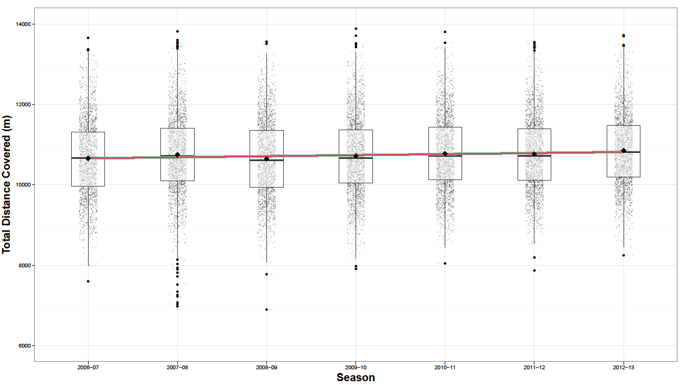

Figure 1B.
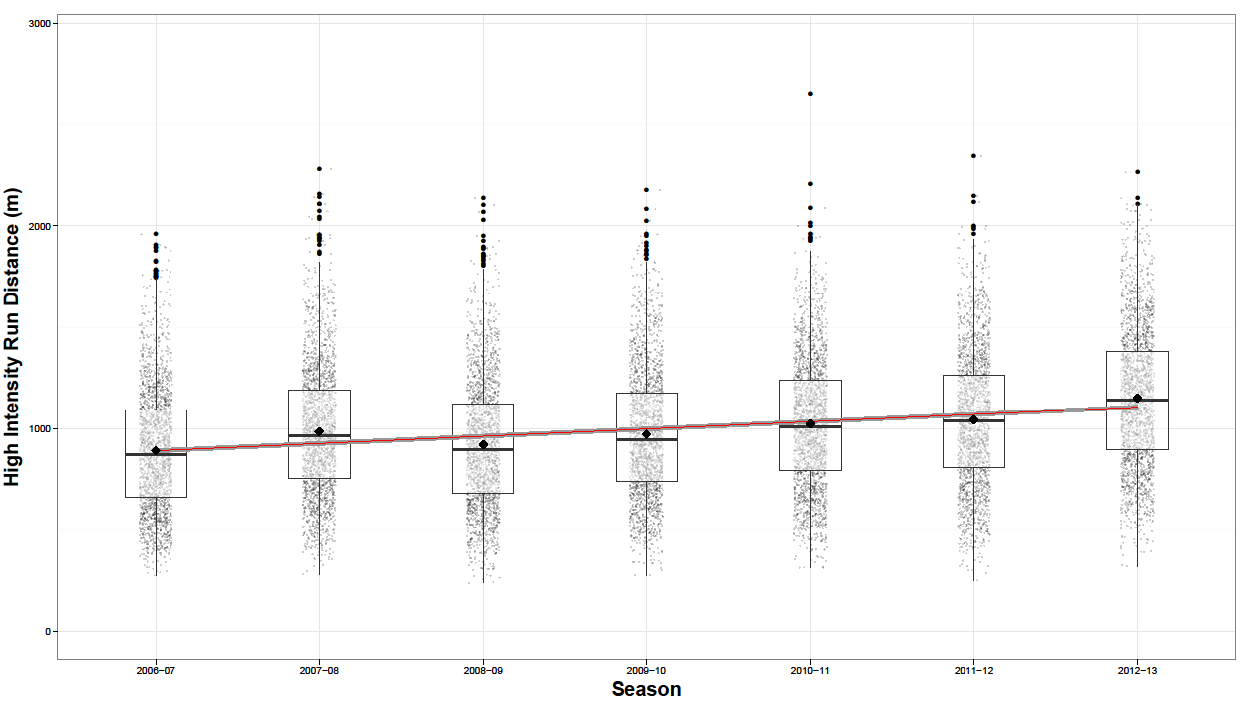

Figure 1C.
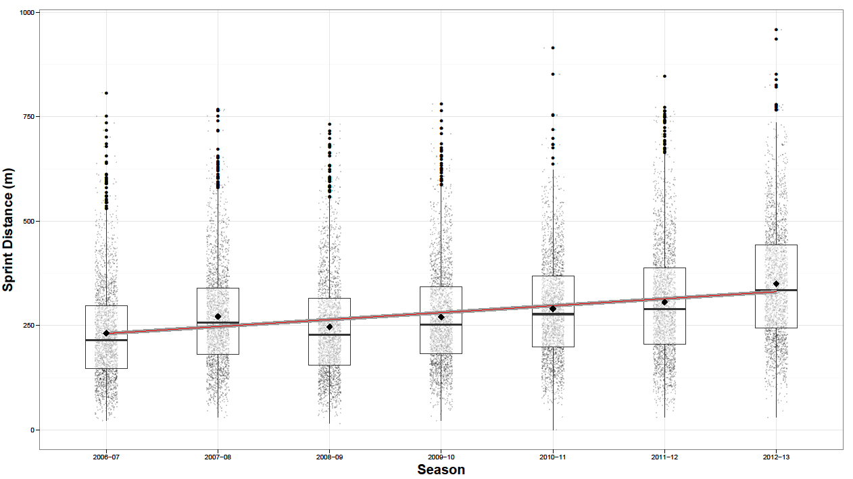

Figure 2A.
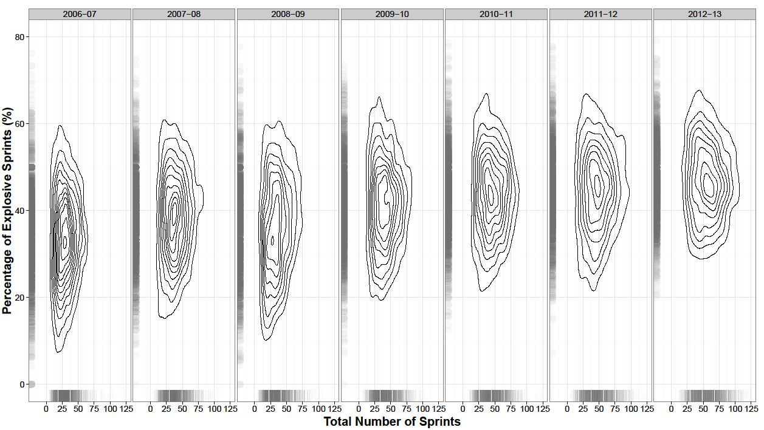

Figure 2B.
