Evolution of Match Performance Parameters for Various Playing Positions in the English Premier League

Michael Bush^{a,b}, Chris Barnes^{c,e}, David T Archerª, Bob Hoggª, Paul S. Bradley^{a,d*}
ªDepartment of Sport and Exercise Science, University of Sunderland, City Campus, Chester Road, Sunderland, UK
^{b}Performance Analysis Department, Academy of Light, Sunderland Association Football Club, Cleadon, UK
^{c}Medical Department, West Bromwich Albion Football Club, UK
^{d}Carnegie School of Sport, Leeds Metropolitan University, UK
^{e}CB Sports Performance Ltd, Rugeley, UK

*Corresponding Author: E-mail address: paulbradley94@yahoo.co.uk (P.S.Bradley).

Running Title: Evolution and Playing Position

PsycINFO Classification: 3720

Abstract
This study aimed to investigate position-specific evolution of physical and technical performance parameters in the English Premier League (EPL). Match performance observations (n=14700) were collected using a multiple-camera computerised tracking system across seven seasons (2006-07 to 2012-13). Positions were split into central defenders (n=3792), full backs (n=3420), central midfielders (n=3200), wide midfielders (n=2136) and attackers (n=2152). High-intensity running distance increased in the final season versus the first season in all playing positions (p<0.05, ES: 0.9-1.3) with full backs displaying the greatest increase (≈36% higher in 2012-13). Similar trends were observed for sprint distance with full backs demonstrating the most pronounced increase across the seven seasons (36-63%, p<0.001, ES: 0.8-1.3). Central players (central defenders and central midfielders) illustrated the most pronounced increases in total passes and pass success rate (p<0.05, ES: 0.7-0.9) whilst wide players (full backs and wide midfielders) demonstrated only small-moderate increases in total passes and pass success (p<0.05, ES: 0.6-0.8). The data demonstrates that evolving tactical modifications in the EPL have impacted on the physical demands of wide players and the technical requirements of central players. These findings could be used for talent identification or position-specific physical and technical training programmes.

Keywords: Longitudinal, football, positional, passing, sprinting

1. Introduction
Soccer is characterised by its sporadic nature whereby multidirectional physical actions are mixed with an array of technical skills (Bradley et al., 2009; Wallace & Norton, 2014). Semi-automated computerised tracking systems have been used to identify the physical demands and technical requirements of elite soccer and how these are influenced by positional, contextual and tactical factors (Bradley et al., 2011; Carling, Williams, & Reilly, 2005; Di Salvo et al., 2007; Lago, Casais, Dominguez, & Sampaio, 2010; Lago, 2009; Lago-Ballesteros, Lago-Peñas, & Rey, 2012). Relative to the overall distance covered by players, approximately 7-12% is covered at high-intensity and 1-4% whilst sprinting (Bradley et al., 2009; Di Salvo et al., 2010). Although team success is complex and multifactorial, technical indicators have been demonstrated to predict team success more accurately than physical indicators (Carling, 2013; Castellano, Casamichana, & Lago, 2012). More specifically, ball possession, number of shots, shots on target, number of passes and pass completion rate are all correlates with team success (Castellano et al., 2012; Collet, 2013; Hughes & Franks, 2005; Lago-Ballesteros et al., 2012; Lago-Peñas & Lago-Ballesteros, 2011). Although physical parameters are not associated with success, they are important for maintaining technical proficiency (Rampinini et al., 2008), thus cannot be disregarded as contributors to overall performance. Nevertheless, researchers often adopt a reductionist approach, analysing either physical or technical indicators in isolation (Mackenzie & Cushion, 2013) usually over short periods of time. Although physical and technical performance parameters can be seen as individual aspects of match-play, success is a culmination of suitable tactics completed with the appropriate level of physical and technical performance, analysing each in isolation restricts the context, understanding and application of the findings. Therefore, more research should adopt an integrated approach, analysing physical and technical and/or tactical longitudinally in order to understand the overall development of soccer match-play.
Our research group recently identified that, over a seven year period, high-intensity running and sprint distance have increased by 30-50% in the English Premier League (EPL) while the overall number of passes have increased by 40% (Barnes, Archer, Hogg, Bush, & Bradley, 2014). These longitudinal changes in the EPL mirrored those measured over a 44 year period in FIFA World Cup Final matches (Wallace & Norton, 2014). Nevertheless, previous studies failed to account for specific positional evolutionary trends (Bradley et al., 2009; Di Salvo et al., 2007, 2010; Gregson, Drust, Atkinson, & Di Salvo, 2010). Central midfielders have consistently been found to cover the greatest total distance whilst full backs, central midfielders and wide midfielders covered greater distances at high-intensities (Barros et al., 2007; Bradley et al., 2009; Di Salvo et al., 2007; Di Salvo, Gregson, Atkinson, Tordoff, & Drust, 2009). Mixed reasons have been proposed as to why these positional differences in locomotive patterns exist. Some research has found positional differences in VO_{2max} and aerobic capacity for soccer players with central midfielders and full backs having greater VO_{2max} results (Reilly, Bangsbo, & Franks, 2000), whist others found no differences (Haugen, Tønnessen, Hem, Leirstein, & Seiler, 2014). Nevertheless central midfielders and full backs consistently have the greatest results when assessed in intermittent running tests (Mohr, Krustrup, & Bangsbo, 2003; Reilly et al., 2000). In addition central midfielders and full backs perform and complete more passes compared to other positions (Redwood-Brown, Bussell, & Bharaj, 2012; Taylor, Mellalieu, & James, 2004). Given the evolutionary changes highlighted previously in elite soccer (Barnes et al., 2014; Wallace & Norton, 2014), it would be of interest to track longitudinal positional changes to gain insight into physical and technical requirements of modern players. Thus, this study aimed to investigate the position-specific evolution of physical and technical parameters in the EPL using one of the largest controlled samples published to date.
2. Methods
2.1 Match Analysis and Player Data
Match performance data were collected from seven consecutive EPL seasons (2006-07 to 2012-13) using a computerised multiple-camera tracking system (Prozone Sports Ltd®, Leeds, UK). Players’ movements were captured during matches by cameras positioned at roof level and analysed using proprietary software to produce a dataset on each player’s physical and technical performance. The validity and reliability of this tracking system has been quantified to verify the capture process and data accuracy (Bradley et al., 2009; Bradley, O’Donoghue, Wooster, & Tordoff, 2007; Di Salvo, Collins, McNeill, & Cardinale, 2006; Di Salvo et al., 2009). Ethical approval was obtained from the University of Sunderland (Ethics Code 182) with Prozone Sports Ltd® supplying the data and granting permission to publish.
Data were derived from Prozone’s Trend Software and consisted of 1036 individual players across 22846 observations. Original data files were de-sensitised and included 33 different teams overall with all 20 teams evaluated in each season. Individual match data were only included for outfield players that had completed the entire 90 min, matches were excluded if a player dismissal occurred (Carling & Dupont, 2011). The total number of observations were substantially different across season (2006-07 to 2012-13), phase of season (Aug-Nov, Dec-Feb, Mar-May), position, location (Home and Away) and team standard based on final league ranking (A: 1st-4th, B: 5th-8th, C: 9th-14th, D: 15th-20th). The original data were re-sampled using a stratification algorithm in order to balance the number of samples in each of the time periods (season and phase of season), match location and relative proportions of playing position thus minimising errors when applying statistical tests. The re-sampling was achieved using the stratified function in the R package “devtools” (R Development Core Team) using the procedures of Wickham & Chang (2013), the complete breakdown of the sample is shown in Barnes et al. (2014). Positions were categorised as central defenders (n=3792), full backs (n=3420), central midfielders (n=3200), wide midfielders (n=2136) and attackers (n=2152).
2.2 Match Performance Parameters
Activities were coded into: standing (0-0.6 km·h⁻¹), walking (0.7-7.1 km·h⁻¹), jogging (7.2-14.3 km·h⁻¹), running (14.4-19.7 km·h⁻¹), high-speed running (19.8-25.1 km·h⁻¹) and sprinting (>25.1 km·h⁻¹). Total distance represented the summation of distances in all categories. High-intensity running consisted of the combined distance in high-speed running and sprinting (≥19.8 km·h⁻¹) and was separated into three subsets based on the teams’ possession status: with (WP) or without ball possession (WOP) and when the ball was out of play (BOOP). Sprinting was divided into two subsets: explosive (entry into sprint category with no incursion into the high-speed category in the previous 0.5 s) and leading (entry into sprint category immediately after an incursion into the high-speed zone for 0.5 s or more; Di Salvo et al., 2010). Coding of technical events according to playing position was also conducted (Di Salvo et al., 2007). All positions included match events of passing variables (number of passes, passes received, pass distance and pass success), average touches per possession and possession won/lost. Clearances were included in the analysis for wide and central defenders while shots and final 3rd entries were included for attackers, wide and central midfielders and full backs. Pass distance referred to the overall length of pass, split into short (<10 m), medium (11-24 m) and long (>25m).
2.3. Statistical Analysis
One-way independent-measures analysis of variance (ANOVA) tests were used to compare each season with Dunnet’s post hoc tests used to verify localised differences. Statistical significance was set at p<0.05. The effect size (ES) was calculated to determine the meaningfulness of the difference with magnitudes classified as trivial (<0.2), small (>0.2-0.6), moderate (>0.6-1.2) and large (>1.2-2.0), (Batterham & Hopkins, 2006). All analyses were conducted using statistical software (R Development Core Team) and data visualisation was carried out using the “ggplot2” package accessed via the Deducer Interface for the R statistical programming language.
3. Results
3.1. Physical Parameters
Total distance covered during matches showed small changes between 2006-07 and 2012-13, increasing for central midfielders and defenders only (Figure 1A; 200-300 m, p<0.05, ES: 0.3 and 0.5 respectively). Full backs showed the greatest change in high-intensity running distance (Figure 1B; 35% increase, p<0.001, ES: 1.3), nevertheless all positions demonstrated moderate increases in high-intensity running distance over the seven seasons (central defenders: 33%; wide midfielders: 27%; central midfielders: 30%; attackers: 24%, p<0.05, ES: 1.1, 1.1, 1.0 and 0.9).
Central defenders, full backs and wide midfielders demonstrated moderate increases in high-intensity running distance covered WP (central defenders: 114±61 vs. 193±86 m, p<0.001, ES: 1.1; full backs: 355±159 vs. 503±181 m, p<0.001, ES: 0.9; wide midfielders: 591±178 vs. 710±171 m, p<0.01, ES: 0.8). In contrast, central midfielders and attackers showed small increases (≈100 m, p<0.05, ES: 0.5 and 0.6). All positions showed moderate increases in high-intensity distance covered WOP between 2006-07 and 2012-13, central defenders increased from 438±120 to 533±138 m (p<0.001, ES: 0.7), full backs increased from 498±133 to 657±150 m (p<0.001, ES: 1.1), central midfielders increased from 519±166 to 697±213 m (p<0.001, ES: 0.9), wide midfielders increased from 480±168 to 624±200 m (p<0.001, ES: 0.8) and attackers increased from 278±124 to 386±148 m (p<0.05, ES: 0.8).
Sprint distances covered by full backs (62%, ES: 1.3) showed a greater increase compared to wide midfielders (53%, ES: 1.3), central positions (≈53%, ES: 1.1) and attackers (Figure 1C; 36%, ES: 0.8). The number of high-intensity runs and sprints performed increased for each position between 2006-07 and 2012-13 (Figure 2AB; ES: 0.8-1.3, 1.6-2.0, respectively). For both parameters, attackers exhibited the smallest increases whereas wide positions exhibited the greatest.
The number of explosive sprints increased by very large magnitudes (p<0.001) for all positions (central defenders: 7±5 vs. 19±8, ES: 1.8; full backs: 11±6 vs. 28±10, ES: 2.1; central midfielders: 11±7 vs. 29±10, ES: 2.1; wide midfielders: 14±7 vs. 33±11, ES: 2.1; attackers: 12±6 vs. 27±9, ES: 2.0). Leading sprints showed moderate-large increases for all positions (central defenders: 13±5 vs. 20±7, full backs: 22±8 vs. 35±10, central midfielders: 20±9 vs. 30±10, wide midfielders: 27±9 vs. 41±11, p<0.001), whereas attackers showed the smallest increase (p<0.01) from 23±9 to 32±11 (ES: 1.2, 1.4, 1.1, 1.4 and 0.9, respectively).
3.2. Technical Parameters
Moderate-large increases were observed for central players (central defenders and midfielders) in the total number of passes performed between 2006-07 and 2012-13 compared to wide players (full backs and wide midfielders) and attackers who showed small increases (Figure 3). Central defenders increased the number of passes by ≈70%, central midfielders increased ≈50% (p<0.001, ES: 0.9). Full backs, wide midfielders and attackers showed similar increases (≈25%) in the number of passes over the seven seasons (p<0.001, ES: 0.5). Although wide players showed small increases in the number of passes over the seven seasons, similar increases in the pass success rate compared to central players were observed (all positions increased by ≈7%, p<0.01, ES: 0.7-0.9). No differences were identified for the pass success rate for attackers (p>0.05, ES: 0.3).
Central midfielders and full backs performed 4 more short distance passes between 2006-07 and 2012-13 (p<0.001, ES: 0.9). Central defenders and wide midfielders also showed small-moderate increases in the number of short distance passes performed (central defenders: 2.6±2.5 vs. 4.5±3.3; wide midfielders: 8.6±4.5 vs. 12±6.5, p<0.05, ES: 0.6). Central midfielders performed 10 more medium distance passes in 2012-13 compared to 2006-07 (p<0.001, ES: 0.9), whilst central defenders performed 8 more medium distance passes (p<0.001, ES: 0.8) and full backs performed 5 more medium distance passes in 2012-13 (p<0.001, ES: 0.6). Central defenders performed more long distance passes in 2012-13 (p<0.001, ES: 0.6), whereas full backs and wide midfielders performed fewer long distance passes over the seven seasons (p<0.05, ES: 0.4). Attackers showed trivial-small non-significant changes in the number of short, medium and long distance passes performed over the seven seasons (p>0.05, ES: 0.6, 0.5 and 0.04 respectively).
All positions showed a decrease in the number of possessions lost between 2006-07 and 2012-13 (central defenders: 20±6 vs. 16±6, p<0.001, ES: 0.6; full backs: 23±7 vs. 20±7, p<0.001, ES: 0.4; central midfielders: 21±6 vs. 19±6, p<0.05, ES: 0.4; wide midfielders: 26±6 vs. 22±6, p<0.05, ES: 0.7; attackers: 23±7 vs. 21±6, p<0.05, ES: 0.5). Small decreases in the number of final third entries were identified for full backs and wide midfielders between 2006-07 and 2012-13 (9±5 vs. 7±4, p<0.001, ES: 0.5; 5±3 vs. 4±3, p<0.05, ES: 0.3 respectively). In addition none of the five positions showed changes in the number of tackles or tackled events over the seven seasons.
4. Discussion
This study investigated the position-specific evolution of physical and technical parameters in the EPL. Previous large-scale studies have not controlled for seasonal, tactical and contextual factors (Di Salvo, Pigozzi, González-Haro, Laughlin, & De Witt, 2013; Gregson et al., 2010). These factors have been found to influence the physical and technical performance of elite players and thus should be accounted for in the methodological design (Bradley et al., 2009; Castellano et al., 2012; Di Salvo et al., 2009; Lago et al., 2010). Our study is the first to re-sample data using a randomised stratification algorithm to account for these factors. Thus, this analytical approach will allow more appropriate generalisations to be made regarding the longitudinal performance characteristics of various playing positions.
Our research group recently reported that total distance covered in EPL matches had typically increased by 2% across seven seasons (Barnes et al., 2014) although position-specific trends were not reported. Interestingly, the current study identified an increase in total distance covered for central players only (central defenders and midfielders), with wide players (full backs and wide midfielders) and attackers demonstrating negligible changes. These observed changes were, however, within the inherent match-to-match variability for total distance covered by all positions in the EPL (Gregson et al., 2010) and as such should be treated with care. It has been reported that the distance covered at high-intensity seems a superior, more sensitive indicator of performance than total distance covered as it correlates better with physical capacity (Bradley et al., 2011; Krustrup, Mohr, Ellingsgaard, & Bangsbo, 2005) and is a distinguishing variable between competitive standard and gender (Andersson, Randers, Heiner-Møller, Krustrup, & Mohr, 2010; Bradley et al., 2013; Mohr, Krustrup, Andersson, Kirkendal, & Bangsbo, 2008; Mohr et al., 2003). The findings of the current study revealed pronounced increases for high-intensity running distance for all positions (24-36%), the magnitude of these changes were greater than the inherent match-to-match variability previously reported for high-intensity running (Bush, unpublished data; Gregson et al., 2010). This could suggest that the elevation in high-intensity running over the seven seasons is due to evolving game patterns as opposed to natural variability.
Our findings suggest that the physical requirements of modern soccer, particularly for high-intensity running, have evolved more for defenders (central defenders and full backs) and central midfielders (30-36%) than for attacking players (wide midfielders and attackers, 24-27%). This trend in physical performance could potentially be attributed to improvements in the players’ physical capacity through enhanced physical preparation, or via an influx of players with innately higher levels of physical fitness. Evidence would suggest maximal oxygen uptake (VO_{2max}) of elite soccer players has stayed relatively stable over the last two decades (Tønnessen, Hem, Leirstein, Haugen, & Seiler, 2013) although this may not be the most appropriate measure of physical capacity in elite team sports, with intermittent exercise capacity identified as a more sensitive measure of training adaptations than VO_{2max} (Iaia, Rampinini, & Bangsbo, 2009; Krustrup & Bangsbo, 2001). Data from our laboratory indicates that the average distance covered by elite soccer players during the Yo-Yo Intermittent Endurance Level 2 Test has increased minimally (Bradley et al., 2011, 2013) in contrast to the dramatic increases in high-intensity running distances in EPL matches across a similar time period (Barnes et al., 2014). Thus, if the physical capacity of EPL players has remained stable across this time then these findings could be the result of players working at a higher proportion of their physical capacity in games. In support of this notion Bradley et al. (2013) reported no differences in the intermittent exercise capacity of players in the top three tiers of the English games but found that the lower tier players covered more distance at high-intensity compared with top tier players. Thus, it is plausible that current EPL players are expected to work at a higher relative intensity compared to nearly a decade ago, possibly driven by changes in tactics and playing systems. For example, when in possession, modern tactics often require wide midfielders to play in more central positions attracting defenders inside and creating space for full backs to move into, thus introducing more players into attacking positions (Bangsbo & Peitersen, 2004; Tipping, 2007). When possession is lost players must quickly recover from attacking positions into defensive positions, increasing the number of defensive players behind the ball and therefore reducing the space for attacking play (Bangsbo & Peitersen, 2002; Wallace & Norton, 2014). These tactical changes support the finding that full backs demonstrated the most pronounced increases in high-intensity running and sprinting across the seven seasons. This tactical change has arisen from changes in the traditional rigid playing systems (4-4-2, 4-3-3 and 4-5-1) to move to more dynamic contemporary systems (4-2-3-1, 4-1-4-1). Although is it difficult to discuss the impact of playing formations on physical performance as limited studies exist, the increasing popularity of the compact 4-2-3-1 system in the EPL could be one potential reason why full backs now cover more high-intensity and sprinting distances, but more research needs to be undertaken to verify this.
Overall sprint distances increased by ≈50% between 2006-07 and 2012-13, however when analysed by position interesting differences were observed. The greatest increases were observed in full backs (63%), followed by central defenders, central midfielders and wide midfielders increased sprint distance (all 54%) and attackers (36%). In 2012-13 players in wide (full backs and wide midfielders) and attacking positions covered a higher percentage of total distance by sprinting (3.5-4.2%) than central defenders or central midfielders (2.3-2.9%). These findings have implications in terms of the physical preparation of players. This could be achieved through individual drills for each position or ideally during soccer simulations that incorporate all 5 positions working in tandem with specific instructions provided where tactical and technical aspects are merged with the unique physical demands of each position (e.g. full backs sprint whilst creating overlaps with wide midfielders followed by recovery runs).
Previous research has reported that the absolute number of explosive and leading sprints is dependent on playing position (Di Salvo et al., 2009). Across the timeframe of this study, all positions in this study showed increases in the number of leading (39-59%) and explosive sprints (125-171%). For both types of sprints attackers showed the smallest relative change whilst full backs and central defenders demonstrated the greatest. Although differences were observed in the absolute number of leading and explosive sprints the proportions of explosive sprints are comparable amongst all positions (44-49%). The increase in the number and proportion of sprints in soccer match-play has been proposed as one causative factor for increased injury propensity, in particular groin and hamstring strains (Junge & Dvorak, 2010). Changes in injury rates are unclear over a comparable time period (Ekstrand, Hägglund, & Waldén, 2011), but are based on a small sample across Europe, and not purely on the EPL. The aetiology of muscle injuries in soccer is complex, however there is currently widespread use of prehabilitation and preventative programmes utilising exercises such as Nordic lunges to reduce injury risk (Daly, 2013; Opar, Williams, & Shield, 2012). The absolute numbers of leading and explosive sprints as well as the distance covered at high-intensity and maximal speeds in 2012-13 were greater than previous studies conducted on players competing in the UEFA Champions League, Spanish La Liga and EPL (Bradley et al., 2009; Di Salvo et al., 2007; Lago et al., 2010), therefore supporting the general perception that the EPL has evolved into one of the most physically demanding leagues in soccer.
Soccer is based on a combination of physical, technical and tactical aspects of match play. Although the physical and tactical aspects are central to high-level soccer match performance (Bradley et al., 2013; Lago-Ballesteros et al., 2012), players and teams technical ability have been identified as the best indicators of success (Castellano et al., 2012; Collet, 2013; Rampinini, Impellizzeri, Castagna, Coutts, & Wisløff, 2009). The number of passes performed in FIFA World Cup final matches has been shown to have increased by 40% over a 44 year period (Wallace & Norton, 2014), a similar increase to that observed over a seven year period in the EPL (Barnes et al., 2014). When broken down by position we can show that passes performed increased by a greater extent for central defenders (≈66%) and central midfielders (44%), compared to full backs, wide midfielders and attackers (all ≈25%). This increase in the number of passes is comprised primarily from increased short and medium distance passes (30-72% increases), whilst there was little or no increase in the number of long distance passes across all positions. A previous analysis of World Cup final matches identified an increase in passing tempo over a 44 year period (Wallace & Norton, 2014). Although this study did not directly analyse the number of passes per minute, the observed increase in passes over the course of a match, coupled with previous findings demonstrating increases in match stoppage time (Wallace & Norton, 2014) would infer an increase in passing tempo. The relatively greater increases in the number of passes by central players may be as a result of a change in positional roles. Previously central defenders were used purely in a defensive role, and although the defensive role of a central defender is unchanged (no differences in the number of tackles and interceptions), the attacking role has evolved. The increase in the number of passes could indicate an evolution of positional tactics, with many teams now focussing on possession based strategies, awaiting opportunities to exploit gaps in opposition defence. Teams use short to medium distance passes to increase the likelihood of pass success, essential for maintaining possession in areas of increased player density whilst still attempting to find weakness in the opposition defence (Bangsbo & Peitersen, 2004; Tipping, 2007). As a consequence defenders, in particular central defenders, provide extra passing options when in possession (Bangsbo & Peitersen, 2004; Tipping, 2007). This is further supported by recent findings by Prozone (2014) who noted an increase in the number of passes per shot since 2006-07, suggesting more patient build up play by teams, probing at opposition defence before finding weaknesses which may lead to a shot on goal. Further evidence can be seen in the number of passes received with central defenders (109%) and central midfielders (70%) showing greater increases that colleagues in other positions.
The technical findings of this study have implications for the scouting process, it is now important for scouts to find and recruit players who are able to play a similar system and style of play compared to the club which is looking to recruit them, possession based teams need to search for central defenders who are not only good defenders but also comfortable and confident on the ball with good passing ability. Direct style teams require central defenders who are good defenders with fewer requirements on passing ability.
5. Conclusions
This study demonstrates that players in wide and attacking positions have increased the distance covered whilst sprinting and at high intensities to a greater extent than central defenders and central midfielders between 2006-07 and 2012-13. In contrast central players were found to have increased the number of and success rate of passes over the same period. The evolution demonstrated is probably down to a change in positional tactics. The findings of the present study provide baselines for requirements of players performing in the English Premier League and can therefore assist in player recruitment and development of position-specific programmes.
Acknowledgements
The authors would like to thank Paul Neilson and Will Jones from Prozone Sports for providing access to the data used in this study.
References
Andersson, H., Randers, M. B., Heiner-Møller, A., Krustrup, P., & Mohr, M. (2010). Elite Female Soccer Players Perform More High-Intensity Running When Playing in International Games Compared With Domestic League Games. Journal of Strength and Conditioning Research, 24(4), 912–919.
Bangsbo, J., & Peitersen, B. (2002). Defensive Soccer Tactics: How to stop players and teams from scoring. Champaign, IL: Human Kinetics.
Bangsbo, J., & Peitersen, B. (2004). Offensive Soccer Tactics: How to control possession and score more goals. Champaign, IL: Human Kinetics.
Barnes, C., Archer, D., Hogg, B., Bush, M., & Bradley, P. S. (2014). The Evolution of Physical and Technical Perofrmance Parameters in the English Premier League. International Journal of Sports Medicine, (Epub ahead of print).
Barros, R. M. L., Misuta, M., Menezes, R., Figueroa, P., Moura, F., Cunha, S., … Leite, N. (2007). Analysis of the distances covered by first division Brazilian soccer players obtained with an automatic tracking method. Journal of Sports Science and Medicine, 6, 233–242.
Batterham, A. M., & Hopkins, W. G. (2006). Making meaningful inferences about magnitudes. International Journal of Sports Physiology and Performance, 1(1), 50–57.
Bradley, P. S., Carling, C., Archer, D., Roberts, J., Dodds, A., Di Mascio, M., … Krustrup, P. (2011). The effect of playing formation on high-intensity running and technical profiles in English FA Premier League soccer matches. Journal of Sports Sciences, 29(8), 821–830.
Bradley, P. S., Carling, C., Diaz, A. G., Hood, P., Barnes, C., Ade, J., … Mohr, M. (2013). Match performance and physical capacity of players in the top three competitive standards of English professional soccer. Human Movement Science, 32(4), 808–821.
Bradley, P. S., O’Donoghue, P., Wooster, B., & Tordoff, P. (2007). The reliability of Prozone MatchViewer: a video-based technical performance analysis system. International Journal of Performance Analysis in Sport, 7, 117–129.
Bradley, P. S., Sheldon, W., Wooster, B., Olsen, P., Boanas, P., & Krustrup, P. (2009). High-intensity running in English FA Premier League soccer matches. Journal of Sports Sciences, 27(2), 159–168.
Carling, C. (2013). Interpreting Physical Performance in Professional Soccer Match-Play: Should We be More Pragmatic in Our Approach? Sports Medicine (Auckland, N.Z.), 43(8), 655–663.
Carling, C., & Dupont, G. (2011). Are declines in physical performance associated with a reduction in skill-related performance during professional soccer match-play? Journal of Sports Sciences, 29(1), 63–71.
Carling, C., Williams, M., & Reilly, T. (2005). Handbook of Soccer Match Analysis. Oxon, UK: Routledge.
Castellano, J., Casamichana, D., & Lago, C. (2012). The Use of Match Statistics that Discriminate Between Successful and Unsuccessful Soccer Teams. Journal of Human Kinetics, 31(March), 139–147.
Collet, C. (2013). The possession game? A comparative analysis of ball retention and team success in European and international football, 2007-2010. Journal of Sports Sciences, 31(2), 123–136.
Daly, B. Y. C. (2013). Sprint-related hamstring injuries the current state of play. sportEX Medicine, 58, 20–27.
Di Salvo, V., Baron, R., González-Haro, C., Gormasz, C., Pigozzi, F., & Bachl, N. (2010). Sprinting analysis of elite soccer players during European Champions League and UEFA Cup matches. Journal of Sports Sciences, 28(14), 1489–1494.
Di Salvo, V., Baron, R., Tschan, H., Calderon Montero, F. J., Bachl, N., & Pigozzi, F. (2007). Performance characteristics according to playing position in elite soccer. International Journal of Sports Medicine, 28(3), 222–227.
Di Salvo, V., Collins, A., McNeill, B., & Cardinale, M. (2006). Validation of Prozone: A new video-based performance analysis system. International Journal of Performance Analysis in Sport, 6, 108–119.
Di Salvo, V., Gregson, W., Atkinson, G., Tordoff, P., & Drust, B. (2009). Analysis of High Intensity Activity in Premier League Soccer. International Journal of Sports Medicine, 30(03), 205–212.
Di Salvo, V., Pigozzi, F., González-Haro, C., Laughlin, M., & De Witt, K. (2013). Match Performance Comparison in Top English Soccer Leagues. International Journal of Sports Medicine, 34(06), 526–532.
Ekstrand, J., Hägglund, M., & Waldén, M. (2011). Injury incidence and injury patterns in professional football: the UEFA injury study. British Journal of Sports Medicine, 45, 553–558.
Gregson, W., Drust, B., Atkinson, G., & Di Salvo, V. (2010). Match-to-match variability of high-speed activities in premier league soccer. International Journal of Sports Medicine, 31(4), 237–242.
Haugen, T. A., Tønnessen, E., Hem, E., Leirstein, S., & Seiler, S. (2014). VO 2max Characteristics of Elite Female Soccer Players , 1989 – 2007. International Journal of Sports Physiology and Performance, 9, 515–521.
Hughes, M., & Franks, I. (2005). Analysis of passing sequences, shots and goals in soccer. Journal of Sports Sciences, 23(5), 509–514.
Iaia, F. M., Rampinini, E., & Bangsbo, J. (2009). High-Intensity Training in Football. International Journal of Sports Physiology and Performance, 4(3), 291–306.
Junge, A., & Dvorak, J. (2010). Injury risk of playing football in Futsal World Cups. British Journal of Sports Medicine, 44(15), 1089–1092.
Krustrup, P., & Bangsbo, J. (2001). Physiological demands of top-class soccer refereeing in relation to physical capacity: effect of intense intermittent exercise training. Journal of Sports Sciences, 19(11), 881–891.
Krustrup, P., Mohr, M., Ellingsgaard, H., & Bangsbo, J. (2005). Physical demands during an elite female soccer game: importance of training status. Medicine and Science in Sports and Exercise, 37(7), 1242–1248.
Lago, C. (2009). The influence of match location, quality of opposition, and match status on possession strategies in professional association football. Journal of Sports Sciences, 27(13), 1463–1469.
Lago, C., Casais, L., Dominguez, E., & Sampaio, J. (2010). The effects of situational variables on distance covered at various speeds in elite soccer. European Journal of Sport Science, 10(2), 103–109.
Lago-Ballesteros, J., Lago-Peñas, C., & Rey, E. (2012). The effect of playing tactics and situational variables on achieving score-box possessions in a professional soccer team. Journal of Science and Medicine in Sport, 30(14), 37–41.
Lago-Peñas, C., & Lago-Ballesteros, J. (2011). Game location and team quality effects on performance profiles in professional soccer. Journal of Sports Science and Medicine, 10, 465–471.
Mackenzie, R., & Cushion, C. (2013). Performance analysis in football: a critical review and implications for future research. Journal of Sports Sciences, 31(6), 639–676.
Mohr, M., Krustrup, P., Andersson, H., Kirkendal, D., & Bangsbo, J. (2008). Match Activities of Elite Women Soccer Players at Different Performance Levels. Journal of Strength and Conditioning Research, 22(2), 341–349.
Mohr, M., Krustrup, P., & Bangsbo, J. (2003). Match performance of high-standard soccer players with special reference to development of fatigue. Journal of Sports Sciences, 21(7), 519–528.
Opar, D. a, Williams, M. D., & Shield, A. J. (2012). Hamstring strain injuries: factors that lead to injury and re-injury. Sports Medicine, 42(3), 209–226.
Prozone. (2014). STYLE AND SUBSTANCE The Evolution of the Premier League - Prozone Sports. Retrieved July 22, 2014, from http://www.prozonesports.com/style-and-substance-the-evolution-of-the-premier-league/
Rampinini, E., Impellizzeri, F., Castagna, C., Coutts, A., & Wisløff, U. (2009). Technical performance during soccer matches of the Italian Serie A league: Effect of fatigue and competitive level. Journal of Science and Medicine in Sport, 12(1), 227–233.
Rampinini, E., Impellizzeri, F. M., Castagna, C., Azzalin, A., Ferrari Bravo, D., & Wisløff, U. (2008). Effect of match-related fatigue on short-passing ability in young soccer players. Medicine and Science in Sports and Exercise, 40(5), 934–942.
Redwood-Brown, A., Bussell, C., & Bharaj, H. S. (2012). The impact of different standards of opponents on observed player performance in the English Premier League. Journal of Human Sport and Exercise, 7(2), 341–355.
Reilly, T., Bangsbo, J., & Franks, A. (2000). Anthropometric and physiological predispositions for elite soccer. Journal of Sports Sciences, 18(9), 669–683.
Taylor, J. B., Mellalieu, S. D., & James, N. (2004). Behavioural comparisons or positional demands in professional soccer. International Journal of Performance Analysis in Sport, 4(1), 81–97.
Tipping, J. (2007). The 1-4-5-1 System. Soccer Journal, (April), 40–45.
Tønnessen, E., Hem, E., Leirstein, S., Haugen, T., & Seiler, S. (2013). Maximal aerobic power characteristics of male professional soccer players, 1989-2012. International Journal of Sports Physiology and Performance, 8(3), 323–329.
Wallace, J. L., & Norton, K. I. (2014). Evolution of World Cup soccer final games 1966-2010: Game structure, speed and play patterns. Journal of Science and Medicine in Sport / Sports Medicine Australia, 17(2), 223–228.
Wickham, H., & Chang, W. (2013). Tools to make developing R code easier.

Figure Legends:
Figure 1: Plots for distances covered in (A) total, (B) high-intensity and (C) sprinting across the seven seasons in the English Premier League. Each plot is split to represent each of the five positions analysed.
Figure 2: Plots for number of (A) high-intensity activities, (B) sprints across the seven seasons in the English Premier League. Each plot is split to represent each of the five positions analysed.
Figure 3: Two-dimensional kernel density plots representing the number of passes and the pass success rate of central (central defenders and central midfielders) and wide players (full backs and wide midfielders) in the English Premier League.

Figure 1A:
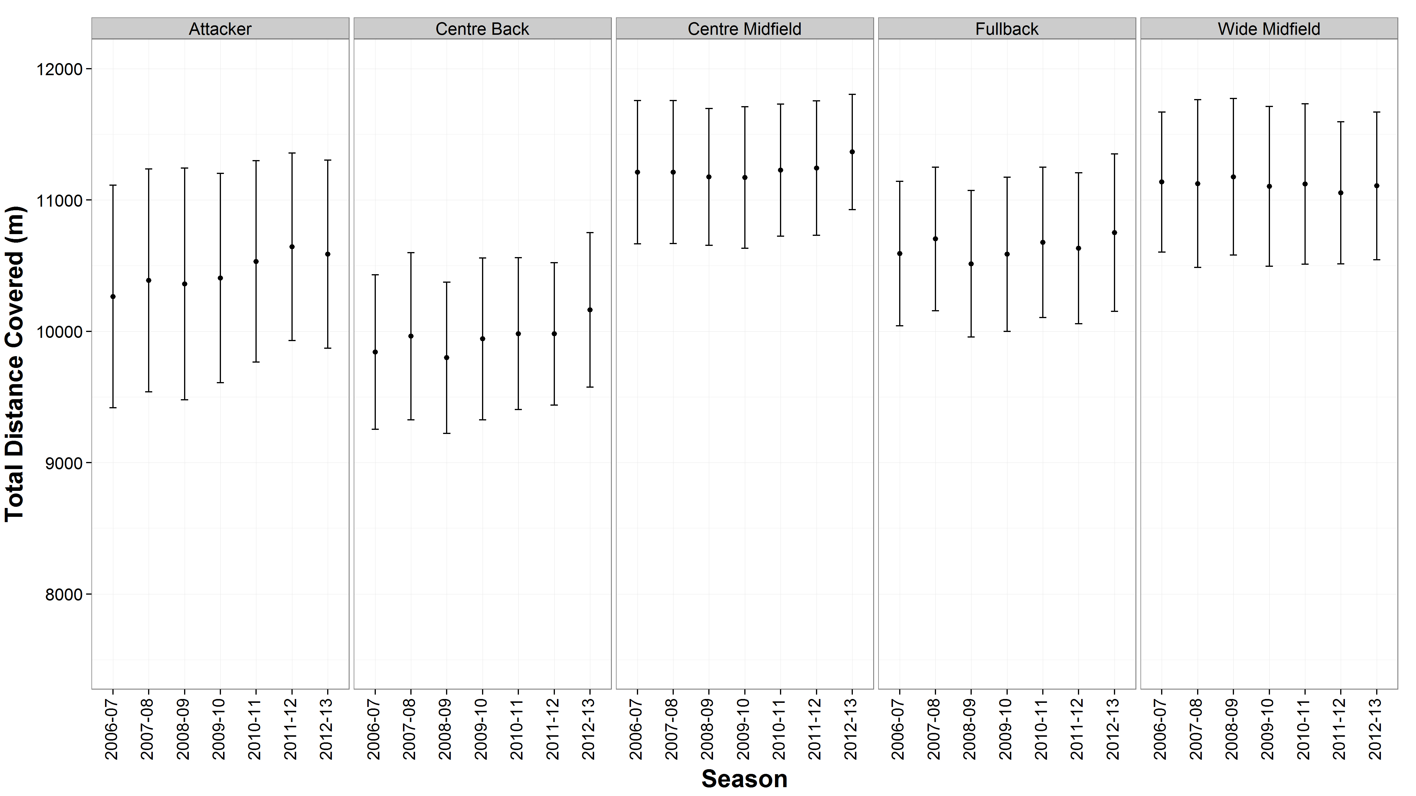
Figure 1B:
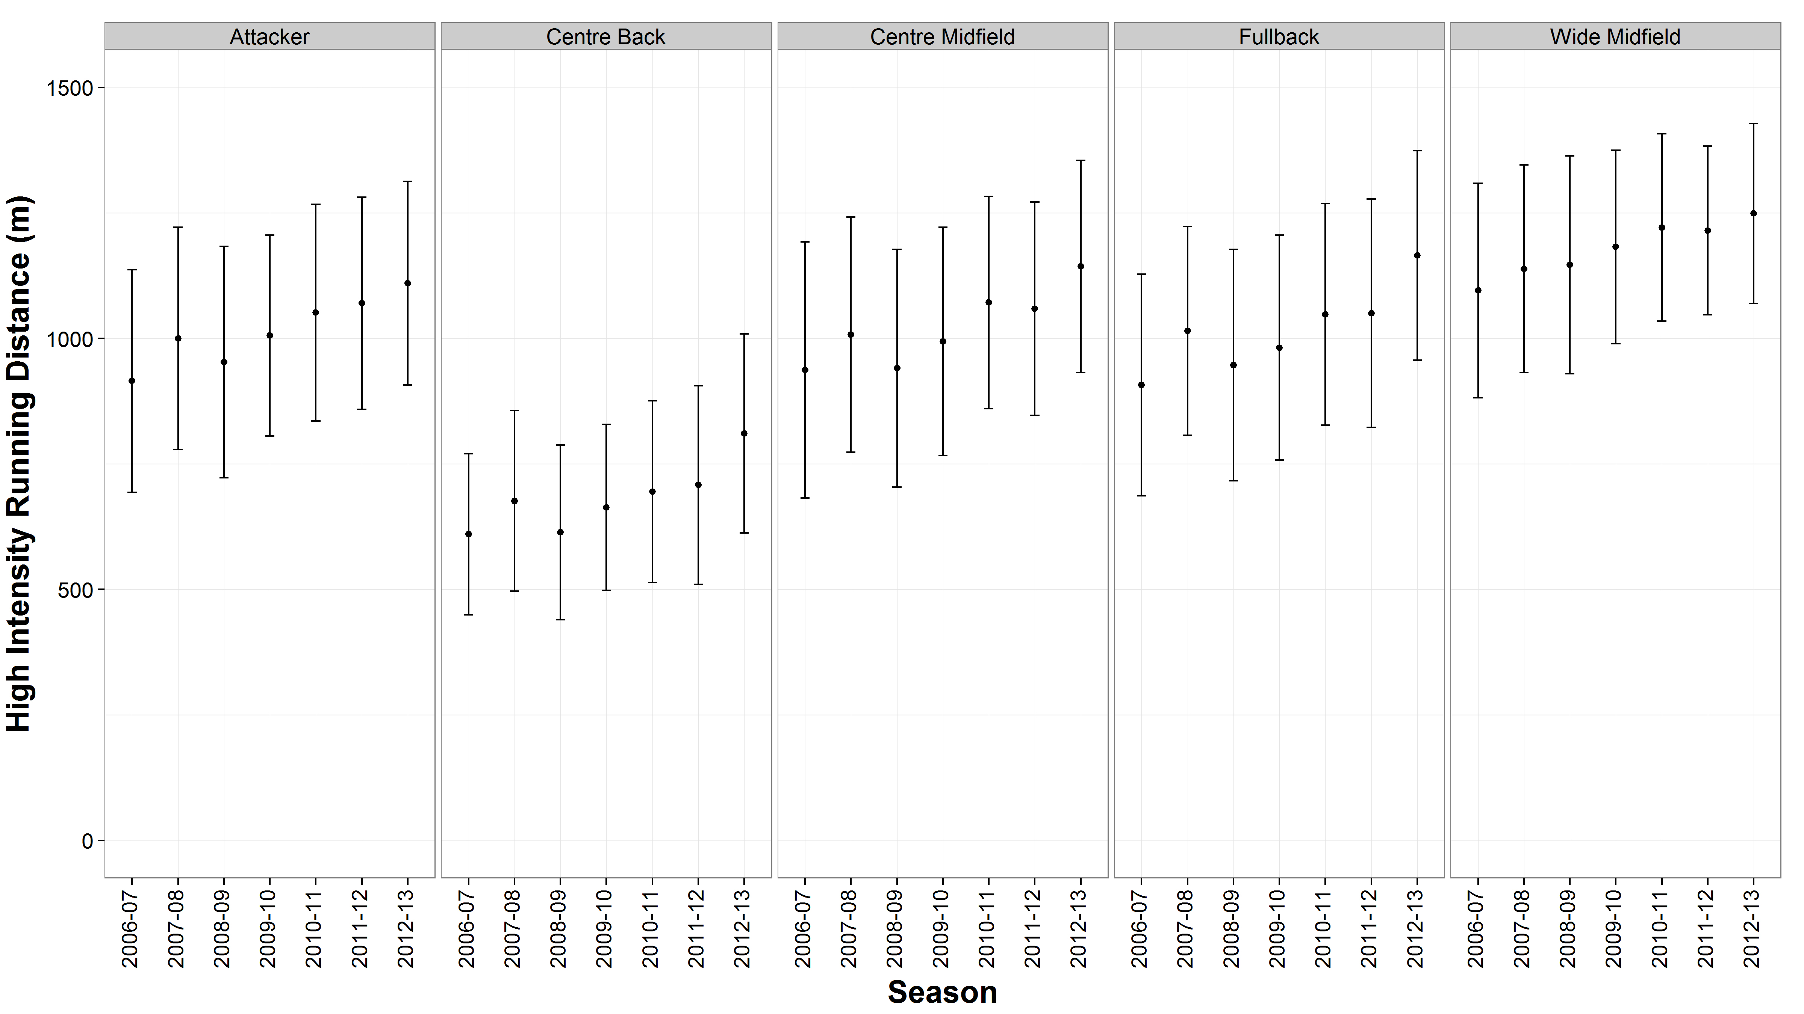
Figure 1C:
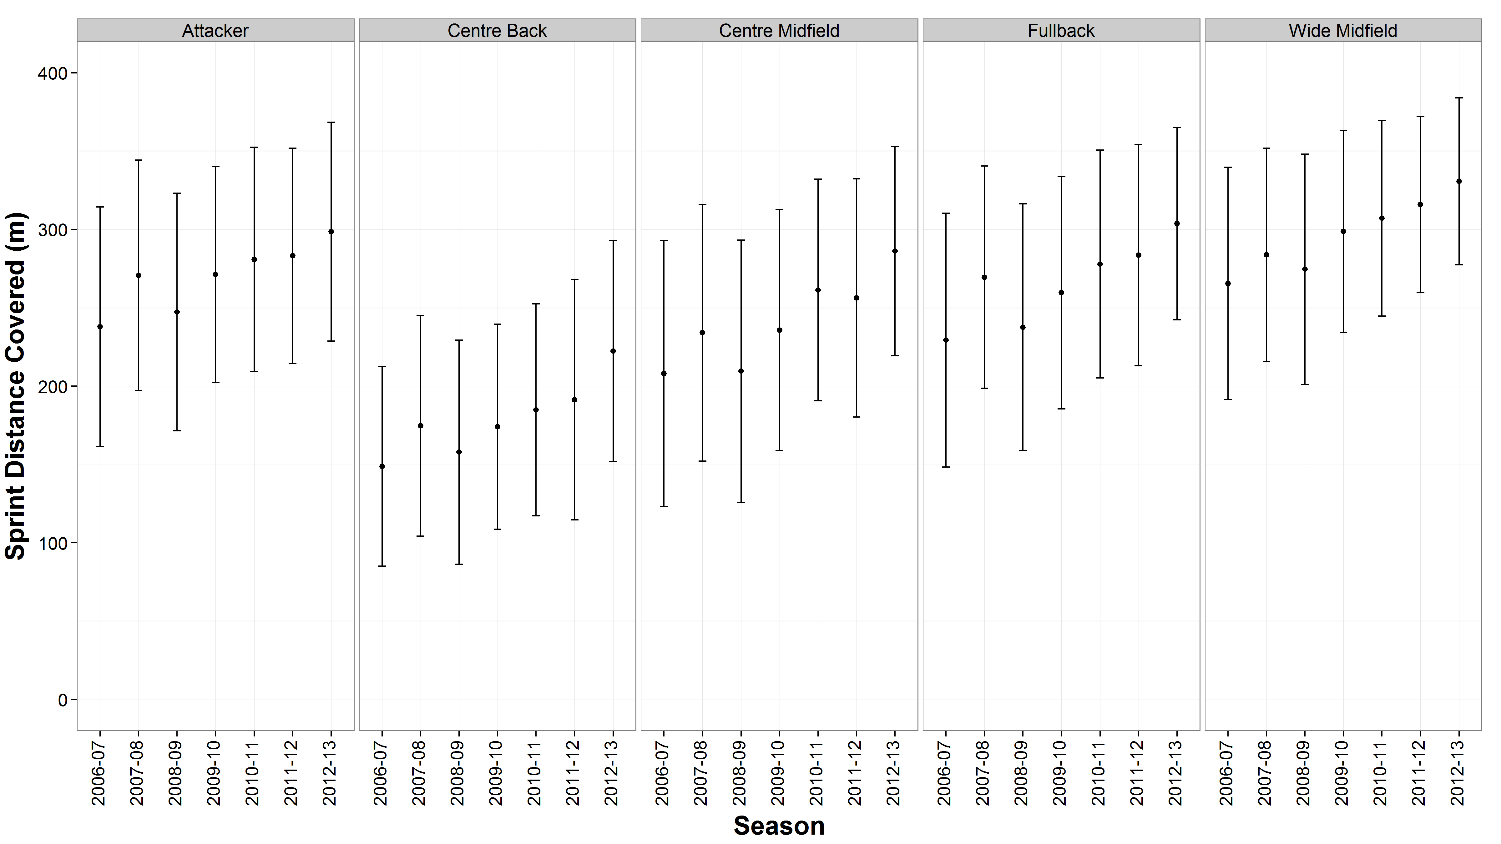
Figure 2A:
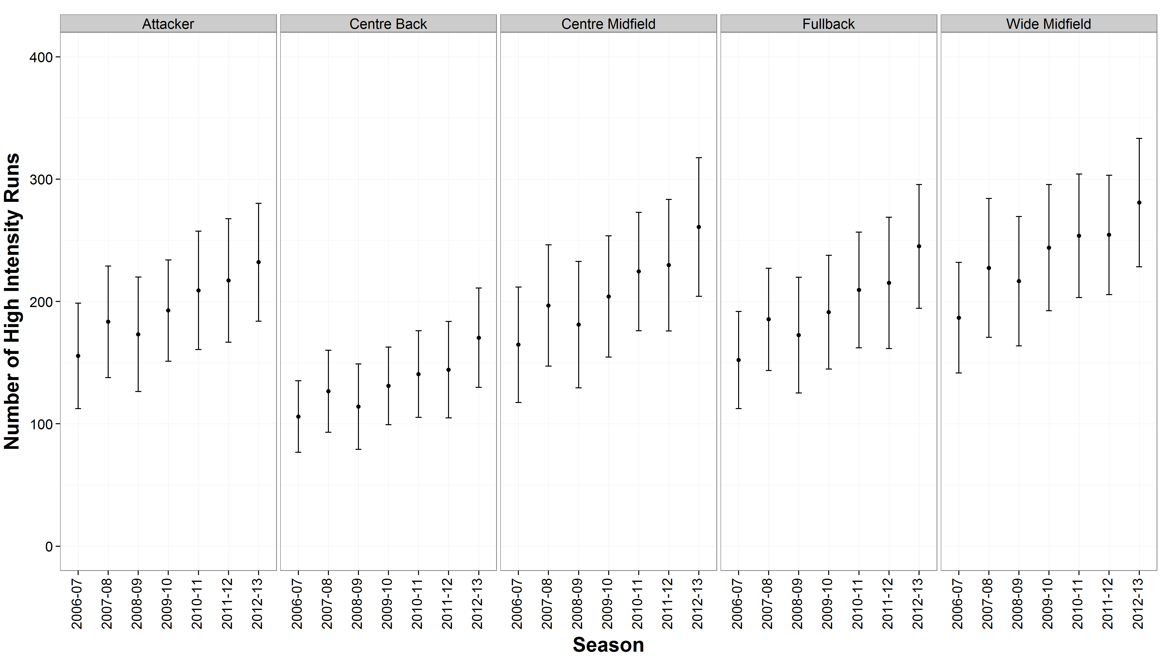
Figure 2B:
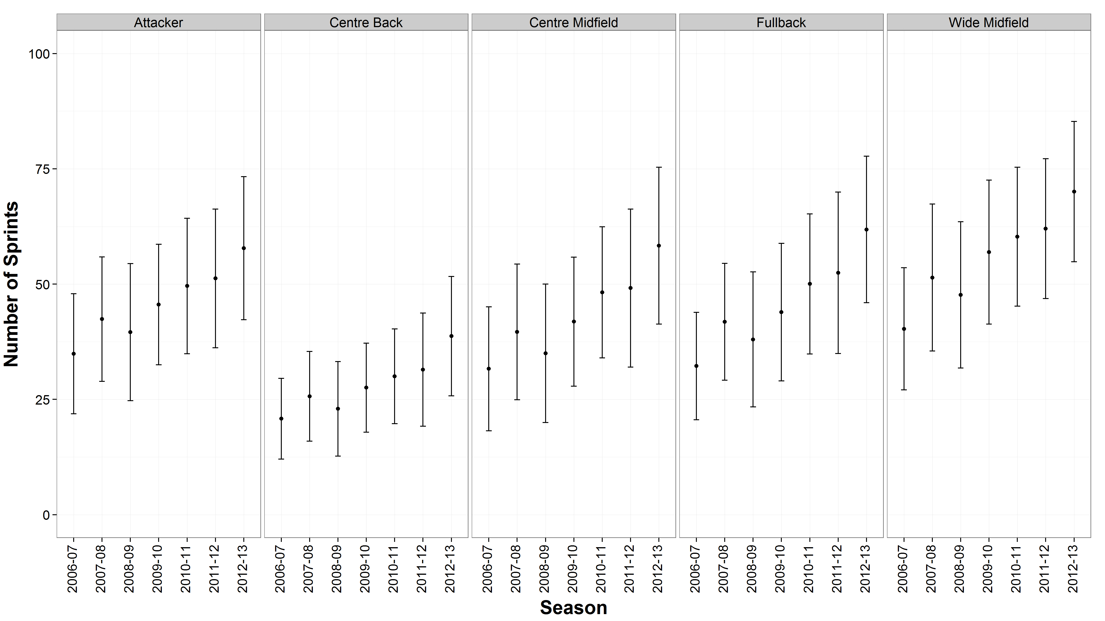
Figure 3:
