Factors Influencing Physical and Technical Variability in the English Premier League

Michael D. Bush^{a,b} David T. Archerª Robert Hoggª Paul S. Bradley^{a,c}

ªDepartment of Sport and Exercise Science, University of Sunderland, UK
^{b}Performance Analysis Department, Academy of Light, Sunderland Association Football Club, UK
^{c}Carnegie School of Sport, Leeds Beckett University, UK

Corresponding Author: E-mail address: paulbradley94@yahoo.co.uk (Paul S. Bradley)
Abstract
Purpose: To investigate match-to-match variability of physical and technical performances in English Premier League (EPL) players and to quantify the influence of positional and contextual factors. Methods: Match data (n=451) were collected using a multi-camera computerised tracking system across multiple seasons (2005-06 to 2012-13). The coefficient of variation (CV) was calculated from match-to-match for physical and technical performances in selected positions across different match contexts (location, standard and result). Results: Wide midfielders demonstrated the greatest CVs for total distance (4.9±5.9%) whilst central midfielders the smallest (3.6±2.0%), nevertheless all positions exhibited CVs <5% (p>0.05, ES: 0.1-0.3). Central defenders demonstrated the greatest CVs and wide midfielders the lowest for both high-intensity running (20.2±8.8% and 13.7±7.7%, p<0.05, ES: 0.4-0.8) and sprint distance (32.3±13.8% and 22.6±11.2%, p<0.05, ES: 0.5-0.8). Technical indicators such as tackles (83.7±42.3%), possession won (47.2±27.9%) and interceptions (59.1±37.3%) illustrated substantial variability for attackers compared to all other positions (p<0.05, ES: 0.4-1.1). Central defenders demonstrated large variability for the number of times tackled per match (144.9±58.3%), passes attempted and received compared to other positions (39.2±17.5% and 46.9±20.2%, p<0.001, ES: 0.6-1.8). Contextual factors had limited impact on the variability of physical and technical parameters. Conclusions: The data demonstrate that technical parameters varied more from match-to-match than physical parameters. Defensive players (full backs and central defenders) displayed higher CVs for offensive technical variables, whilst attacking players (attackers and wide midfielders) exhibited higher CVs for defensive technical variables. Physical and technical performances are variable per se regardless of context.

Keywords: football, contextual, high-intensity, passing, variation.

Abstract word count: 244

Text word count: 3439

Introduction
In the last two decades there has been substantial investment in computerised tracking systems in elite soccer in an attempt to evaluate and optimise team performance. Although some progress has been made in this research area, some caveats exist. For instance, researchers typically adopt a one-dimensional approach analysing individual aspects of soccer performance (physical, technical or tactical) with the main intention of predicting future performance or identifying trends that lead to successful performances.^{1–3} Thus, more research is needed that integrates multiple parameters that allow a more holistic understanding of the important facets of performance.
Assessing performance is essential in order to develop intervention programmes and to improve performance. Nevertheless without measuring the variability between performances it is impossible to evaluate the effectiveness and success of an intervention programme.¹ One method proposed is to use the coefficient of variation (CV) to calculate the inconsistency on a match-to-match basis. demonstrated that players analysed in two consecutive elite matches played within a 3-wk period produced a CV of 3% and 9% for the distance covered in total and at high-intensity respectively. Interestingly, the variability in high-intensity running across different stages of the season was much higher (CV=25%) than across shorter periods of time. However, this study only quantified variability of <20 elite players across 1-3 observations, thus restricting the application of the findings.⁴ Gregson and collegues⁵ used a large sample of elite players and demonstrated that high-intensity activities can vary by ≈15-30% from match-to-match and that variability is higher for central defenders and midfielders than for wide midfielders and attackers.
Rampinini et al.⁶ found that physical parameters were reduced when playing against lower standard opponents, nevertheless this difference equated to approximately 100 metres in total distance covered and 50 metres at high-intensity. Despite analysing variation in performance Rampinini et al.⁶ examined performance across the season rather than on a match-to-match basis. Teams finishing higher in competitive leagues were found to perform more technical variables such as passes and shooting compared to teams finishing lower in the leagues.⁷ Home teams have been identified to perform greater technical performance compared to away teams for passing and shooting variables as well as goals scored whilst home teams lost possession less.⁷ In addition, teams spend less time in the attacking third and more in the defensive third when playing away from their home ground.⁸ However, no studies have been published to date that have used a combined approach (analysed both physical and technical variability), and taken into account the influence of context on match-to-match variability (e.g. team standard, match location and result).¹ This is surprising as numerous studies have found that context influences both physical and technical performance of teams ^{7–9} and thus the variability in performance could be partly explained by some of these factors.
Thus, this study aimed to investigate match-to-match variability of physical and technical performances in English Premier League (EPL) players and quantify the influence of positional and contextual factors.

Method
Players and Design
Match performance data were collected from multiple EPL seasons (2005-06 to 2012-13) and consisted of 451 individual players across 3016 observations (mean = 7, range = 2-93 observations per player). Data were analysed in five playing positions: central defenders (n=110), full backs (n=99), central midfielders (n=108), wide midfielders (n=59) and attackers (n=75). Original data files were de-sensitized and included 20 teams in each season. Individual match data were only included for players that completed entire matches. Ethical approval was granted from the appropriate institutional ethics committee.
Methodology
Data were obtained from a computerised multiple-camera tracking system (Prozone 3, Prozone Sports Ltd®, Leeds, UK). Players’ movements were captured during matches by cameras positioned at roof level and analysed using proprietary software to produce a dataset on each players’ physical and technical performance. The validity and reliability of this tracking system has been quantified to verify the capture process and data accuracy.^{10,11} Inter-operator reliability of technical performance parameters has been measured at 99.3% with 95% of variables coded within one tenth of a second by both observers.¹⁰ The computerised-tracking system was tested in comparison to timing gates with almost perfect correlations measured for a variety of tests including straight sprints, angled runs and dribbles with the ball (r>0.9).¹¹
Match Performance Parameters
Activities were coded into: standing (0-0.6 km.h⁻¹), walking (0.7-7.1 km.h⁻¹), jogging (7.2-14.3 km.h⁻¹), running (14.4-19.7 km.h⁻¹), high-speed running (19.8-25.1 km.h⁻¹) and sprinting (>25.1 km.h⁻¹).^{3,6,12,13} Total distance represented the summation of distances covered in all categories. High-intensity running consisted of the combined distance in high-speed and sprinting (>19.8 km.h⁻¹) and was separated into three subsets based on teams possession status: with (WP) or without ball possession (WOP) and when the ball was out of play (BOP). Technical events included the number of passes attempted, passing success, number of passes received, interceptions, the number of tackles completed per player and the number of times the player was tackled, the number of possessions won/lost and the average number of touches per possession were selected for analysis.
Data Analysis
All analyses were conducted using statistical software (SPSS v21, SPSS Inc., Chicago, USA). CVs were used to quantify match-to-match variability of EPL players¹⁴ and subsequently calculated for each playing position and context such as match location (home and away), standard of opposition (stronger/equal standard/weaker) and result (won/lost/drawn). One- and two-way analysis of variance tests were used to analyse CV differences between playing positions and contexts. Statistical significance was set at p<0.05. The effect size (ES) was calculated to determine the magnitude of the effect and was classified as; trivial (<0.2), small (>0.2-0.6), moderate (>0.6-1.2), large (>1.2-2.0) and very large (>2.0-4.0).¹⁵ Relationships between selected physical and technical indicators were evaluated using Pearson’s product moment test. The magnitudes of the correlations were considered as trivial (<0.1), small (>0.1-0.3), moderate (>0.3-0.5), large (>0.5-0.7), very large (>0.7-0.9), nearly perfect (>0.9) and perfect (1.0).¹⁶ Values are presented as means±SD unless otherwise stated.

Results
Physical Match-to-Match Variability
Wide midfielders illustrated the largest CVs for total distance covered, while central midfielders illustrated the smallest CVs, nevertheless no meaningful differences were found for total distance covered between positions, with all demonstrating CVs <5% (p>0.05; ES: 0.1-0.3). Central defenders produced the most variation from match-to-match for high-intensity running distance compared to all other positions (Fig. 1; p<0.05 and ES: 0.4-0.8), particularly high-intensity running distance WP (p<0.001; ES: 0.6-1.1). Sprint distance CVs were greater for central defenders (32.3±13.8%) compared to attackers (25.5±13.5%), full backs (26.0±12.0%, p<0.05; ES: 0.5) and wide midfielders (22.6±11.2%, p<0.01; ES: 0.8). The CVs for high-intensity running distance WOP were greatest for attackers (27.6±16.6%) compared to central positions (CD: 21.8±10.1%; CM: 21.9±11.3%, p<0.05; ES: 0.4) and full backs (18.6±9.1%, p<0.001, ES: 0.6).
Technical Match-to-Match Variability
Central defenders produced the highest CVs for passes (39.2±17.5%), passes received (12.9±7.8%) and the number of times they were tackled per match (144.9±58.3%) compared to other positions (Fig. 2; p<0.01; ES: 0.6-0.7, 1.4-2.4 and 0.7-1.2 respectively). In contrast, attackers demonstrated the largest CVs for the number of tackles per match (83.7±42.3%), possession won (47.2±28%, p<0.01; ES: 0.3-0.8, 0.4-1.0) and interceptions (59.1±37.3%, p<0.05; ES: 0.5-1.1) compared to other positions. Full backs illustrated higher CVs for the number of times tackled per match (76±36.4%) compared to central midfielders (56.5±29.4%), attackers (41.5±22.7%) and wide midfielders (37.7±21.4%, p<0.05, ES: 0.6-1.3). Wide midfielders demonstrated higher CVs for the number of interceptions (45±24.1%) and possession won (36.9±19%) than central defenders (29±14.3% and 26±12.1%), central midfielders (31.6±19.1% and 26±14.4%) and full backs (30.2±19.7% and 26.9±17.6%, p<0.05; ES: 0.6-0.8 and 0.5-0.7 respectively).
Contextual Match-to-Match Variability
No meaningful differences were observed across physical and technical parameters for match location (p>0.05, ES: <0.4). Central defenders produced lower CVs for high-intensity running distance WP when playing against stronger opposition compared to playing similar standards and weaker opposition (p>0.05, ES: 0.2-0.5), although high-intensity running was less variable against weaker opposition (p>0.05, ES: 1.1-1.2). In contrast wide midfielders produced lower variation when playing against weaker opposition for all physical parameters (p>0.05, ES: 0.2-1.2). Central defenders, attackers and wide midfielders displayed larger CVs for the number of passes received when playing weaker opposition (p>0.05, ES: 0.4-1.2). In addition, full backs, attackers and wide midfielders demonstrated larger CVs for the number of passes made when playing weaker opposition (p>0.05, ES: 0.4-1.2). For match result, the number of high-intensity efforts and recovery time between these showed significantly lower CVs for wide midfielders when matches were won compared to matches that were lost or drawn (p<0.05; ES: 0.5-0.9). Full backs were found to have greater CVs for the number of tackles made in matches that were won compared to matches that were lost or drawn (p>0.05, ES: 0.9).
Correlations between Physical and Technical CVs
Correlation analysis between the CVs for physical and technical variables mainly produced small magnitude correlations (Fig 3; r<0.20). The variability in the number of times tackled displayed the highest correlations with sprint distance (r=0.25, p<0.01), high-intensity running (r=0.25, p<0.01) and high-intensity distance WP (r=0.37, p<0.01). Nevertheless none of the CV correlations between physical and technical variables illustrated associations greater than a moderate magnitude. Analysis of physical parameters identified very large magnitude correlations between the variability of high-intensity running and sprint distance (r=0.75, p<0.01) and moderate correlations with high-intensity running distance WP and WOP (r=0.42, p<0.01). The CVs for the number of high-intensity activities displayed near perfect correlations with recovery time between high-intensity activities (r=0.96, p<0.01) and large magnitude correlations with high-intensity running distance (r=0.66, p<0.01). Moderate-large magnitude correlations were observed for CVs between sprint distance and high-intensity distance WP (r=0.37, p<0.01), recovery time (r=0.41, p<0.01) and high-intensity running distance (r=0.66, p<0.01). Analysis of technical parameters identified very large magnitude correlations for CVs between possessions won and the number of interceptions (r=0.85, p<0.01) and moderate magnitude correlations with the average number of touches per possession (r=0.34, p<0.01). Moderate magnitude correlations were observed for CVs between the number of passes attempted with pass success, and the number of passes received (r=0.30-0.50, p<0.01).
Discussion
The present study was the first to quantify the match-to-match variability of physical and technical parameters across both position and context. The data demonstrate that technical parameters varied more from match-to-match than physical parameters. Defensive players displayed higher CVs for offensive technical variables, whilst offensive players exhibited higher CVs for defensive technical variables. Physical and technical performances are variable regardless of context.
Currently no exact measure of physical performance in elite soccer matches exists, the total distance covered and that performed at high-intensity provide useful indicators of physical performance.^{3,4} Both measures correlate with physical capacity but high-intensity running to a higher degree than total distance covered.¹⁷ This supports the existing contention that high-intensity running is a better indicator of match performance than total distance covered.^{4,18} In the current study total distance covered did not vary from match-to-match (CV<5%) which is in line with previous studies quantifying the match-to-match variability elite soccer.^{4–6} The present study found CVs for high-intensity running distance ranged from 14% for wide midfielders to 20% for central defenders and thus compares well with values reported for the same positions (13-19%)⁵ and the average variability for all positions (14%).⁶ The greater variability for central positions is probably indicative of the higher player density in central regions of the pitch in the modern game.^{19,20} Previous research demonstrated that CVs for sprint distance were greater than high-intensity running distance⁵, whereas these two parameters produced similar CVs in the present study. This is unsurprising due to the large magnitude of correlations between the CVs for the two variables. The high variability of these parameters has a direct impact on the assessment and evaluation of intervention strategies on match running performance, this is especially important as high-intensity running and sprint bouts usually occur during significant moments in the game.²¹
This study was the first to quantify match-to-match variability of technical performance parameters. We identified indicators such as possession won, possession lost and average touches were higher, although non-significantly, for attackers compared to all other positions. Attackers generally receive the ball in the offensive third of the pitch, often within sight of goal. Thus, attackers are required to take many touches to hold the ball up to retain possession in densely populated areas of the pitch.^{22,23} Nevertheless an attacker’s ability to hold-up play will be affected by the number and quality of possession won along with the aptitude and tactics of the opposition defenders, thus affecting the variability in performance. The low match-to-match variability observed for the number of possessions won and lost indicate teams in the EPL now adopt more possession based strategies, maintaining possession in order to develop goal-scoring opportunities. Recent research has found that the number of short and medium passes performed during matches has increased since 2006-07.¹⁹ Although this current study did not measure the variability of passing distance, the previous findings combined with the current data demonstrating low match-to-match variability for possession won and lost supports the notion that teams now adopt possession based playing styles rather than the direct playing styles previously embraced.²³
The number of passes and percentage pass success for each position showed variability to be <40%. Passes made and pass success occur when the team is in possession. High levels of ball possession increase the time in possession and therefore providing greater opportunity to perform passes. In contrast matches with low-ball possession will reduce the time available to perform passes. Over the course of a season teams will encounter or adopt varying playing styles and tactics, which could potentially explain the variability in passing measures. In contrast the number of tackles made and the number of times they were tackled demonstrated the highest CVs out of the technical parameters (>50%). Attackers and wide midfielders had lower variability for the number of times they were tackled. Players in these positions gain the ball in attacking areas, and are thus more likely to be tackled to reduce the attacking threat. In contrast, defenders (wide and central) experienced a more variable number of times they were tackled as they are less likely to pose a threat to the opposition goal; as a consequence opposition strategy is more of an influence on these technical indicators. For example, some teams try to regain possession high up the pitch applying pressure on players in defensive positions; whilst other teams will allow defenders to keep possession. As a result, depending on a team’s strategy on regaining possession the number of tackles completed between attackers and defenders will be affected and may explain the high CVs observed.
The relatively high CVs discovered for the number of tackles and times tackled may be due to the low frequency of occurrences in matches. As a result small changes in the frequency of occurrences can have large impacts on the CVs observed.^{2,7–9} In contrast the numbers of passes attempted and successful passes made are more frequent and hence stable technical parameters. A 70% pass success statistic is deemed a minimum requirement for elite soccer²⁴ and thus the potential range of this measure is low, resulting in relatively low variability. The high variability observed in the majority of technical parameters highlights the difficulties in assessing the effectiveness of interventions or coaching adaptations on technical performance. Large subject numbers would be required to determine whether improvements in performance would be due to interventions or the inherent variability in performance. In addition, although researchers have previously analysed the parameters that are important for success^{2,8,9,25}, the high CVs observed for technical parameters in this study would suggest that success cannot be defined by a small list of elements, but is a combination of factors.
One of the key findings of this study was the higher match-to-match variability observed for technical variables when compared to physical variables. The physical data trends found in the present study are similar to previous findings on EPL populations^{5,6} suggesting that physical variability has remained relatively constant over recent seasons. Although there is inherent match-to-match variability observed in the physical performance of soccer players, the CVs observed may provide further evidence for the adoption of pacing strategies by players to ensure game completion.¹² For instance, sparing low-intensity activity such as walking and jogging in an attempt to preserve essential high-intensity running, could the reason why total distance covered remains the same but high-intensity is highly variable.^{26,27} In contrast, the variability of technical performance has not previously been analysed. In the present study the contextual factors examined had minimal influence on the variability of player’s technical performance. Therefore, the results suggest that the changes in absolute technical performance^{7–9,25} between different match situations are as a result of different contexts rather than variability in performance. Technical performance in matches is not only affected by player ability or capacity, but is highly dependent on team and opposition tactics as well as situational factors,^{7–9,25} consequently external factors have greater influence on players’ technical performance.
Rampinini et al.⁶ found that physical indicators were less variable when playing against the same opposition, suggesting that playing styles, fitness and tactics could influence variability in match-play. Surprisingly, match location, standard and match result had little effect on overall match-to-match variability of physical and technical parameters in this study. Central defenders, full backs and central midfielders displayed lower variability when playing at home compared to away matches for high-intensity running distance WP. Although previous research has highlighted differences in match indicators^{8,9,25,28}, performance would be expected to vary a similar amount whether matches are at home or away, won or lost or whether playing against a higher or lower standard of opposition. The limited influence of situational factors on match-to-match CVs would suggest that the game is intrinsically variable and that could be driven by tactics and playing strategies.
Although previous research has begun to analyse both technical and physical performance parameters within the same articles^{13,19,29,30} researchers have not analysed the relationships between performance measures.¹ The correlation analysis performed in this study found small-moderate associations (r=0.22-0.37, p<0.001) between CV values for the number of times tackled per match and the distance covered at high-intensity, high-intensity distance WP, sprint distance and recovery time between high-intensity actions. All other correlations were less than trivial (r<0.2). The low correlations observed in this study would suggest that physical match-to-match variability is not related to technical variability, although tactical factors may warrant further study.
Despite the novel data presented and analysed, there are some limitations in the present study. The range of observations for each player was high, though similar to Gregson et al. , which could have influenced the variability observed. In addition, low numbers of observations had a direct impact on the contextual variables measured and the number of observations for different situational factors. Furthermore, the study was restricted by the number of contextual variables available for analysis and therefore future research could take into account more situational variables such as the severity of match won/lost and the effect of tactical variables and formations. Future research could also investigate the interaction of the situational variables on match-to-match variability, i.e. matches at home played against weaker opposition compared to matches played away against stronger opposition.
Practical Applications
The findings of this study provide useful information on the variability of match-play for practitioners in elite soccer. Specifically, it extends previous research, demonstrating that several important contextual factors (match location, standard of opposition, match result) do not influence match-to-match variability. It also presents data for the variability of important technical factors. This information could help with interpreting interventions and provide practitioners with an indication of the number of matches required to gain an accurate assessment of a player’s physical and technical performance during match-play.
Conclusion
This is the first study to demonstrate the match-to-match variability of technical as well as physical performance parameters in elite soccer. Positional analysis showed attackers had high variability for defensive variables such as possession lost and the number of tackles made per match. In contrast defensive positions demonstrated higher CVs for attacking variables such as the number of times tackled per match and the number of passes received. Despite the considerable knowledge base linking technical performance and success, the findings from this study highlight the large variability in technical performance and therefore may suggest a cautious approach must be taken when making these associations. In addition, match contexts (match location, match result and opposition standard) had limited influence on match-to-match variability for either technical or physical parameters. The effect of match contexts on match performance as found in previous research is potentially a result of different playing strategies rather than the inherent variability between matches.

Acknowledgments
The authors would like to thank Will Jones and Mark Boddy from Prozone Sports for providing access to the data used in this study.
References
1. Mackenzie R, Cushion C. Performance analysis in football: a critical review and implications for future research. J Sports Sci. 2013;31(6):639–676.
2. Castellano J, Casamichana D, Lago C. The Use of Match Statistics that Discriminate Between Successful and Unsuccessful Soccer Teams. J Hum Kinet. 2012;31(March):139–147.
3. Bradley PS, Sheldon W, Wooster B, Olsen P, Boanas P, Krustrup P. High-intensity running in English FA Premier League soccer matches. J Sports Sci. 2009;27(2):159–168.
4. Mohr M, Krustrup P, Bangsbo J. Match performance of high-standard soccer players with special reference to development of fatigue. J Sports Sci. 2003;21(7):519–528.
5. Gregson W, Drust B, Atkinson G, Di Salvo V. Match-to-match variability of high-speed activities in premier league soccer. Int J Sports Med. 2010;31(4):237–242.
6. Rampinini E, Coutts a J, Castagna C, Sassi R, Impellizzeri FM. Variation in top level soccer match performance. Int J Sports Med. 2007;28(12):1018–1024.
7. Lago-Peñas C, Lago-Ballesteros J. Game location and team quality effects on performance profiles in professional soccer. J Sport Sci Med. 2011;10:465–471.
8. Lago C. The influence of match location, quality of opposition, and match status on possession strategies in professional association football. J Sports Sci. 2009;27(13):1463–1469.
9. Taylor JB, Mellalieu SD, James N, Shearer D a. The influence of match location, quality of opposition, and match status on technical performance in professional association football. J Sports Sci. 2008;26(9):885–895.
10. Bradley PS, O’Donoghue P, Wooster B, Tordoff P. The reliability of Prozone MatchViewer: a video-based technical performance analysis system. Int J Perform Anal Sport. 2007;7:117–129.
11. Di Salvo V, Collins A, McNeill B, Cardinale M. Validation of Prozone: A new video-based performance analysis system. Int J Perform Anal Sport. 2006;6:108–119.
12. Bradley PS, Noakes TD. Match running performance fluctuations in elite soccer: indicative of fatigue, pacing or situational influences? J Sports Sci. 2013;31(15):1627–38.
13. Bradley PS, Carling C, Archer D, et al. The effect of playing formation on high-intensity running and technical profiles in English FA Premier League soccer matches. J Sports Sci. 2011;29(8):821–830.
14. Atkinson G, Nevill AM. Statistical Methods for Assessing Measurement Error (Reliability) in Variables Relevant to Sports Medicine. Sport Med. 1998;26(4):217–238.
15. Batterham AM, Hopkins WG. Making meaningful inferences about magnitudes. Int J Sports Physiol Perform. 2006;1(1):50–57.
16. Hopkins WG, Marshall SW, Batterham AM, Hanin J. Progressive statistics for studies in sports medicine and exercise science. Med Sci Sports Exerc. 2009;41(1):3–13.
17. Krustrup P, Mohr M, Amstrup T, et al. The yo-yo intermittent recovery test:physiological response, reliability and validity. Med Sci Sports Exerc. 2003;35(4):697–705.
18. Krustrup P, Mohr M, Ellingsgaard H, Bangsbo J. Physical demands during an elite female soccer game: importance of training status. Med Sci Sports Exerc. 2005;37(7):1242–1248.
19. Barnes C, Archer D, Hogg B, Bush M, Bradley PS. The Evolution of Physical and Technical Perofrmance Parameters in the English Premier League. Int J Sports Med. 2014;35(13):1095–1100.
20. Wallace JL, Norton KI. Evolution of World Cup soccer final games 1966-2010: Game structure, speed and play patterns. J Sci Med Sport. 2014;17(2):223–228.
21. Faude O, Koch T, Meyer T. Straight sprinting is the most frequent action in goal situations in professional football. J Sports Sci. 2012;30(7):625–31. doi:10.1080/02640414.2012.665940.
22. Bangsbo J, Peitersen B. Offensive Soccer Tactics: How to control possession and score more goals. Champaign, IL: Human Kinetics; 2004.
23. Carling C, Williams M, Reilly T. Handbook of Soccer Match Analysis. Oxon, UK: Routledge; 2005.
24. Dellal A, Chamari K, Wong DP, et al. Comparison of physical and technical performance in European soccer match-play: FA Premier League and La Liga. Eur J Sport Sci. 2011;11(1):51–59.
25. Lago-Ballesteros J, Lago-Peñas C, Rey E. The effect of playing tactics and situational variables on achieving score-box possessions in a professional soccer team. J Sci Med Sport. 2012;30(14):37–41.
26. Drust B, Atkinson G, Reilly T. Future perspectives in the evaluation of the physiological demands of soccer. Sport Med. 2007;37(9):783–805.
27. Edwards AM, Noakes TD. Dehydration: Cause of Fatigue or Sign of Pacing in Elite Soccer ? Sport Med. 2009;39(1):1–13.
28. Sánchez P a., García-Calvo T, Leo FM, Pollard R, Gómez M. an Analysis of Home Advantage in the Top Two Spanish Professional Football Leagues 1. Percept Mot Skills. 2009;108(3):789–797.
29. Bradley PS, Lago-Peñas C, Rey E, Diaz AG. The effect of high and low percentage ball possession on physical and technical profiles in English FA Premier League soccer matches. J Sports Sci. 2013;31(12):1261–1270.
30. Bradley PS, Carling C, Diaz AG, et al. Match performance and physical capacity of players in the top three competitive standards of English professional soccer. Hum Mov Sci. 2013;32(4):808–821.

Figure Legends
Figure 1: Total CVs for physical performance parameters across all positions. The Box and Whisker plot displays median values, interquartile ranges and outliers for the physical performance in matches in the English Premier League. Each player’s observation is jittered and is included as a small dot around the box. The larger dots at the top and bottom of boxes are outliers.
Figure 2: Total CVs for technical performance parameters across all positions. The Box and Whisker plot displays median values, interquartile ranges and outliers for the technical performance in matches in the English Premier League. Each player’s observation is jittered and is included as a small dot around the box. The larger dots at the top and bottom of boxes are outliers.
Figure 3: A correlation matrix between physical and technical CVs. Data are presented as Pearson’s correlations (r values) except the central panel, which includes a histogram of distribution.
Figure 1:
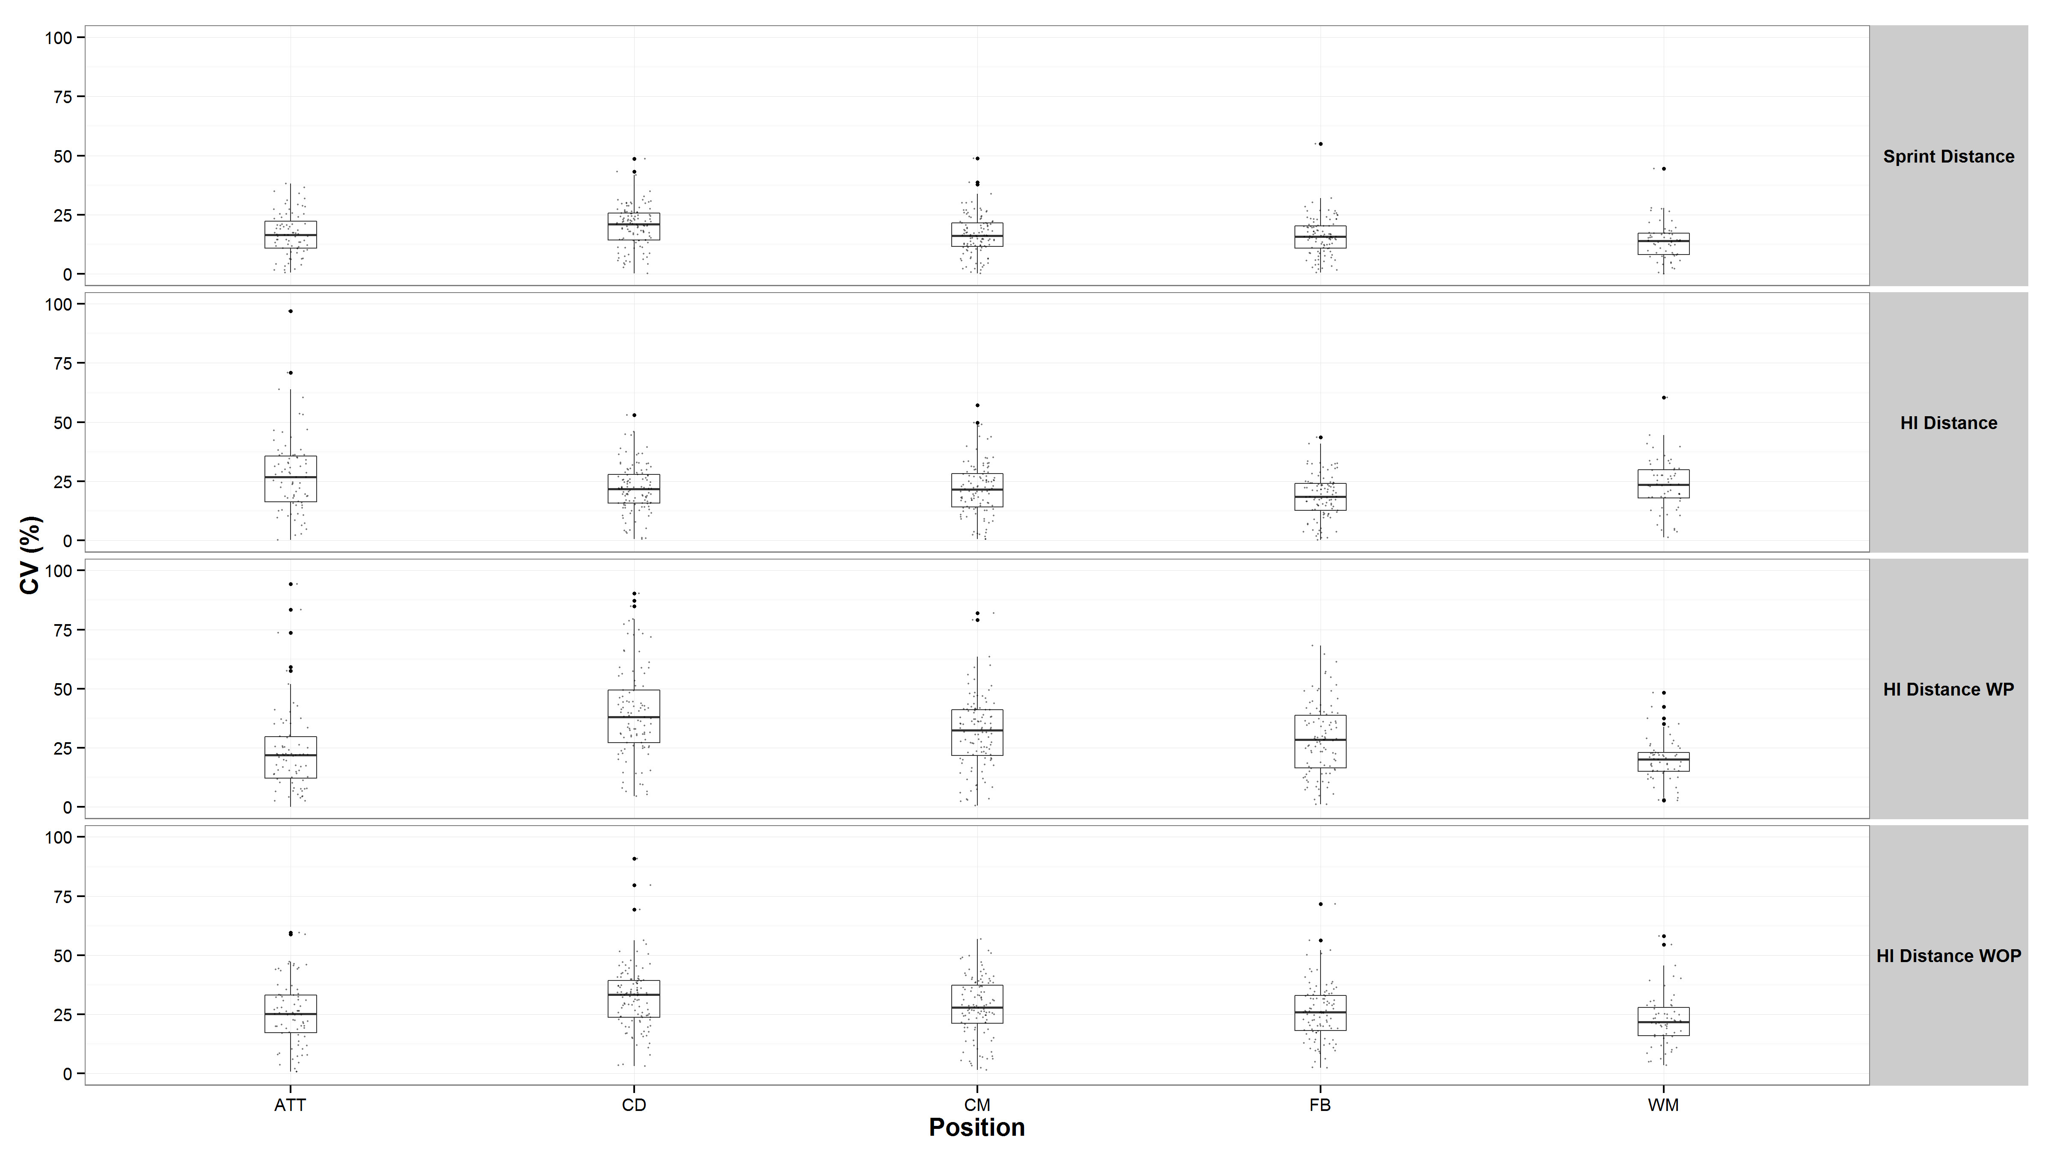

Figure 2
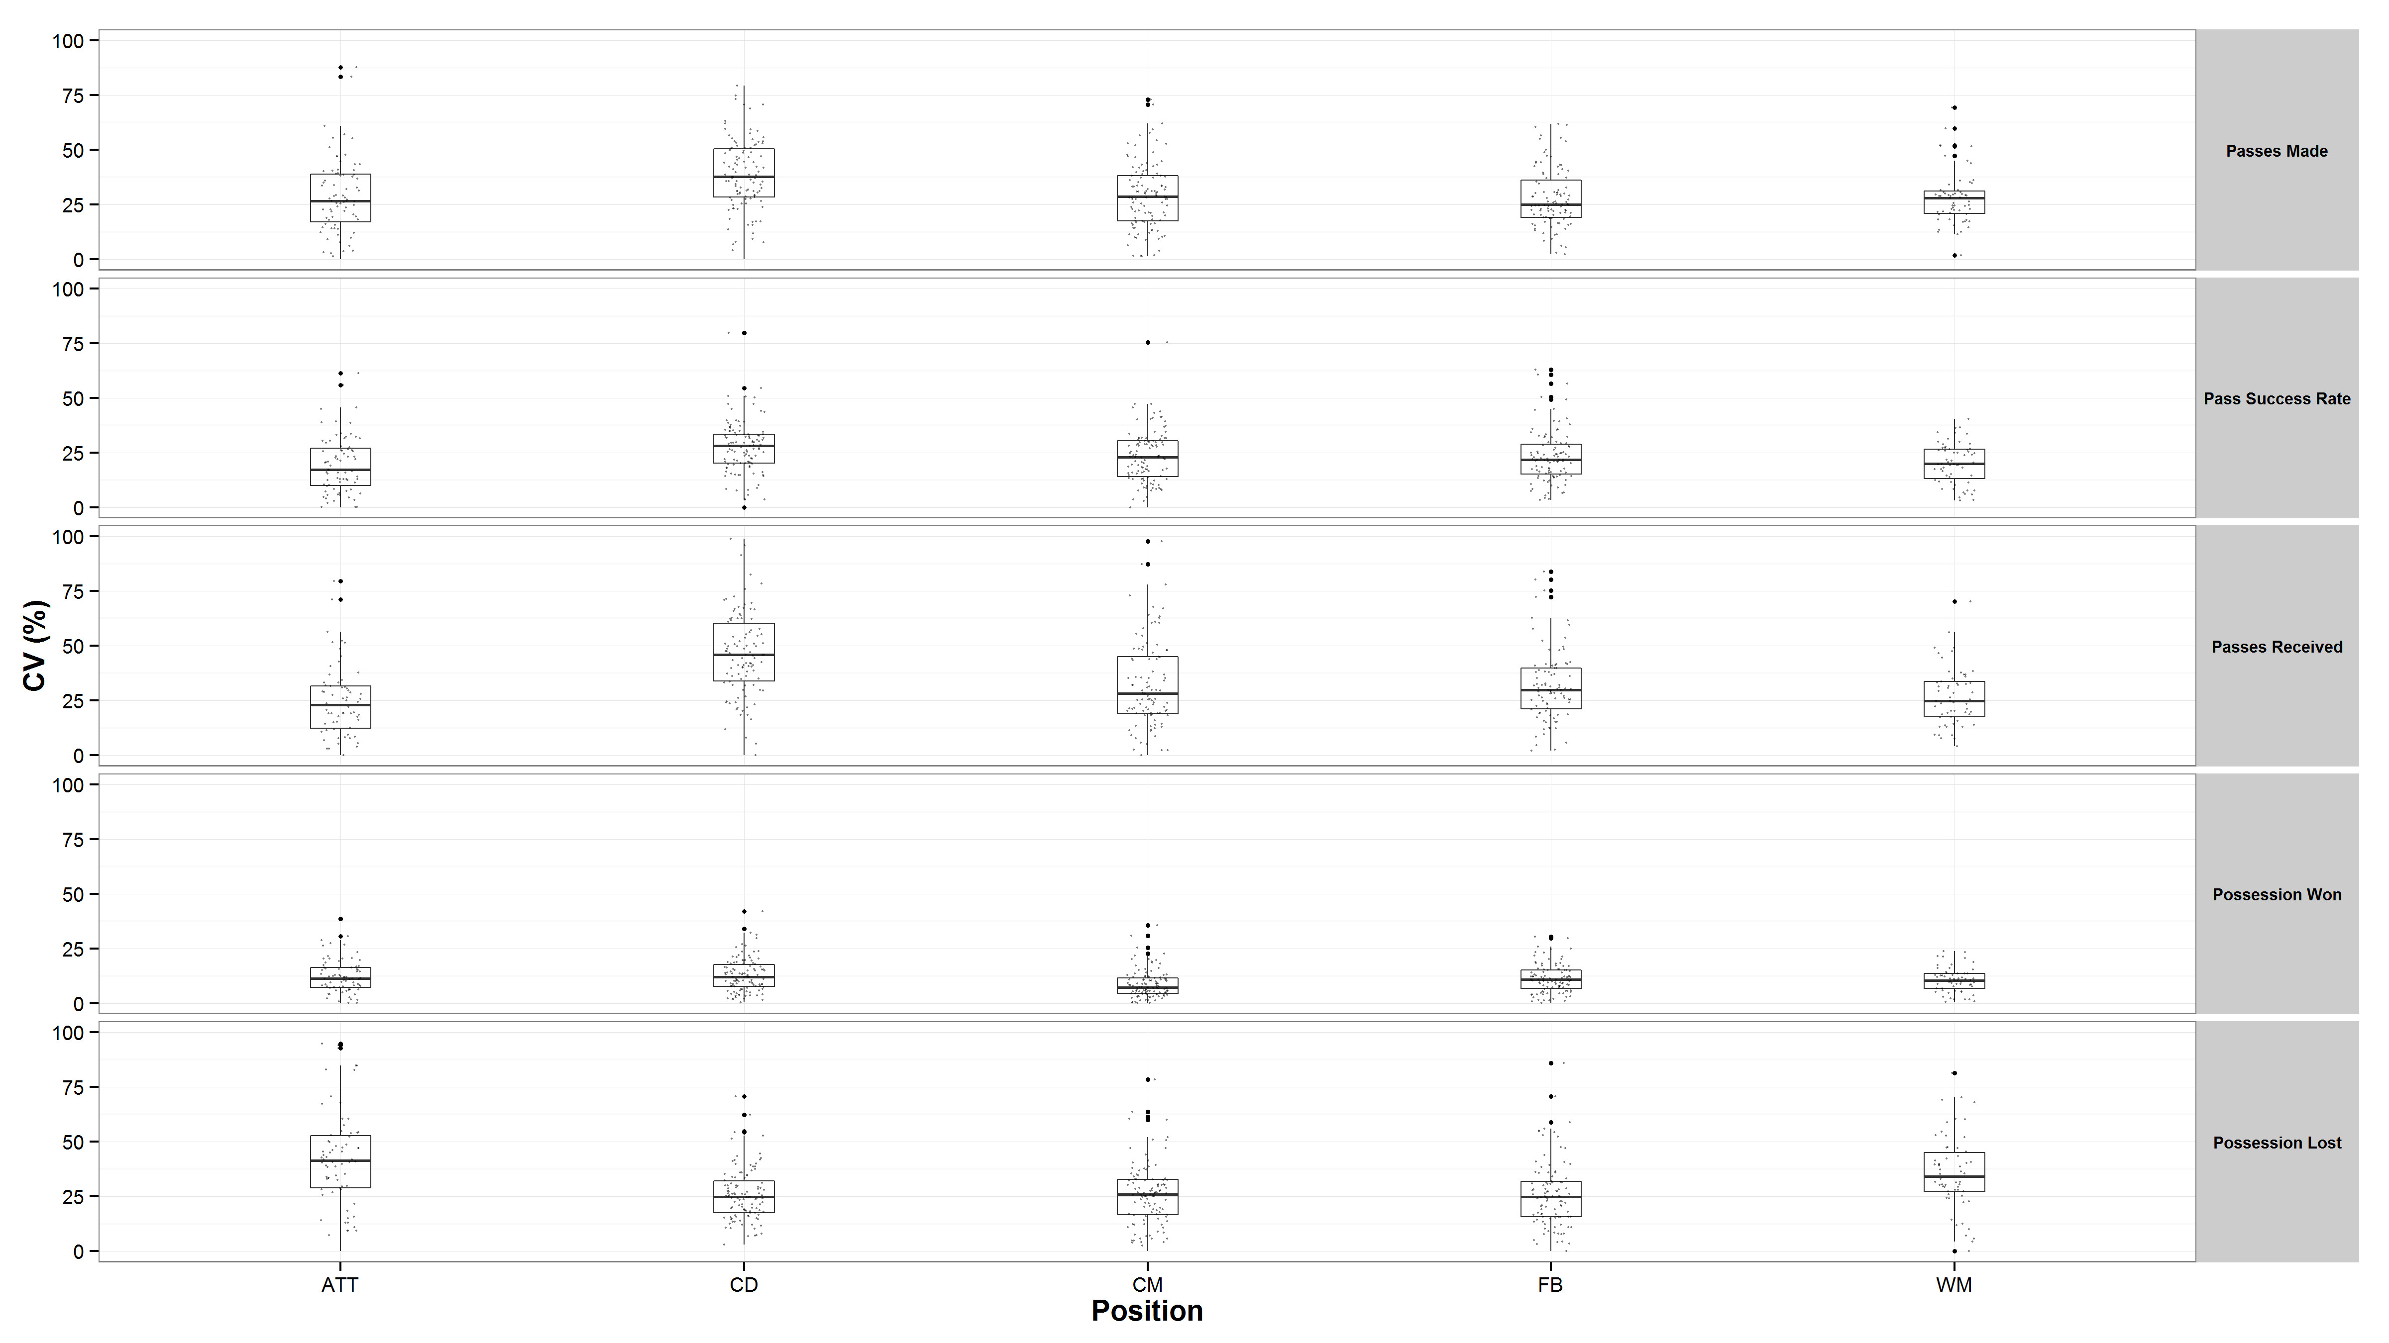

Figure 3:
