Fig. 1: Chemical structure of a) Copovidone, b) Kollicoat® MAE 30 DP, c) Eudragit® RL PO

Fig. 2: Scanning electron microscopy images of spray-dried and freeze-dried lysozyme formulations.

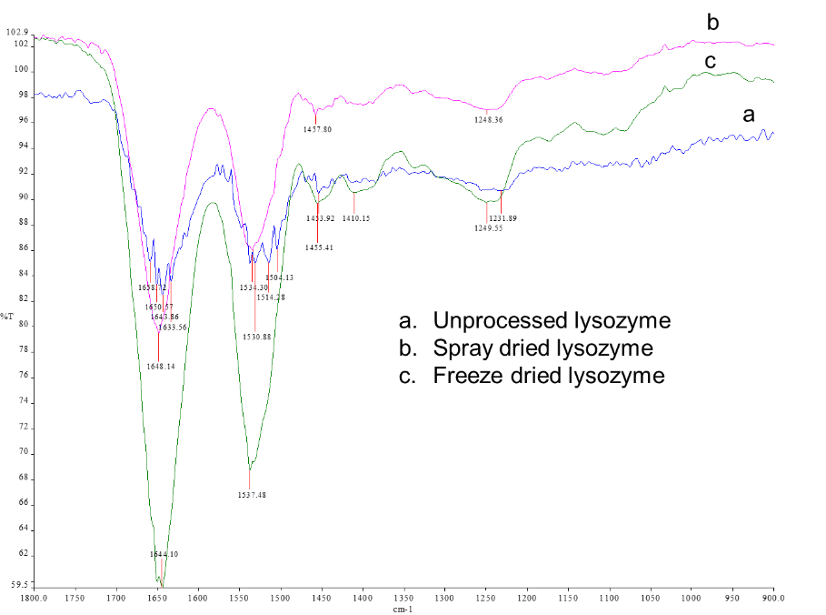
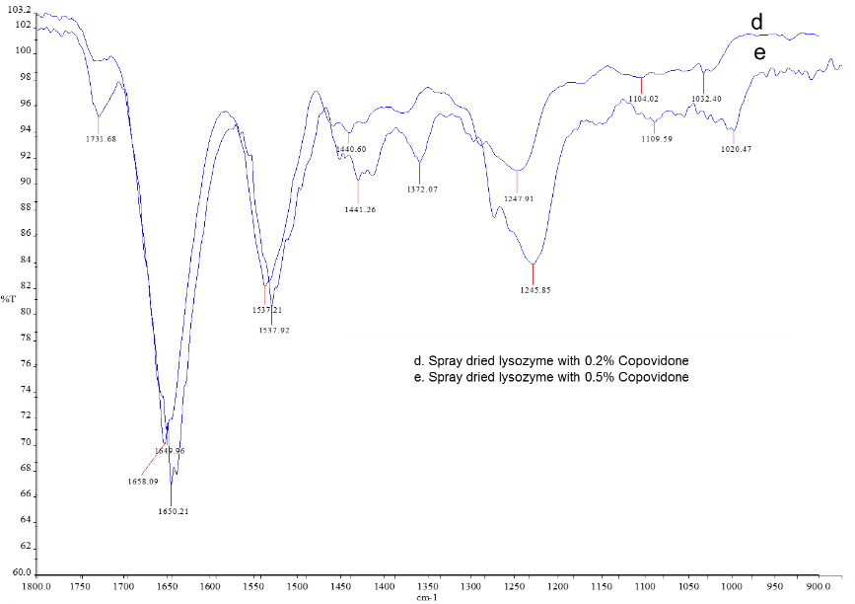
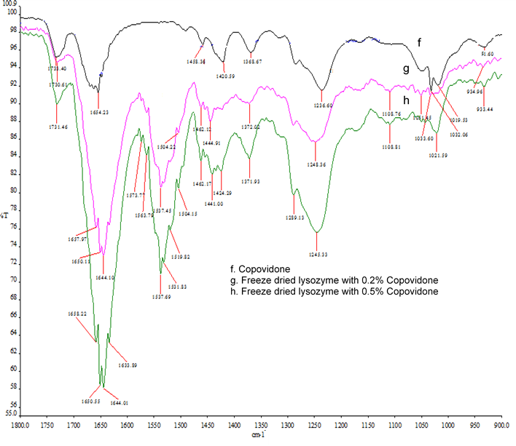
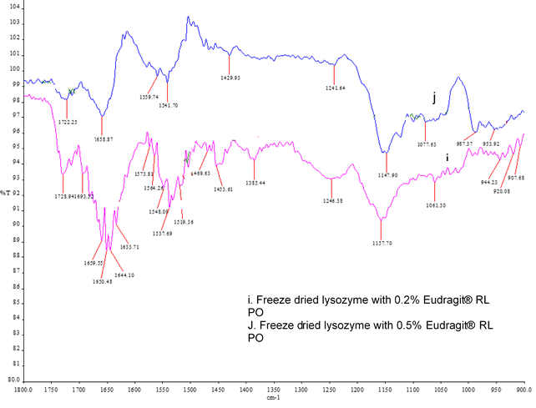
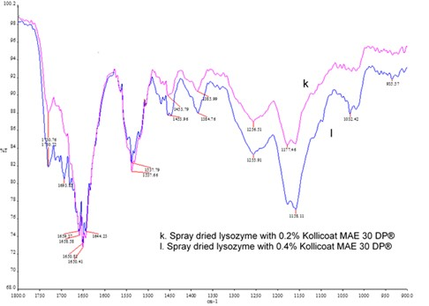

Fig. 3: FT-IR data for spray-dried and freeze-dried lysozyme samples 1800-900 cm⁻¹

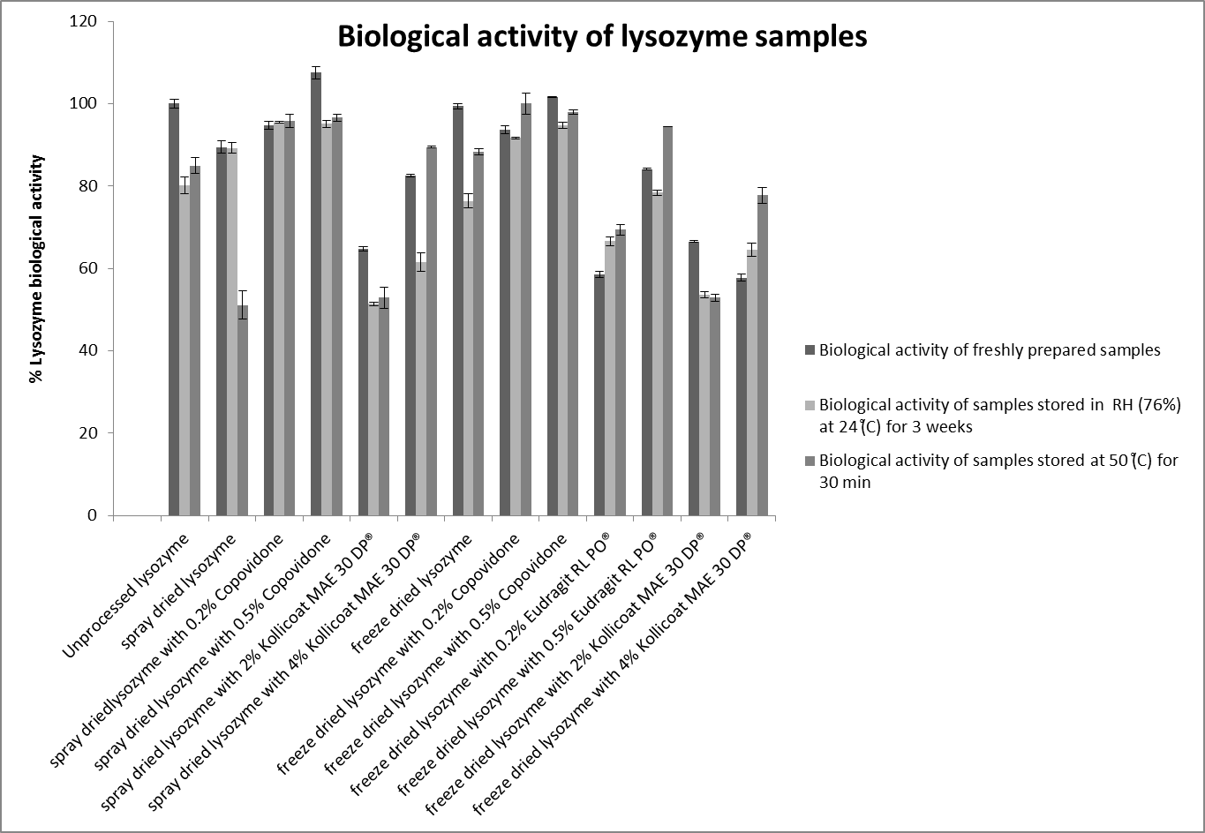
Fig. 4: Biological activity percentage of protein samples pre- and post-storage; 3 weeks at 76% RH and 24 °C (solid forms) and at 50 °C for 30 min (liquid forms).

Table 1: % Yield results for spray-dried lysozyme
Formulations | % yield of spray-dried lysozyme
Spray-dried lysozyme | 65.5
Spray-dried lysozyme with 0.2% Copovidone | 60.9
Spray-dried lysozyme with 0.5% Copovidone | 61.7
Spray-dried lysozyme with 2% Kollicoat® MAE 30 DP | 70
Spray-dried lysozyme with 4% Kollicoat® MAE 30 DP | 71.4

Table 2: Apparent denaturation temperatures, T_{m}, of lysozyme samples as determined by Differential Scanning Calorimetry (DSC)
Formulations | Apparent Denaturation Temperature (Tm, °C)
Unprocessed lysozyme as received | 201.3
Freeze dried Lysozyme 1% w/v | 199.9
Freeze dried Lysozyme 1% w/v and Copovidone 0.2 %w/v | 192.2
Freeze dried Lysozyme 1% w/v and Copovidone 0.5 %w/v | 181.7
Lysozyme 1% w/v and Eudragit® RL PO 0.2 %w/v | 197.2
Lysozyme 1% w/v and Eudragit® RL PO 0.5 %w/v | 199.4
Lysozyme 1% w/v and Kollicoat® MAE 30 DP  4 %v/v | 192.6
Lysozyme 1% w/v and Kollicoat® MAE 30 DP  2 %v/v | 193.6
Spray dried Lysozyme 1% w/v | 200.1
Spray dried Lysozyme 1% w/v and Copovidone 0.2 %w/v | 194.5
Spray dried Lysozyme 1% w/v and Copovidone 0.5 %w/v | 185.4
Spray dried Lysozyme 1% w/v and Kollicoat® MAE 30 DP 4 %v/v | 192.0
Spray dried Lysozyme 1% w/v and Kollicoat® MAE 30 DP 2 %v/v | 195.8

