The advantages of visual methods in exploring hidden subjectivities in post-compulsory education.
Ewan Ingleby^{a*}, Gary Currie^{b}, Ryan Williamsª.
ªEducation Department, Teesside University, UK; ^{b} School of Health and Life Sciences, Teesside University, UK
Abstract
This article exemplifies the advantages that researchers have if they apply visual methods and in particular photo-elicitation to qualitative research. The research context is post-compulsory education with the field of study being a new vocational degree programme, and the theoretical content of the article draws on the work of Goffman, alongside theories of literacy as social practice. It is interesting that the policy documents that are framing new vocational degrees are texts written in particular ways and that in the UK these texts are informed by political and economic agendas. However, the texts that have given rise to new vocational degree programmes do not appear to necessarily align with the rich subjective practices which are occurring within this form of post-compulsory education. The research that is presented in this article from selected students and academics who are working on a particular vocational degree reveals profound interpretations of the purpose of new vocational degrees. The imaginative and creative images that are captured by the application of photo-elicitation to this study reveal a fascinating interplay between the policy texts and the subjective interpretations of the purpose of post-compulsory education.
Keywords: new vocational degrees; visual methods; photo elicitation; literacy as social practice.
*corresponding author e.ingleby@tees.ac.uk

Introduction
It can be argued that in view of the challenges that are being offered to researchers in education as a consequence of the global pandemic, rethinking traditional qualitative research methods for gathering data about post-compulsory education is advisable. This article explores the application of photo-elicitation to a qualitative research project that has explored the views of selected students and their academic tutors about a new vocational degree programme in England. The images that are presented in the paper reveal profound and interesting interpretations of the research participants’ views about a new vocational degree. Had the research been completed by a series of Skype interviews using a conventional set of loosely structured interview questions, the subsequent data might not have necessarily revealed the creative interpretations of new vocational degrees that are made manifest by the research participants. As a consequence of photo-elicitation, in the research process in this article we see the enactment of what Ellingson (2009) refers to as crystallisation in qualitative research. There is the capture of creative and artistic interpretations about the research focus, and the images are subsequently used to inform the conversations that are taking place about the research area. In this way, new subjective understandings about the purpose of post-compulsory education have been revealed.
The application of photo-elicitation to the research area has highlighted what Goffman (1971) refers to as a ‘back region’ where hidden elements of the ‘drama’ that is taking place in a new vocational degree programme are revealed. This is also similar to what Vermunt (2016) describes as the black-box of conversations in education that are rarely heard, and the power of photo-elicitation rests in its ability to act as a catalyst to reveal profound reflections about the social world. A ‘holy grail’ of research methodology appears to be concerned with enabling ways of engaging with the entirety of the research focus, as much as this is ever possible, and in this study about new vocational degrees in post-compulsory education, the research methodology has become a vibrant and highly significant element of the success of the research project. This in turn means that the reflection on methodology is a vital part of the creative subjectivities that have been explored during the research (Ellingson 2009).
The theoretical basis of the paper is based on the work of Barton (2007), Barton, Hamilton, and Ivanić (2000), and Gee (1996), where theories of literacy as social practice have been applied to the research context. There are key policy documents (for example, BIS 2009; BIS 2013; and The Browne Report 2010) that have contributed to the literary understanding of the new vocational degree programme and its purpose, and these policy documents have resulted in the production of an academic degree programme that has been validated by a University in England. The policy documents have in turn helped in shaping a curriculum that is delivered by academic tutors to University students and it is the subjective understandings of this academic programme that have been explored during the research. The research reveals that there is tension between the policymaker documents and the individual perceptions of the purpose of the new vocational degree. Whereas the neoliberal policy documents are characterised by making reference to ‘value for money’ and the development of ‘skills of employability’ in the students, other interpretations about the purpose of the academic programme are revealed which are not evident in the policy documents. These hidden subjectivities have been explored via photo-elicitation to reveal that the actual practices which are occurring in the new vocational degree programme are profound and in consequence worth presenting in developing the field of research in post-compulsory education.

Research context
The post-compulsory research context of the article is CSS (Crime Scene Science). Broadly speaking, CSS is one of a number of vocational based higher education courses that are characterised by a heavy emphasis being placed on the practical aspects of applied science. Within the three year degree programme, the students attain the underpinnings of scientific knowledge alongside developing the skills which are required to investigate crime scenes effectively through the application of common forensic science techniques. The degree programme also explores the principles of crime investigation and the management of criminal incidents as well as considering how forensic evidence is interpreted and applied in the courtroom. The students who are studying on the degree programme engage in practical tasks such as photography, fingerprint enhancement techniques, and they learn how to locate and recover trace evidence such as glass, fibres, and footwear impressions. Alongside developing these skills, the students need to understand the law in respect of the legislative powers that can be exercised. In addition to this, the students reflect on the skills that are necessary in dealing with people in stressful, confrontational, and hazardous situations. Personal attributes such as these are described by Kelty, Julian, and Robertson (2011) as being generic competencies that are integral to the competency frameworks of external accrediting bodies such as The National Occupational Standards (NOS), The Forensic Science Society (FSS), and The Sector Skills for Justice (SSfJ), and all of these organisations have accredited the UK degree programmes.
In general, there has been limited research surrounding the role of CSS in developing the skills that are necessary to perform the role effectively although Butler (1992) draws attention to the importance of being aware of quality assurance in this area. Moreover, Harrison (2006) and Crispino (2008) discuss crime scene investigation and crime scene management to argue that scientific knowledge ought to be integrated into the way of thinking in the field as opposed to being situated predominantly within a technical realm. It is also important to consider that the development of CSS in the UK can be attributed to factors imposed from outside the Universities, as neoliberal policies have influenced the development of higher education in this area (Ingleby 2015). Global and national changes appear to have repositioned Universities as being required to respond to a range of pressures including new forms of employment, and global competition from other Universities.
In the past 15 years CSS has grown as a discipline in selected UK Universities with the emergence of a variety of degree programme titles, although in essence all of the CSS degrees strive to incorporate the scientific principles that are part of the investigative process from the crime scene examination, in tandem with the analysis of recovered evidence and the presentation of the findings to a court of law. The term ‘forensic’ is used in many of the degree programme titles (for example ‘Forensic Science and Human Resource Management’ ([Keele University], and ‘Football Technology and Forensic Computing’ [Staffordshire University]). Although there is no national figure specifically for the exact and relatively small discipline of CSS, figures from the Higher Education Statistics Agency (www.hesa.ac.uk) show full-time undergraduates studying ‘forensic or archaeological science’ trebled between 2002 and 2007 from 3065 to 9115 under the New Labour administrations, and although the austerity measures that have been imposed by UK governments since 2010 have not increased the numbers of students, they have been maintained.
Theoretical framework
The research paper applies a theoretical framework that understands the curriculum as being made up of texts, which result in curriculum events, and in turn produce subjective interpretations of these curriculum events. This theory of literacy as social practice is also aided by an understanding of students and academic staff having to navigate a way through a number of educational occurrences that depend upon a myriad of factors. This interaction holds the potential to change the presentation of the academic tutors and the students during their involvement in the educational processes that are associated with the CSS degree programme. In reflecting on the interaction that occurs between the students and the academic tutors on the CSS degree programme, we argue that it is helpful to consider theories of literacy as social practice alongside reflecting on how this influences what Eraut (2007) refers to as the epistemology of practice. Ingleby (2019) notes that literary texts can be understood as being ‘ways of representing the world to others’ (Barton 2007, 34). In the CSS degree, the ‘texts’ include policy documents that have shaped the purpose of higher education in England alongside books about CSS, for example Harrison (2006), and Crispino (2008). It is these texts that in turn generate ‘literary events’ which are regarded by Barton (2007, 35) as being ‘occasions in everyday life where the written word has a role’. These literary events inform the development of the CSS curriculum that is associated with the research. A number of policy documents, for example DfEE 1999; DES 1987; DfES 2003a. and 2003b have influenced the key curriculum goals of the CSS degree and helped to establish what Eraut (2000) refers to as the codified knowledge that students are expected to grasp. In related studies, for example in the work of Hedges, Ingleby, and Cosson (2020), it is revealed that policy documents hold the potential to generate the key aspects of the curriculum events that are in turn interpreted subjectively by those who are working on degree programmes. In helping to develop this understanding of literacy as social practice, the work of Eraut (2007, 46) is also helpful as he argues that ‘practice’ is influenced crucially by cultural knowledge, and that this is a further key ingredient in the ‘personal knowledge’ which helps in generating subjective practices.
In formulating the theoretical content of the research, we have reflected on the work of Goffman (1971, 26) via the conceptualisation of social interaction as a performance that produces what are referred to as ‘dramaturgical problems’, in terms of the presentation of social activities to others. The application of photo-elicitation to the research area has helped in capturing the subjective experiences of the students and their academic tutors, and what appears to be particularly important in this dramaturgical performance, are the rich and profound meanings that are given to the CSS degree programme.
This observed part of the performance that has been captured via photo-elicitation is what Goffman (!971, 33) refers to as the ‘front’ and essentially our research has captured the nature of the ‘performance environment’ and the application of the ‘props’ which are used to explain the subjective interpretations of the CSS students and their academic tutors. The use of visual methods in the research has allowed us to collate information on other aspects of Goffman’s (1971) front, including the emotions of the students and their academic tutors, and their expressions and reflections on what the degree programme means to them in what appears as a complex and fascinating set of circumstances. Essentially via the application of photo-elicitation, we have managed to create what Goffman (1971, 114) refers to as a ‘back region’ where we have been able to access ‘suppressed facts’. The value of this data is that we have been able to reveal subjective practices about the CSS degree programme, and this provides insightful information about a fascinating aspect of post-compulsory education which potentially holds shared characteristics with other related academic programmes.
A useful aspect of literacy as social practice is the conceptualisation of students and tutors moving across different ‘domains’ of learning (Barton 2007; Barton, Hamilton and Ivanić 2000; Gee 1996, cited in Ingleby 2019), that is ‘different places in life where people act differently and use language differently’ (Barton 2007, 39, cited in Ingleby 2019). This theoretical perspective allows us to explore the challenges that the students and the academic tutors face in interpreting the curriculum in subjective ways, alongside maintaining a coherent sense of a curriculum which can be understood by others who are beyond the immediate CSS degree programme. This links to Goffman’s (1971) ideas about managing the setting and the manner of the performance, and these two aspects of the CSS degree lie within the potential control of the students and the academic tutors. Of course, the research has revealed that there are more than two or three factors that exist within an academic curriculum. Indeed, it can be argued that viewing a curriculum as being formed from texts, curriculum events, and subjective practices is very simplistic, however we argue that this is a necessary simplicity that acts as a platform upon which the real depth and profundity of an academic curriculum can be understood. Barton’s (2007) notion of texts, events, and practices provides a map that enables researchers to discover the rich nature of an academic curriculum, especially when the research methods that are applied enable this objective. We argue that the use of a framework which explores policy texts to see how curriculum activities are generated, and are in turn understood in subjective ways, enables the possibility of revealing the complex nature of the CSS degree programme. Moreover, it can be argued that it is a failing of the policy documents that they are written in ways that appear to simplify the purpose of the CSS degree programme, and that it is the framework of literacy as social practice that has enabled the effective capture of the subjective interpretations of the curriculum events that have been generated by these policy texts.
Methodology
The research findings in this project were gathered via photo-elicitation and this is a methodological technique originating in the fields of social anthropology, ethnography, and visual sociology. The methodology has been applied successfully in a number of post-compulsory education fields, for example in the work of Close (2007), and in Wells, Ritchie and McPherson (2013). The photographer and researcher John Collier is initially associated with the term ‘photo-elicitation’ in 1957 during his exploration of the Canadian mental health systems, and in 1960 a text was produced that was based on his fieldwork involving the use of images and interviewing. The sociologists Harper (1986; 2002) and Banks (2001) helped to develop photo-elicitation as a research method involving photographs as a key part of the data collection process. Harper (2000) argues that the power of photo-elicitation rests in gathering the participants’ interpretations of the social world, from the capturing of images to their subsequent use for reflective dialogue. The approach focuses on images that are chosen by the research participants prior to the research interviews, and the images can be single or a series of images that are compiled on the basis of their significance for the research participants (Pink 2001). Moreover, this process of using a single photo or collections of photos is applied during the research interviews to reflect on the participants’ values, attitudes, and beliefs.
Data collection through visual methodologies holds the potential to allow researchers to gather material that would otherwise be harder to obtain via traditional qualitative research approaches. This is made evident, in particular with the engagement with social and emotional perspectives that in turn inform individual values and subjectivities (Richard and Lahman 2014). As an example, photographs can be used to stimulate discussions around topics that may appear to be ‘uncomfortable’ in formally structured interviews, and this is one of the reasons for the growing popularity of the application of visual methods across the social sciences. Moreover, photographs can carry meanings that transcend words, with Cohen, Manion and Morrison (2018) arguing that in consequence, the research participants can use images to describe moods and atmospheres in rich, detailed, and holistic ways. Furthermore, by allowing the research participants choice, photo-elicitation can empower individuals, and this helps in making the research process as inclusive as possible (Barton 2015). Meo (2010) and Elliot, Reid, and Baumfield (2016) argue that this form of participant-led qualitative research helps in building rapport and trust within the research process, and that this enables the researcher to use emotion and intuition in helpful ways within the research process.
In this research project, a total of 36 one-to-one digitally recorded semi-structured photo-interviews were conducted, and the research participants included students from all three years of a CSS degree programme (n=30), some former students (n=3), and academic staff (n=3) working on the degree programme. The research aimed at ‘understanding behaviour and the meaning of that behaviour in a specific social context’ (Bryman, 2004, 27). The research transcripts were analysed by constant comparison, and this was informed by the work of Mehan (1979) and Seale (1999) and Braun and Clarke (2006). All of the research participants were provided with the opportunity to read through the research transcripts and provide further comments, retractions, or alterations if they wished (Merriam 2009), and the research participants were subsequently anonymised following the recommendations of the research ethics committee of the University.
Findings
The research reveals two key findings: 1. The policymaker views of the purpose of post-compulsory education differ in significant ways from the CSS students and the academic tutors, and 2. The interpretations of the CSS students and the academic tutors about the purpose of post-compulsory education are varied and highly subjective. 51 images or ‘frames’ were collated during this research, however, owing to the word limit of the journal, 10 frames of images have been selected as being representative of the views of the research sample. These 10 frames and the subsequent reflections on these images are juxtaposed with the discourse that is present in key policy documents to outline the neoliberal policymakers’ interpretation of the purpose of post-compulsory education in the UK.
Frame 1
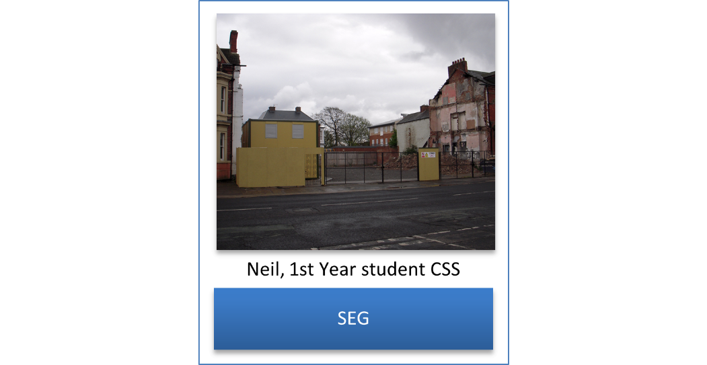
The first photograph in this section of the article reveals the thoughts of ‘Neil’, a first year CSS student, with the abbreviation ‘SEG’ referring to ‘socio-economic group’. The image features a gap between two buildings where a third building once stood, and it is also important to note that the image contains other significant features including grey clouds, and the area is fenced off. This highlights the challenges that a number of students face in feeling comfortable about studying on a new vocational degree programme. ‘Neil’ goes on to reflect that: ‘I suppose I felt that I don’t really fit into the respective classes at the moment’, and this presents a dilemma with being comfortable and secure as a student on a new vocational degree programme. In contrast, the language from the policy documents about the purpose of post-compulsory education is markedly different. BIS (2009, 3) reveals the awareness that there are challenges in including students in post-compulsory education, however the concerns about educational uptake are expressed more as statements about a problem as opposed to being suggestions for how to address these particular needs. Reference is made to ‘the UK participation rate for higher education’ slipping from ‘7th in the OECD to 15th’, as ‘others have grown faster’. In contrast, ‘Neil’ provides insights into the challenges that can exist for students from lower socio-economic backgrounds being part of a world that does not appear to ‘fit’ with what they are used to. The image that has been selected to show this concern is profound in its emotion as opposed to being a mere statement of fact that there are learners in the UK who do not fit easily within post-compulsory education.
Frame 2
The images in this frame reveal what the research participants consider as being ‘the purpose of CSS’ and there are three broad responses to this aspect of the research. The first row of images reveals that the perceptions of CSS are influenced by the media portrayal of the subject discipline through the television crime drama franchise ‘CSI’ (Crime Scene Investigation). It appears that many of the research participants in this study first became aware of CSS via these television experiences. The images in the middle row of the frame reveal the research participants’ view that CSS is ‘glamorized’, and this is illuminated by ‘John’s’ view that CSS, ‘like a sports car’ is ‘over-glamorized’. The research participants reflected that they were no longer able to watch the television programme CSI, because the study of CSS had made them realise that the programme is a misrepresentation of reality. The ‘new’ and potentially ‘highbrow’ reality of CSS is captured in the third row of images, with ‘Kelly’ (a first year CSS student) complementing these images by referring to the emotional connections that she made to the year group and the importance to her of the academic capital that was being generated via the programme. In contrast to the nuanced reflections about the nature of a new vocational degree programme that is made evident by the research participants, BIS (2012, 96) refers to overly general aspects of the UK higher education agenda, like ‘widening participation’, and ‘employability’. The purpose of higher education is linked to the development of ‘knowledge societies’ which are considered to be dependent upon ‘flexible’ delivery that is responding to ‘global’ trends. This general tone about a sector of higher education that is revealed in BIS 2012 is markedly different to the three specific types of reflection about the purpose of CSS that are revealed by the research participants.
Frame 3
The importance of being the first student to attend University is also reflected on by some of the research respondents and this is revealed by ’Michelle’, who considers herself to be in a ‘celebrity’ world because she is studying for a degree in CSS. ‘Michelle’ refers to this profession as ‘a middle class job’ because the role involves being ‘a scientist’. ‘Michelle’ goes on to say that a reason why she wanted to study CSS ‘was to wear the overalls and look clever and bag the evidence’, and although the importance of providing opportunities to students through widening participation is present in the policy documents, the subjective motivations for studying new vocational degrees like CSS are not acknowledged in the policy documents. The key theme of BIS (2013) is ‘widening participation’ in higher education, and this document acknowledges that there are challenges in getting students from low socio-economic backgrounds to attend Universities in England. There are what are referred to as ‘low participation neighbourhoods’ where there are not many students who go on to attend a University (BIS 2013, 28), alongside the ‘most selective’ Universities (BIS 2013, 30). However, the ways of changing this situation are more complex than merely enabling those from ‘low participation neighbourhoods’ to attend high ranking Universities. ‘Michelle’ reflects that she saw CSS as being a means whereby she could change her ‘social identity’, and this reveals that the perceptions of those who are within ‘Michelle’s’ social world are deemed to be vital influencers, yet the language of BIS (2013) implies that change can happen by the government ‘widening participation’ to those who are traditionally beyond a University education. As ‘Michelle’ reveals, the reality of this situation is more complex and depends upon the particular subjectivities of individuals.
Frame 4
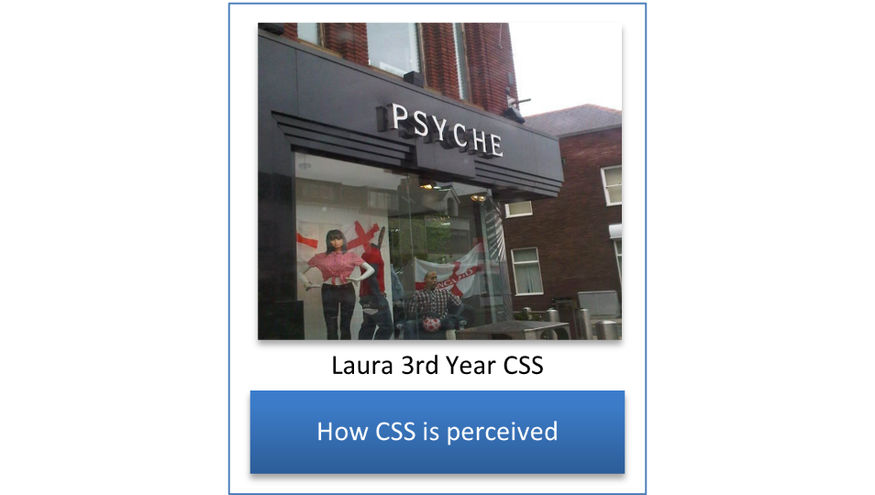
‘Laura’s’ chosen image representing the CSS degree programme is what she refers to as ‘a cool shop’, and ‘Laura’ goes on to reflect that those beyond the subject discipline misinterpret the nature of CSS as they appear to think that the degree programme is ‘just like it is on TV’. ‘Laura’ reveals that much of the work that takes place on the degree programme is not at all like this, as the reality is that ‘you’re in your overalls, and I come back with aluminium powder all over my face’. The over-glamorization of CSS is very different to the actual reality of the new vocational programme, and much of the curriculum content involves hard work and dedication as opposed to acquiring a magical set of skills, according to ‘Laura’. However, the neoliberal policy documents present the acquisition of the skills of employability in neat and contrasting ways to ‘Laura’. In DfES (2003a 68), ‘skills councils’ are referred to as being charged with the responsibility for ‘transferring technologies and knowledge, and in skills development within local communities of practice’. This process does not appear to involve the ‘crawling around some scratty car’ that ‘Laura’ reflects on. DfES (2003a, 68) refers to the development of ‘new sector skills councils’ with their ‘stronger alliances between businesses in their sectors’, however the language that is being used in this policy document is overly general and less aware of the reality of individual degree programmes in comparison to ‘Laura’s’ insightful experiences that are based upon being a student on a new vocational degree programme.
Frame 5
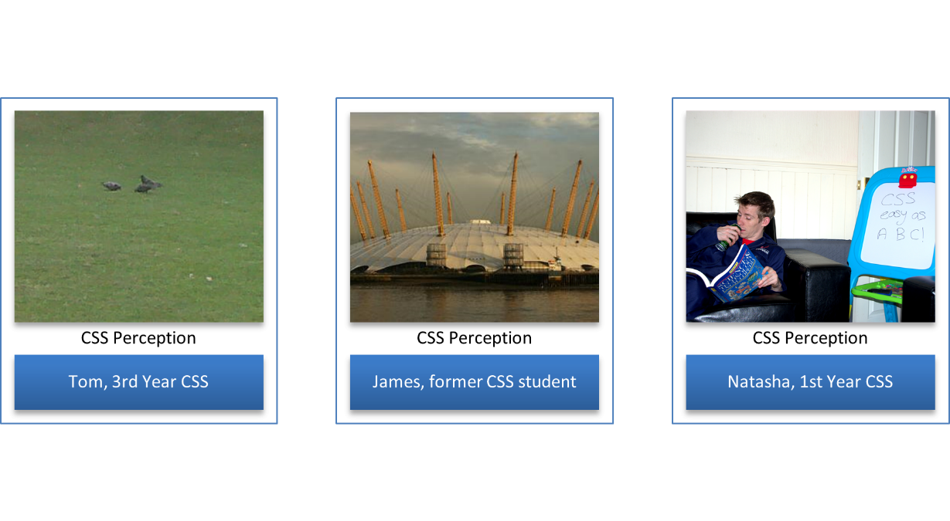
The perception of the new vocational degree programme appears to vary across the students’ social class backgrounds, especially from students who are from middle class backgrounds, and not first generation higher education students. ‘Tom’ refers to CSS as ‘a bird course’, because ‘you just fly through it’. ‘Tom’ contrasts the perception of CSS with traditional science degrees, and this view is reinforced by ‘Natasha’, who also notes the perception of the CSS degree programme ‘being really easy’ in contrast to ‘maths or physics’. However, the student perceptions of CSS are complex, and ‘James’ refers to the degree programme as appearing to be initially ‘something new, exciting, and modern’, and yet also being regarded by those beyond the subject discipline as ‘a white elephant’. In contrast, DfES (2003b, 11) equates all degree programmes with the acquisition of ‘skills’ that help in ‘raising employability’. It is noted that ‘a job for life’ has now been replaced with ‘employability for life’ and ‘raising skills’ is regarded as being the key way to achieve this goal (DfES 2003b, 11). Although it is acknowledged in DfES (2003b, 12) that ‘we have listened carefully to the concerns of employers, trade unions, colleges, and other partners’ the insightful views of students like ‘Tom’, ‘Natasha’, and ‘James’ do not appear to be informing this agenda directly, as their specific comments about the nature of new vocational degrees do not appear to have been acted on by the neoliberal policymakers.
Frame 6
The reference to ‘skills’ that occurs in the policy documents is also viewed in more complex ways by the students who are studying on the new vocational degree programme. The images in the above ‘frame’ reveal that ‘attaining knowledge’ is considered as being particularly important for the students in the research sample. The books that are highlighted by ‘Jackie’ and ‘John’ are revealed as being physical objects and there appears to be the perception that this knowledge rests within books as representations of sacred truths. ‘Natasha’ also objectifies the purpose of higher education with her image of a traditional building that represents the old way of studying and learning about educational matters. In contrast, BIS (2009, 8) makes no reference to the importance of ‘books’ or ‘tradition’. The perception of higher education is that it ought to ‘constantly evolve’. Moreover, it is stated that ‘there is no room in the system for vocational programmes that do not constantly evolve’ (BIS 2009. 8). In this differing perception of the purpose of higher education, neither ‘books’ nor ‘tradition’ are regarded as being a vital part of higher education. There is the expectation that ‘students should leave university better equipped with a wider range of employability skills’ (BIS 2009, 8). As opposed to demonstrating that their degree programmes are based on ‘books’ and ‘tradition’, BIS (2009) states that Universities are expected to demonstrate how they are preparing their students for employment by developing modern workplace skills.
Frame 7
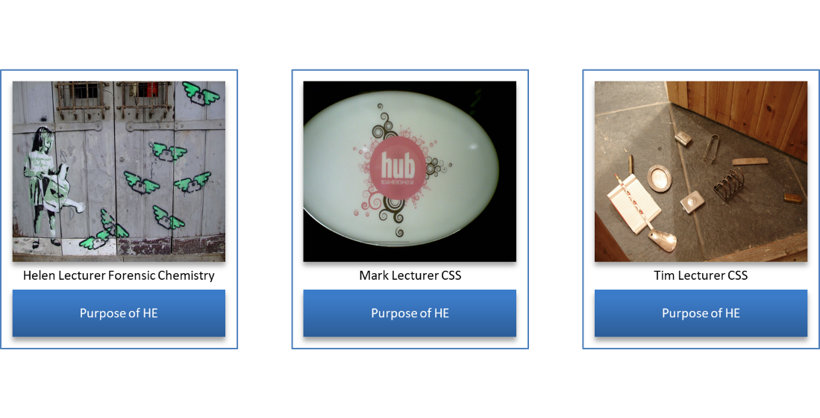
The academic tutors in the research sample also appear to have much more profound views of the purpose of CSS than the policy documents. ‘Tim’ reveals that there are not enough job vacancies for all of the graduates, however providing the ability to grow and develop and think on the degree programme is considered as being worthwhile in itself. The ‘bric-a-brac’ in ‘Tim’s’ image may not be ‘precious metal’, however the objects are still considered to be of value, nonetheless. Likewise, the policy documents appear to be closed out from the entrance of the door way in ‘Tim’s’ image, and it is only once one moves beyond this space that the real intrinsic value of the academic programme is revealed to the students. ‘Helen’ makes reference to CSS doing what the neoliberal governments require in respect of producing large numbers of graduates, however it is claimed by ‘Helen’ that the purpose of higher education is surely more than this? ‘Mark’s’ image reveals the entrance to a student union bar area and ‘Mark’ reflects that even despite the ‘austerity’ that is being experienced by students in England, ‘they looked happy, they looked engaged, they were buying food and they were sitting down, and they were chatting about their courses’. In contrast to these varied interpretations of the purpose of higher education, BIS (2012) reveals a narrower policy focus that is based more on the importance of ensuring that there is ‘growth, broader participation, greater diversity, and more work-based forms of higher education’. Moreover, in HE in FE (Higher Education in Further Education) in England, agendas of ‘transparency in funding arrangements’ appear to have influenced this particular post-compulsory education landscape (BIS 2012, 43). Although a focus has been placed on ‘widening participation’ to higher education, the policy documents do not reflect on the whole experience of being a student in the profound ways that the staff in the research sample do during the research interviews.
Frame 8
‘Fern’ reflects on the importance of the ‘pastoral’ aspects of the CSS degree programme, by drawing attention to ‘the nice, controlled environment’ that is being experienced by the CSS students, ‘with people there to help you’. ‘Fern’ reflects on the skills of the academic staff who are working on the programme, who are ‘there to help you and direct you if you're doing something wrong, so you're always learning’. This reflection reveals the importance of humanist pedagogy, where the academic staff are there to help and support the students, and ‘Fern’ reflects that this is very different to the world of work, where you can be ‘on your own and you’re not going to get the help’. Although BIS (2013) is about the widening participation in higher education agenda, the supportive pedagogical skills that are needed to enable access to post-compulsory education for students from under privileged backgrounds are not mentioned. Reference is made to pupils who are on ‘free school meals’ (BIS 2013, 3), however the pedagogical means of coping with this situation are not commented on. ‘Fern’ appears to value the support that is offered by her University academic tutors and this element of the academic programme is incredibly important to ‘Fern’, however the language of the policy documents does not take this aspect of pedagogy into consideration.
Frame 9
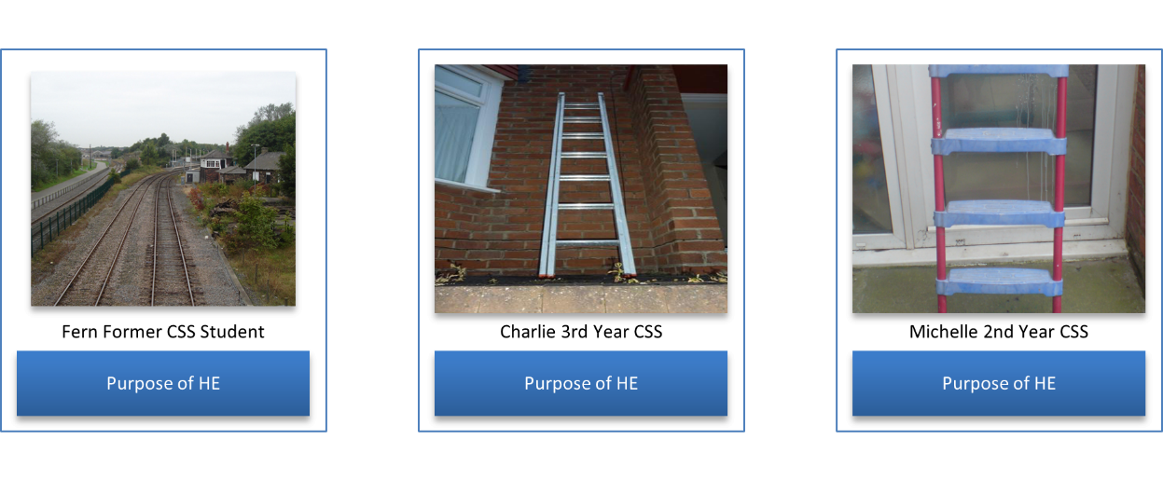
The students in the research sample make reference to ‘employability’ and ‘getting a job’ and this is captured in the images that refer to ‘train lines’ and ‘ladders’, however this theme is more complicated than it might seem initially. The students in the research sample make reference to the importance of being enabled to have the freedom to apply for jobs that would not have been available to them without having a degree. ‘Fern’s’ image of a ‘train track’ is considered as being ‘a fast track to a job’, however the way of achieving success is referred to by ‘Michelle’ as becoming involved with ‘voluntary work’ alongside studying for a degree, and the degree alone is not regarded ‘as being enough’ to get the job that ‘Michelle’ wants. ‘Michelle’ makes reference in her reflection to having ‘a career’, and this view is more complex than the way that ‘employability’ is presented in the policy documents. The language that is used in BIS (2009) is vague, with reference being made to ‘excellence’ (BIS 2009, 10), however, ‘excellence’ is never explained fully, and although it is stated that ‘multidisciplinary centres’ are to be developed in order to build ‘relationships between teams in universities and industry’, there is no practical advice as to how this objective will actually be achieved.
Frame 10
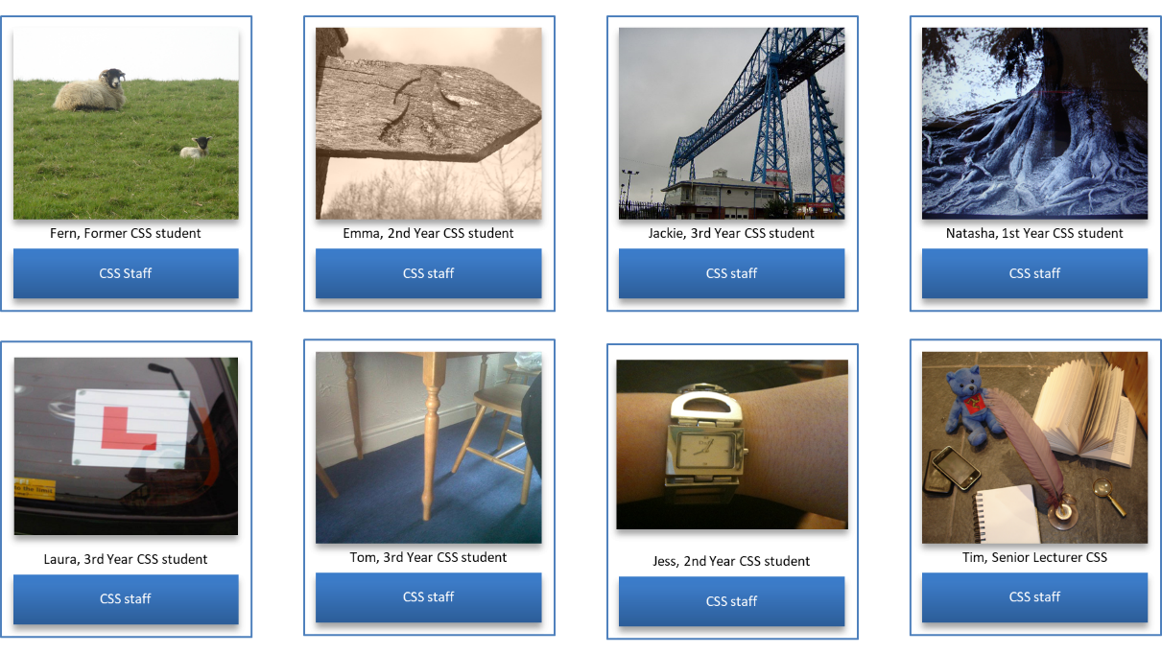
As well as ‘Fern’s’ reflection on ‘support’ and ‘guidance’ by the academic staff on the CSS degree programme, the research participants considered the processes of pedagogy in other profound ways, with ‘nurture’, ‘direction’, ‘support’, and ‘having the space to learn’ being regarded as essential. ‘Emma’ makes reference to the staff being ‘there to direct you’, however, ‘like a sign’ the academic staff on the degree programme are ‘not in your face’. ‘Jackie’s’ image of a ‘transporter bridge’; and ‘Natasha’s’ image of ‘the roots of a tree’ are also used to summarise the importance of the supportive role of the academic staff who are teaching on the CSS degree programme. ‘Laura’s’ image refers to the students as ‘learners’ and the staff as having ‘done it before’, while ‘Tom’s’ reflection is based on the ‘support’ that is provided to a table by the ‘table legs’, and this is used as a metaphor to reflect on the extensive help and support that is provided by the CSS degree staff to the students who are working on the programme. ‘Jess’ chooses a ‘watch’ to explain that the staff are there for the students because ‘they have the time’, and ‘Tim’ draws attention to the importance of having both ‘practitioner’ and ‘academic’ experience in order to enable the creation of a course team who are able to ‘communicate’ and ‘look after the students and each other’. However, in DfES (2003a), student support is phrased more in terms of the financial support that is being made available to students in post-compulsory education. The purpose of ‘student support’ is regarded as being based on ensuring that attempts are made to ‘integrate learning support across all post-compulsory education’, however, reference is made to ‘loans, grants, and benefits’, and the emotional support that is referred to as being important by the research participants is not acknowledged (DfES 2003a, 67).
Concluding discussion
The research that has been presented makes two main contributions to post-compulsory education. In the first instance, visual research methods reveal that it is possible to enable students and tutors to reflect in profound ways about their educational experiences. Of course, this is possible too through the application of other qualitative research methods, however visual research methods and the application of photo-elicitation has been especially useful in this research, as the students and the tutors provide full and fascinating reflections about their experiences working with the CSS degree programme. The images that have been selected by the participants are thought-provoking, and they enable us to engage with the experiences of the research participants as they are participating in the degree programme. Moreover, the visual methods that have been used in the study have empowered the research participants. As noted, in photo-elicitation, the research participants choose the images that they present to the researchers, and this results in a research process in which the participants are fully engaged. This has enabled research participants like ‘Fern’ to feel safe and secure so that she was able to talk about the importance of the pastoral care that has been offered to her by the academic tutors. Of course, this revelation may also have occurred via other qualitative research methods such as focus groups, however the image that ‘Fern’ has selected is particular to her, and this enables ‘Fern’ to direct the research process in a way that brings out her rich subjective experiences of being a student on the CSS degree programme. This research finding reinforces the arguments of other researchers who advocate the application of visual research methods to qualitative research including Banks (2001); Barton (2015); Close (2007); Harper (2002); Richard and Lahman (2014); and Wells, Ritchie, and McPherson (2013). Perhaps the methodological approach that has been so successful in this research can be applied to other post-compulsory programmes in the future?
The second main contribution that the research makes to post-compulsory education is a justification of the helpful nature of literacy as social practice in understanding the CSS degree programme. This form of post-compulsory education has been shaped by policy documents, for example BIS (2009), and these policy documents are responsible for enabling the curriculum events that are made evident in the academic curriculum. However, these curriculum events are interpreted in particular ways by the students and the tutors who are engaging with the academic curriculum. This threefold way of understanding the academic curriculum is helpful as we witness the emergence of what are referred to as different ‘domains’ of learning (Barton 2007; Barton, Hamilton and Ivanić 2000; Gee 1996, cited in Ingleby 2019) ‘where people act differently and use language differently’ (Barton (2007, 39, cited in Ingleby 2019). This use of language is expressed subjectively by the students and the tutors via the images that have been captured through photo-elicitation, and it is interesting that the policy agendas with their reference to ‘employability’ and gaining a ‘degree level qualification’ are interpreted in other ways by the students and the tutors on the CSS degree programme. The research essentially reveals the complex subjectivities that are present in the texts, events, and subjective practices of a CSS degree programme, and the insights that have been gleaned have their basis in photo-elicitation and its capacity to release hidden subjectivities. Moreover, although this research is based on the CSS degree, the findings that are revealed may be similar on other programmes, and it will be interesting to see if future applications of photo-elicitation can be applied subsequently to other post-compulsory programmes.
Funding details
The research has been funded by Teesside University’s University Research Fund.
Disclosure statement
No potential conflict of interest was reported by the authors in the research.
References

Banks, M. 2001. Visual Methods in Social Research, London, Sage Publications.
Barton, D. 2007. Literacy: An Introduction to the Ecology of Written Language. Oxford: Blackwell Publishing.
Barton, D., M. Hamilton and R. Ivanić. 2000. Situated Literacies: Reading and Writing in Context. London: Routledge.
Barton, K. C. 2015. “Elicitation Techniques: Getting People to Talk About Ideas They Don’t Usually Talk About”. Theory & Research in Social Education 43 (2): 179-205.
Braun, V., and V. Clarke 2006. “Using Thematic Analysis in Psychology”. Qualitative Research in Psychology 3 (2): 77-101.
Browne, J. 2010. Securing a Sustainable Future for Higher Education: An Independent Review of Higher Education Funding and Student Finance. London: UK Government.
Bryman, A. 2004. Social Research Methods (2nd Edition). Oxford: Oxford University Press
Butler, A. J. P. 1992. “Developing Quality Assurance in Police Services”. Public Money & Management 12 (1): 23 – 27.
Close, H. 2007. “The Use of Photography as a Qualitative Research Tool”. Nurse Researcher 15 (1): 27-36.
Cohen, L., Manion, L., and K. Morrison. 2018. Research Methods in Education. Routledge.
Crispiano, F. 2008. “Nature and Place of Crime Scene Management within Forensic Sciences”. Science & Justice 48 (1): 24-28.
Department for Business Innovation and Skills. 2009. Higher Ambitions: the Future of Universities in a Knowledge Economy. Norwich: HMSO.
Department for Business Innovation and Skills. 2012. Understanding Higher Education in Further Education. London: HMSO.
Department for Business Innovation and Skills. 2013. Widening Participation in Higher Education. London: HMSO.
Department for Education and Employment. 1999. Labour Market and Skill Trends, 1998–99. A Skills and Enterprise Network Publication Produced from Original Material Provided by Business Strategies Ltd and Glyn Owen. Sudbury: DfEE Publications.
Department of Education and Science. 1987. Higher Education: Meeting the Challenge. London, HMSO.
Department for Education and Skills. 2003a. The Future of Higher Education. Norwich: HMSO.
Department for Education and Skills. 2003b. 21st Century Skills, Realising our Potential, Individuals, Employers, Nation. The Stationery Office: London.
Ellingson, L.L. 2009. Engaging Crystallization in Qualitative Research. London: Sage.
Elliot, D. L., K. Reid, and V. Baumfield. 2017. “Capturing Visual Metaphors and Tales: Innovative or Elusive?” International Journal of Research and Method in Education 40 (5): 480-496.
Eraut, M. 2000. “Non-formal learning and tacit knowledge in professional work”. British Journal of Educational Psychology 70 (1): 113-136.
Eraut, M. 2007. “Learning from other people in the workplace”. Oxford Review of Education 33 (4): 403-422.
Gee, J.P. 1996. Social Linguistics and Literacies. London: RoutledgeFalmer.
Goffman, E. 1971. The Presentation of the Self In Everyday Life London: Pelican Books.
Harper, D. 1986. “Meaning and Work: A Study in Photo Elicitation”. Current Sociology 34 (3): 24-45.
Harper, D. 2002. “Talking About Pictures: A Case for Photo Elicitation”. Visual Studies 17 (1): 13-26.
Harrison, K. 2006. “Is Crime Scene Examination Science, and Does It Matter Anyway?”. Journal of the Forensic Science Society 46 (2): 65-68.
Hedges, C., E. Ingleby, and P. Cosson. 2020. “‘Real’ Formative Assessment? An Exploratory Study of Simulated Learning in the Post-Compulsory Radiography Curriculum”. Research in Post-Compulsory Education 25 (3): 279-294.
Higher Education Statistics Agency (HESA). Available on line at: https://www.hesa.ac.uk/ [Last accessed 04.02.21].
Ingleby, E. 2015. “The House That Jack Built: Neoliberalism, Teaching in Higher education and the Moral Objections”. Teaching in Higher Education 20 (5): 518-5390.
Ingleby, E. 2019. “It Does More Than it Says on the Tin! Problematising Higher Education in Further Education in England”. Studies in Higher Education 44 (1-2): 20-31.
Kelty, S., F., R. Julian, and J. Robertson. 2011. “Professionalism in Crime Scene Examination: The Seven Key Attributes of Top Crime Scene Examiners”. Forensic Science Policy & Management 2 (4): 175–86.

Mehan, K. 1979 Learning Lessons: Social Organisation in the Classroom. Cambridge MA: Harvard University Press.
Meo, A. I. 2010. “Picturing Students’ Habitus: The Advantages and Limitations of Photo-Elicitation Interviewing in a Qualitative Study in the City of Buenos Aires”, International Journal of Qualitative Methods 9 (2): 149–171.
Merriam, S.B. 2009. Qualitative Research: A Guide to Design and Implementation. San Francisco, CA: Jossey-Bass.
Pink, S. 2001. Doing Ethnography: Images, Media and Representation in Research. London: Sage.
Richard, V. and M. Lahman. 2014. “Photo-elicitation: Reflexivity on Method, Analysis, and Graphic Portraits”. International Journal of Research & Method in Education 38 (1): 3-22.
Seale, C. 1999 The Quality of Qualitative Research. London: Sage.
Vermunt, J.D. 2016. Keynote address. Paper presented at the IPDA conference, 25-26 November, Stirling, UK.
Wells, F., D. Ritchie, and A.C. McPherson. 2013. ‘‘It is Life Threatening but I Don't Mind’. A Qualitative Study Using Photo Elicitation Interviews to Explore Adolescents' Experiences of Renal Replacement Therapies”. Child: Care, Health and Development 39 (4): 602-612.
Word count: 7205

