PUBLICATION

‘TAPIO WIRKKALA: A POET IN GLASS AND SILVER’

400pp and extensively illustrated.Published by the Finnish Glass Museum, 2013, to accompany the major exhibition of the same name at the Museum from May – end of December 2013. A slightly modified version of the exhibition will then tour to Milan.

‘Tapio Wirkkala: Iconic Designer and Myth Maker’, by Jack Dawson, p10 – p196.

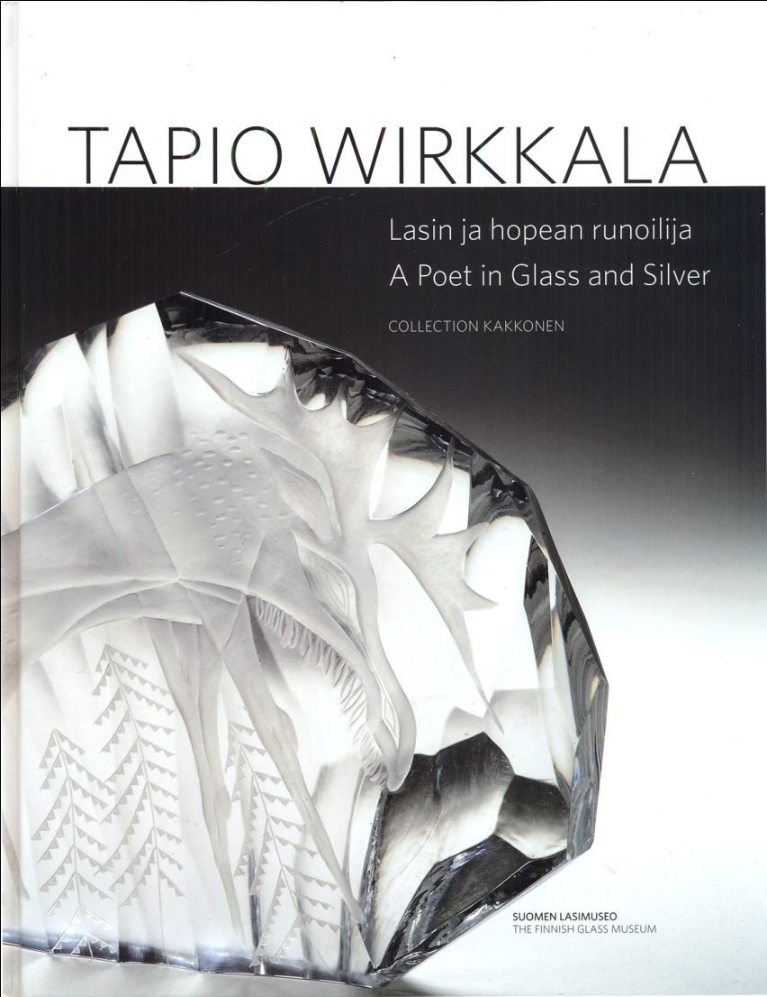

The publication charts the influence and development of Tapio Wirkkala in 20thC Finnish glass, and as an iconic figure in international glass and design. The focus of the research has been an analysis and evaluation of the artist and his individual creative, visual, and technical contribution to the art of glass, glass making and design within the factory system. The research also explored the complex relationship between technological and cultural change and their impact on individual artistic expression. The role of the artist in industry, and an investigation of the collaborative process between artists, master-craftsmen and glass technologists has therefore been an important area for discussion. This publication and the accompanying exhibition differed from other studies of Wirkkala’s glass and design in that it was researched, written and curated from the perspective of an analysis and evaluation of the contextualization of those objects that essentially fall within the creative category known as glass art, limited serial production and sculpture. Whilst acknowledging the importance – both in sociological and commercial terms of functional ware, this protocol has consciously avoided yet another re-appraisal of the designs that have dominated earlier Finnish and Scandinavian studies within the more traditionally held perception of ‘Scandinavian Modern’.

Central to the research was an exploration and interrogation of the discourses and exhibitions that have come to support the ‘myth’ of an overriding Nordic psyche and visual vocabulary. The vital role played by Wirkkala and Finnish glass production within the broader context of the design phenomenon ‘Scandinavian Modern’ or the more generic ‘Scandinavian Design’ with its emphasis on the concept of the specific engagement with nature, craft ideals and practice, and a clearly defined emphasis on a more humanized approach to good affordable design for everyday living, can be clearly evidenced in the international attention devoted to the topic by critics, writers, designers, historians and curators.

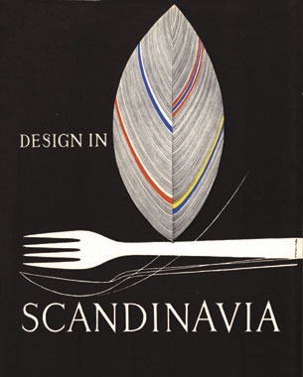

(Cover of catalogue for the American Tour 1954-7, designed by Wirkkala)

The ongoing research protocol was also driven by a need to reassess Wirkkala’s pivotal role in establishing the international importance and status accorded to Scandinavian design during the 1950s and 60s, through a questioning of the myths that he helped create to promote a specific and carefully controlled political and socio-economic concept and ideology of ‘Scandinavian Design’ or ‘Scandinavian Modern’. The stereotypical post-war romantic ideal of Scandinavian design was extolled in the annals of the Modern Movement, where mythical concepts such as homeliness, purity, simplicity, clarity of line, and closeness to nature were destined to become the key design clichés of the mid – twentieth century.

In the forward to the publication, the Director of the Finnish Glass Museum, Prof Heikki Matiskainen PhD makes the following statement-

‘The description of Tapio Wirkkala and the history of his work contain new information based on material that includes interviews with contemporaries. This analytical scholarly study will remain a source for art-historical studies that will be referred to around the world’.

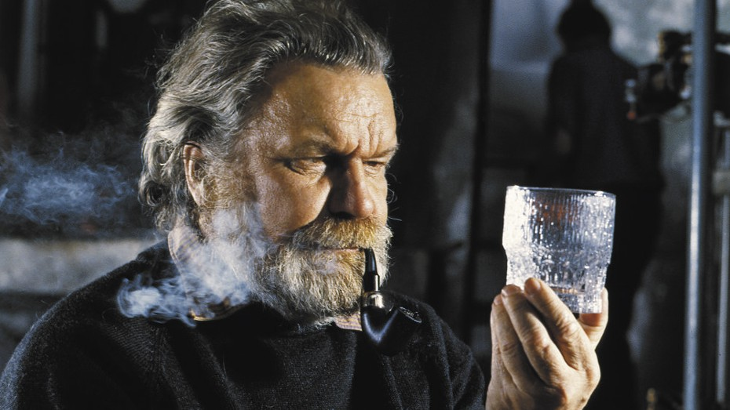

(Typical image of Wirkkala to bring emphasis to the Scandinavian myth)

